GLOBALIZATION - THE WAY TO ECONOMIC PROSPERITY OR DOWNFALL OF HUMAN SOCIETY?

Rajko Macura, PhD¹; Nenad Novaković, PhD²; Mr Nikola Novaković, MSc³;
¹Banja Luka College; Banja Luka; Republic of Srpska, BiH; macurarajko@gmail.com
²Banja Luka College; Banja Luka; Republic of Srpska, BiH; blcnenad@gmail.com
³Banja Luka College; Banja Luka; Republic of Srpska, BiH; nikola.novakovic@blc.edu.ba

Abstract: Globalization is a dynamic economic, political and cultural process that has enabled the rapid development in the field of transport and communication, It led to a series of economic, political, environmental, ethical and other problems. Large companies merge and beyond, while the small wrinkles and fade away. It has increased the gap between rich and poor. The negative consequences of globalization, most are reflected in the undeveloped countries, which are rich in resources. Looking for resources is sometimes neglected by business ethics and wider social interests, in favor of profits.The aim of the consideration of the consequences of globalization for human society and the possible directions which will it take place. The assumption of this paper is that without the intervention of society, globalization can have long-term incalculable negative consequences, particularly in developing countries and the poor strata of society. Were the statistical methods, the method of analysis and synthesis, induction and deduction, the description method and the comparative method.

Keywords: Globalization, the dimensions of globalization, the implications of globalization,

INTRODUCTION
In the last decades, interactions on a global scale have rapidly increased, starting with economic systems, transferring financial resources to the distribution of media information across the globe. The flow of goods and capital is getting faster and takes on a broad scale. This led some authors to move from previous forms of transboundary interactions to a new phenomenon called "globalism" (Featherstone, 1990; Giddens, 1990; Albrow and King, 1990), "global formation" (Chase-Dunn, 1991) "global process" (Friedman, 1994), "global city" (Sassen, 1991, 1994; Fortuna, 1997).
According to Gidens, globalization is "strengthening social relationships around the world that connect mutually distant places so that local events are shaped by events that take place at long distances and vice versa." More and more authors criticize sociologists because they are in favor of the idea that "society" is a closed system (Gidens, 1994: 64). Federston urges sociologists to "simultaneously form theoretically and carry out systematic research that will explain the processes of globalization and the destructive forms of social life whose action calls into question what has long been regarded as the basic theme of sociology: society is understood almost exclusively as a bordered nation state" (Fedearstone 1990: 2 ). In the opinion of the Lisbon Group, national systems as the central core of organized human activities and strategies go towards their end (Grupo de Lisboa, 1994). According to them, globalization is a phase that logically follows after the stages of internationalization and multinationalization. Globalization is a multi-dimensional process. It has an economic, social, political, cultural, religious and legal dimension. The model of homogeneous and uniform globalization is abandoning, so in the last decades the process of globalization combines universality and the abolition of national borders, on the one hand, with local specificity and ethnic identity on the other.
On the scene, we have parallel and diverse in the world, such as the dramatic stratification of the population, between the countries, as well as within countries, the disappearance of the middle class, overcrowding, ecological disasters, ethnic conflicts, mass migrations on a wider scale, an increasing number of civil wars, etc.
We can observe globalization from an economic, political and cultural point of view. When considering the concept of globalization, it is necessary to take into account its dimensions.

- DIMENSIONS OF GLOBALIZATION

When making a difference between the dimensions of globalization, it is important to note that the boundaries between dimensions cannot be quite strictly set. The interconnectedness between dimensions is one of the peculiarities of globalization. In order to gain an objective insight into the phenomenon of globalization, it is important to determine what falls into globalization. The dimensions of globalization can be:
−Economical
−Technological
−Informational
−Political
−Cultural
−Demographic

Globalization is not based on consensus. It is followed by fierce clashes between different interest groups, states, and even within a hegemonic camp where there are more or less divisions in that sense. Regardless of all these conflicts, the hegemonic camp operates on the basis of the consensus of its most influential members. On the basis of this consensus, the dominant features of globalization are manifested. This consensus is known as the "neoliberal" or "Washington consensus" (since it was signed in Washington in 1989 by states that form the core of the world system and which has ten neoliberal economic proposals or guidelines). This agreement paves the way for the world economy, development policy and the place of the state in such an economy. The neoliberal consensus has led to the current state, that is, to the characteristics of the present globalization. Neoliberal consensus is common to enter a period in which the deep political splits that have led to the great wars disappear. The interdependence of the great powers has led to the establishment and development of cooperation and regional integration. Today only controlled low-intensity wars are in the world, on the periphery of hegemonic states. Countries that make up the core of the world system apply different mechanisms to keep local conflicts under control, such as selective intervention, manipulation of international assistance, external debt control, and so on.
Social transformation will no longer be a political, but a technical issue. It represents an accelerated repetition of the relationship of cooperation between social groups and states (Fukuyama, 1992). After that, the idea of ​​a "collision of civilizations" followed, according to which the cleavages are no longer political, but are civilized (Huntington, 1993). A number of authors consider that the dominant feature of globalization is in fact the characterization of dominant or hegemonic globalization.

- CHARACTERISTICS OF GLOBALIZATION

Globalization is recognizable by many trends, which include an increased flow of information, goods, people and money. The development of the technologies, legal systems and infrastructure, as well as the Internet, enabled these trends.
Observed from the economic point of view, it can be noted that globalization has the following key characteristics:
− Increased rate of growth of international trade in relation to the growth rate of the world economy
− Increase in the international capital flow
− Growth and importance of foreign direct investment
− Increased participation of multinational corporations in the world economy
− Development and distribution of communication and transport services
− Deregulation and market liberalization
− Privatization of the public sector
− Erosion of national sovereignty and national borders
− Development of global financial systems
− Increased role of international organizations, such as the World Trade Organization, the World Organization for the Protection of Intellectual Property, the World Bank, the IMF and the like.

Regarding the cultural characteristics of globalization, it can be said that it has led to the spread of multiculturalism and easier access to cultural diversity, as well as increased world cultural exchanges.
On the other hand, globalization can lead to the suppression of local culture and its diversity, through its assimilation.
Globalization has some other features, such as:
− Growth of tourism and cross-border international travel
− Increased migration
− Growth of global telecommunications
− Increase in the number of international standards,
− Increase in terrorism
−Reductions or abolition of customs rates, benefits, subsidies for local entrepreneurs and producers
− Protection of intellectual property

- ECONOMIC GLOBALIZATION AND NEOLIBERALISM

At the end of the 1970s, a new international division of labor was created based on the globalization of production. The key factors in creating a new world economy have become multinational companies. The new world economy is characterized by global dominance of the financial system and investments, significantly lower transport prices, rapid technological jump in communication and information technology, flexibility in production processes, and giving priority to multilateral financial agencies. Three major transnational economies have been created, embracing the regions: American, Japanese and European.
This has affected national economies, which have an obligation to open up to the world market, while domestic prices have to comply with international prices. Economic policies should be focused on the export of fiscal policy towards reducing inflation and national debt. A balance should be maintained between import and export prices. A special accent is placed on the rights of private owners who are indefensible.
State regulations in the field of economy have a trend to be minimized. Social policy must not have priority in the state budget. Social benefits should be reduced to the minimum, primarily for social groups that have become vulnerable to market trends (Stallings, Barbara (ed.) (1995)).
Sassen points to profound changes in the geography, composition and institutional structure of the global economy (Sassen, 1994: 10). He states that the geographic space of the global economy was narrowing and that the East-West axis strengthened, so the investments, which until then were mostly directed to Latin America, were directed to the territories of South and Southeast Asia. Likewise, the level of investment and trade within the so-called triad has significantly increased: USA, EU and Japan (Sassen, 1994: 10). Thanks to the reorientation of investments in South and Southeast Asia, the average annual growth rate increased by more than 37%. In the period 1980s - 1990s, direct foreign investment on the global level increased averagely by 29% annually (Sassen, 1994: 14).
Under the influence of the neoliberal economic, there has been an enormous concentration of economic power in multinational companies. The data show that 47 multinational companies are among the 100 strongest economic systems in the world, that 500 multinational companies control 70% of the total world's trade, and 1% of multinational companies hold 50% of foreign direct investment (Clarke, 1996). It can be concluded that economic globalization is encouraged by the neoliberal economic concept, which has brought three innovations:
− a drastic restriction of state regulation in the economy,
− new international ownership rights of foreign investors, inventors and creators of innovations that can become intellectual property (Robinson, 1995: 373) and
− subordination of national states to multilateral agencies such as the World Bank, the International Monetary Fund (IMF) and the World Trade Organization.
Different countries apply different neoliberal regulations to varying degrees. In different ways, they impose peripheral and semi-peripheral countries by the hegemonic power centers.
Through multilateral financial agencies, they can be transformed into conditions under the re-negotiation of external debt. Even countries that have a hegemonic position, whose public debt is growing, sometimes suffer the consequences of the decisions of the financial rating agencies.

- CAUSES AND CONSEQUENCES OF GLOBALIZATION

The authors believe that globalization has come about due to rapid technological development, reduction of transport costs, the end of the cold war, global problems, such as climate, migration and liberalization. Globalization is linked to the emergence of the Internet, which has enabled quick and simplified communication. Globalization of the financial market enables the transfer of large sums of money over long distances. The increase in trade reduced transport costs.
Often, the cause of globalization is the end of the Cold War, after which Eastern European countries opened and entered the market. More and more countries are working towards a market economy. The globalization was facilitated by the liberalization of world trade within the framework of GATT and WTO.
Figure 1 shows the key causes of globalization.

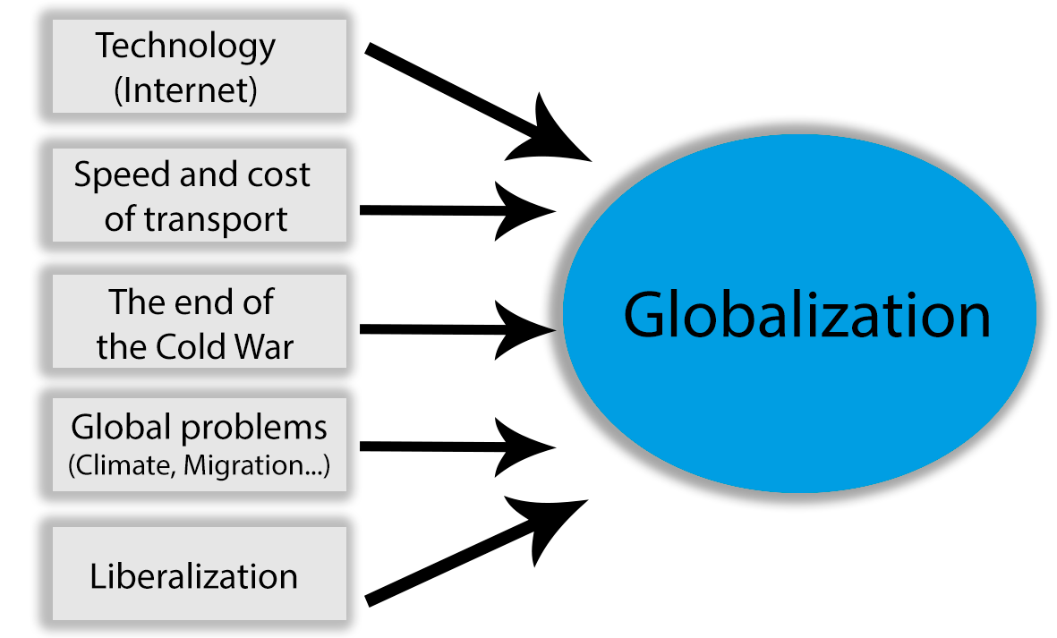

Figure 1: The key causes of globalization
Source: http://www.dadalos.org/globalisierung_hr/grundkurs_3.htm, accessed, 8.7.2017.

As a consequence of globalization, there is erosion of the nation-state, "social waste", the gap between rich and poor, the destruction of the environment (Figure 2).

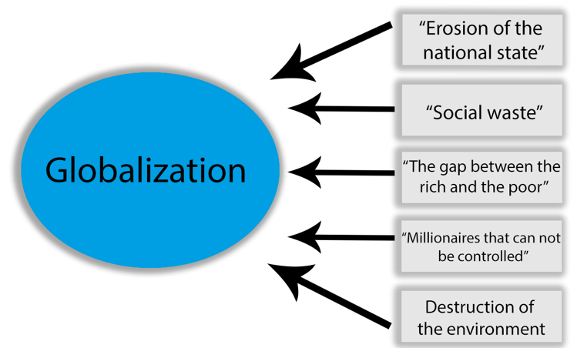

Figure 2: Consequences of globalization
Source: http://www.dadalos.org/globalisierung_hr/grundkurs_4.htm, accessed, 9.7.2017.
We have an example of state erosion in the European Union where states have transferred their responsibilities to supranational organizations.

- POSITIVE AND NEGATIVE EFFECTS OF GLOBALIZATION

Globalization as a process has its positive and negative effects on enterprises, states, supranational institutions and individuals.
The positive effects of globalization include:
- Faster access to different locations in the world
- Easier access to information, knowledge, countries, cultures, technologies
- Faster economic development
- Global optimization of production
- Economy of volume
- Increase in GDP in the world
Among the negative consequences of globalization are:
- Weakening and assimilation of local and national cultures
- Deepening the gap between the rich and the poor
- The benefits of globalization are appropriated by a small number of individuals
- The cost of globalization is borne by the majority
- The source of the anti-globalization movement
Global processes have led to the need to create global institutions.

- GLOBALIZATION AND INEQUALITY

As one of the consequences of globalization, a transnational capitalist class that is present throughout the planet has emerged and which can easily bypass national unions, as well as weak peripheral states. Multinational companies are the main institutional form of a transnational capitalist class. They are the creators of more than one-third of the world's industrial product. They differ from earlier forms of international companies by their prevalence and by the degree and efficiency of centralized management (Becker and Sklar, 1987: 2).
A "triple alliance" between multinational companies, the local capitalist elite and the so-called "state bourgeoisie" is emerging as the basis for the accelerated industrialization and economic development of semi-peripheral countries, for example, Brazil (Evans, 1979, 1986). Becker and Sklar point to the emergence of a bourgeoisie that has executive power, which represents a new social class, has a local and international branch, derived from the relationship between the administrative sector of the state and large private or privatized companies. The local branch includes the entrepreneurial elite, company managers, senior state officials, influential political leaders and experts. The international branch, the international bourgeoisie, includes managers of multinational companies and directors of international financial institutions (Becker and Sklar, 1987: 7).
The World Bank and the International Monetary Fund, although they were the leaders of the globalization model, fully recognize that the aforementioned class structure produces new social inequalities. The above-mentioned "triple alliance" is undeniably unfair and produces the redistribution of capital: "from the population to the state bourgeoisie, multinational companies and local state capital. According to Evans, maintaining a delicate balance between these three partners excludes the possibility of seriously resolving the issue of redistribution "(Evans, 1979: 288). Observed from the degree of inequality, it can be said that the Asian model of development has caused a relatively minor inequality than the Brazilian. The data from the last decades show that inequality in the distribution of world capital has become has become even greater. Thus, in the eighties of 84 underdeveloped countries, 54 of them experienced a decline in domestic gross domestic product per capita, and more than 1.2 billion people (slightly less than a quarter of the world's population) live in absolute poverty, that is, there are incomes less than $ 1 a day, and 2.8 billion live only twice larger amount (UNDP, 2001: 9). About 46% of the absolutely poor world population lives in Sub-Saharan Africa, 40% in South Asia, and 15% in the Far East, in the Pacific region and in Latin America (Wade (1990, 1996)).
In the report of 1999, the Human Development Program states: In 1997, 20% of the world's population of the world's richest countries owned 86% of the world's gross domestic product, and 20% of the poorest people in the world only 1%. Inequality in the distribution of capital between countries has dramatically increased over the past thirty years. The capital of the three richest people in the world goes beyond the sum of grossdomestic product in the 48 underdeveloped countries in the world (UNDP, 2001). A drastic example of the concentration of capital created by neoliberal globalization is the United States, which led the new economic model. According to Federal Reserve Bank data, at the end of the 1980s, 1% of North American families held 40% of the country's capital, while the richest 20% owned 80%. Such a concentration of capital has no precedent in the history of the United States and cannot be compared to any other industrialized country (Mander, 1996: 11).

The neoliberal concept provides the basis for a reduction in wages, which allows liberalization of the labor market, which causes a decrease in the labor cost. According to this consensus, it is forbidden to adjust salaries to increase productivity and cost of living, and abolish laws on the minimum wage. This has the effect of reducing the purchasing power of households. This problem is solved by going to foreign markets. The neoliberal consensus of the countries that make up the basis of the world system is imposed on peripheral countries through the control of external debt by the International Monetary Fund and the World Bank. According to Chossudovsky, these two institutions are considered responsible for the "globalization of poverty" (Chossudovsky, 1997). New globalized poverty is caused by unemployment and wage cuts, and not by the lack of human and material resources. One of the most serious consequences of poverty is the health care problem. According to the latest Human Development Report, in 1998, 968 million people could not afford drinking water, and 2.4 billion (a little less than half of the world's population) nor basic health care; In 2000, 34 million people were infected with HIV - of which 24.5 million were from sub-Saharan (UNAIDS, 2000: 6);
The percentage of assistance disbursements for vulnerable people is being reduced. This percentage fell from 0.33% to 0.22% between 1987 and 1997 (OECD / DAC, 2000). International aid programs mask financial transfers that flow from poor to wealthy countries. External debt is increasing. For example, between 1980 and 1995, total external debt of countries of sub-Saharan Africa rose from $ 84.19 to $ 226,483 million; i.e. from 30.6% to 81.3%.
In addition, the transfer from the South to the North implies many other forms, such as the "brain drain": according to the United Nations, about one thousand highly educated India people have emigrated to the United States, which represents a loss of $ 2 billion for India (UNDP, 2001: 5).
Top of Form
Bottom of Form

- UNDEVELOPED COUNTRIES AND GLOBALIZATION

Observed from the corner of third countries, globalization has more negative effects than positive ones. In search of profit, large corporations often neglect business ethics and behave socially irresponsibly. Some authors believe that globalism is a new form of imperialism.
The process of globalization follows the shift of "dirty technology" from developed countries to developing countries, where for them more favorable legislation and capital can be fertilized faster and at a higher profit rate.
Large corporations internacionalize their business in markets where they can find quality and cheap labor and raw materials. They are handled by international institutions that enable them to easily transfer and retransfer their resources.
Globalization has led to unequal participation of developed and underdeveloped countries, causing polarization of the world and unequal development. Industrial North is more active, while on the other hand, most undeveloped and developing countries do not feel the benefits of the global process.
Powerful countries often have double standards. They intervene in the defense of human rights in countries with rich natural resources, but they do not work in countries for which they have no interest. Likewise, the European Union insists on trade liberalization, while on the other hand it has established a Schengen border control system.
The informational gap between the developed and the undeveloped is deepening. Poverty in countries also leads to terrorism that is a major global problem. Industrial development leads to increased greenhouse gas emissions, leading to global warming, hurricane and storm. In response to globalization, nationalism and regionalism are emerging.

- DEVELOPMENT OF THE GLOBALIZATION IN THE FUTURE

It can be said thatglobalization represents a process that changes usual political, economic, cultural and social relations at a global level. This process has led to spatial and temporal "downsizing" of the world.
The process of globalization brings with it the danger that hegemonic centers of power will be able to impose universal standards in the interests of individual states and move towards the creation of a uniform world state. National states are increasingly less able to influence economic processes. Since globalization implies a unique economic space, the economic crisis in any region would have planetary implications.
Globalization has implications for both employment and living conditions, which particularly affect developing countries. The tendency of the global processes is to increase competition on the market, which is increasingly imposed by high criteria of quality, efficiency, development capabilities and competencies of managers. Fierce competition requires increasing capabilities, developing new skills and the ability to timely respond to ever-changing demands of employment throughout the working lives.
It is certain that we should not go in the direction of the world state, but to ensure global solidarity on issues of general global interest. The very outcome of the process of globalization is uncertain, and it will depend on all of us. (Michael Hardt, Antonio Negri, 272, 2003)
Problems borne by new world processes take on a global character, indicating that their solutions should be global. New forms are proposed, among which there is a dominant form, which is referred to as "Global Governance". Global Governance is explained as:
- governing the world without a world government;
- internal world politics;
- world policy of regulation;
- politics in the 21st century;
- concept opposite to neoliberalism;
- response to globalization.
"Capitalism is a tiger that is full of power who can be used to revive the economy, but only if its forces are controlled by state and political institutions. Globalization has dropped this tiger out of the cage and liberated" wild "capitalism, who, like a freed tiger, began to show its preference of the wild beast."[Benjamin R. Barber].
The goal of Global Governance is (again) the domestication of the "tiger" liberated by globalization.
The table below lists the views and explanations related to "Global Governance".

Global Governance is...
“…political correction of a globalized market economy in terms of linking economic systems into comprehensive social goals ... "  [Holger Mürle | "... the joint action of state and non-governmental actors from local to global level ..."  [Dirk Messner / Franz Nuscheler]
"... not only the foreign policy concept, but the reorganization of politics at all levels of action ... It is the elimination of the threatening policy denial in favor of anonymous logics of system and the construction of a single world without states ..."  [Dirk Messner / Franz Nuscheler] | "... fulfillment of a task which implies seeking solutions to solutions that do not undermine the economic and political benefits of globalization and agree that it is necessary to remove or mitigate the injustices and dangers that arise with globalization ..."  [Deutscher Bundestag – Parliament of Federal Republic of Germany]
"... a complex system of multi-level governance on the one side of the national state ..."  [Ulrich Menzel]" | "... an attempt to overcome global problems ..."  [Dirk Messner / Franz Nuscheler]"
"... is the opposite of the rules whose content is further globalization and market liberalization ..."  [Holger Mürle]" | "... a concept that was created due to the lack of regulation of world politics. This concept should increase the competence and transparency of the work of international institutions with the participation and control of non-governmental actors ..."  [Klaus Müller]

Table 1: Attitudes and explanations related to "Global Governance"
Source: http://www.dadalos.org/globalisierung_hr/grundkurs_5.htm

CONCLUSION

Views on the concept of globalization and its future are different. Hyperglobalists believe that globalization is a completely new time of human history, characterized by global politics and economics as well as global civil society. On the other hand, skeptics consider that globalization does not offer anything new. Transformationalists have the highest number of supporters and they believe that globalization is a reality and that it is a complex and contradictory process.
According to them, globalization should be seen as an unpredictable process. It is an open dynamic concept that does not have a predetermined direction or a way of transforming the world.
The caution of the transformationalists is inspired by the belief that modern models of global economic, political, cultural, technological, military, ecological and migratory flows can hardly be predicted and cannot be compared with any other period of human history.
It is interesting that the president of the United States, the initiator and the supreme supporter of liberalization and globalization, shows a turn in relation to the process of globalization and a turn to protect the domestic economy. New trade policy, " America first", is presented as sublimation to the environment in which companies want to stay in the US and open jobs here, pay taxes and therefore contribute to the development of the American society.
Such an unexpected turn was most surprised the ones who had the greatest benefit from globalization, primarily multinational companies, as well as China and other Asian countries, who were partners in globalization, and derived tremendous benefits.
As globalization results in an increasing stratification of population, the redistribution of capital from the population to corporations and capitalists, and the growing gap between the rich and the poor, it is uncertain where this process is leading. Peripheral and semi-peripheral countries are in the most difficult situation, in which the majority of the population lives in poverty and on the verge of existence. There is a dilemma for countries: to remain committed to the neo-liberal concept of development or turn to the reforms of national policies and economies.
Literature

- Becker, David; Sklar, Richard (1987), “Why Postimperialism?” u Becker et al.,1-18
- Clarke, Tony (1996), .Mechanisms of Corporate Rule., u J. Mander i E. Goldsmith (ur.), The Case Against the Global Economy. São Francisco: Sierra Club Books, 297-308
- Chossudovsky, Michel (1997), The Globalization of Poverty: Impacts of IMF and World Bank Reforms. London: Zed Books
- Evans, Peter (1986), .State, capital and the transformation of dependence: the Brazilian computer case., World Development, 14, 791-808
- Featherstone, Mike (1990), “Global Culture: An Introduction”, u Featherstone (ur.), 1-14
- Featherstone, Mike (ur.) (1990), Global Culture: Nationalism, Globalization and Modernity. London: Sage
- Featherstone, Mike et al. (1995), Global Modernities. Thousand Oaks: Sage
- Friedman, Jonathan, Cultural Identity & Global Process (London; Thousand Oaks, CA: Sage,1994),
- Giddens, Anthony (1990), Sociology. Oxford: Polity Press Giddens, Anthony (1991), The Consequences of Modernity. Oxford: Polity Press Giddens, Anthony (1999), Para uma terceira via: A renovaãç o da social-democracia. Lisboa: Presença
- Mander, Jerry; Goldsmith, Edward (ur.) (1996), The Case against theGlobal Economy. San Francisco: Sierra Club Books
- OECD/DAC (2000) .Development Co-operation Report 1999 - Efforts and Policies of the Members of the Development Assistance Committee., The DAC Journal 1 (1)
- Saskia, Sassen, (1991), The Global City: New York, London, Tokyo. Princeton: Princeton University Press
- Saskia, Sassen, (1994), Cities in a World Economy. Thousand Oaks: Pine Forge Press
- Stallings, Barbara (ur.) (1995), Global Change, Regional Response: The New International Context of Development. Cambridge: Cambridge University Press
- UNDP - Human Development Report (2001) Making New Technologies Work for Human Development. New York: Oxford University Press
- Wade, Robert (1996), .Japan, the World Bank and the Art of Paradigm Maintenance: The East Asia
- http://www.dadalos.org/globalisierung_hr/grundkurs_5.htm

