KAIZEN COSTING IN SERBIAN SMEs: A CASE STUDY OF PERFORM Ltd.

Nemanja Radović¹, M.Sc.
¹Business and Technical College of Applied Sciences in Užice, Serbia, nemanjardc@gmail.com

Abstract: While entering foreign markets, Serbian SMEs are confronted with very aggressive competition. Maintaining competitiveness, in such conditions, means continuous improvements in every aspect of business operations. Kaizen Costing is powerful strategic cost management technique, which allows significant cumulative cost reductions, based on minor, but continuous changes. Originally developed in Japan, this technique has been transferred in many companies around the world. This paper is showing achievements and perspectives in its implementation in Serbian SMEs, based on the case study of Perform Ltd. Great efforts have been made in this company, significant results in cost efficiency were achieved, but it is still facing cultural barriers and accounting information system incompleteness.

Keywords: Kaizen Costing, continuous improvements, cost management, Perform Ltd.

1. INTRODUCTION

Kaizen Costing is a modern cost management system, which was derived from Kaizen concept. As it implies the implementation of Kaizen philosophy in business operations, Kaizen Costing represents a cost reduction process, based on the small, but continuous improvements, which are performed by all the employees. It allows the engagement of their ideas through suggestion system, and the directing of their activities through multifunctional teams.
Considering that Kaizen philosophy is characteristic of the Japanese mentality, this concept has yielded highest results in their companies. However, in recent decades, efforts have been made to implement this technique in other economies, as it has been recognized as a source of company competitiveness. This paper shows the attitude of Serbian workers according to this concept, the possibilities and results of its application on the example of Perform Ltd. Also, it points to the need for developing an accounting information system according to the requirements of Kaizen Costing.

2. ABOUT KAIZEN

The word „Kaizen“, which names a traditional Japanese living philosophy, is consisted of two words: „Kai“, which means „change“, and „Zen“, which means „good“, so its name already defines it as „change for better“. Actually, Kaizen as a living philosophy, among the Japans, means small, but everyday improvements in every aspect of living. As such, Kaizen philosophy has found its place in business life, and since the 1960s, it contributes to competitiveness of Japanese products on the global markets.
The basic characteristics of Kaizen, which led to its successful implementation in business life, are:
- Continuity – the implementation of Kaizen doesn't lead to one, static goal. Instead, it implies frequent revision of goals or setting new ones. These goals include small, easy achievable business improvements, and that's what makes this process permanent.
- Incremental nature – improvements are made through minor changes. This is in contrast to the other two ways of business improvement, reorganization and innovation, which represent rapid and significant changes. Kaizen, as such, requires less investment, so it is followed by a lower risk. Certainly, after a while, its results become clearly visible as a cumulative result of minor, but continuous changes. Also, employees prefer small business changes, because their effects are less uncertain, so they don't have to worry about their jobs.
- Participatory approach – the main goal of Kaizen is to engage the ideas of employees within the company, not external experts. It gives employees confidence, which creates motivation and sense of belonging to the organization. Kaizen activities are actually implemented through multifunctional teams within the company, which enables better information exchange, activity guidance and control. [1]
Kaizen in business is a concept which consolidates techniques, which aim to reduce costs, increase market share, strengthen the brand, increase profit, upgrade information exchange within the company, reduce unused capacity, eliminate wastage, improve process and product quality [2]. Since it implies a harmonized application of independent techniques, it is usually presented like Kaizen umbrella (Figure 1). As such, Kaizen concept has produced a modern cost management system, called Kaizen Costing. The thing that separates Kaizen Costing from traditional costing systems is just coordination of cost reductions with other targets, according to which the techniques of Kaizen umbrella are striving. That allows a comprehensive approach to cost management, which makes Kaizen Costing a strategic cost management system.
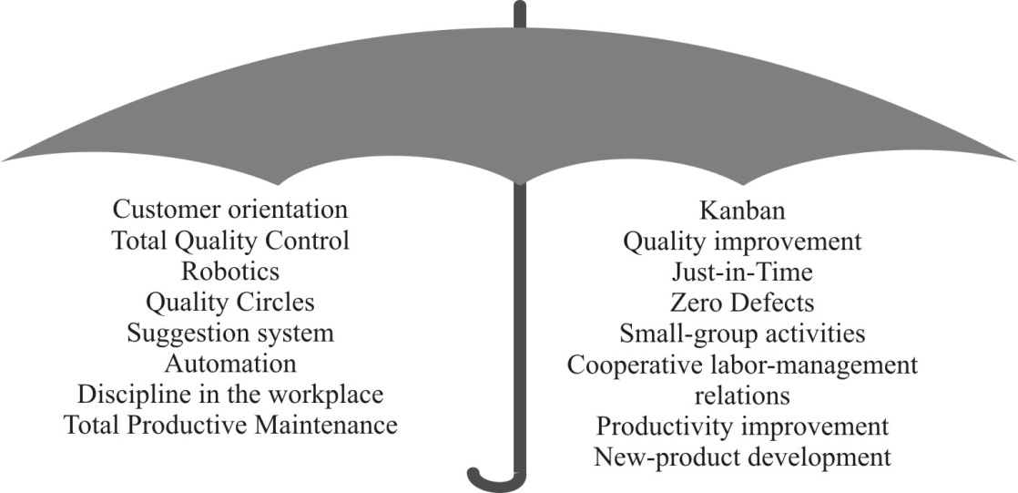
Figure 1: Kaizen umbrella [3]

Traditionally, one of the simplest ways to reduce costs was to reduce the number of employees. Kaizen is showing that it is not the most appropriate way, except in the case of a significant, long-term decline in sales volume. Namely, employee engagement, instead of layoffs, may significantly reduce costs. The company just has to recognize this potential, and as it has been shown in case of Perform Ltd., the results will be evident soon, because the Kaizen allows company to utilize it.

3. KAIZEN COSTING IN PERFORM Ltd.

Perform Ltd. was established in 1981, in Požega, Serbia. It was based on the foundation and long lasting experience of family blacksmith wheelwright workshop. Today, Perform Ltd. is still a family company, which has accumulated 70 years' experience in metal processing and production. Its basic activity is manufacturing of perforated sheet metal and similar products. It employs nearly 90 employees. Besides domestic market, a significant portion of sales is realized on the markets of the former Yugoslavia, Central and Western Europe, USA and Canada [4].
With business expansion, Perform Ltd. had begun exporting its products to developed markets, where it was confronting very competitive producers, which were mostly based on lean production system. In such circumstances, government „Kaizen program“ was ideal solution for strengthening its competitiveness.
Every year, between 10 and 15 domestic companies had the opportunity to became participant in „Kaizen program“, getting a chance to begun implementation of modern concept of cost management, called „Kaizen Costing“. The program organizer was the Serbia Investment and Export Promotion Agency (SIEPA), with the help of the Japan International Cooperation Agency (JICA). Given that Kaizen Costing is a Japanese creation, the help of Japanese consultants, who came under the support of the JICA, was precious to Serbian managers. The entire „Kaizen program“ was generally managed by Norihiko Imamura and Mateja Milenković.
Perform Ltd. had been a participant in „Kaizen program“ since 2011. The program had lasted 4 years in this company, and it had been managed by 2 Japanese consultants. A leader in its implementation in Perform Ltd. was, and still is, Mr. Miloš Janković, the owner and the director of the company.
At the beginning, Perform Ltd., circumstantially, had some important predispositions for the implementation of Kaizen Costing. Namely, the director's office was already placed on the second floor of the production hall, offering a view of the whole production section through wide windows. Thus, the director, as a Kaizen leader, in any time, has a visual access to „Gemba“ (work area), which is enabling him to monitor the process of value creation, in real time, in every work order in production section [5].
Secondly, traditionally in Perform Ltd., special attention had been attributed to staff development in order to build their individual integrity, dignity and uniqueness in their workplace. This was an excellent precondition for acceptance of the Kaizen philosophy in all aspects of business. Namely, the training and development of employees built their moderate individualism, with moderate power distance of the director.
Thirdly, employees were sure they were part of long term oriented enterprise, because the current owner is the third generation of metal producers in a family business. It has been confirmed by the fact that since the beginning of the introduction of Kaizen concept till today, the company has not fired a single employee. Actually, with the growth of business volume, the number of employees has increased significantly.
For the above reasons, there was no employee resistance to the Kaizen concept. Therewith, production hall architecture did not require significant investment in order to adapt to this concept.
At the very beginning of its implementation, cost reduction wasn't the main goal of the Kaizen concept. The main goals were directly achievable to employees, like arranging workspace, ergonomics, number of hand movements, number of steps and the like. Cots were reduced indirectly, through increase in productivity, after the application of Kaizen techniques.
The first applied technique was „5S“ technique. It has been named after the Japanese words for the steps through which it has to be implemented. Related to this steps, which are shown in Table 1, it can be noted that „5S“ technique is focused on the improvements which are in the employee's view, precisely, in his immediate work environment. [6]

Table 1: „5S“ technique
Step name | Requirement
Seiri | Disposal of items which are not needed in the workspace
Seiton | Arranging the remaining items and their labeling
Seiso | Cleaning the workspace for easy defects detection
Seiketsu | Setting standards for arranging the workspace and their maintenance
Shitsuke | Forming the standard procedure, consisting of the steps above, which is repeated continuously, with standards improvement

The next applied technique was „5M“ quality management. It was named after the English name for the 5 areas through which it controls the quality of the business process. Those steps are shown in Table 2. This technique was equally understandable to all employees, regardless of their job type. This had a favorable effect on the motivation of employees and their active involvement in quality improvement activities. Actually, a very small number of employees did not provide suggestions for the quality improvement in their workspace. It was due to their personal disinterest, because „it is impossible that everything was perfect at the workspace“, according to the company owner.

Table 1: „5M“ quality management [6]
Quality area | Requirement
Manpower | Marking the required level of professional training of the employees for executing work related activities
Machines | Coloring the machines in bright colors, which will immediately notice an oil leak. Also, parts that are regularly held are visually accessible, which will immediately notice mechanical failures.
Materials | Clearly separating and labeling places where inventories are kept during the execution of work order, which will immediately notice potential inventory out or, otherwise, overload in the workplace.
Methods | Standardizing and labeling procedures and time of performance in the workplace.
Measurements | All the measurers on the machines (temperature, pressure, etc.) must be cleaned and visually accessible

The third and the last applied technique was „kanban“. Within it, the boxes for the inventory holding were clearly marked at the maximum required level of inventories, and at the safe level of inventories below which the unobstructed execution of work orders was affected. It had simplified and accelerated the inventory procurement system, because then the employees themselves could order it from warehouse, when they fall at the safe level, in amount that would supplement supplies to the maximum level. Also, when inventories in warehouse were at safe level, employees sent the code and the required amount of the material to the director, who then just forwarded it to the suppliers.
The „kanban“ had identified some bottlenecks in production, too. Namely, the boxes for receiving work orders in the workplace had been marked at the maximum level, so when their number exceeds this line, it was a sign that there is a bottleneck. Besides, the work operations were marked with the names that were then written in the work order, so that its path through production hall was known in advance. It has allowed the tracking work order's degree of completion and possible delays.
The implementation of „kanban“ technique has allowed the continuous flow of production. Besides, its implementation has allowed the introduction of just-in-time inventory management system, which still could be enabled when relationships with suppliers and customers will be established at the higher level than now.
Generally, the implementation of Kaizen concept in Perform Ltd. has significantly increased productivity through shortening the duration of the processes and through reducing the number of production stoppages. Compared to the period prior to its implementation, on average, per month, the company is now processing 25 tons of sheet metal more. After the workspace rearrangement and a review of work operations, significant improvements has been achieved in the field of health and safety at work, which is indicated by a decrease in the number of injuries at work.
Due to the complexity of business operations and to a wide product assortment, construction of accounting information system, which could quantify the impact of applying Kaizen concept on cost lowering, would be too expensive. However, it is certain that costs of goods sold (COGS), per unit, are considerably lower now, as a direct consequence of the increase in productivity.
Currently, most of Kaizen activities in Perform Ltd. are focused on the implementation and maintenance of quality standards, which are required by foreign customers. Although they only indirectly affect cost reduction, they certainly are ways of improvements in competitiveness. Actually, quality standards are the result of the nature of business cooperation with large foreign customers, who, at the beginning of cooperation, insist on ensuring compatible quality standards in supplier facilities, while only then focus on reducing supplier's costs. It could be concluded that so far in the company has been implemented „general” Kaizen Costing. There still could not be singled out one product on which Kaizen activities are directly focused. Yet, the company owner points out that, among customers, there could be singled out those who are more demanding, than the others, so the company continuously encourages dedicated improvements in the quality of the products they order.
It is important to note here, that juts after the start of implementation of Kaizen concept, Perform Ltd. has achieved significant growth in sales volume. Growth has continued in coming years, at a rate of about 40% each year on average. This has been a significant success, but, on the other hand, it had slowed down the implementation of Kaizen concept, because the number of employees had to be doubled in this period. Also, the additional machines and equipment was installed. Every new employee should primarily be trained to carry out its core tasks, and only than it is possible to introduce him to Kaizen concept and to include him in appropriate Kaizen team. Nevertheless, the director highlights that the difficulties, encountered in the implementation of Kaizen, are not due to the nature of concept. Actually, they are the result of a dynamic business environment, due to which it wasn't easy to immediately start a system of continuous improvements, in full swing. Anyhow, in spite of the significant increase in the number of employees, achieved level of application of Kaizen techniques is very high. After the stabilization of the number of the employees and company organization, there is a plan to improve this concept with additional Kaizen techniques.
Accessing the markets of Europe and America, Perform Ltd. has become a subcontractor of major international companies in auto industry, machine building, construction, shipbuilding, etc. So, it has become a part of global supply chains, which, due to strong competition in the markets of final products, require constantly improving the competitiveness of all participants in the chain. In these chains, Perform Ltd. now deals exclusively with the production of components, while component design is already defined by a customer. That is the main reason why Kaizen Costing is adequate system for reducing costs in this company, unlike for example Target Costing, which is mostly focused on component design. On the other hand, this certainly doesn't inhibit the company to participate in an integrated cost management system, where target cost reductions, which are defined in design phase, can be realized through kaizen cost reductions during production phase in Perform Ltd. [7]

3.1 Organizational aspects

In terms of organization, the implementation of Kaizen concept in Perform Ltd. is conducted through 9 multifunctional teams. These teams have their leaders, who participate in monthly Kaizen meetings with the company owner, while these meetings are much more frequent and less formal within individual teams. Kaizen meetings include: consideration of suggestions for improvements received from employees, evaluation of the achievement of objectives from the previous period and setting the objectives for the next period. The goal setting process doesn't go unidirectional, from the director to the team leaders. It is done through complementing the vision of the director with real possibilities of the employees and with their suggestions. In literature, this system is known as „Management by Objectives“ (MBO). Its functioning in Perform Ltd. can be shown as in the Figure 2. For example, one of the objectives, which has been realized through cumulative effect of Kaizen improvements, which were guided through periodic Kaizen meetings, is the achievement of the degree of production capacity utilization of 80%.
An important part of this kind of goal setting process is the employee suggestion system. It operates through standardized forms, which employees leave in special box, in front of the director's office. According to an internal company statistic, employees, on average per month, leave between 7 and 8 high-quality suggestions for the improvements. These suggestions could become new objectives or they could adjust already set objectives. The advantage of this system is that it prevents employee opportunism, because they have the ability to point out objectives which are not achievable with a standard effort. Also, this system engages employee creativity, because their ideas are being considered during goal defining. Employees' ideas have a great potential for Kaizen improvements, because no one in the company knows their work operations better than themselves.
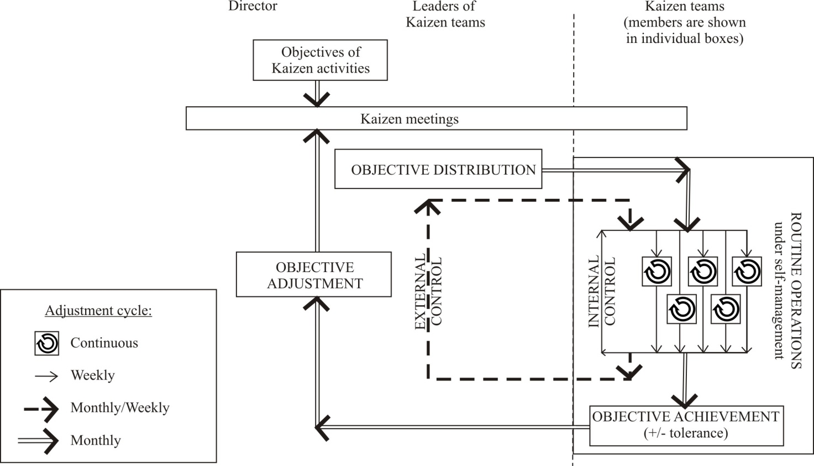
Figure 2: Management by Objectives in Perform Ltd. (customized according to [1])

Still, this suggestion system is not self-sustainable. The owner has to enforce the employees' suggestions, constantly. According to him, for less significant improvements, employees are usually satisfied with intangible incentives. For excellent suggestions, certainly, there are cash bonuses provided, but generally, after truancy of material incentives, the employees will show satiation and disinterest soon.
This could be explained with employee mentality. Namely, it is already confirmed in this paper that the long term orientation, moderate power distance and moderate individualism attracted Perform's employees to take a part in Kaizen. But, one more feature of the Japanese mentality has led to the successful implementation of Kaizen in business, and it was high uncertainty avoidance. It is possible that this does not feature Serbian workers, which is why they are more inclined to occasional, large-scale innovations in their work environment, compared to constant, small improvements. [8]

4. KAIZEN COSTING AND ACCOUNTING INFORMATION SYSTEM

Kaizen Costing is a cost reduction system, which is based on minor, but continuous improvements in business operations. As can be seen in Figure 1, these improvements could be results of employees' ideas or they could be required by the director, but in both cases they are conducted through goal planning system. That means that goals have to be set at the beginning of the period, and also that their achievement must be controlled at the end of the period. According to this, Standard Costing system could provide relatively good information support to Kaizen Costing.
Standard Costing is a traditional costing system, which requires defining amounts of standard, objectively necessary costs [9], at the beginning of the period, and determining the differences between this amounts and actual costs, at the end of the period. These differences are known as cost variances. According to [10], the total cost variance is made by: a) costing system errors; b) inappropriate standards; c) uncontrollable random factors; d) controllable variances with operational causes.
From period to period, in which standard costing system is used, costing system errors and inappropriate standards could be eliminated by accountants, so then uncontrollable random factors could be separated from controllable variances with operational causes. Those controllable variances with operational causes are the most valuable information which standard costing system could offer to Kaizen Costing, and in that moment these two costing systems diverge.
Namely, this information indicates places in company where cost reductions must be taken, and while Standard Costing is fulfilled when standard amounts are reached, Kaizen Costing requires constant reduction of standard amounts after their achievement. Of course, standard cost amounts in Standard Costing system are being reviewed once annually, but even when it is done twice or more often, it can't guarantee that standard amounts are correspond to changes in business environment. On the other hand, Kaizen Costing provides more often reviews of the amounts of costs. As it can be seen in Figure 1, through Management by Objectives, they can be reviewed monthly on the company level, or even weekly or daily on the team level. Secondly, the process of setting standard cost amounts in Standard Costing system is more formal and less flexible. It is a responsibility of upper management and engineers, and there is a possibility that the standard cost amounts, which are set by them, will face employees' resistance, because it is mostly top-down goal setting process. In Kaizen Costing this is an everyday process (Figure 2), because the suggestion system allows maximum employee engagement. Thanks to that, the targeted cost amounts surely correspond to the real possibilities of the employees, and also, it is possible to engage their ideas which arise during everyday business operations. So, it equally involves top-down and bottom-up approaches in goal setting process.
One example, from Straus Adriatic Ltd. – Šimanovci, illustrates how big the potential of employees’ ideas is. Namely, in 2012, one employee had suggested that waste from their coffee production can be used for heating, instead of propane-butane gas. LP gas was replaced with briquettes of coffee beans, which reduced costs in amount of 83.000$ [11]. Another example comes from Japan Tobacco International AD Senta, where one employee's proposal in 2013 reduced costs in amount of 75.000$. The best proposal in 2016 saved them 42.000$. Accordingly, there are enough reasons for wider employee engagement in cost reduction process.
The third reason why Standard Costing doesn't respond fast enough to changes in business environment could be find in its focus on quantity-based cost objects, like work hours or machine hours. During last decades, due to fast changing business conditions, there is noticeable increase in relative significance of indirect costs, which are less related to the product quantity. Unlike Standard Costing, Kaizen Costing has the ability to affect the sources of indirect costs through many Kaizen techniques, which reduce waste, failures, stoppages, employee's steps, hand movements, etc.
For the above reasons, Standard Costing is tending to be used just as an internal reporting system, while the cost reduction is tending to be left to other systems, like Kaizen Costing [10]. Thanks to wider employee engagement, Kaizen Costing allows more comprehensive analysis of the cots variances. Also, it involves the analysis of nonfinancial performance measurers, because they certainly will affect financial performances someday in future. Therefore, while Standard Costing requires reaching the objectively necessary production costs within the existing technology, Kaizen Costing may even require modifying whole technology and method of production [12].
Still, the above facts don't mean that Standard Costing is being less used by companies. According to [10], a large number of companies in the world, even in Japan, continue to use it. The reason is that, due to the lack of an adequate accounting information system, the system of Standard Costing represents adequate support in cost estimation. So, this could be a recommendation to Perform Ltd. too, whose costing system is currently based on actual costs, instead of standard costs. Building a system of Standard Costing requires upgrading company's chart of accounts and investments in hardware, software and employees, but it certainly will advance currently level of Kaizen Costing implementation. It will allow the evaluation of the results of Kaizen activities and their orientation towards specific products. This complementarity of Standard Costing and Kaizen Costing could be shown in the next figure:
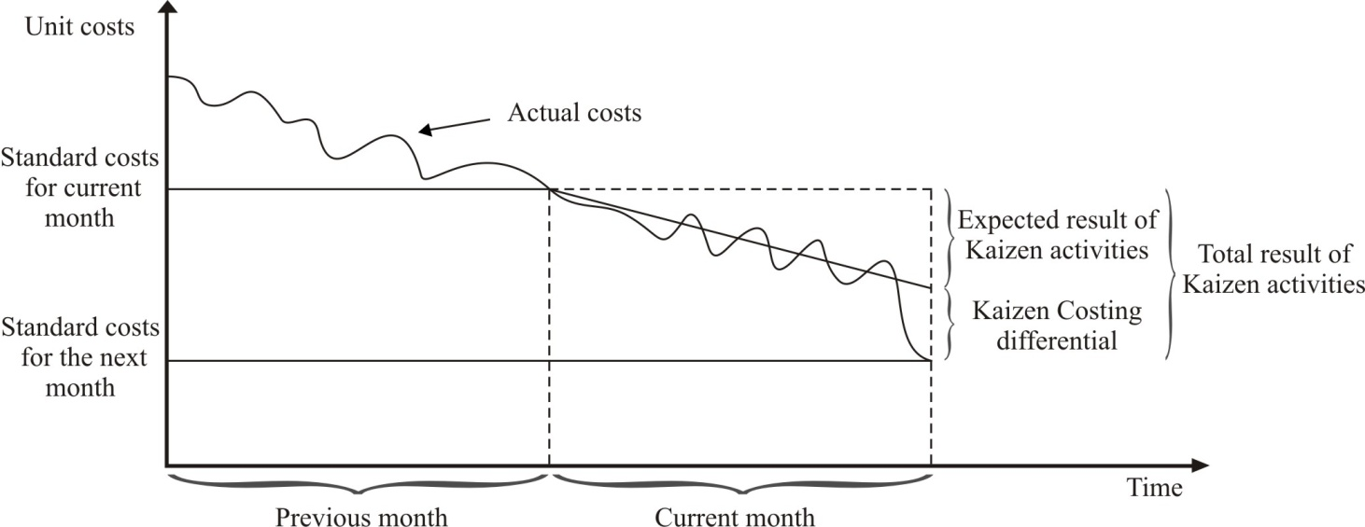

Figure 3: Standard Costing as information support to Kaizen Costing (customized according to [13])

If we assume, that standard costs are revised once per year, then their planning isn't done on monthly basis, so for the standard amount of costs for the next month, in Figure 2, we could take the actual costs from the previous month. On the other hand, knowing that Kaizen activities are carried out continuously, we can expect cost reductions in every month. In fact, if these activities are directed towards the specific product, we could estimate their impact on the unit costs (Expected result). So the standard amount of costs, set by the Standard Costing, is being modified by the amount of the expected result of Kaizen activities, at the beginning of the period. Then, at the end of the period, Kaizen Costing is using Standard Costing information system again, when it requires information about realized costs. The realized amount of costs could be lower, equal or higher than the expected amount. In case when it is lower, like in Figure 2, then Kaizen Costing differential will be achieved. It represents the amount of cost reduction which is higher than the expected one, which was estimated on Kaizen meeting, at the beginning of month. Such as, this differential has control function. It is showing the ability of Kaizen team to reduce costs more than it was expected, so it is the basis for the bonus and incentive plan. In other words, it is showing that employees have adopted the Kaizen philosophy, so they do not remain on the set goals, but they are constantly improving business operations.
It is certain that Standard Costing will allow better monitoring of Kaizen activities in Perform Ltd., but it is a special kind of investment. So, the modification of existing Actual Costing system will be realized only after appropriate cost-benefit analysis [14]:
$$\frac{incremental benefits of aditional accounting informations}{incremental administrative cost}>1$$
It is important to note here, that company's chart of accounts has already been upgraded. Namely, participation in global supply chains implies that Perform Ltd. has to participate in theirs integrated cost management systems. That is why, in the last years, in company are coming requests for „open calculations“ of costs and prices of components it produces. Their purpose is to provide information basis for adjusting cost and profit management between the buyers and suppliers within the supply chain.

5. CONCLUSION

Kaizen Costing is a powerful cost management tool, which, besides cost savings, allows improvements in production process and product quality, based on the employee engagement. As a part of government „Kaizen program“, Perform Ltd. has implemented Kaizen since 2011. The most significant results of its application in this company are: shortening the duration of the processes, reducing the number of production stoppages, increase in processing capacity by 25 tons of sheet metal and significant decrease in the number of injuries at work.
There are no precise measures about cost savings in this company, which are the results of Kaizen activities, because of the accounting information system incompleteness, but it is certain that costs per unit of product are considerably lower now, as a direct consequence of the increase in productivity. The upgrade of accounting information system, at least to the level of Standard Costing is desirable, because it will allow better managing and monitoring of Kaizen activities in Perform Ltd., but still, it will be realized only after appropriate cost-benefit analysis.
Given that the company has achieved significant growth in sales volume during the last few years, and that the number of employees was doubled after the start of implementation of Kaizen concept, achieved level of application of Kaizen techniques is very high. After the stabilization of the number of the employees and company organization, there is a plan to improve this concept with additional Kaizen techniques.

REFERENCES

[1] BRUNET, A.P.; NEW, S.: Kaizen in Japan: an empirical study, International Journal of Operations & Production Management, Vol. 23, Iss 12, Emerald Group Publishing, Bingley, United Kingdom, 2003.
[2] MALINIĆ, S.: Upravljačko-računovodstveni aspekt Kaizen Costing-a, Računovodstvo, SRRS, Beograd, Srbija, 2008.
[3] IMAI, M.: Kaizen – ključ japanskog poslovnog uspeha, Mono i Manjana, Beograd, 2008.
[4] http://www.perfom.rs
[5] IMAI, M.; HEYMANS, B.: GembaKAIZEN: Organizational Change in Real Time, Available at: www.flowmakers.com/articles/gembakaizen7.14.06.pdf
[6] IMAI, M.: Gemba Kaizen: A Commonsense Approach to a Continuous Improvement Strategy, McGraw-Hill, New York, United States, 1997.
[7] RADOVIĆ, N.: Integrisano upravljanje troškovima na bazi ciljnih i kaizen troškova, Master rad, Ekonomski fakultet, Beograd, Srbija, 2015.
[8] RECHT, R.; WILDEROM, C.: Kaizen and culture: on the transferability of Japanese suggestion systems, International Business Review, No. 7, 1998.

[9] JABLAN-STEFANOVIĆ, R.: Interni obračun, Ekonomski fakultet, Beograd, Srbija, 2010.

[10] DE ZOYSA, A.; KANTHI HERATH, S.: Standard costing in Japanese firms: Reexamination of its significance in the new manufacturing environment, Industrial Management & Data Systems, Vol. 107, No. 2, Emerald Group Publishing, Bingley, United Kingdom, 2007.
[11] NEŠANOVIĆ, N.: Kaizen Costing: savremeni upravljačko-računovodstveni pristup obračunu i upravljanju troškovima preduzeća, Master rad, Ekonomski fakultet, Beograd, Srbija, 2015.
[12] MONDEN, Y.; HAMADA, K.: Target Costing and Kaizen Costing in Japanese Automobile Companies, Journal of Management Accounting Research, United States, 1991.
[13] BUDUGAN, D.; GEORGESCU, I.: Cost Reduction by Using Budgeting Via the Kaizen Method, Stiinte Economice, Universitatii "Alexandru Ioan Cuza", Iasi, Romania, 2009.
[14] Implementing Activity-Based Costing, Institute of Management Accountants, available at: https://www.imanet.org/-/media/d5beff30c5864c7383e6ebb61556bab3.ashx

