SOFTWARE SUPPORT TO THE IMPLEMENTATION OF MULTI-CRITERIA OPTIMIZATION IN INVESTMENT PROJECT RANKING

Ivica Veža¹, PhD; Zoran Nešić², PhD; Miroslav Radojičić³, PhD; Boženko Bilić⁴, PhD
¹Faculty of Electrical Engineering, Mechanical Engineering and Naval Architecture, Split, University of Split, Croatia, ivica.veza@fesb.hr
²University of Kragujevac, Faculty of Technical Sciences, Čačak, Svetog Save 65, 32000 Čačak, zoran.nesic@ftn.kg.ac.rs
³University of Kragujevac, Faculty of Technical Sciences, Čačak, Svetog Save 65, 32000 Čačak, miroslav.radojicic@ftn.kg.ac.rs
⁴Faculty of Electrical Engineering, Mechanical Engineering and Naval Architecture, Split, University of Split, Croatia, bozenko.bilic@fesb.hr

Abstract: This paper presents the application of a multi-criteria optimization on the example of an analysis of investment projects. For this purpose, a model of a multi-criteria base is developed and the methodology for the selection of the optimal alternative is discussed. The software solution applied in the paper enables sophisticated visual support in the analysis and multi-criteria decision-making.

Keywords: Management, Multi-Criteria Decision Making, Investment Projects, Software Solution

1. INTRODUCTION

Management business requires a complex and multidisciplinary approach practically in all activities, starting with direct production management, managing investment activities, performing various projects, and deciding in all segments. In that sense, it is necessary to apply different methods, knowledge and approaches. Business decision-making is one of the most complex activity which is essential and the most common activities of management operations. Parker Case and point out that "the essence of management decision making because it is the most basic functions that managers perform" [1].
Considering theoretical and fundamental basis of decision-making, numerous authors emphasized their basic characteristics and gave a number of definitions, based on the following: "The decision is the choice of one, from a set of possible alternatives, or actions, which to the decision-maker (individual or group stand on available "[2], or this is "a process which selects a number of alternative options for changing the state of the system in order to achieve the objectives" [3], as well as the detailed theoretical considerations of these problems [4] - [6], and systematic approach to solving the problem of decision making [7].
Analyzing the problem of decision making, many authors developed different directions in solving it, such as:
- Spreadsheet modeling and application [8]
- Implementation of business statistics in decision making [9]
- Various mechanisms of decision making [10]
- Financial aspects in decision making [11]
- Influence of uncertainty in decision making [12]
- Emotions in Decision Making [13]
Some of the most important characteristics of modern decision-making methods are, on one hand, the complexification of decision-making methods and the acquisition of increasingly sophisticated techniques, while on the other hand a requirement is made for their simpler use. In addition, some authors emphasize the need for modern organizations for a significant reduction in time for decision-making, and also that "the time for decision-making at all levels of governance in organizations is still shortened" [14]. In this respect, significant decision support has the application of information technology in different segments [15] - [18].
The development of information technology to support the needs of management operations also contributed to the development of management information systems [19] - [21]. "Management information system is a set of procedures for the collection, processing, storage and the dissemination of information for managers" [22].
In the narrow sense, decision support systems, in addition to providing the necessary information to managers, enable them to be processed. This paper presents the application of original software for the application of multi-criteria optimization in the ranking of investment projects. The aim of this paper is to demonstrate the use of sophisticated multicriteria optimization methods [23] - [27] through a developed software tool for that purpose.
Some authors point out that decision support systems "represent the symbiosis of information systems, the application of a set of functional knowledge and the current decision-making process" [28]. It can be expected that using the software solution to support multi-criteria decision-making methods, the final result is obtained through user and computer dialogues. The result that represents the final decision must be left to man. Decision support systems should only be a tool that would allow consideration of problems from different aspects and create alternative options for obtaining final solutions [29] - [35].
2. SOFTWARE SUPPORT TO THE MULTI-CRITERIA OPTIMIZATION

Investment projects are one of the most important large project activities. They are characterized by the conditions of great risks and uncertainties, and, on the other hand, large financial investments. The choice of the best investment solution is based on a large number of criteria that can often be contradictory. In addition, the criteria are, as a rule, of a different nature, starting with economic investment, the risk of a project from a large number of aspects, the time of returning the invested funds to environmental, security and other factors.
In addition, the criteria, as a rule, have a different relative significance that complicates the evaluation of the best investment solution. Given that there are a large number of criteria and alternative solutions, it is very difficult to find an optimal variant. Investing large financial assets under risk conditions entails great responsibility and also the consequences of wrong decisions.
In this sense, the application of multi-criteria optimization methods in the selection of investment projects is of great importance. In this paper will be on the specific case, through methodological studies show a case that can be generally the first step in this analysis.
Based on the expert assessment, as the general and most important criteria for the selection of the best investment project, they were taken into consideration:
- Economic criteria (F1)
- Technical-technological criteria (F2)
- Logistic criteria (F3)
- Ecological criteria (F4)
- Security criteria (F5)
Analyzing the values of individual alternatives in relation to individual criteria, a multi-criteria database is presented in Table 1.
Table 1: Multicriteria base
Criterion | Request | Weight | Alternative
 |  |  | a₁ | a₂ | a₃ | a₄ | a₅ | a₆ | a₇
F1 | Max | 0,3 | 165 | 142 | 175 | 184 | 170 | 160 | 146
F2 | Max | 0,3 | 27 | 33 | 39 | 32 | 29 | 35 | 29
F3 | Max | 0,2 | 193 | 190 | 224 | 209 | 216 | 221 | 195
F4 | Min | 0,1 | 3,0 | 2,8 | 3,1 | 2 | 2,6 | 3,5 | 2,4
F5 | Min | 0,1 | 0,95 | 1,3 | 0,5 | 0,6 | 0,4 | 0,8 | 0,9

The importance of applying a software solution in multi-criteria analysis is of great importance primarily for practical reasons. By automating the calculation of the mathematical model, it is possible to eliminate the error of the budget, as well as to shorten the time of the budget. In addition, the user does not need to be familiar with the methodology of mathematical calculations. These are the most important reasons for the practical application of methods of multi-criteria analysis. The application enables the creation of a multi-criteria database, the input of criteria, alternatives, and the calculation of three methods of multi-criteria optimization - Promethee, Elektra and Compromise Programming. Figure 1 shows the input of the value of the alternative for the considered multi-criteria base.

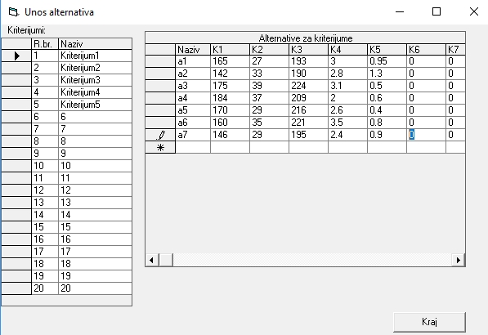
Figure 1: Values of the alternatives

Promethee method of multi-criteria optimization also enables visual analysis of the preferences of certain criteria. The mathematical model of the Promethee method used in the consideration includes the Universal Preferential Function [36] which enables the creation of an unlimited number of different preference curves and therefore a sophisticated expression of the preference of decision-makers according to individual criteria. The software solution enables the display of all preferential functions based on the mathematical model of one universal preference function. Faster growth of the function also means a higher level of preference for decision-makers in that value area and vice versa.

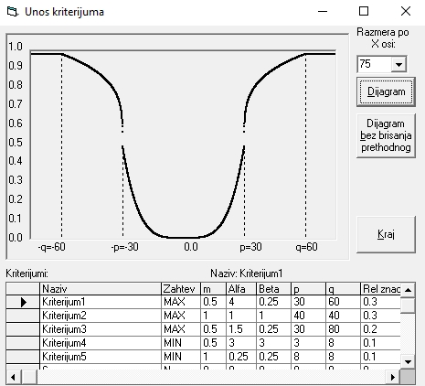  Figure 2: Economic criterion | 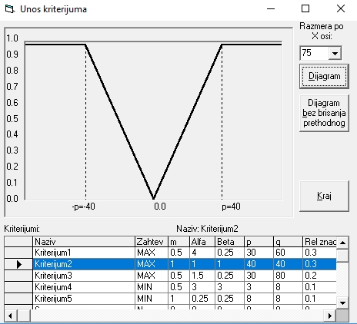  Figure 3: Technical-technological criterion
In Figure 2, the economic criterion is analyzed and shows a lower level of preference in the lower value area. This would mean less significant investment of economic resources if they have little value. With the increase in the value of financial investments, their importance in terms of multi-criteria decision-making is growing. This is shown by a faster growth of a preferential function with higher values. The decision maker is the most important character of the economic criteria in the area of preference changes.
Figure 3 shows the analysis of the technical and technological criteria. The decision maker expressed the equal importance of this criterion in the overall multi-criteria area. This means that the technical and technological characteristics should have the same significance regardless of the value of any alternatives according to this criterion.
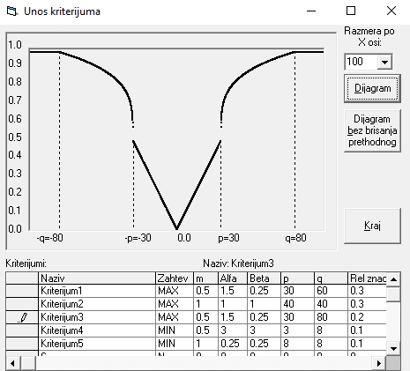 Figure 4: Logistic criterion | 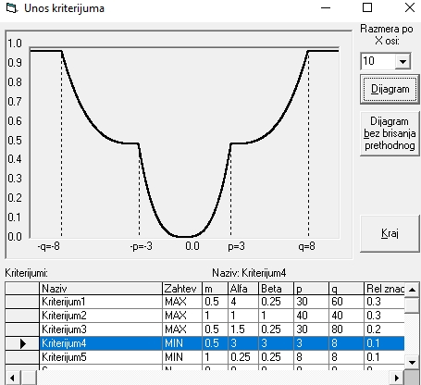 Figure 5: Ecological criterion
In Figure 4, one eventual analysis of the logistic criterion was carried out. The decision maker expressed the equal importance of preferences according to this criterion at lower and initial values, up to a change in the preference, or values that may be significant. This is reflected in the rapid growth of the preferential function in that area and directly higher values. At the end of the preference margin there is a decline in its significance.
Figure 5 shows one possible analysis of the ecological criterion. In the analysis presented, it does not exhibit a greater significance at the lowest values of the preferential values. It is expressed by approaching the boundary of changing the rate of preference, as well as by approaching the very limit of preference. This also highlighted two possible moment for significant environmental criteria.

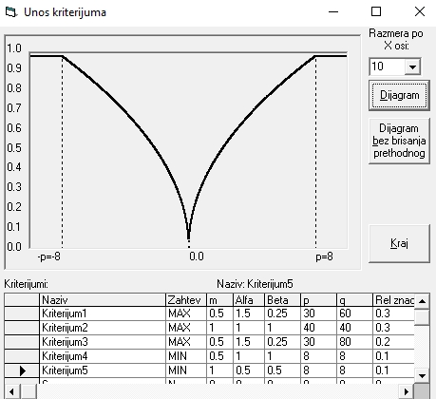 Figure 6: Security criterion | 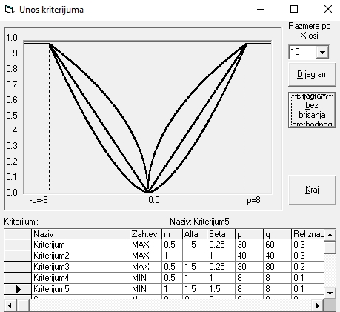 Figure 7: Comparative analysis of several preference curves
Figure 6 shows that the decision-maker expresses the importance of the least value in the area of preferential space. The developed software solution also allows a comparative visual analysis of various preference functions, Figure 7. This allows the decision maker to perform a detailed comparative analysis of different prediction statements according to individual criteria before calculating the mathematical model and obtaining the results.
Figure 8 shows the comparative results of different methods of multi-criteria decision making. It can be seen that alternatives 3 and 4 dominate in the first place, alternatives 5 and 6 are medium-good, while 1,2 and 7 should not be taken into account. Different methods of multi-criteria decision-making do not always give absolutely the same results due to different approaches in forming their mathematical models.
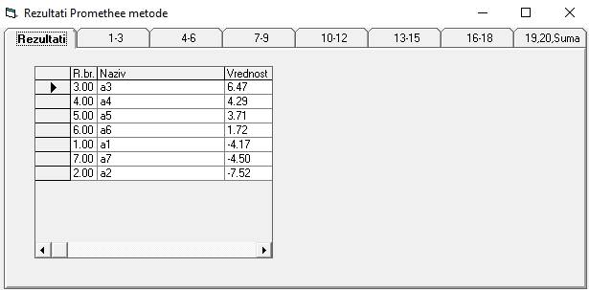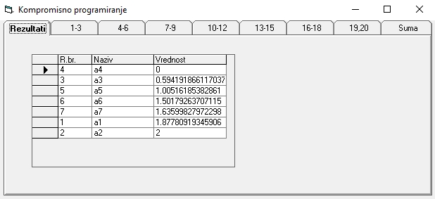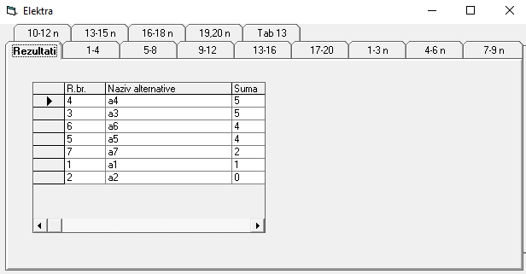

Figure 8: Comparative results of multi-criteria decision making

3. CONCLUSION

This paper presents some possibilities of software support in the application of multi-criteria optimization for ranking investment projects. A unique software solution based on an advanced Promethe method is displayed. The software solution provides an improved approach to the analysis of individual criteria based on the visual representation of an unlimited number of preferential functions, as well as the calculation of results in other methods of multi-criteria optimization - Elektra and Compromise Programming.
Investment projects are one of the most important large project activities. For this purpose, the model of a multi-criteria database has been developed. By the methodological way is presented and the discussed choice of the optimal alternative is presented.
Based on the presented analysis, it can be concluded that the application of multi-criteria optimization methods in the selection of investment projects is of great importance. The application of mathematical models allows a more exact approach to finding the optimal variant. However, it is precisely the application of mathematical models that enables automation of the budget using software solutions.
It can be concluded that the importance of application software solutions in multicriteria analysis is of great importance primarily for practical reasons, such as elimination of the error o calculation, reducing the time of the budget, the user does not need to be familiar with the mathematical calculation based methodology, enabled the visual and comparative analysis of preferential function.
This paper presents a general model of a multi-criteria basis for the selection of investment projects which can serve as a starting point for this purpose in general.

Acknowledgment: Research presented in this paper was supported by Ministry of Education and Science of the Republic of Serbia, Grant TR 35017.

REFERENCES

- PARKER C., CASE T.: Management Information Systems, Second Edition, Mitchell Mc Graw-Hill, New York, 2003.
- ČUPIĆ M., TUMMALA R.: Savremeno odlučivanje, metode i primena, II izdanje, UBK, Beograd, 1994
- BULAT V: Industrijski menadžment, ICIM, Kruševac, 1997.
- ADAIR J.: Decision Making and Problem Solving Strategies, Kogan Page Publishers, London, 2010.
- NUTT P.C., WILSON D.C.: Handbook of Decision Making, John Wiley & Sons, United Kingdom, 2010.
- HICKS M.J.: Problem Solving and Decision Making: Hard, Soft and Creative Approaches, Cengage Learning EMEA, London, 2004.
- GRINIG R., KÜHN R.: Successful Decision-making: A Systematic Approach to Complex Problems, Springer Science & Business Media, Berlin, 2005.
- RAGSDALE C. Spreadsheet Modeling & Decision Analysis: A Practical Introduction to Business Analytics, Cengage Learning, USA, 2016.
- BLACK K.: Business Statistics: For Contemporary Decision Making, John Wiley & Sons, USA, 2011.
- HAMMERSTEIN P., STEVENS J.R.: Evolution and the Mechanisms of Decision Making, MIT Press, Cambridge, 2012.
- BIERMAN H., SMIDT S.: Financial Management for Decision Making, Beard Books, Washigton, USA, 2003.
- BYRNE P.: Risk, Uncertainty and Decision-Making in Property, Routledge, New York, 2002.
- ROLLS E.T.: Emotion and Decision Making Explained, OUP Oxford, Oxford, 2013.
- ČUPIĆ M., SUKNOVIĆ M.: Odlučivanje, FON, Beograd, 2008.
- STAIR R., REYNOLDS G.: Fundamentals of Information Systems, Cengage Learning, Boston, 2015.
- MARIA VAN DER HEIJDEN J.G., Designing Management Information Systems, Oxford University Press, Oxford, 2009.
- WHITMAN M.E., Woszczynski A.B.: The Handbook of Information Systems Research, Idea Group Inc (IGI), USA, 2004.
- RAINER R.K., CEGIELSKI C.G.: Introduction to Information Systems: Enabling and Transforming Business, John Wiley & Sons, USA, 2010.
- BAGAD V.S.: Management Information Systems, Technical Publications, India, 2008.
- OZ E.: Management Information Systems, Cengage Learning, USA, 2008.
- LUCEY T.: Management Information Systems, Cengage Learning EMEA, 2004.
- BULAT V., ČUPIĆ M., GAVRIĆ Z., NADRLJANSKI Đ., RADOJIČIĆ M., RANĐIĆ S., ŠLJIVIĆ S.: Menadžment informacioni sistem, Izdavački centar za industrijski menadžment, Kruševac, 1998.
- TZENG G.H., HUANG J.J.: Multiple Attribute Decision Making: Methods and Applications, CRC Press, London, 2011.
- MUNIER N.: A Strategy for Using Multicriteria Analysis in Decision-Making: A Guide for Simple and Complex Environmental Projects, Springer Science & Business Media, Dordrecht, 2011.
- TRIANTAPHYLLOU E.: Multi-criteria Decision Making Methods: A Comparative Study, Springer Science & Business Media, Boston, 2013.
- GAL T., STEWART T., HANNE T.: Multicriteria Decision Making: Advances in MCDM Models, Algorithms, Theory, and Applications, Springer Science & Business Media, New York, 2013.
- LEITMANN G., MARZOLLO A.: Multicriteria Decision Making, Springer, New York, 2014.
- ČUPIĆ M., NOVAKOVIĆ T., SVILAR M.: Generatori i aplikacije sistema za podršku odlučivanju, Naučna kniga, Beograd, 1992
- POWER D.J.: Decision Support Systems: Concepts and Resources for Managers, Greenwood Publishing Group, London, 2002.
- BURSTEIN F., HOLSAPPLE C.W.: Handbook on Decision Support Systems 1: Basic Themes, Springer Science & Business Media, Berlin, 2008.
- JANAKIRAMAN V.S., SARUKESI K.: Decision Support Systems, PHI Learning Pvt. Ltd., New Delhi, 2008.
- HOLSAPPLE C.W., WHINSTON A.B.: Recent Developments in Decision Support Systems, Springer Science & Business Media, 1993.
- SAUTER V.L.: Decision Support Systems for Business Intelligence, Wiley, 2011.
- TURBAN E., ARONSON J.E.: Decision Support Systems and Intelligent Systems, Prentice Hall, Upper Saddle River, NJ, 2001.
- SUGUMARAN R., DEGROOTE J.: Spatial Decision Support Systems: Principles and Practices, CRC Press, London, 2010.
- RADOJICIC M., ZIZOVIC M., NESIC Z., VESIC VASOVIC J., Modified approach to PROMETHEE for multi-criteria decision-making, Maejo International Journal of Science and Technology, 2013, Vol. 7., No. 3. pp. 408-421,

