PREVENTIVE TESTING OF ELECTRICAL INSTALLATIONS AND PROTECTIVE DEVICES OF DIFFERENTIAL CURRENTS
PhD Vidoje Milovanovic
Business-Technical College, Uzice

Abstract: This paper presents the tests of the correctness of electrical installations and differential current protection devices using the Eurotest 61557 instrument. Measurements of the expected contact voltage, time, current and disconnection current and impedance loops are shown. The obtained results of the measurement show that the tested electrical installation in Business-Technical College in Uzice is correct and safe to use.
Key words: Electrical installations, contact voltage, exclusion time, exclusion current, loop impedance, measurement.

- PROTECTIVE DEVICE OF DIFFERENTIAL CURRENTS

The basic task of automatic power off is to when there is a fault on the insulation of electrical equipment prevent hurting people from the dangerous contact voltage that may occur on that occasion. In order to have automatic shutdown, any equipment isolation failure should cause power disruption in a time that does not pose a risk to h The differential current protection device is a protective element designed to protect live beings from electric shock. The principle of operation is based on the difference between the phase current going to the different receivers and the current returning through the neutral conductor. If this difference is greater than the disconnection current of the installed power protection device, the device will react and automatically turn off the power. The mentioned difference in current must flow to earth as a leak current (through isolation or capacitive coupling) umans [2].
To ensure that the device differential current protection is efficient, it is necessary to:
- the device is properly installed,
- insulation is properly carried out,
- the ground resistance value is below the permissible value for the built-in device.

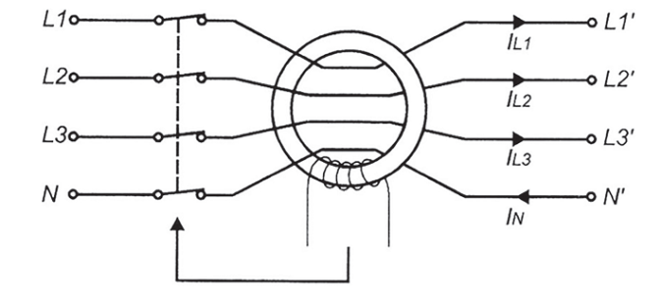
Figure 1. Graphical representation of differential current protection device
In Figure 1. the differential current protection device is shown graphically where:
- L1, L2, L3, N input ports for connection to the supply network,
- L1 ', L2', L3 ', N' output connectors for connection to installations in the object.
According to Figure1. the equation can be written:
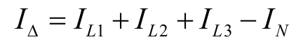
This equation is valid for each type of connected receiver (single-phase, three-phase, symmetrical, asymmetric).
The disconnection condition of the differential current protection device is:
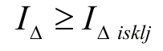
Where is: 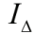 the differential current equal to the sum of the current of the fault and the leak current, 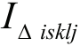 the current of the exclusion of the differential current device.
To ensure safe protection using a differential current protection device, the following parameters must be tested:
1. Contact voltage U_{C} is the voltage that occurs under the conditions of breakdown on the available part of the drive and can come into contact with the human body. The maximum contact voltage value is called the permissible contact voltage and is usually 50 V, and in some cases only 25 V (hospitals , rooms with electronic equipment) [2].
2. Time to turn off the t_{Δ} that the differential current device must disconnect the current circuit at nominal
differential current I_{ΔM}.
Maximum permissible values of this time are defined in EN 61009 and are shown in Table 1.
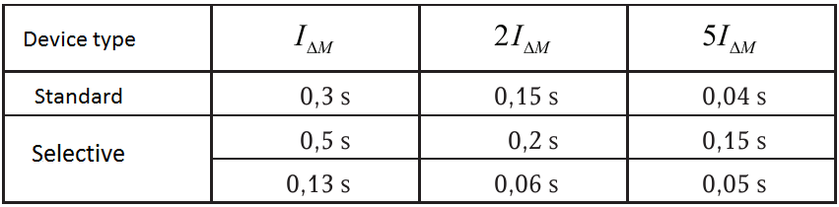
Table 1. Maximum permissible exclusion time of the differential current protection device [2]
3. The switching current I_{Δ} represents the lowest differential current which can cause the differential current protection device to react [2].
4. Earthing Resistance R_{E} is of great importance when using this protection. If the ground resistance is too high, an unacceptably high contact voltage may appear on available running parts in malfunctions. The grounding resistance value can only be measured using an ancillary probe. By measuring without an auxiliary probe, the resistance of the tested loop (loop loop) is obtained, which has an approximate grounding resistance [2].
2. MEASURING THE EXPECTED CONTACT VOLTAGE
The contact voltage is the voltage that occurs in any fault condition in any part of the drive which can come into contact with the human body. The maximum permissible contact voltage is 50 V and in some cases 25 V. The measurement of the contact voltage is carried out by the intensity I_{Δn} / 2 or I_{Δn} / 3, so that the differential current protection device does not exclude it during the measurement.
During the measuring instrument simulates the failure of the connected receiver, conducting fault current from the phase conductor to a protective conductor and then into the ground.
The measurements in this paper were performed at the premises of the Business-Technical College in Užice with the Eurotest 61557 instrument.
The Eurotest 61557 switch is placed in the RCD position. Using the F₁ key, the option for measuring the expected voltage of the RCD Uc is selected. Use the F₂ key to select the rated differential current I_{Δn} to one of the values ​​10, 30, 100, 300, 500 or 1000 mA, which is displayed at the top of the screen. Use the F₃ key to select the polarity to be displayed in the upper right corner [1].
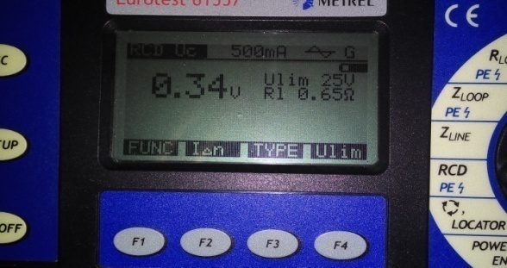
Figure 2. Measurement of the expected contact voltage
The resulting measurement of the expected contact voltage of 0.34V is considerably lower than the values permitted by the 50V or 25V regulations.
3. MEASURING TIME OF EXCLUSION
The switch-off time is defined as the time required to disconnect the differential current protection device
Current Circuit at nominal differential current I_{Δn}.The maximum permissible values of this time are shown in Table 1. The method of connecting the instrument is the same as in the case of the measurement of the contact voltage. If the time of shutdown exceeds the permissible values shown in Table 1, the differential current protection device should be replaced. The Eurotest 61557 instrument switch is set to RCD position. Use the F₁ key to select the RCD measuring time of exclusion option. Use the F₂ key to select the nominal differential current, using the F₃ key, the test current is selected and the polarity is selected with the F₄ key [1].
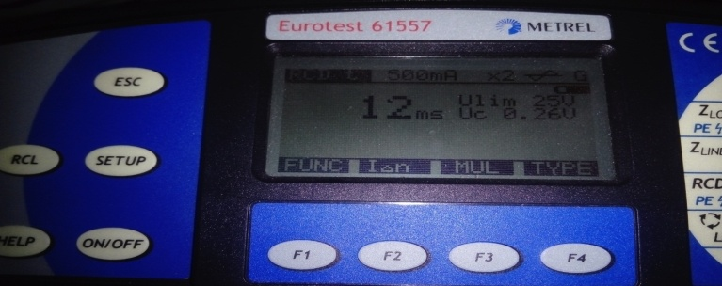
Figure 3. Measurement of exclusion time
The obtained result of the 12 ms disconnection time meets all technical regulations and indicates that the electrical installation and the protective current of the differential current are correct.

4. MEASUREMENT OF THE CURRENT OF THE DISCONNECTION
The switching current is the lowest differential current IΔn, which can still be caused by the differential current protection.
The instrument initially passes a current of 0.5 I_{Δn} and then gradually increases until the device reacts or until it reaches 1.1 I_{Δn}. If this current is out of range, then the tested appliance, electrical installations and receivers should be checked.
The Eurotest 61557 switch is placed in the RCD position. Using the F₁ key, the measurement option is selected Exclusion current. Using the F₂ key, the nominal differential current I_{Δn} is selected at one of the values ​​10, 30, 100, 300, 500 or 1000 mA, which is displayed at the top of the screen. Use the F₃ key to select the polarity that will be displayed in the upper right corner [1].
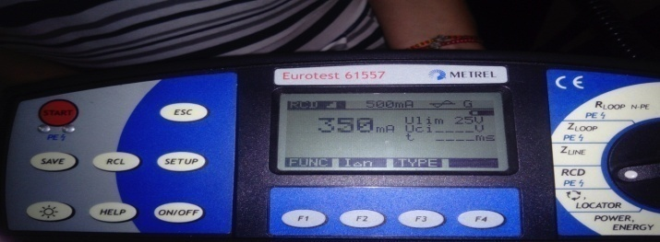
Figure 4. Measurement of the current of the disconnection
The 350mA off-flow measurement result meets all technical regulations and indicates that the electrical installation and the differential current protection device are correct.
5. MEASURING THE IMPEDANCE OF LOOP
Protection of electrical installations has been achieved by overcurrent protection devices (fuses and protective devices of differential Current) by automatically switching off power. Therefore, it is necessary to measure the impedance of loop Z_{S}. It is necessary that the failure loop impedance is small enough to cause a potential fault current to trigger the protective device in the predicted time interval in case of a fault on the receiver[2].
The impedance of loopback is equal to the following sum:
where is: Z_{sec} - impedance of the secondary transformer, R_{L1} - resistance of the phase conductor from the transformer to the measured location, R_{PE} - resistance of the protective conductor from the measured point to the transformer.
The instrument is connected between the phase and the protective conductor and strongly loads the network in a short time. The test stream flows through the loop. The instrument measures the voltage drop caused by the test current and the resulting phase shift, on the basis of which it calculates the loop impedance.
The Eurotest 61557 instrument switch is set to the Zloop position. Use F₁ to select the initial polarity, which can be positive or negative. By choosing a polarity, it is possible to prevent the disconnection of the differential current device during the measurement [1].

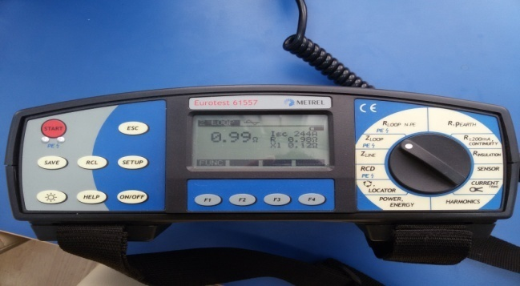
Figure 5. Measuring the impedance of loop failure
The obtained result of the 0.99 Ω loop impedance measurement meets all technical regulations, which ensures the proper functioning of the differential current protection device.

6. CONCLUSION
In order to ensure safety, it is necessary to periodically check the correctness of the electrical installations and the protective of the differential current device intended to protection the living beings from electric shock. The principle of work is based on the difference between the phase current that goes to different receivers and the current that returns through the neutral conductor. If this difference is greater than the current of the disconnected current of the installed protective device, the device will react and automatically switch off the power.
With the instrument Eurotest 61557 measurements were made of the expected voltage of the contact, time and current of the disconnection and the impedance of loopback in the premises of the Business-Technical College in Uzice. The obtained measurement results indicate that the tested electrical installations and the protective of the differential current device are correct and safe to use.

5. LITERATURA
[1] Metrel: Eurotest 61557, Measuring and Regulating Equipment Manufacturer d.d.
Horjul 188, 1354 Horjul Slovenia.
[2] Milovanović V.:Opasnosti i zaštita od električne struje,Visoka poslovno tehnička škola,Užice 2015.ISBN 978-86-908785-9-8
[3] Popović B: Osnovi elektrotehnike I i II, Građevinska knjiga, Beograd, 1983.
[4] Petrović F: Električna merenja I i II, Naučna knjiga, Beograd, 1989.
[5] Nikolić N, Petrović M: Opasnost i zaštita od električne struje, Naučna knjiga, Beograd, 1987.

