THE IMPACT OF NATO BOMBING ON THE HEALTH OF THE POPULATION AND THE ENVIRONMENT

Miodrag Pantelić¹, Zora Jugović², Dragan Golubović³, Dragan Brajović³
¹University of Kragujevac, Faculty of Technical Science, Čačak, SERBIA
²High sanitarian Health School of Professional Studies "Visan", Belgrade, SERBIA
³High School of Professional Studies, Čačak, SERBIA

Apstract:The paper presents: the basis of the human body-decoding of the human genome, what is cancer, the main factors of cancer, prevention ofcervical cancer, breast cancer, colon, prostate and brain cancer.

Keywords: Human body, depleted uranium (DU), chemical mutagens, cancer prevention.

- INTRODUCTION

At the end of the nineteenth century and early twentieth century there were epochal discoveries. Discovery of X-rays (1895), radioactivity (1896), electrons (1897), radium (1898), the separation of radiation (1899), the nature of beta rays (1900), the nature of the alpha rays (1908), the first artificial radioactive element - phosphorus - 30, as well as beta decay (1934), K-Grip (1937), and finally (1939) splitting the nuclei of uranium, the so-called Fission.

- HOW DO RADIOACTIVE MATERIALS GET INTO ORGANISMS LIVING BEINGS?

Depleted uranium (DU) due to its radioactivity (of ionizing effects), while passing through a material ionizes atoms of the environment (pushes out the electrons from atoms). This phenomenon is often referred to as nuclear radiation, because it mainly originates from the core (nucleus) of the atom.

- BASIS OF THE HUMAN BODY - DECIPHERING THE HUMAN GENOME

The human body is composed of more than 50 billion cells. In the center of each cell is core (nucleus). Each nucleus contains 23 pairs of chromosomes with both inherited characteristics of both parents. Each chromosome contains a double strand of DNA (deoxyribonucleic acid), and which consists of the purine and pyrimidine bases, bonded by hydrogen bond as well as carbohydrates and phosphate with Oxygen-bound connection. Gens carriers, of the factors are found in the DNA strand.
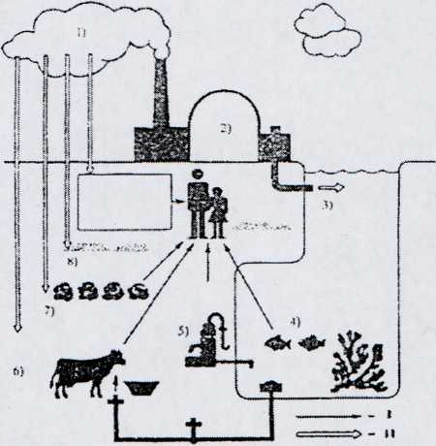
Figure 1: Paths of radiation effects of nuclear power plants to humans: 1.emissions into the atmosphere; 2. nuclear power plants and fuel cycle; 3. liquid waste; 4. natural waters; 5. drinking water; 6. pastures; 7. crops; 8. land; 9. internal (inhalation) and external irradiation: I) undiluted radioactive substances into the human body, II) deposition of radioactive materials
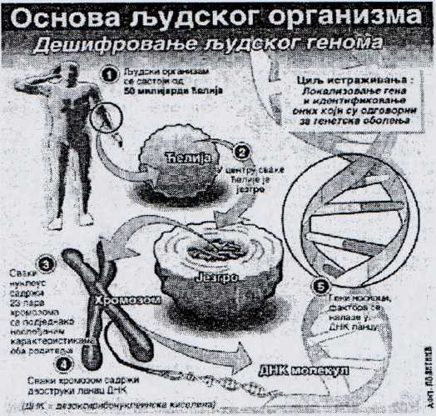
Figure 2: Basis of the human body

- WHAT IS CANCER (TUMOR)?

Cancer is a disease in which the body of the patient leads to the uncontrolled growth and spread of abnormal forms of cells. This is one of the main causes of death of people with cancer. Abnormal characteristics of cancer cells are due to altered GENE expression caused by different genetic mutations.
Normal cell becomes hostile when it is not able to take oxygen to transform glucose into energy through oxidation. In the absence of oxygen, cell converts to a primitive nutritional program to maintain producing glucose - fermentation. Lactic acid produced by fermentation lowers the cell pH (acid alkaline balance) and destroys the ability of DNA and RNA to control cell division. The cell then begins to multiply uncontrollably. Lactic acid simultaneously causes intense local pain and destroys cell enzymes. Therefore, the cancer appears as a fast-growing cell mass with the core of dead cells.
In the absence of oxygen glucose begins the fermentation in order to make lactic acid. This causes the cell’s pH to drop between 7.3 and 7.2 and even up to 7.0. Later, it can drop to 6.5, while in the advanced stages of cancer metastases the pH drops to 6.0 and 5.7 (Dr. Otto Warburg, a Nobel Prize winner).
Dr. Warburg has in 1966, declared that every therapy that is used in cancer therapy has two goals: to stop the further process of uncontrolled cell work or alkaline-acid imbalance and to destroy recalcitrant cells of already formed tumor. The perfect ratio of cations and anions healthy functioning of the body. Then it feeds with the most energy. At this point the blood must have a pH (7.4), saliva and urine (6,4) (Doctor Rems “Biological theory of ionization”).
The reasons for the emergence of disobedient cells are disorders in complex electro-biochemical process, and violation of the necessary metabolic balance. Therefore, the cancer is metabolic disorder. This disorder is caused by action RADIO-ACTIVE PARTICLES AND TOXIC SUBSTANCES in: air, soil, food and water that the cells do not recognize as dangerous by inhalation and in the food chain it absorbs them. (Doctor Keichi Mazishita“, hidden truth about cancer”).
In a healthy body there is a process of cell renewal that is strictly controlled. In case of loss of control results excess of cells that create growths called tumors. Tumors can be benign or cancerous (malignant).
BENIGN TUMORS can be easily removed, can never create a colony, nor can endanger health and life.
MALIGNANT TUMORS can spread and damage nearby tissues and organs, as these cells are tightly interconnected, can be easily detached and penetrate into lymphatic and blood vessels through which they can be transferred to other organs.
METASTASES are the most common in the lymph nodes, bones, liver and brain.

- FACTORS OF CANCER

Factors of cancer are:
Genes (teratogenic influence)
Stress (changes the potential the electrons of cell membrane, leading to a low immune system and abnormal cell division)
Infection by viruses (human papillomavirus) which is directly transmitted from infected person during unprotected sexual intercourse.
From patients with AIDS because of reduced immunity and resistance to papillomavirus-y.
The enjoyment of tobacco smoke, which causes damage to DNA due to the presence of smoke in more than 50 chemical mutagen substances.
Depleted uranium (DU) due to its radioactivity (ionizing effect) causes changes in the membrane, cytoplasm and nucleus. Changes in the nucleus are the chromosomal aberrations that are responsible for changing the function of cell, the formation of mutations and ultimately its death.
The radiation of depleted uranium reduces the concentration of the enzyme (enzymes) that regulate the synthesis of DNA and RNA, it breaks hydrogen bonds between purine and pyrimidine bases, as well as the oxygen bonds between carbohydrates and phosphates.
Biological effects of radiation are somatic (acute, late, teratogenic) and genetic (mutations in gametes) Chemical mutagens - causes of structural modifications in the structure of DNA.
Numerous chemicals have adverse effects on the structure and function of the gene causing somatic and generative mutations, which are made in no gametes and gametes body tissues. According to the mode of action of the genetic material, these chemical substances are divided into direct (cause small structural modifications in the structure of DNA) and indirect (cause extensive structural damage to DNA and still inhibit (prevent) the synthesis of new DNA).
In both cases, toxins (chemical substances) act as inhibitors of enzymes, wherein the inactivation of enzymes can be reversible and irreversible. Inhibitors of enzymes are divided into two groups: general (salts of heavy metals - lead, mercury, cadmium, copper, etc.), and specific (cyanides, sulfides, asides, hydrogen sulfide, carbon (II) - oxide, dioxin, 3,4benzopyran...).
Heavy metals (lead and mercury) bind in the organism to the sulfhydryl groups and disulfide bonds and thus inhibit the activity of enzymes, preventing the process of protein metabolism.
Specific inhibitors of enzymes (ferments) have a higher affinity to the hemoglobin, than oxygen, a normal cell becomes cancerous, because it is unable to take the oxygen, wherein the activity leads to the inhibition of enzymes, which are of vital importance for normal cell function.

- PREVENTION OF CERVICAL CANCER, BREAST, INTESTINES, COLON, PROSTATE, BRAIN CANCER

  - Cervical cancer

CERVICAL CANCER develops gradually and of cells that were initially changed to precancerous to after a long time transform into cancer.
A successful treatment and full recovery is timely detection of cells on the cervix and in that purpose the application of papanicolaou (PAP) test, a microscopic examination of cells from the cervix obtained by direct smear allows the detection of initial changes in cervical cells of the cover of cervix which prevents the formation of cancer in over 90% of cases. Smear from the cervix is collected by ENDOCERVICAL brush.

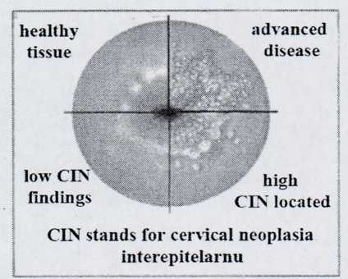
Figure 3: Cervical cancer

  - Breast cancer

In order to prevent breast cancer MAMMOGRAPHY is used, i.e. x-ray record of breast. In Serbia it is stipulated that all women older than 45 years should in every two years do MAMMOGRAPHY and so on until 69 years. PAP smear and MAMMOGRAPHY are two methods irreplaceable for early and timely detection of cervical cancer and breast cancer.
  - Bowel cancer

In order to prevent bowel cancer VIDEOCAPSULE is used. After it is swallowed with a glass of water, the capsule with cameras passes through the entire intestinal tract. After a few minutes the capsule tums, off to save battery and tums on after an hour and 45 minutes, as it needs to reach the intestine. At this point it begins to send four images per second to a small receiver that patient carries.

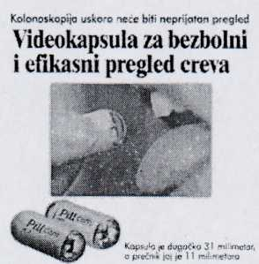
Figure 4: Bowel cancer

- Colon cancer

Screening tests are used to detect the presence of oculus, blood in the stool invisible to the eye, which may be an early sign of malignant diseases of the colon.

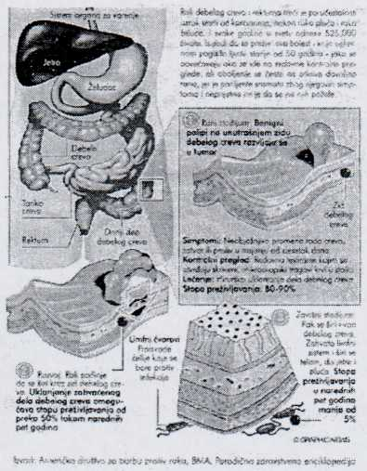
Figure 5: Colon cancer

- Prostate cancer

RADIO WAVES in tile fight against prostate cancer: British experts have developed an experimental therapy for prostate cancer at an early stage, which is based on the use of radio waves. Technique called HIFU is used to by millimeter precision heat up and destroy cancer cells. Testing in which 172 respondents participated showed that this method of treatment has a success of 92 percent.

- Brain cancer

The treatment of a brain tumor is performed by means of a special device, - “Gamma knife” which very accurately radiates and takes away the brain tumors smaller in size, and the same cannot be operated by conventional neurosurgical instrument. This device “gamma knife” is in the form of a cube which contains radioactive cobalt (Co), the size of a grain of wheat, which directs the precise beams that precisely hit a specific area in the brain where a tumor the size of a pea, or wheat is, which surgeons cannot reach with surgical instruments.
This device “gamma knife - helmet” with a greater number of symmetrical round holes, through which rays penetrate, which very precisely radiate and remove tumors, is placed on the patient's head.

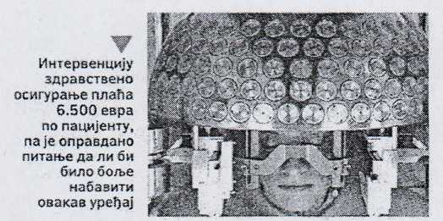
Figure 6: Brain cancer-” GAMMA KNIFE”

  - Positron emission tomography (PET)

Positron emission tomography (PET scan) is performed on the patient with suspected cancer in a way that before recording a solution of the radioactive isotope of glucose is injected into the blood as an indicator. Since it is known that cancer cells consume 15 times more glucose than normal, cancerous will thus take 15 times as much of the radioactive glucose. The objective is to show that cancer cells under X rays.
Radiopharmaceutical emits radiation which is detected by means of a special device, and provides the image of processes in the body. Radio pharmacy – deoxyglucose, we import because we don’t have CIKLOTRON device for producing the same.
Using positron radiopharmaceuticals allows live visually monitoring of processes in the cell. Radiopharmaceutical that is injected into the body by infusion, emits radiation that is detected by a special unit, which indicates how much the cancer has spread, as well as to verify the effects of the therapy.
RADIOPHARMACS are produced by CYKOLOTRON. This device (cyclotron), our country does not have so we are forced to import expensive radiopharmaceuticals.

- CONCLUSION

Today it is considered that toxic substances have inhibitory effect on enzymes and enzyme systems, which are vital for the normal function of cells and that from the genetic aspect THERE IS NO PERMITTED CONCENTRATION OF RADIATIONS OR CHEMICAL MUTAGENS.
It is known that in fish, and in our body, comes to the accumulation of radionuclides and heavy metals in concentrations more than 1,000 times higher than in the content in the water (Japan, 1945, Hiroshima, Nagasaki - the consequences). (M. Pantelic carp (fish) with mercury and cadmium, Politika 9.8.2003.).
Higher sensitivity to radioactivity show younger organisms, infants and young children in development, also the most sensitive tissues and organs are those that multiply quickly, such as blood, bone marrow, lymph glands.
Gina Mertens, a physician and member of the “Doctors against nuclear war” (Nobel Peace Prize winner), said that the uranium contained in the NATO ammunition simultaneously, and radioactively radiates and has hemotoxic effect, and that in the body, due to the long decay, it stays forever. As possible consequences she mentioned the bone diseases (including cancerous), renal disease, anemia, and damage to the embryo.
The aforementioned data Dr. Mertens presented on April 28, 1999 at a press conference in Bonn (Germany), as well as information on how the health, soil and air destroys depleted uranium contained in ammunition used by NATO, Dr. Mertens asked participants: would you like to live in such a country! I would not!
NATO had no right to bomb Serbia. We all have the right to the natural death. In this moment we feel horribly the absence of the United Nations, an organization that supposed to and that had to intervene (Jose Saramago, Portuguese Nobel Prize winner).
If we don’t remind the world and ourselves what they did to us, we will justify all the bombs that exploded in those 77 days, and finally, we must admit that they were wrong, and enrich history by the fact that we were a PEOPLE WHO HAD DISAPPEARED.
Population is still dying from depleted uranium (DU), and will continue to die.

REFERENCES

- R. Antanasijević, I. Anićin: Moguće posledice vojne primene osiromašenog urana, III jugoslovenski simpozijum "Hemija i zaštita životne sredine", Vmjačka banja, 1998.
- M. Pantelić, Gordana Bmn i D. Brković,Ekologija i zaštita životne sredine, Univerzitet u Rragujevcu - Tehnički fakultet Čačak, Čačak, 2001.
- Institut za političke studije, Informativna agencija INPRES, Beograd, 2006.
- M. Pantelić, Uticaj osiromašenog urana (OU) sadržanog u NATO projektilima na zdravlje stanovništva i čovekovu okolinu, Tehnički fakultet Čačak, 2007.
- M. Pantelić, B. Jordović, G. Bmn, D. Brković, Ekologija i zaštita životne sredine, Univerzitet u Kragujevcu - Tehnički fakultet Čačak, Čačak, 2007.
- M. Pantelić, Ekološka čitanka, pitanja i odgovori, Univerzitet Kragujujevac, Tehnički fakultet, Čačak 2008.
- M. Pantelić, D. Golubović, Uticaj osiromašenog urana (OU) na zdravlje stanovništva, Zbornik radova, Tehnika i mformatika u obrazovanju, Univerzitet u Kragujevcu, Tehnički fakultet Čačak, Čačak 2008.
- M. Pantelić, Z. Jugović, B. Jordović i B. Mihailović, Uticaj ratne zaostavštine na bezbednost i zdravlje na radu, Tehnički fakultet Čačak, Privredna komora Srbije, Odbor za zaštitu životne sredine i održivi razvoj Čačak, 2009.
- M. Pantelić, S. Stefanović, D. Golubović,Ekološki problemi u zaštiti životne sredine, Tehnički fakultet Čačak, Čačak 2010.
- M. Pantelić, D. Golubović, Z. Jugović, N. Stanković: Globalni problemi planete Zemlje, u eri informatičkih tehnologija, 6. Međunarodni Simpozijum, Tehnički fakultetČačak, Čačak, 2011
- M. Pantelić, D. Golubović, Z. Jugović, N. Stanković, Ekološki problemi — kuda i kako dalje, 7. Međunarodm simpozijum, Tehnički fakultetČačak, Čačak 2012.

