TYPES AND FEATURES OF GREEN ROOF SUBSTRATES

Nemanja Petrović¹; drJasmina Radosavljević²; Natalija Tošić³; Ana Vukadinović⁴
College of Applied Technical Sciences, Nis, SERBIA, nemanja.petrovic@vtsnis.edu.rs
Faculty of Occupational Safety, Nis, SERBIA, radosavljevic_jasmina@yahoo.com
College of Applied Technical Sciences Nis, SERBIA, natalija.tosic@vtsnis.edu.rs
Faculty of Occupational Safety, Nis, SERBIA, ana.vukadinovic@fznr.ni.ac.rs

Abstract: The interest for utilizing green roofs on different types of urban area buildings is on the rise. Green roofs have various advantages compared to traditional roofs: reduction of rain water inflow, favorable effect on the microclimate, noise reduction, and reduction in exploitation costs for heating and cooling energy products... Many of these benefits depend directly on the substrate and green layers which can differ in different types of green roofs. This paper will give basic information on green roofs, their advantages, construction elements, as well as different substrate types and features. In order to reduce differences based on roof types, we will only deal with the extensive roof type. The basic features of different substrate types will be given in general, without going into details of certain materials which are part of the substrate.

Keywords: green roof, substrate, green construction, layer for retaining water, urban vegetation

- INTRODUCTION

As architecture advanced over time, objects have been perceived differently. The architect Le Corbusier stated that the roof is actually the fifth façade of the object [1]. If we perceive the roof in such a manner, than it must not be overslaughed in favour of other facades which have been and remained the main object features through the course of time.
The sudden urbanization and increase in population in cities leads to climate changes which dictate the onset of solutions for this omnipresent problem of the modern society. The biggest problems of modern cities are the small green areas which contribute to an array of negative effects. One of the most prominent negative effect is the temperature increase in in cities due to the global warming, but also forming heat islands in cities since traditional materials have great heat energy absorption potential.
One of the ways to mitigate the downsides of the modern society caused by the sudden expansion of cities and increase in population, as well as the need to build new buildings, is to utilize the energy efficient materials in an even more intensive way, in addition to building green roofs which would increase the overall green area surfaces in cities.
The application of green roofs in previously built objects is possible through repairing buildings which is clearly indicated in the Regulation on energy efficient buildings which defines the building energy repairment as "performing construction and other works on an existing building or repairing or substituting building devices, equipment and installing the device of the same or lower capacity which do not affect the stability and safety of the object, do not change the construction elements, do not affect the safety of adjacent objects, traffic, do not affect the fire protection installations and environment protection, but which can change the exterior appearance for the sake of increasing the building energy efficiency with prior consent." [2].

- GREEN ROOF TYPOLOGY

Green roofs can be categorized by substrate thickness, usage intensity, application, vegetation type... The basic green roof categorization is done in line with the FLL standards (Forschunssgesellschaft Landschaftsentwicklung Landschaftsbau).

  - Extensive green roofs

The basic feature of extensive roofs is the substrate thickness and types of plants which can be cultivated on them. The thickness of the substrate is around 7-12cm and the surface weight of load is about 150kg/m² excluding plants. The types of plants characteristic to this type of roofs are sedums, or meadow-type grass including medicinal and aroma herbs which have non-branched roots and can handle droughts well. This is the main feature of extensive green roofs – no maintenance required. They are installed on flat roofs and roofs of 30% slope. They are perfect for regulating atmosphere water drainage as well as in object thermo regulation. The main drawback of the extensive green roof type is the small number of plants that can be cultivated. Unlike the other two types of green roofs, the possibility of a diversified use in this type is rather limited.

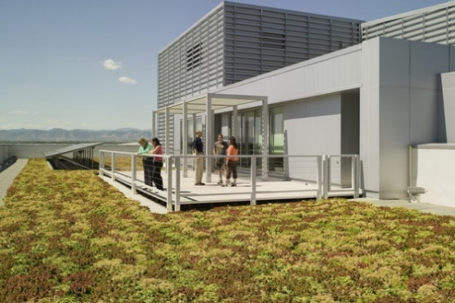
Picture 1: Extensive green roof

  - Semi-intensive green roofs

Unlike the extensive ones, semi-intensive green roofs have a wider scope of utilization in terms of physical availability to users. Substrate thickness is this type is about 30cm, and the surface weight of load is around 350kg/m² excluding plants. Semi-intensive roofs are characterized by lower vegetation shaped like bushes which do not require a branched root system, as well as different grass surfaces. Plants on these roofs require occasional light maintenance, which is why drainage and irrigation systems are being implemented. They can withstand more atmospheric waters than extensive green roofs and are used for rest, relaxation, growing vegetables...

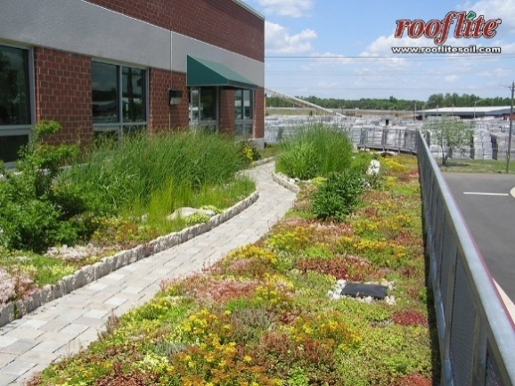
Picture 2: Semi-intensive green roof

  - Intensive green roofs

Intensive green roofs are also called roof gardens. The thickness of their substrate is from 35-80cm and the surface weight of load is about 1200kg/m² excluding plants. The roof gardens on this type of roofs are built in the same way as gardens on the ground. The features of the intensive green roof include the diversity of the plants which can be cultivated and it involves low, medium and high vegetation. The design of the intensive green roofs can be diverse in terms of plant types, but also in terms of content available to users. In order for these roofs to survive, it is necessary to build drainage and irrigation systems. The main drawback for this roof type in comparison to extensive and semi-intensive ones is that it is necessary to meet specific static object requirements in order to set up intensive green roofs so that they could withstand great static load.

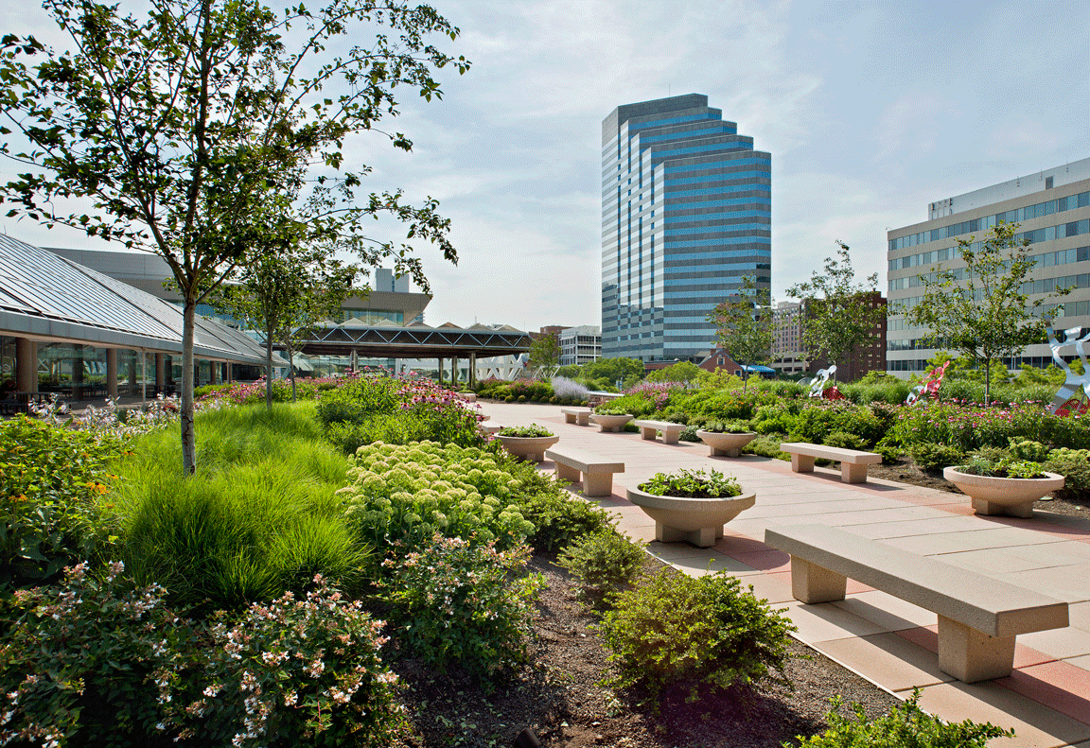
Picture 3: Intensive green roof

- ADVANTAGES OF GREEN ROOFS

  - Ecological advantages of green roofs

Green roofs offer the opportunity to reduce air temperature in urban areas. The air temperature difference between urban and rural areas can amount to 5-7 degrees during the summer. Traditional flat roofs absorb a great amount of heat so their temperature can be up to 40 degrees higher than that of green roofs on the same location. The Center for Climate Changes mentioned that there is a need to increase green areas for about 10% in cities in order to mitigate the effect of heat islands. [4]
One of the greatest causes of global warming is carbon-dioxide. Green roofs have the ability to absorb large quantities of CO₂. A green roof of an area of 1m² can absorb 5kg of carbon-dioxide. In addition, having in mind that green roofs are good insulators, around 3.2kg of carbon-dioxide would be prevented from releasing into the atmosphere while using just 1m² of green roofs. [4]
According to the research done by the American Environment Protection Agency (EPA), 1m² of green roofs can absorb around 0.2kg of different particles (smog, heavy metals, vaporizable organic compounds...) from air annually. Furthermore, the process of biofiltration prevents the pollution of water streams so that 95% of lead, copper, and cadmium-sulfide and 19% of zinc are contained in the rain water substrate and do not flow away further. [5]
In addition to their role in the biofiltration of water, green roofs also affect the load reduction of sewage systems during the summer heavy rains by retaining certain amounts of water in their substrate. In this way, there is a reduction in threats caused by rain of some 70-95%. The green roof system reduces the noise level, gives good sound insulation, and creates a more favourable environment in urban areas. This is especially important in proximity to big traffic roads, industry zones and airports.

  - Economic advantages of green roofs

Green roofs have an up to 3x longer life span than traditional flat roofs since the layers beneath the green layer are protected from mechanical damage, UV rays, and extreme temperature differences. This leads to the conclusion that it takes far less money for maintaining and renovating green roofs. Taking into account energy efficiency, the energy consumption is up to 100% lower for cooling and 40% lower for heating objects which directly affects the object exploitation price with maintaining the same level of heat comfort. The performance depends on several aspects including climate changes, construction type, insulation thickness... [6]

  - Social advantages of green roofs

The natural appearance of green roofs gives a sense of pleasantness and a step away from the traditional concrete constructions in urban areas. According to some studies, the presence of the green areas has a positive psychological effect on users, lowers hypertension, and heart rate. Therefore, advantages of green roofs increase the value of the space for living, but also for other commercial services manifold.
Bu using green roofs instead of traditional flat roofs in urban areas which has a limited number of open space, we are given an opportunity to use the roof surface as a garden or space for recreation and play.
Another advantage is that different plants can be cultivated, so one can grow their own fruits and vegetables. [7]

- CONSTRUCTION OF GREEN ROOFS

Green roofs can be built independently from the object construction. This is why it is possible to reconstruct existing roofs with green roofs in an efficient way. Depending on the manufacturer, types and layers of green roof constructions differ.

  - Waterproofing membrane and root barrier

Waterproofing membrane and root barrier are the first layers to be set on the existing construction of the object and offers protection from roots penetrating the construction and potential roof construction moisture due to the penetration through the membrane. There are two types of root barrier protection: physical and chemical protection. Physical protection consists of polyethylene 0.5mm thick. Chemical protection contains toxins which contain copper and prevent further root penetration into the construction. [8]

  - Drainage system

The water from the atmosphere or green roof irrigation is partly retained in order to secure enough amounts as a reserve for plants, but there also must be a system for draining the excess of water. This is the role of the drainage layer. Depending on the manufacturer, it comes in many shapes and depends on climate changes, roof type, and manner of construction; however, the operation principle is the same. The design material is mostly polyethylene and polypropylene. In extensive roofs, due to the small weight of load, these materials com in smaller thickness and the height of the layer is around 1-1.5cm. In intensive roofs, the material is of larger thickness due to the larger weight of load and the height of the layer is from 4cm upward. Drainage layers are set up with additional materials: revision chutes and drainage canals. [9]

  - Filtration layer

The filtration layer is mostly comprised of geotextile and its role is to cleanse the water from the substrate so that there is no clogging of the drainage system and potential loss of substrates by drainage. This layer often comes together with the drainage layer. [9]

  - Layer for retaining water – SUBSTRATE

All green roofs, regardless of being extensive or intensive require a layer of substrate which serves multiple functions. One of which being maintaining and nurturing the vegetation layer, affecting the object thermoregulation...The thicker the substrate layer, the greater the energy savings. This layer is located beneath the vegetation layer and can be 7-80cm thick depending on the green roof type and vegetation. The substrate is not like the growing media for plants in nature. It has specific contents and requires improved structure and nutrients in line with the conditions it is used for and in line with the choice of dendro materials. This is why the contents of the nutrient substrate differ from situation to situation and it is extremely important that it is in line with the conditions in which it is used, so that the green roof can stay active and vital for as long as possible, and so that the investment failure chances are reduced to a minimum. [9]

  - Vegetation layer

Any plant can be cultivated on the green roof, but the choice of dendro materials depends on the thickness of the nutrient substrate, climate, object statics, design and budget – therefore, the vegetation layer differs from situation to situation. Overall, extensive green roofs usually have plants such as sedums or meadow-type grass which have a shallow root system which can withstand a thin layer of substrates. On the other hand, intensive green roofs with a larger substrate thickness can withhold almost any plant which can be found on traditional green areas (decorative trees, fruits, vegetables, bushes...) Apart from the aesthetic and use function, the vegetation layer plays a big role in managing atmosphere waters and object thermoregulation.
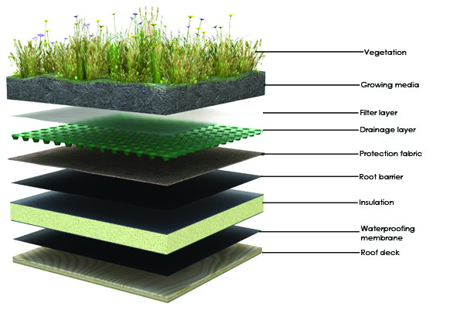
Picture 4: Green roof construction elements

- SUBSTRATE FEATURES AND TYPES

The choice of substrates directly affects plant growth and green roof efficacy. This is why we must pay attention to the choice of substrates depending on climate conditions and foreseen vegetation type. As previously mentioned in the chapter on green roof advantages, the choice of substrates directly affects the water biofiltration, reduces flood risks due to heavy rains, increases the thermoregulation features of the object and reduces noise levels. Due to different and complex effects which can occur at the top of buildings, it is necessary to pay attention to the right choice of substrates which will meet the needs of the vegetation, but also have an effect on the object itself. This is why the substrate is often a mixture of different materials which combined give the better results, instead of sing a single-material substrate. The majority of researches up to day have been on factory substrates, but there are also those which based their researches on waste materials and by-products. Some of the materials used in creating substrate mixtures include pumice stone (a stone of high porosity whose specific density is smaller than the specific density of water), zeolite, ground clay, vermiculite, perlite, turf, etc.[10]
The choice of different materials in the substrate mixture depends on the climate in which the green roofs are set. Usually, specific mixtures are created for each market in line with the material availability on that location in order to meet the demands of the planned vegetation, climate conditions of the location and expected maintenance levels in order to secure the appropriate price of green roof design. The substrate import from other countries can be expensive and sometimes prohibited based on its contents. [11]
The basic criteria a substrate should meet are small weight both when dry and moist, reduced level of rainwater runoff, high level of water retention, good air saturation and air flow, high hydraulic conductivity, stability, good binding properties for different types of plant roots, minimal amount of organic contents.

Picture 5: Substrate features

Small material density used in the substrate affects the small weight which presents a load for the construction. As green roofs are often set up as part of the renovation for existing flat roofs, this precondition is extremely important since any larger load set on the object can have a negative effect on the object stability. This is why it is important to reduce the weight of the substrate to the lowest level by applying recycled non-organic materials of small density. One such material is perlite, whose specific density is 9.4x less than that of the traditional soil. [12]
The level of runoff from the substrate depends on the materials it contains. The flow of water leads to the separation of materials and its flow through filter layers and drainage. The higher the part of organic matter in the substrate, the bigger the danger from substrate runoff, since the organic materials are quickly separated and affect the loss of substrate amounts. Hence the recommendation to reduce the amounts of organic materials in the substrate, and the FLL standards recommend 4-8% of organic materials in the extensive, and 6-12% in the intensive green roof. [13]
Good binding ability is also one of the features a substrate should have. It is related to both binding water, but also binding substances from water for the sake of securing plant nutrients, but also water biofiltration. As organic materials have better binding abilities than non-organic, they should be included in maximum allowed quantities.
The level of retaining water in substrates is significant for the survival of plants which are cultivated on the roof in droughty conditions, but also plays a role in the reduction of water runoff during heavy rains. According to FLL standards, the level of retaining water should be greater than 20% for the extensive roofs. [13]
Should traditional soil be used as the substrate on green roofs, water retaining would be low and soil would have weak vegetation, big specific density, would cause large loads on the construction, weeds could appear, there is a chance of a high runoff of the substrate. [14]
Not even clean fertilizer is recommended since it can cause the vegetation to shrink, enhance the growth of weeds, significantly increase the loads during heavy rains and can jeopardize the long-term existence of the green roof. One of the ways to secure a high level of water retention is through the usage of a hydrogel. The role of the hydrogel is to collect water from air or from the soil and in this way to secure enough moist during droughts for plant roots. The degree of hydrogel particle absorption is 150-200x greater than that in ground or clay of the same size. It remains in the soil for 4 years and during this period will not lose its properties. It releases water in just the right amounts for plants.

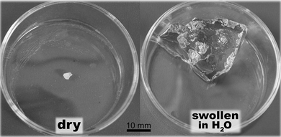
Picture 6: Hydrogel particle before and after being submerged in water

Beside different material mixtures, the substrate can be of mineral wool as well. The Urbanscape Green Roll substrate can be found on the market which is used for greening and is comprised of long stone mineral wool fibers which are joined together in such a way that they create a compact and stable felt. It consists of natural mineral stone fibers which can contain and keep water for different space arrangement applications and presents a good medium for growth consisting of different mineral mixtures. [15]
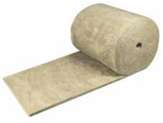
Picture 7: Urbanscape Green Roll substrate

The substrate is 8-10x lighter compared to ground substrates. It can contain 3-4x more water in relation to its volume and compared to other substrates. Water retention enables faster plant growth. Because it is light when dry, it does not endanger the stability of the object construction. [16]

- CONCLUSION

One of the ways to repair existing roofs and construct new objects which would be environmentally friendly is to implement green roofs. Green roof areas can be extensive, semi-intensive and intensive. Each of these roof types is characterized by certain types of greenery divided according to the size of their root system. One of the most significant layers of the green roof is the substrate layer which serves to bind plant roots. Apart from this, substrates participate in the thermal protection of the object, water biofiltration, retaining excess water after heavy rains...According to its composition, the substrate is mostly heterogenic. Materials used for the production of the substrate are mostly characterized by low specific density, high porosity and good water absorption. The main features of a good substrate include small weight, when dry and moist, reduced risk of runoff, high level of retaining water, good air saturation, and air flow, high hydraulic conductivity, stability, good binding to different plant roots, minimal amounts of organic content. Modern materials have their application in the green roof industry so it is possible to conduct different researches and create different material combinations so that certain plants can utilize all benefits of the soil in the most efficient way. Apart from the mixtures that can be found, and which play the role of the soil, other materials such as mineral wool can also be used as a substrate and which also have all the features of a high-quality substrate.

- LITERATURE

[1] | J. G. Richard Cook, „The Fifth Facade: Designing Nature into the City,“ u Global interchanges: Resurgence of the Skyscraper City, New York, 2015.
[2] | Manual on building energy efficiency, Official Gazette of the Republic of Serbia, 2011.
[3] | http://zelenikrovovi.rs/zeleni-krovovi/vrste-zelenih-krovova/.
[4] | http://efb-greenroof.eu/green-roof-basics/.
[5] | K. Insolation, Urbanscape Modular Green Roof System, 2013.
[6] | http://www.green-urbanscape.com/en/content/economic-benefits.
[7] | http://www.green-urbanscape.com/en/content/social-benefits.
[8] | http://www.greenroofs.com/Greenroofs101/waterproofing.htm.
[9] | http://zelenikrovovi.rs/zeleni-krovovi/slojevi-zelenog-krova/.
[10] | K. Vijayaraghavan, „Green roofs: A critical review on the role of components, benefits, limitations and trends,“ Renewable and Sustainable Energz Reviews, t. 57, pp. 740-752, 2016.
[11] | N. A. D. N., „The relationship between percentage of organic matter in substrate and plant growth in extensive green roofs,“ Landscape Urban Plan, t. 103, pp. 230-236, 2011.
[12] | R. F. Vijayaraghavan K, „Design and development of green roof substrate to improve runoff water quality: Plant growth experiments and adsorption,“ Water Res, t. 77, pp. 217-226, 2014.
[13] | F. L. L. FLL, Guideline for the planning, execution and upkeep of green-roof sites, Bonn: ForschunssgesellschaftLandschaftsentwicklungLandschaftsbau, 2002.
[14] | L. Y. H. J. Z. G. Xiao M, „A review of green roof research and development in China,“ Renew Sustain Energy Rev, t. 40, pp. 633-648, 2014.
[15] | http://appft1.uspto.gov/netacgi/nphParser?Sect1=PTO2&Sect2=HITOFF&p=1&u=%2Fnetahtml%2FPTO%2Fsearchbool.html&r=1&f=G&l=50&co1=AND&d=PG01&s1=20140130410.PGNR.&OS=DN/20140130410&RS=DN/20140130410.
[16] | http://www.knaufinsulation.rs/sr/zeleni-krovovi.

