MOTIVATION MODELS

OliveraNovitović, PhD¹, ZoranaVidić, MSc², BojanaŠaljić, MSc³
¹Užice, SERBIA, nolivera@mts.rs
²Užice, SERBIA, zvidic87@live.com
³Belgrade business School, Belgrade, SERBIA

Abstract: The basic concept of work is to create a model of motivation, which should help the systematic study on the time, which is a key to success, good practice and the keys to sustainable development. Using of modern media with elements of didactic process, flexible identification required, creative thinking, analytical problem solving, teamwork, career development opportunities, selective and effective information, necessity of changes the mechanism of learning and teaching, directing professor in the role of supervisors and moderators, lifelong learning of professor , instruments of development projects for lifelong learning, defining activities, inspiration and work are just some of the issues that are directly linked with the issue of motivation which is present everywhere, in every family, in society, both at local and at national and global levels. The reason for writing this work on the transfer of own as well as experience with the various universities that have a critical role in innovation, measurability and the prestigious world universities.

Key words: motivation, measurability, transfer of knowledge, competence, understanding algorithms.

1. INTRODUCTION

There is no unique formula for motivation. What is the basis is understanding above memorization, then methodology of learning, innovative algorithmic techniques, fundamental principles of algorithmic thinking, preparation of valid data, knowledge, validation, selection, use of relevant instruments and their development, well-established motivation goals and their understanding, to the main successes and goals, selecting good examples from practice (Max Planck, Cambridge, Monte Carlo), correlation between algorithms and motivational processes.
The degree of understanding depends on knowledge, creativity, talent, and all this creates conditions for satisfaction and commitment to work. The innovation infrastructure is not only a local but also a global problem, bearing in mind that the 21st will be marked with multidisciplinary knowledge, with the effective use of information technologies and mathematical skills along with algorithmic thinking and their application in all areas of life. Therefore, in Brussels, from November 30 to December 1, 2017, the promotion of the European Digital Infrastructure Service with a special emphasis on innovation will be held, all in terms of strengthening the science and impact of Horizon 2020 projects.
Development is conditioned by the design of keys, methods and recommendations of focusing on planning and measurement in real time and space. Strengthening the position of transparency leads to a clear vision of priority changes, the definition of engineering passports, the development of online courses, knowledge, skills and good practice. Motivation for innovation is the key to sustainable development that can be sustained by using renewable sources, with flexible work, constant monitoring, and measurability is security for success. It is certain that joint work, at the local, national and global level, with constant increase of competence leads to the realization of the needs of mankind.
Real dialogue and practical partnership, the development of the recycling industry, will have priority in the future. Certainly there will be technological barriers that can overcome with more or less skills and inspirations.
An important question to be answered is how to develop a motivation model and link it to creativity and achievement of the goal with full commitment and raising the quality of people's lives. This is a global issue.
Presently, a lot of motivation models and motivation theory, a deeper analysis, it can be noted that each area has some of its specificities, such as growing up bearing its particularities.
Figure 1 gives a model of motivation for work in the construction industry. It is noted that motivation affects productivity, harmony in man and with the environment, and that there are parameters that can be influenced by the development of motivation, productivity and product quality levels are improved. An important fact is that work in construction is influenced by internal and external motivation (intrinsic and extrinsic motivation), all of which improves the management of processes in construction, achieving specific goals, better communication at both horizontal and vertical levels.
Priority motivation factors are given in Table 1[1].

Table 1. Priority motivation factors [Hewege, 2014]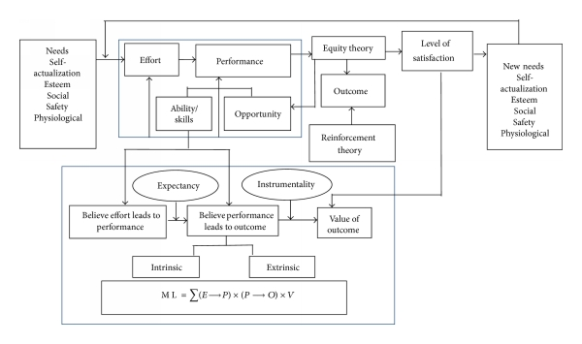
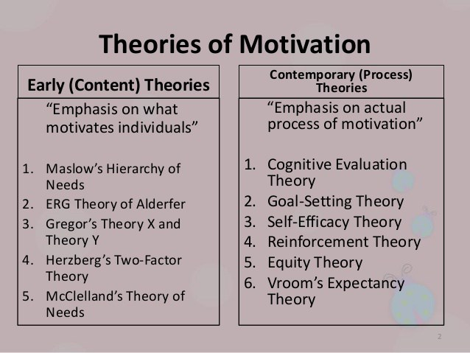
Figure 1:Theory of motivation [1]

2.MASLOW’S THEORY

Of all the theories offered, from various universities, the widest is used of the Maslow theory.
.Maslow's hierarchy of needs is a theory in psychology proposed by Abraham Maslow in his 1943 paper "A Theory of Human Motivation" in Psychological Review. Maslow subsequently extended the idea to include his observations of humans' innate curiosity. His theories parallel many other theories of human developmental psychology, some of which focus on describing the stages of growth in humans. Maslow used the terms "physiological", "safety", "belonging" and "love", "esteem", "self-actualization", and "self-transcendence" to describe the pattern that human motivations generally move through. The goal of Maslow's Theory is to attain the sixth level of stage: self-transcendent needs.
Maslow studied what he called exemplary people such as Albert Einstein, Jane Addams, Eleanor Roosevelt, and Frederick Douglass rather than mentally ill or neuroticpeople, writing that "the study of crippled, stunted, immature, and unhealthy specimens can yield only a cripple psychology and a cripple philosophy. Maslow studied the healthiest 1% of the college student population.
Maslow's theory was fully expressed in his 1954 book Motivation and Personality. The hierarchy remains a very popular framework in sociology research, management training and secondary and higher psychology instruction.

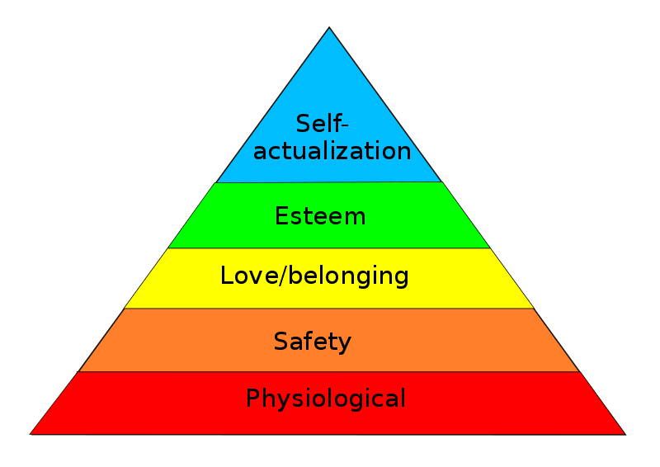
Figure2: Maslow's hierarchy of needs, represented as a pyramid with the more basic needs at the bottom [2]

Maslow's hierarchy of needs is often portrayed in the shape of a pyramid with the largest, most fundamental levels of needs at the bottom and the need for self-actualization and self-transcendence at the top.

The most fundamental and basic four layers of the pyramid contain what Maslow called "deficiency needs" or "d-needs": esteem, friendship and love, security, and physical needs. If these "deficiency needs" are not met – with the exception of the most fundamental (physiological) need – there may not be a physical indication, but the individual will feel anxious and tense. Maslow's theory suggests that the most basic level of needs must be met before the individual will strongly desire (or focus motivation upon) the secondary or higher level needs. Maslow also coined the term "metamotivation" to describe the motivation of people who go beyond the scope of the basic needs and strive for constant betterment.

The human brain is a complex system and has parallel processes running at the same time, thus many different motivations from various levels of Maslow's hierarchy can occur at the same time. Maslow spoke clearly about these levels and their satisfaction in terms such as "relative", "general", and "primarily". Instead of stating that the individual focuses on a certain need at any given time, Maslow stated that a certain need "dominates" the human organism. Thus Maslow acknowledged the likelihood that the different levels of motivation could occur at any time in the human mind, but he focused on identifying the basic types of motivation and the order in which they should be met.

Physiological needs are the physical requirements for human survival. If these requirements are not met, the human body cannot function properly and will ultimately fail. Physiological needs are thought to be the most important; they should be met first.

Air, water, and food are metabolic requirements for survival in all animals, including humans. Clothing and shelter provide necessary protection from the elements. While maintaining an adequate birth rate shapes the intensity of the human sexual instinct, sexual competition may also shape said instinct.

Once a person's physiological needs are relatively satisfied, their safety needs take precedence and dominate behavior. In the absence of physical safety – due to war, natural disaster, family violence, childhood abuse, etc. – people may (re-)experience post-traumatic stress disorder or transgenerational trauma. In the absence of economic safety – due to economic crisis and lack of work opportunities – these safety needs manifest themselves in ways such as a preference for job security, grievance procedures for protecting the individual from unilateral authority, savings accounts, insurance policies, disability accommodations, etc. This level is more likely to be found in children as they generally have a greater need to feel safe.

Safety and Security needs include:
- Personal security;
- Financial security;
- Health and well-being;
- Safety net against accidents/illness and their adverse impacts;
- Social belonging.

After physiological and safety needs are fulfilled, the third level of human needs is interpersonal and involves feelings of belongingness. This need is especially strong in childhood and it can override the need for safety as witnessed in children who cling to abusive parents. Deficiencies within this level of Maslow's hierarchy – due to hospitalism, neglect, shunning, ostracism, etc. – can adversely affect the individual's ability to form and maintain emotionally significant relationships in general, such as:
- Friendships;
- Intimacy;
- Family.

According to Maslow, humans need to feel a sense of belonging and acceptance among their social groups, regardless whether these groups are large or small. For example, some large social groups may include clubs, co-workers, religious groups, professional organizations, sports teams, and gangs. Some examples of small social connections include family members, intimate partners, mentors, colleagues, and confidants. Humans need to love and be loved – both sexually and non-sexually – by others. Many people become susceptible to loneliness, social anxiety, and clinical depression in the absence of this love or belonging element. This need for belonging may overcome the physiological and security needs, depending on the strength of the peer pressure.

Motivation should be understood as the process of application, development and monitoring and the application of criteria that lead to an algorithmic way of thinking, but the basic result is the quality of learning and teaching with the formation of the best paths for creativity and the definition of a formula where creativity can be measured through a series of steps:

Step 1:Choose the problem;
Step 2: Take notes;
Step 3: Mind map;
Step 4: Crazy eights;
Step 5: Storyboard;
Step 6: Silent critique;
Step 7: 3-minute critiques;
Step 8:Super vote.

Riddles
Step 1:Choose and answer;
Step 2: Brainstorm your answer;
Step 3: Use a thesis;
Step 4: Think like the object;
Step 5: Use figurative language;

One of the mechanisms for optimizing motivation are:

I Software solutions;
II Analaytics software- s-a-servise solutions;
III High performance with a team focused on continual improvement.

A pilot study on motivation has been developed at the Massachusetts University, whose concept is based on precise defining of the testing system and continuous improvement of the level of learning and teaching quality through the use of validation, measurability and visualization of the process, whose result is based on keys and computer control through the 2D and 3D model motivation and their simulation, which is the basis of the structure of algorithms and the best examples of motivation.

3.CONCLUSIONS

Improving the level of motivation increases inspiration, develops skills, and provides the opportunity for a modern approach to learning and teaching by focusing on results that lead to optimal success, through the algorithmic overcome of all barriers.
In the modern world, the traditional learning and teaching mechanism is abandoned, the advantage is given to the understanding over memorization, and the use of visualization mechanisms gives a new dimension of knowledge and its applicability, which leads to impressive results using innovative algorithmic tecniques, fundamental principles of algorithm. The primary goal of motivation is to promote learning and create a relationship between algorithms and motivation, solving the problem step by step, creating conditions for the realization of new ideas and programs.
Originality is the basic value of motivation and creativity and should not be ignored. Creativity is a mixture of originality and efficiency. Originality is a vital basis of creativity. Creativity requires idea and motivation. Efficiency has a certain form and value. All this is quite impressive and can be problematic, with the level of experience and knowledge with the development of motivation the path for professional solutions.Creativity can be measured as well as motivation.

REFERENCES

- https://www.researchgate.net/figure/275066003_fig2_Hewage%27s-expectancy-theory-of-motivation-16.
- MASLOW, A.: Theory of Human Motivation, Psychological Review, 50(4), 370-396. Available at: http://psycnet.apa.org/doiL anding?doi=10.1037%2Fh0054346
[3] http://mazur.harvard.edu/sentFiles/Mazur_393413.pdf
[4] http://gsa.confex.com/gsa/2004AM/finalprogram/abstract_75839.htm

