ZOOBENTHOS OF MACROINVERTEBRATES IN SOME STREAMS OF THE WATER CATCHMENT AREA OF LAKE MODRAC (BOSNIA AND HERZEGOVINA)
Dr.sc. Isat Skenderović¹, dr.sc. Avdul Adrović¹, dr.sc. Edina Hajdarević¹, dr.sc. Alen Bajrić¹
¹ Faculty of Natural Sciencesand Mathematics of University in Tuzla, Tuzla, Bosnia and Herzegovina, isat.skenderovic@untz.ba

Apstrakt: The hydrobiological research of macrozoobenthos in the water catchment area of Modrac Lake was conducted in 11 locations from 6 streams during a 1-year period. Biodiversity of macroinvertebrates was represented by 11 groups and 87 taxons. The analysis of macrofauna structure revealed that the group of Ephermeroptera had the largest diversity (24), followed by Plecoptera (17), Diptera (7), and the groups with a lower number of taxons, Gastropoda, Oligochaeta, Odonata, Hirudinea, Crustacea and Turbellaria. The presence of different taxons was observed in the researched locations of streams where the following numbers of taxons were noted: Zlaća 65, Oskova 57, Spreča 35, Jablanica 28, Turija 23 and Gostelja 17.

Key words:Modrac Lake, macroinvertebrates, zoobenthos,bioindicators

INTRODUCTION

Hydro accumulation Modrac is located in northeastern Bosnia at an altitude of 200 meters, between 18 ° 28' and 18 ° 35' longitude and 44 ° 28' and 44 ° 44' latitude. It is located in the southwestern part of the territory of the municipality of Tuzla and in the northwestern part of municipality Živinica and the southern part of the municipality of Lukavac. Tuzla region occupies an area of ​​1405 km2. The catchment area of ​​the Modrac reservoir covers an area of ​​1189 km2, of which 832 km2 belong to the Spreče river basin, 240 km2 belong to the Turija river basin and 117 km2 belong to the immediate basin of accumulation. LakeModrac is the largest water management facility of its kind in the country, consisting of the Spreča and Turija rivers with its tributaries and small tributaries that directly flow into the accumulation. Bosnia and Herzegovina is characterized by a high degree of biodiversity, which is influenced by numerous ecological factors. The best indicator of the state of the environment is the level of biodiversity. The responses of macroinvertebrate communities to different types and forms of pollution are diverse and useful in assessing the impact of various wastes on freshwater ecosystems. The presence, diversity and distribution of aquatic macroinvertebratesdepends on the influence of the environmental factors.

MATERIAL AND METHODS OF WORK

Surveys of the catchment areas of Lake Modrac were carried out in the second half of 2016 and in the first half of 2017. 11 sites were selected on six flows: Zlaća (spring Zlaće), site 1 (L1); Zobik, locality 2 (L2); Oskova (GornjeŽivinice), site 3 (L3); Upstream 50 m from the mouth of the Oskova River into the riverSpreča, site 4 (L4); Stream Jablanica (Krivalići), locality 5 (L5); Suha, site 6 (L6); Gostilna (Stupari), locality 7 (L7); Đurđevik, location 8 (L8); Spreča (Dubrave), site 9 (L9); Vukovija, locality 10 (L10); Site 11 on the river Turija in the settlement of Turija (L11). Sampling ofzoobenthosmacroinvertebrates from waterflows of the investigated catchment area of ​​Lake Modrac was carried out using the "kick sampling" method [1]. The material was processed in the Zoology Laboratory of the Faculty of Science, University of Tuzla. The determination was performed up to the level of the species according to available detection keys [2], [3], [4], [5], [6]. The diversity of macroinvertebrate communities is represented by the Shannon-Weaver Diversity Index. [7] In order to examine a more complete picture of the presence of macroinvertebrate communities in the research sites, a cluster analysis was performed. Cluster analysis was based on the Bray - Curtis' similarity index.

RESULTS OF RESEARCH AND DISCUSSION

The analysis of samples of zoobenthos in some of the waterflows of the catchment area of the Lake Modrac showed a different presence of macroinvertebrates at all 11 sites of research. The results of the analysis of the qualitative-quantitative composition of zoobenthos showed a high diversity in samples from 6 waterflows of the investigated area.In total, the presence of 2644 individuals was determinated and they were classified into 11 groups and 87 taxa. The largest number of taxa 73 (84.25%) belong to the Insect class, six belong to group of Gastropoda, four groups of Oligochaet, two taxa belong to the group Hirudinea and one taxon group of Turbellaria and Crustacea. Zooobenhtos samples that are standing out come from the Zlaćeriver - 65, Oskove - 57, Spreče - 35, followed by the Jablanica stream with 28 taxa, and the flows: Turija (23) and Gostelja (17). The number of taxa and insect species in the research sites is different . Particular importance represented insects from (Ephemeroptera, Plecoptera, Trichoptera and Diptera) order, which are present in all the studied waterflows of the catchment area of Lake Modrac.The presence of individuals from the order of Coleoptera was not detected in the Gosteljariver, and representatives of the Odonata order were not identified in the samples of the fauna of the river Turija.

Table 1: Qualitative - quantitative composition of zoobenthosmacroinvertebrates from Lake Modrac basin
RIVER |  | Zlaća |  | Oskova |  | Jablanica |  | Gostelja |  | Spreča |  | Turija
LOCALITY |  | L1 | L 2 | L 3 | L 4 | L 5 | L 6 | L 7 | L 8 | L 9 | L10 | L 11
TAXON
GASTROPODA
Ancylus fluviatilis |  | 25 |  | 10 | 6
Lythoglyphus naticoides |  | 2
Viviparus viviparus |  |  | 2 |  |  |  |  |  |  | 7 |  | 4
Physa fontinalis |  |  |  | 4 | 5
Lymnaea tentaculata |  |  |  |  |  |  |  | 10 | 17 |  | 18
Theodoxus fluviatilis |  |  |  |  |  |  |  |  |  |  | 60 | 5
TURBELLARIA
Dugesia gonocephala |  | 4 | 1 |  |  | 5 | 4 | 2 |  | 2
OLIGOCHAETA
Eiseniella tetraedra |  | 2 |  |  |  |  |  |  |  | 3 |  | 3
Stylodrilus heringianus |  | 1 | 2 | 1 | 3
Tubifex tubifex |  |  |  |  | 2 |  |  |  |  | 4 | 12 | 15
Nais pardalis |  |  |  |  | 2 |  |  |  |  |  | 5 | 13
HIRUDINEA
Erpobdella octoculata |  | 5 | 1 |  |  |  | 25 |  |  | 2 | 7
Haemopis sanguisuga |  | 6 | 1 |  |  |  | 5
CRUSTACEA
Gammarus balcanicus |  |  |  |  | 2 | 18 | 5 | 4 | 6 |  | 20 | 6
EPHEMEROPTERA
Baetis rhodani |  | 8 | 2 | 1 | 9 | 6 | 3 |  |  | 3 |  | 5
Baetis muticus |  | 2 | 1 | 1 |  | 21 | 7 |  |  | 2
Baetis scambus |  |  | 1 |  | 3 | 3 | 3
Baetis lutheri |  |  | 3 | 3 |  | 3 | 1 | 16 | 4 |  |  | 3
Baetis fluvistriga |  | 5
Cloeon simile |  |  |  | 14
Procloeon bifidum |  |  |  | 3
Procloeon fragile |  |  |  | 3
Paraleptophlebia submarginata |  | 5 | 3 | 1 |  | 4
Rhithrogena semicolorata |  | 7 | 2 |  |  |  |  |  |  | 2
Rhithrogena carpatoalpina |  | 16 |  |  |  |  | 6
Heptagenia sulphurea |  | 11 | 22 | 8 | 6 |  |  | 3 | 5 |  |  | 4
Heptagenia quadrilineatus |  | 10 | 22 | 6 |  | 2 | 9 |  |  | 3 | 3
Ecdyonurus dispar |  | 1 | 2 | 7
Ecdyonurus venosus |  |  |  |  | 4
Epeorus assimilis |  | 3 |  | 1 |  |  |  |  |  | 1
Ephemerella ignita |  |  | 3 |  |  |  |  |  |  |  |  | 4
Ephemerella major |  | 4 | 2 |  | 4 |  |  | 2
Ephemera hellenica |  |  |  |  | 2 | 1 |  | 3
Ephemera danica |  | 1 | 5 | 1
Calopteryx virgo |  | 2
Caenis robusta |  |  |  | 3 | 21 | 4
Caenis macrura |  |  |  |  | 19 |  |  |  |  | 5
Oligoneuriella rhenana |  |  |  |  | 1 |  |  |  |  |  |  | 3
PLECOPTERA
Amphinemura sulcicollis |  | 3 | 3
Leuctra hippopus |  |  | 4 | 1 | 2 | 4 | 3 |  |  | 6 | 8 | 3
Leuctra nigra |  |  | 2
Leuctra fusca |  |  | 3 | 1 |  |  |  |  |  | 3
Nemoura cinerea |  | 2 |  | 3 |  | 4 | 4 |  | 9
Nemoura fluviceps |  |  | 1 | 2
Nemourella picteti |  | 1
Protonemoura auberti |  | 5 | 1 |  |  |  |  | 2 | 1
Perlodes microcephalus |  | 2 | 9 | 11
Isoperla tripartita tripartite |  | 6 |  |  |  |  |  | 2
Perla marginata |  | 6 | 9 | 3 | 13
Perla illiesi |  | 66 | 23 | 11 | 7 | 3 |  |  |  | 2
Perla burmeisteriana |  |  | 4 | 9 | 17
Capnia vidua |  | 4 |  | 1
Brachyptera seticornis |  | 1 |  | 9 |  |  |  | 2 | 1 |  |  | 3
Taeniopterix kuehtreiberi |  |  |  | 2
Dinocras megacephala |  | 1 |  |  |  |  |  | 3
ODONATA
Gomphus vulgatissimus |  | 8 | 5 | 41 | 31 | 11 | 8 |  | 3 | 44
Anax imperator |  |  |  |  |  |  |  |  |  | 2
TRICHOPTERA
Agapetus fuscipes |  | 3 | 11
Limnephilus bipunctatus |  |  | 4 | 17 | 3
Goera pilosa |  | 3 | 3
Sericostoma personatum |  | 13 | 3 | 13 |  | 2 | 1 |  |  |  |  | 4
Athripsodes aterrimus |  | 1 |  |  |  |  |  |  |  |  | 2
Hydropsyche siltalai |  | 22 | 27 | 19 | 13 | 7 | 17 |  |  | 88 |  | 3
Hydropsyche incognita |  | 3 | 2 |  | 1
Hydropsyche pellicidula |  | 1 | 5
Hydropsyche angustipennis |  | 24 | 30 | 6 | 6 |  |  |  |  | 40 | 30 | 4
Hydropsyche instabilis |  | 4 | 16 | 15 | 3 |  |  | 12 | 2 | 2
Rhyacophila dorsalis |  | 3 |  |  |  |  |  |  |  |  | 15
Silo pallipes |  |  |  |  |  | 18 | 7
Silo piceus |  |  |  |  |  | 5 | 6
Rhyacophila nubila |  |  | 2 | 4
Rhyacophila fasciata |  |  | 1 |  |  |  |  |  |  |  |  | 5
Philopotamus montanus |  | 15 | 6 | 6 | 3 |  |  |  | 9
Odontocerum albicorne |  | 3 |  | 1 |  |  |  |  |  | 3
DIPTERA
Tipula saginata |  | 4 | 1 | 1 | 23 | 5 | 3 |  |  |  | 3
Tipula lateralis |  | 2 |  | 55 |  | 58 | 41 |  |  |  | 48 | 3
Chironomus thummi |  | 9 | 5 | 2 |  | 6 | 76 |  |  | 45 | 44 | 11
Prodiamesa olivacea |  | 5 | 6 | 1 |  | 9 | 7
Pedicia imaculata |  |  |  | 1 |  |  |  | 4
Pedicia rivosa |  | 36 | 16 | 22 | 3 |  |  |  |  | 2
Atherix ibis |  | 24 |  | 75
Tabanus maculicornis |  |  |  |  | 3 | 4 | 4 |  | 4
COLEOPTERA
Elmis aenea |  |  | 2 | 3 |  |  |  |  |  |  | 7 | 5
Riolus cupreus |  | 2 | 3 | 3 |  |  |  |  |  |  |  | 2
Gyrinus natator |  | 8 | 10 | 15 | 4 |  |  |  |  | 1 |  | 1
Limnius volckmari |  |  |  |  |  | 14 | 22 |  |  |  | 5 | 5
Hydraena gracilis |  |  |  |  |  | 7 | 15
∑ individuals |  | 410 | 292 | 420 | 221 | 219 | 282 | 65 | 61 | 273 | 287 | 114
∑ taxa |  | 52 | 47 | 46 | 30 | 25 | 24 | 13 | 11 | 23 | 16 | 23
Total | individuals | 702 |  | 641 |  | 501 |  | 126 |  | 560 |  | 114
 | taxa | 65 |  | 57 |  | 28 |  | 17 |  | 35 |  | 23

Among the insect orders, the most diverse are Ephemeroptera with 24 species, followed by Plecoptera and Trichoptera with 17 species, while the diversity of other insect orders is lower (Table 1). Groups of insects with least found taxa in the investigated area are Odonata and Coleoptera.Biodiversity of taxa of the recorded groups of macroinvertebrates varied among the studied rivers (Table 1). Largest variety was recorded in the river Zlaća, the most common were representatives of Plecoptera, Ephemeroptera and Trichoptera, in the river Oskova the greatest diversity was shown by representatives of Ephemeroptera, Plecoptera, Trichoptera and Diptera.In Jablanica the greatest diversity was shown by representatives of Ephemeroptera, Trichoptera and Diptera taxa, while in the river Gostelja the greatest diversity was shown by representatives of Plecoptera and Ephemeroptera. In the river Spreča the greatest diversity was shown by representatives of Ephemeroptera, Trichoptera, Plecoptera, Coleoptera and Diptera, unlike all other waqterflows of the studyed area in the river Turija the greatest diversity was shown by representatives of Ephemeroptera, Trichoptera and Coleoptera.According to [8] in the river Weidlingbach tributary of the Danube in Vienna, the presence of several representatives of the order Coleoptera was shown on several sites.Elmismaugetiiand Riolussubviolaceus accounted for 66.3% of the total, while Hydraenagracilis was the most common species of Hydraenidae.In the analyzed waters of the catchment area of ​​Lake Modrac, among the insect orders, the most dominant participation is represented by Ephemeroptera, Plecoptera, Trichoptera and Diptera (Figure 2) .

Picture 1: The number of macrozoobenthostaxons according to research sites
Dominant taxa in whole community of macroinvertebrates are shown in Table 1. In benthic samples the greatest diversity and abundance had a group of aquatic flowers (Ephemeroptera), including sensitive species indicating good water quality, particularly theexplored parts of the riverOskova and Zlaća. Ephemeroptera (water flowers) were found at all sites of the investigated waterflows. Of the total number of taxa (59), the largest number was recorded on the riverOskova (19) and riverZlaća (16).
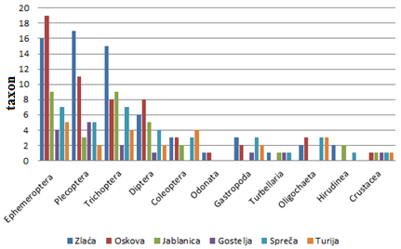
Picture 2. Diversity of macroinvertebrates of investigated waterflows
The most dominant are the representatives of the genus Baetis: (Baetisrhodani, Baetismuticus and Baetislutheri), then Heptageniasulphurea, Heptageniaqandrilineata. According to the literature data the Baetis species are present in the waters of faster and slower flows. The unique species Baetisrhodani is adaptable to different environmental conditions, due to the presence of two generations during development, summer and autumn. [9] As with the species of the order of Ephemeroptera, Plecopter's representatives have been found in the samples of the investigated streams. The presence of individuals of this group points to the good quality of the investigated waterflows. Leuctra hippopus species was found in 8 out of the 11 studied sites. The Leuctra Hippopus settles water with rocky bottom and with low pollution levels. [10] The individuals of this species were not found only in samples taken from the riverGostelje and the source of riverZlaća (L1). According to the number of individuals 112, the species Perlailliesi stands out, whose representatives have not been identified in Gostilja and Turija. The presence of the other species from Plecopter group is lower and is shown in Table 1. The most sensitive to various types of pollution is group Plecopter. [11] Our research has shown that the greatest number of individualsa taxawas found at the source of the riverZlaće, which indicates good water quality. Representatives of the Trichopter order represent a significant share in the overall sample, whose representatives are represented in all watercourses. The dominant species are Hydropsychesiltalai, Hydropsycheangustipennis and Hydropsycheinstabilis. The increasing number of taxa and Trichoptera individuals was found in samples of bentos from Zlaća and Oskova. These are shallow rivers with stony and pebbly sediments. The Dipter individuals are distributed in samples of bentos of all streams of the catchment area of ​​Lake Modrac. The largest number of individuals (202) Diptera belong to the species Chironomusthummiiz of the Chironomidae family whose presence was found in samples from all waterflows except Gostelja. The number and diversity of the established taxa from the order Diptera is lower.
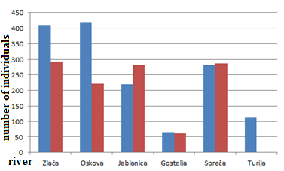
Picture 3: Number of macroinvertebrate individuals of investigated waterflows
Our research has shown that Diptera individuals inhabit the bottom of waterflows with different forms of sediments, which is confirmed by research [12]. The presence of Diptera in particular of the hironomid species at sites where a strong organic load of water is found indicates a higher load on Spreca and Jablanica river waters. In this work, the group of Coleoptera is represented with 5 taxa (Table 1). Representatives of the Odonata order are represented by two taxa, Gomphusvulgatissimus and Anax imperator. The presence of a significant number of Gomphusvulgatissimus species at the investigated sites suggests the presence of favorable conditions for the development of these organisms. For the development of individuals from dragonfly species, well-developed underwater vegetation is required, where the individuals lay eggs after fertilization [13]. This paper presents the distribution of other taxa of established groups. The presence of certain species of snails was found at 6 sites from 11 investigated (Table 1). The largest number of individuals and species was found in the samples of the Spreča river benthos. In the samples from studied zoobenthos from the explored waterflows only one kind of Turbellaria, Dugesiagonocephala was found. Individuals of this species were found in samples of river Spreča, Gostelja, Jablanica and Zlaća with a small number of individuals (table 1.). Distribution of Oligochaeta is shown in Table 1. Individuals Tubifextubifex were found in samples taken from the three waterflows, the site 4 (L4, L9, L10 and L11). The presence of individuals of this type indicate a highly contaminated water. Naisparadalis was found in three locations (L 4, L 10 and L 11) from the three waterflows.Distribution of Hirudinea individuals (leeches) in the studied samples of zoobenthos is shown in Table 1.The individuals of species Erpobdellaoctoculatabelog to the group of carnivorous organisms, they can endure stronger pollution and were found in more investigated locations (5) relative to the individuals of Haemopissanguisuga found at three sites with stony and pebbled bottom. In the explored waterflows, a presence of different fauna species was found at the study sites (Figure 3). The distribution and the number of macrozoobenthos species depend on changing ecological conditions. The highest number of zoobenthos specimens was found in samples from the Zlaća River (702 individuals), followed by Oscova (641), somewhat smaller number in samples taken from Spreče (560) and Jablanica (501), and the smallest number in Gostilja (126) and Turija (114). An increase in the number of some macroinvertebrate representatives was recorded in the Oskova and Zlaća rivers. Similar data has been determined [13] by studying communities of zoobenthos of the Krivajariver.
Table 2: Similarities of the localitys of the investigated waterflows based on the presence of macrozoobenthos communities
Step | Clusters | Distance | Similarity | Joined 1 | Joined 2
1 | 9 | 43,87352 | 56,12648 | 5 | 6
2 | 8 | 48,14815 | 51,85185 | 1 | 2
3 | 7 | 58,14607 | 41,85393 | 1 | 3
4 | 6 | 60,31746 | 39,68254 | 7 | 8
5 | 5 | 60,98418 | 39,01582 | 5 | 10
6 | 4 | 66,30265 | 33,69735 | 1 | 4
7 | 3 | 67,02128 | 32,97872 | 1 | 9
8 | 2 | 68,15742 | 31,84258 | 1 | 5
9 | 1 | 85,96491 | 14,03509 | 1 | 7

Table 3: Percentage of similarity of localitys of investigated waterflows based on the presence of macrozoobenthos communities
Similarity | L-1 | L- 2 | L- 3 | L- 4 | L- 5 | L- 6 | L- 7 | L- 8 | L- 9 | L- 10
Matrix
L- 1 | * | 51,8519 | 40,9639 | 26,3074 | 17,9811 | 23,4104 | 7,1579 | 9,7665 | 26,393 | 14,3472
L- 2 | * | * | 41,8539 | 30,0195 | 17,8295 | 19,1638 | 12,3249 | 11,3314 | 32,9787 | 15,8895
L- 3 | * | * | * | 33,6973 | 30,1242 | 23,9316 | 8,6598 | 9,5634 | 24,2775 | 18,1047
L- 4 | * | * | * | * | 21,1236 | 14,7117 | 8,3916 | 12,766 | 27,9919 | 6,6929
L- 5 | * | * | * | * | * | 56,1265 | 6,9204 | 14,0351 | 15,7258 | 33,6595
L- 6 | * | * | * | * | * | * | 4,0346 | 9,9125 | 30,6859 | 39,0158
L- 7 | * | * | * | * | * | * | * | 39,6825 | 2,3739 | 7,9545
L- 8 | * | * | * | * | * | * | * | * | 3,003 | 13,2184
L- 9 | * | * | * | * | * | * | * | * | * | 31,8426
The similarity of macrozoobenthos communities to the research sites was verified by Bray - Curtis' cluster analysis of the similarities, or the least diversity of the investigated communities. According to the data from Tables 2 and 3, it is clear that the Krivalići and Suha (L5 and L6) locations on the Jablanica stream are the most similar in terms of the number of taxa, with a similarity percentage of 56.1%. The following locations are located on the Zlaćariver (L1 and L2) with a similarity percentage of 51.8%; in all other explored locations the percentage of similarities is less than 50%. Results of the macroinvertebrates diversity studied by research sites were presented in picture 5.According to the presented results the greatest similarity (56.1%) was shown in the samples of macroinvertebrates from the site Krivalići (L5) and dry (L6), and of macroinvertebrates collected at locations (L1 and L2 ) from river Zlaća with a similarity index of 51.8%. The samples taken from locations 7 and 8 ( Dubrave and Vukovije) from river Spreča should be put in a separate group with a low similarity of 39.6%. Picture 5.shows the values ​​of the Shannon - Weaver diversity index.
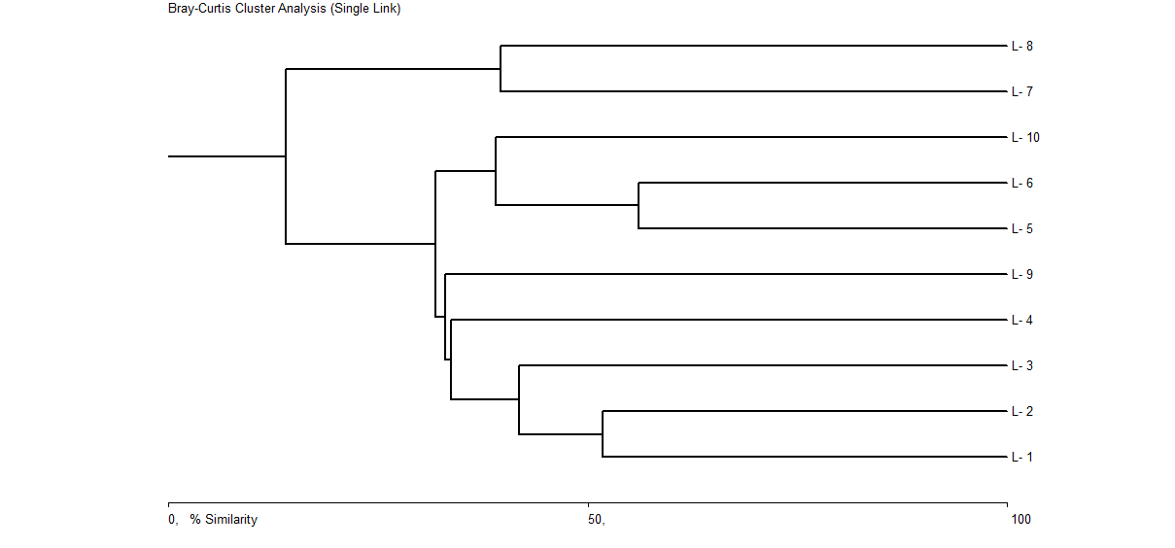
Picture 4: Display of cluster analysis of samples of macrozoobentos of investigated waterflows
Based on the results of the index of diversity it can be concluded that they are quite different in some research localities indicating the heterogeneous composition of the community ofmacroinvertebrates in explored waterflows.
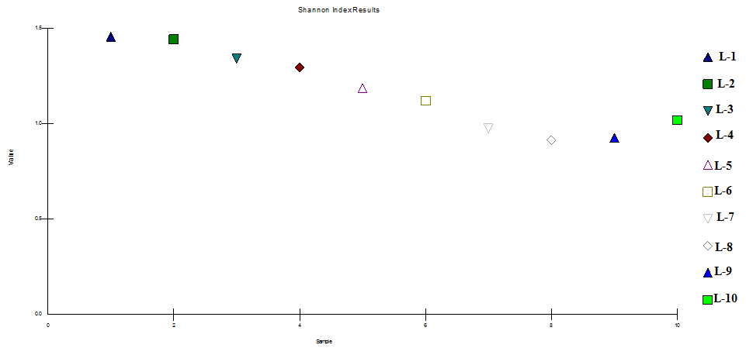
Picture 5: Values of the Shannon - Weaver index of diversity by research site
The highest values ​​of the index of diversity are found on both studied sites of the river Zlaća, which indicatesthelargest presence ofmacroinvertebrates and that the conditions are most favorable on these sites. Somewhat lower values ​​of diversity are registered at the explored locations of the Oskovariver. The lowest values ​​of diversity index were registered on the Sprečariver, which is consistent with our previous studies [14].

CONCLUSION

Hydrobiological research of the macroinvertebrate from waterflows of the catchment area of ​​Lake Modrac showed a high degree of biodiversity, which points to favorable conditions for their life in the analyzed ecosystems. The results of the analysis showed the presence of 2644 individuals classified in 11 groups and 87 taxa. Most species belong to the Insect group - 84.25% and 73 taxa. The highest biodiversity among the order of insects was recorded in Ephemeroptera (24 species), followed by Plecoptera and Trichoptera with 17 species, somewhat smaller with Diptera, Coleoptera and Odonata. The number of taxa established by other macroinvertebrate communities of studied waterflows is considerably lower. The qualitative and quantitative analysis of the studied watercourses revealed the different presence of individuals and taxa. The highest diversity was found in the samples of the Zlaćariver - 65, Oskova - 57, somewhat smaller in Spreča - 35 and Jablanica - 28, while the lowest diversity was found in the Turija (23) and Gostelja (17) rivers. The results of the diversity index show that communities of macroinvertebrates differ in research sites, which indicates the heterogeneous composition of communities of macroinvertebrates of investigated waterflows. The highest values ​​of the Shannon - Weaver index of diversity were found at the sites of the survey in the Zlaćariver, and the lowest on Spreča river. Cluster analysis showed that, by the presence of the number of taxa, the most distinctive sites are the Krivalići (on the Jablanica ) and the Suha (L5 and L6) with a similarity percentage of 56.1%. The similarity figure above 50% was also established on the Zlaća river (L1 and L2) sites, while the percentage of similarities at other surveyed sites is less than 50%.

LITERATURE

[1] DALL, C. P.: Commonly used methods for aassessement of water quality. In: Biological Assessement of Stream Water Quality, University of Ljubljana, Ljubljana, 1995. [2] KEROVEC, M.: Priručnik za upoznavanje beskralješnjaka naših potokairijeka. SNL, Zagreb, 1986. [3] QUIGLEY, M.: "Invertebrates of Streams and Rivers: A key to Identification". Edward Arnold Pub. UK. 1997. [4] DALL, W. B. J. HILL; P.C. ROTHLISBERG & D. J. STAPLES.:The biology of the Penaeidae, p. 1-489. In: J. H. S. Blaxter& A. J. Southward (Eds). Advances in Marine Biology 27. London, Academic Press, 1990. [5] SANSONI, G.: Atlante per ilriconoscimentodeimacroinvertebratideicorsi d acquaItaliani. Centro Italianostudi di biologiaambientale, Provinciaautonoma di Trento, 1992.[6] WARINGER J. & GRAF W.: Atlas der Österreichischen Köcherfliegenlarven.FacultasUniveritätsverlag, Wien, 1997. [7] SHANNON, C. E. & WEAVER, W.: The Mathematical Theory of Communication. The University of Illinois, Illinois1949.[8] DIETRICH,F., WARINGER, J.A.:Distribution patterns and habitat characterization of Elmidae and HydraenidaeInsecta: Coleoptera) in the Weidlingbach near Vienna, Austria. International Review of Hydrobiology 84: 1-15.[9]STUDEMANN, D. LANDOLT, P. SARTORI, M., HEFTI, D. AND I. TOMKA: Ephemeroptera. Insecta Helvetica Fauna, 9.ImprimerieMauron + Tinguely&Lachat SA, Fribourg, 1992. [10]WEGL, R.: Index für die Limnosaprobiat. Wasser und Abwasser, 1983.[11]TROŽIĆ, B.S. HARAČIĆ, M. I SIRĆO, M.: Komparativni sastav makro zoobento sa rijeke Ribnice (Kakanj) irijekeBioštice (iznad Olova). "VODA I MI" Časopis Agencije za vodno područje rijeke Save,broj 82.Sarajevo, 2013.[12]LINDEAARD, C. : The fauna`s response on hu-man impacts in running waters with special refe-rence to lowland conditions. In: Biological Asse-sement of Stream Water Quality, University of Ljubljana, Ljubljana, 1994. [13] CIKOTIĆ, M.:Taksonimakroinvertebratainjihova distribucija u uzorcima Krivaje."VODA I MI" ČasopisAgencijezavodnopodručjerijeke Save,broj 69.Sarajevo, 2009.[14] SKENDEROVIĆ, I. ADROVIĆ, A. BAJRIĆ, A. SKENDEROVIĆ, I.:Use of Softwer Applications in Water Quality Assesment. Tem Journa, Novi Pazar, Novembar 2016.

