ANALYSIS AND PROCEDURE OF THE EVACUATION PLAN FROM COLLEGE OF APPLIED TECHNICAL SCIENCES NIS

Natalija Tošić¹, MSc in environment protection, Jelena Bijeljić², MSc in Civil engineering, Nemanja Petrović³, MSc in Architecture, Milan Pavlović⁴, MSc in Mechanical engineering
¹College of Applied Technical Sciences Nis, Nis, SERBIA, natalija.tosic@vtsnis.edu.rs
²College of Applied Technical Sciences Nis, Nis, SERBIA, jelena.bijeljic@vtsnis.edu.rs
³College of Applied Technical Sciences Nis, Nis, SERBIA, nemanja.petrovic@vtsnis.edu.rs
⁴College of Applied Technical Sciences Nis, Nis, SERBIA, milan.pavlovic@vtsnis.edu.rs

Abstract: This paper presents the importance of proper treatment in case of a risk event in the College of Applied Technical Sciences Nis. The aim of this paper is to present the relevance of the evacuation as one of the most effective ways of rescuing people from buildings where danger can occur. This is organized way of abandoning the building in danger to a safe place outside the building where you cannot expect negative impacts of risky events.
Teaching and non-teaching staff of the College should pay special attention to this paper since they are potential rescue operation leaders. The College of Applied Technical Sciences Nis should have good preconditions for proper abandonment of the object in the shortest possible period, based on properly mounted evacuation signs.

Key words: evacuation, tactics, rescue, prevention

- INTRODUCTION

Great efforts are put in the modern world to prevent life threatening events from occurring. As a result, whatever happens in a certain building in case of unforeseen events proves that efforts put in existing technical and organizational resources are never enough. In real-time situations, there is a big risk that people will not manage to evacuate safely from the danger zone. When risky events occur, evacuation is the best way to save lives and health of people, animals, material and non-material goods, which is why special attention is needed. Proper implementation of evacuation measures and tasks is conducted with the help of a well designed Evacuation plan, together with the required material, technical and financial funds, and responsibility of all participants in conducting the evacuation.
Evacuation planning is based upon the Danger assessment in order to perform beforehand preparations for an organized retreat from danger zones. [1]
The goal of any evacuation measure is to guide people away from the danger zone as quickly as possible, and as safely as possible, as well. People should be encouraged to safe themselves and any risk which creates either mental or physical hindrances should be taken down to a minimum.
By developing a safe and efficient concept of how to act in emergencies and by successfully applying additional measures, the dangers for health and life of people can be reduced to a minimum.

- THE OCCURRENCE OF EMERGENCIES

Emergencies caused by natural disasters or human activities take away many lives on a daily basis, and in many different ways ruin or devastate the environment causing great material damages and losses. The risk of catastrophes exists in every society because catastrophes slow down the sustainable development of the society as a whole. [2]
Emergencies can be classified into natural disasters: floods, earthquakes, landslides, volcano eruptions, extreme cold, heat... Other events which may trigger emergencies include: chemical operations, oil disasters, radiation emergencies, traffic accidents... Other events which can be described as emergencies include terrorist acts, sabotages or arson. [3]
The possible level of accidents is determined based on the potential scenario and harmfulness analysis, and is expressed as the I, II, III, IV and V level of accidents. [4]:
I level of accidents – (facility objects) – negative effects caused by the accident are limited to part of the object-facility or entire object – facility on the complex of the business organization and other legal body and no negative effects on the environment are expected.
II level of accidents - (objects, facilities and complexes) – negative effects of the accidents can reach part of the object – facility or complex of the business organization and other legal body and no negative effects on the environment are expected outside the complex.
III level of accidents – (local authority level) – negative effects of the accidents can be transferred outside the limits of the object in danger – facility and complex of business organization and other legal body and there are effects to be expected on one part or the entire area of the local authority, or city.
IV level of accidents – (national level) – negative effects of the accident on the object – facility and complex of the business organization or other legal body can be spread on part of the territory and entire territory of the Republic of Serbia.
V level of accidents – (international level) – negative effects of the accident on the object – facility and complex of the business organization or other legal body can be spread outside the territory of the Republic of Serbia.

- THE SIGNIFICANCE OF PROPER EVACUATION AND RESCUE

Evacuation can be defined in many ways, however, the closest and most comprehensive definition is that evacuation is a well organized, planned and temporary displacement of people, animals, material and cultural goods, state bodies, business organizations, and other legal bodies from the endangered territory on to a territory determined by the Protection and Rescue Plan in Emergencies, where there is no threat of disasters and which offers conditions for living and protection. [5]
Evacuation is organized and conducted for the sake of protecting and rescuing people, animals, material and cultural goods, state bodies, business organizations, and other legal bodies from natural disasters, technical-technological accidents – traffic accidents and catastrophes, acts of terrorism, war and other major accidents. [1]
In order to conduct the evacuation process from the object properly and as safely as possible, it is necessary to develop the Evacuation and Rescue Plan first and foremost, determine the ways where evacuation is to be conducted and acquaint all employees with the conduct of behaviour upon the occurrence of unwanted events conducting the evacuation. When people in the object are acquainted with the quickest way of abandoning the endangered area and closest exists, the level of panic would be significantly smaller; therefore, the evacuation process itself would be conducted with ease and more efficiently.
The preparation of every one present depends mostly on the acquired knowledge and respect to the manual in case of emergencies, but the behaviour of people cannot be determined up front because it is based on the process psychology of current behaviour. Each process starts with new information from their physical and social environment which should be adopted, interpreted and processed so that a decision on the choice of reaction activity can be reached (including the lack of activity). [6]
Behaviour impact factors which affect how we act in states of emergencies and forceful evacuation can be divided into those which exist before the event, those which act during the event and those which depend on the number and type of signs and information during the event. As these factors are very different one from another, and due to the fact that every individual acts in a unique way, it is very difficult to foresee the development and course of the evacuation process in case of an emergency. This is why it is very important to contribute to an efficient and less risky abandonment of the danger zone. Above all, it is important that the evacuation pathway leads through a separate smoke and fire sector which is ventilated, containing clear and vivid signes and instructions, and the building revetment must be made of non-combustible materials. [7] Proper communication solution in the object must enable the users to move freely within at any given time and be able to evacuate quickly, when necessary and enable a safe pathway for users to safe areas. Good time estimation required for evacuation is especially important for objects where many people gather or spend their time.

- EXISTING TECHNICAL MEASURES FOR SAFE EVACUATION FROM COLLEGE OF APPLIED TECHNICAL SCIENCES NIS

The College of Applied Technical Sciences Nis is located in Aleksandra Medvedeva Street, no 20. The object is part old-build, part new-build which has over time been renovated, modernized and equipped to follow all teaching, research, expert work requirements as well as in line with the newest standards and regulations.
Object planning requirements are such that the object is surrounded by other objects and vegetation which significantly affects the wind flow and guards the object from the blowing winds. [8] The height of the floor of the last object storey does not surpass 30m in relation to the neighbouring terrain, so the object does not belong to a group of high objects. [9] The College takes an area of 1877.97m². The appearance of the object is given in Picture 1.
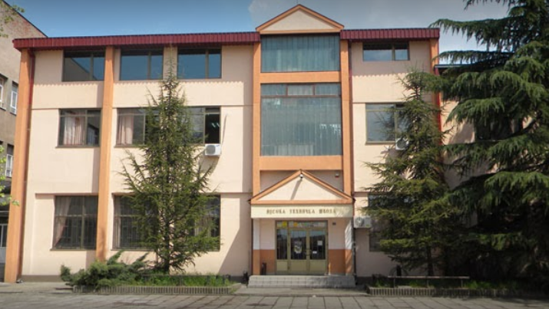

Picture 1: Appearance of the object College of Applied Technical Sciences Nis

The main entrance to the College is from the big parking lot which is an important factor due to the fact that a fire-fighting truck or auxiliary services can approach for the quick evacuation of people. It is also a fact that due to the lack of appropriate roads and paths as well as illegally parked vehicles, auxiliary service vehicles have difficulties to reach objects in risk. Fire-fighting squad can reach the College from the main traffic roads from Bulevar Nikole Tesle Street in approximately 7 minutes from receiving the call, as well as from Bulevar 12. Februar Street in 8 minutes. The third and longest way is via Knjazevacka Street and the maximum time for the arrival of the fire-fighting squad is 9 minutes.

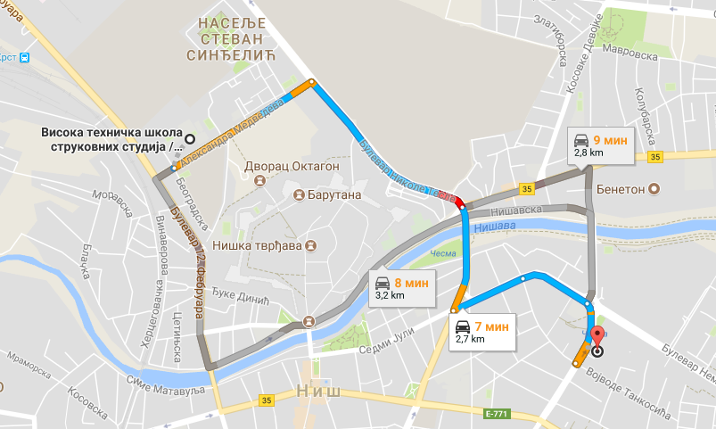
Picture 2: Fire-fighting brigade approach roads (primary and alternative)

The door to the main exit to open space is 1.8m wide and 2.05m high whish satisfies the security conditions. The object consists of the ground floor, first and second floor, with the second floor being added in 2012 and designed in accordance to the latest regulations, from fire-proof materials and equipped with newest equipment. The ground floor is also undergoing the process of renovation which is also to be equipped with the newest technologies and materials. Exists and pathways are properly marked with safe movement signs and enable safe evacuation from the space used by the College.
Existing rooms which can accommodate people include 3 amphitheatres, 5 classrooms, 3 laboratories, 4 computer laboratories, library, reading room, teachers' offices, and halls for thesis, dissertation defence and specialist works, conference hall as well as rooms for the student parliament and administrative personnel of the College.
In case of an evacuation from College, the general alarm system is foreseen to go off over the sirens, through manual alarms installed on each floor as well as through the automatic fire central base situated on the ground floor. There is a minimum 1 optical fire alarm which is checked in line with the regulations every 6 months. There are external and internal hydrants equipped with all required equipment. The interior of the object has 7 wall hydrants built in, 2 on the ground floor, 2 on the first floor and 3 on the second floor which can be used to extinguish initial fires. Wall hydrants are mounted on places which enable covering every part of the object with a jet of water. They are mounted on a visible and accessible place, coloured red, marked with the letter H and have all the required equipment installed: hydrant valve, hose, jet and hydrant key.
Users of the object are obligated to purchase and keep the equipment for personal, joint and collective protection of people in working condition, all for the sake of protecting and rescuing the lives and health of people, material goods, and environment. [10]

  - Communication in College of Applied Technical Sciences Nis

Single, two-flight and three-flight staircases are used for vertical communication, side staircases and fire escape staircase. Staircase can affect the speed of evacuation, especially those used to overcome the height difference between certain floors. The required number of evacuation exits and their dimensions can be calculated using the specific staircase capacity which indicates the number of people which can go through the passage or exit of a certain width during the course of one minute.

Table 1: Number of people that can go through a passage during one minute [11]
PASSAGE WIDTH | SPM
0,9 m | 48-62 persons/ min
1,4 m | 78-90 persons / min
1,8 m | 98-108 persons / min

The College does not have any special fire escape staircase. Rather, it uses the main staircase for regular communication and evacuation. Due to these reasons, it is important that these staircases and pathways are used primarily for evacuation of the personnel as well as all other present persons and property. Unless properly shaped, the staircase is a suitable place for spreading danger. When there is a fire in an object, the protection of the fire staircase from smoke and vertical fire spread is of utmost importance, because the staircase then acts as a chimney of a great cross-section which is ideal for spreading the fire from floor to floor.
The staircase in the College is organized in such a manner that there are big windows wherever there are parts foreseen as rest areas, so the problem of smoke in the staircase areas is partly solved. If windows are open during danger it can help evacuation immensely since the visibility of evacuation pathways would increase.
The evacuation doors in case of danger have to be opened in the same direction as the exit from the object. Using slide or revolving doors as evacuation doors is not allowed when in danger. In case of danger, evacuation doors must not be locked or in any other way blocked so that anyone who should use them can use them quickly and easily. [12]

- ACTS AND PROCEDURES OF POTENTIAL EVACUATION FROM THE COLLEGE OF APPLIED TECHNICAL SCIENCES NIS

In accordance with the reached evacuation plan in case of emergency, all College employees must initiate the evacuation of students from the College calmly and without panic. Students have to be warned that the evacuation is conducted immediately, without collecting their books, equipment, clothes...because the evacuation time needs to be as short as possible for avoiding additional crowds and panic.
Each professor is obligated to take their group of students along the shortest determined evacuation way to a previously determined gathering spot. During the process of evacuation, it is important to know that human life comes first, and then comes the evacuation of property or renovation of danger. [5]
The evacuation process undergoes 3 stages:
- Preparatory evacuation stage,
- First evacuation stage and
- Second evacuation stage
During the preparatory evacuation stage, each professor who is at the moment of an emergency located within the College is obligated to gather all students and set an example with his behaviour as in not to spread panic and acquaint the students with the emergency. After that, it is necessary to take all actions for eliminating panic by issuing short and clear instructions for student evacuation, directing them to specific exits and gathering points.
During the first stage, the students should be directed towards the exits quietly and quickly, having in mind that the evacuation should not be conducted in a running manner. It is necessary to control the entire evacuation course and in case an exit gets blocked, divert the students to the next available exit. The teaching staff and students should help injured persons on their way out, make sure themselves do not get hurt and check if everyone present in the object have abandoned it.
During the second stage, it is very important to switch off all devices and all electric installations. After the students have been evacuated from the object, it is necessary that teachers and professors get evacuated. All evacuated persons should meet at the gathering point where they will receive further instructions from the leader of the evacuation action.

  - Evacuation action leaders

Evacuation training and rescuing is done in three stages:
- Training the evacuation and rescue leader
- Acquainting all workers with the evacuation and rescue plan
- Conducting practical evacuation and rescue exercises
In order to conduct evacuation and rescue plans, workers have to be selected and trained according to a special programme. When choosing the workers who will be trained for evacuation leaders in case of an emergency, it is necessary to pay attention that those are workers who will be able to perform anticipated actions which are an integral part of the evacuation action.
Evacuation and rescue leaders are obligated to do the following during evacuation:
- Control and coordinate actions for the sake of evacuation
- Issue orders to certain professors and other responsible personnel for implementing special measures regarding the changes which depend on the course of evacuation
- Take special measures in cases when evacuation has not been fully implemented.

  - Gathering points of evacuated persons

All students and workers will gather at points which have been set as gathering points on the open after abandoning the buildings in cases of emergencies. Students and workers must gather at these points in all cases of emergencies unless unexpected events occur such as storm winds, hail and dangerous substance clouds start to spread in the open.
In such cases, one should take the following precautions [11]:
- Do not leave the object,
- Take refuge in the most secure indoor rooms,
- Seal all openings on the College tightly
- Turn off all installations, machines and devices which can cause accidents in cooperation with the leader during the rescue mission of professors,
- After the emergency has ended, act in line with the instructions of the evacuation and rescue leader. Gathering points are determined on a location which is set to gather students and workers in the open. These points must be at least 10m away from the object so that each person is protected from any possible effects of the emergency.
After the gathering, students and workers must:
- Wait for further instructions in a calm manner,
- Not create subsequent panic,
- Do not spread around or act in their own will,
- Do not go back to the object before they get a permission from the evacuation leader
Evacuation leaders must do the following at the gathering points:
- Determine if all students and workers have left the building,
- Take rescue actions if not all of them have left the building,
- Coordinate the action with other evacuation and rescue leaders, teaching staff and chief of professional fire-fighting squad in the city,
- Organize first-aid help to all those injured, and direct those who are severely injured to medical facilities (first aid, health centre, hospital...)

- EVACUATION PLAN FROM THE COLLEGE OF APPLIED TECHNICAL SCIENCES NIS

The evacuation plan encompasses detail plans for an organized and planned displacement of people, animals, material and cultural goods from a territory potentially in danger or already in danger to a less risky and safer territory. The integral part of the Evacuation Plan are points where evacuation signs are mounted and have to be marked in object plans. [4]
Signs have to be placed in such a manner that they do not pose threats, are clear and understandable. Attention must be paid to avoid larger grouping of signs in one place. Signs must not be placed on moving objects or close to moving objects such as doors, windows and shelves which can block the sign. Evacuation signs should be placed along the evacuation paths which will indicate the direction of abandoning the object in to a free space. Signs should be placed in eye height spots, on a height of 1.5m to 2m. [11]
Evacuation plans for the College of Applied Technical Sciences have been designed in 2013 which showcase the ways along which it is easiest to conduct a displacement of people from all College rooms to the main exit into free space. Plans have been designed for each floor separately and are displayed on pictures 3, 4, and 5.

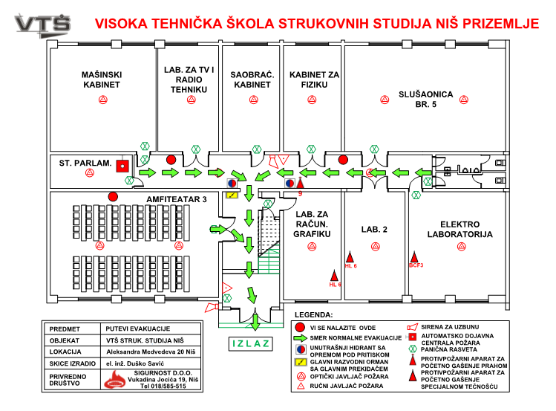
Picture 3: Evacuation Plan for the ground floor of the College of Applied Technical Sciences Nis

There are 10 rooms in the ground floor: one of them an amphitheatre, 3 offices, 3 laboratories and 2 auditoriums. Evacuation of students and workers in case of emergencies is done from these rooms via passages and hallways in to an open space. It is recommended that persons who are located at the ground floor at the moment of emergency fix the doors so as to be always open. Should the entrance be blocked, everyone should be evacuated through windows in the ground floor rooms of the College.
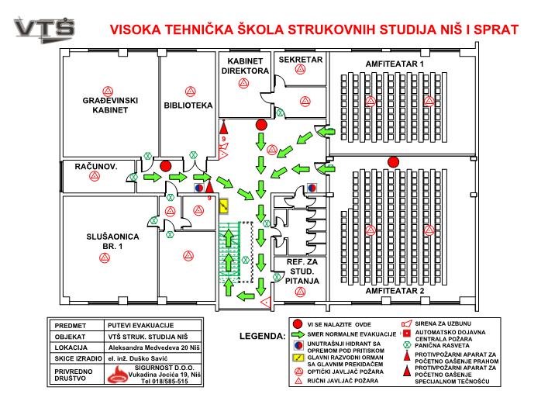
Picture 4: Evacuation Plan for the I floor of the College of Applied Technical Sciences Nis

The manner of conducting the evacuation from upper floors of the College should be performed from hallways to the staircase, then from the staircase go down to the ground floor without panic where the open free space is reached through hallways and passages. After exiting the rooms on the upper floors, students and workers are gathered at specific gathering points in the open space where they receive further instructions from the evacuation and rescue leader. It is important to know the evacuation time from the upper floors in advance, in order to know when the last person can be expected to evacuate from the object.

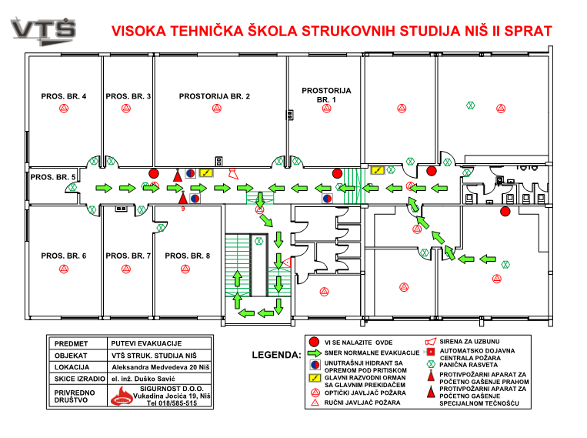
Picture 5: Evacuation Plan for the II floor of the College of Applied Technical Sciences Nis

In order to conduct the process of evacuation and rescue, certain employees need to be selected and trained according to a special programme. The training programme is designed to give necessary theoretical and practical knowledge and skills, it is based on immediate observations about the source of emergency and specific work processes and fire protection measures which need to be taken. It can be done through lectures, seminars, practical exercises, consultations and other forms of training. Upon the completion of the training, one more procedure needs to be conducted. This procedure includes knowledge and skill assessment in employees. [7]
Knowledge assessment is done through tests, oral examination and practical competence check. The training programme at the College is done regularly, through lectures and testing in the end. When choosing the workers who will be trained as evacuation and rescue leaders, it is necessary to pay attention that these are workers who will be able to perform anticipated actions in line with their physical, psychophysical and health abilities. Even if the employees have undergone testing related to rescue prevention and tactics, there are still workers who have not been trained for giving first-aid or conducting the evacuation action. The good side of the College is that the age structure is well balanced, the teaching staff is rather young with the age average of 42.34 years, which means that there are many those present who would be able to assist in emergencies and help others and themselves. Practical evacuation action exercises should be performed at least once every two years and everyone who is trained for their rescue action task can practice their skills. Practical exercise should be performed and conducted by evacuation and rescue leaders in cooperation with the teaching staff and professional fire fighters.

- CONCLUSION

Even in cases when the object has been built according to all standards and regulations, sometimes it is not enough to secure the safety of human lives in cases of emergencies, especially having in mind the human behaviour which can't be defined nor foreseen by any rulebook. When the evacuation plan is well designed, the evacuation measures and tasks can be implemented regularly, as well as the manner of acting. Furthermore, the responsibility of all participants in conducting the evacuation action can be foreseen. College of Applied Technical Sciences Nis has very good Evacuation plans for each floor separately. On each floor one can see where there are manual and optical fire alarms, where hydrants are located, were the main junction box with the main switch is located which helps the coordination of everyone present at the risky spot. In order to be able to conduct the evacuation and rescue actions in a most efficient way, it is recommended that these action drills be organized at least once every two years and at the same time clearly define the worker teams in the College who will be able to conduct the evacuation in the safest possible manner. It is also necessary to foresee the real evacuation time of the last person in the building in order to help plan the rough overall evacuation time.
The College of Applied Technical Sciences Nis has good preconditions for a safe and secure abandonment of the College premises in the shortest time period, keeping in mind the health and life of people as a priority.

LITERATURE

- Regulaiton on conducting the evacuation ("Official Gazette of the Republic of Serbia", no. 022/2011)
- National strategy of protection and rescue in emergencies ("Official Gazette of the Republic of Serbia ", no. 86/2011)
- Martínek, B., Linhart, P. etc. Ochrana člověka za mimořádných událostí: Příručka pro učitele základnícha středních škol. Praha: MV – GŘ HZS ČR, 2003. ISBN 80-86640-06-6.
- Manual on the methodology for designing the risk assessment and rescue and safety plans in emergencies ("Official Gazette of the Republic of Serbia ", no. 96/2012)
- Law on emergencies ("Official Gazette of the Republic of Serbia ", no. 111/2009, 92/2011 i 93/2012)
- Erica D. Kuligowski, The Process of Human Behavior in Fires, Fire Research Division Building and Fire Research Laboratory NIST Technical Note 1632, U.S.Department of Commerce 2009.
- Law on fire protection "Official Gazette of the Republic of Serbia", no. 111/2009, 132/2014
- S. Vasić, R. Jovanov, Preventive protection from explosions and fires, VŠUP, Belgrade. 2000. p.265.
- Manual of technical norms for the protection of high objects from fire ("Official Gazette of the Republic of Serbia ", no. 80/2015)
- Manual on mandatory resources and equipment for personal, joint and collective protection of natural disasters and other accidents ("Official Gazette of the Republic of Serbia ", no. 3/2011 )
- B. Babić, Evacuation and rescue, TEMPUS JPHES 158781: Occupational safety and health – degree curricula and lifelong learning , Novi Sad 2012. god , str. 11
- Manual on preventive measures for a safe and healthy work at the workplace ("Official Gazette of the Republic of Serbia ", no. 21/2009)

