**TECHNOLOGY OF EXECUTION FOUNDATIONS AND PIERS OF THE BRIDGE “MORAČICA” ON THE HIGHWAY BAR – BOLJARE**

**Radomir Zejak1, PhD; Goran Gorašević2, Vlastimir Praščević3, Igor Đuranović4**

1 Faculty of Civil Engineering, University of Montenegro, Podgorica, Montenegro, rzejak@t-com.me

2 RG Group d.o.o. Podgorica, Montenegro, goooxi@yahoo.com

3 Mosting d.o.o. Podgorica, Montenegro, prascevic.vlastimir3@gmail.com

4 X–Inženjering d.o.o. Podgorica, Montenegro, igor.djuranovic11@gmail.com

***Abstract:*** *This paper presents technology of execution– method of statement for the piers of the bridge Moračica on the highway Bar-Boljare – priority section Podgorica – Mateševo, built by Chinese company CRBC. Besides other participants in the construction, the Government of Montenegro has created the Committee for comparative technical work examination during the execution, due to importance of the structure that is under construction. Thereby, the Committee for technical examination, bears in mind the process of construction and has the possibility to perceive all the positions of works which are closing, that is after the construction of structure are not available by visual inspection. The Committee simultaneously monitors and analyzes all the necessary technical documentation which would be the subject to the usual technical inspection after construction*. *Since this approach is a novelty in our area, we thought it would be interesting to present it to competent public. This paper consists of bridge data, technology of execution, dynamics of completion of works to span structure, which execution is followed by completion of piers. The applied procedure and the data obtained during the implementation of this part of the project may be of use to a wide range of civil engineers engaged in similar activities*.

***Keywords:*** *Piers, scaffold and formwork, maintaining the reinforcement, diaphragm, concrete transport.*

**1. INTRODUCTION**

As part of construction of the highway Bar–Boljare through Montenegro, the bridge Moračica is under construction, which represents at the same time the most demanding structure on this route. The design of the bridge construction was made by Željko Ličina, M. Sc., and ordered by the Chinese company CRBC, who arranged complete engineering with the Government of Montenegro, i.e. the production of the Main design and execution. The Main design was made on the basis of preliminary design, made by Faculty of Civil Engineering, University of Montenegro in Podgorica. Figure 1 shows the layout so far realized a part of this magnificent structure.

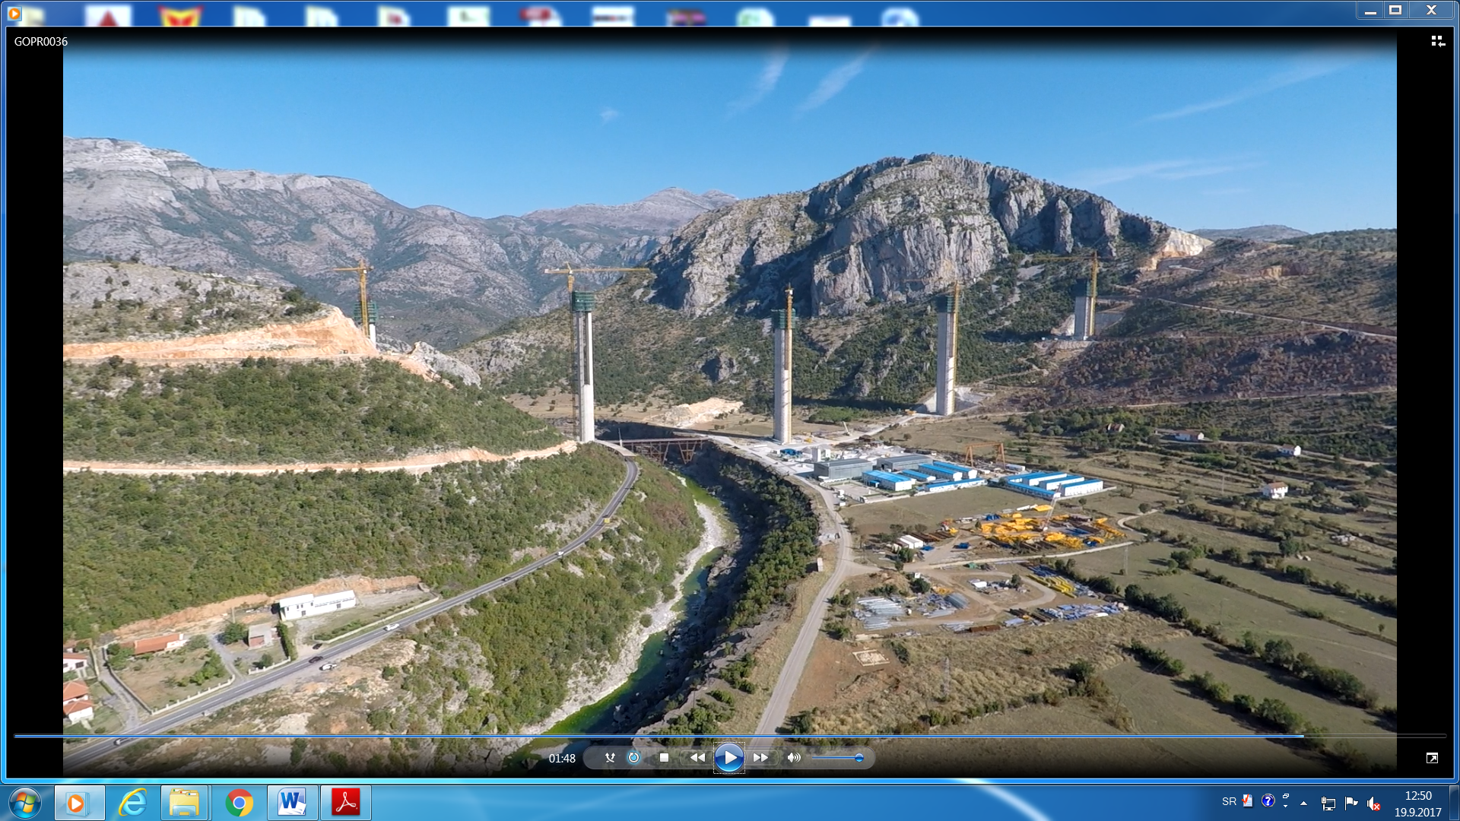

Figure 1: Realized part of the bridge construction as of 15.09.2017.

**1.1. Bridge data – layout [4]**

A unique bridge for both highway lanes is designed. The Bridge spreads from chainage km 6+482.14 to km 7+442.33 per left axis. The bridge spreads from chainage km 6+476.57 to km 7+436.38 per right axis. The space between roadway axis in the basis is 11.70m. The left roadway is on the section in front of the bridge, on the bridge as well as behind the bridge. It is parallel to right roadway. The bridge bridges main road Podgorica–Kolašin, river Morača and plateau Moračica (the bridge is named after this plateau), respectively. It connects northeastern slopes of hill Ždrvanj and west slopes of hill Smrdulja. There is a gorge between them and it’s width is approximately 1000 m. The bridge is approached from shorter part of open route (it’s length is approximately 400m). The tunnel “Mrke” is located in front of it. There is an open route of highway of about 4km behind the bridge and there is a tunnel “Klopot” afterwards (first breached tunnel on the route). The elevation of vertical alignment of the highway at the beginning of the bridge is about 253 meters above sea level, the elevation of vertical alignment at the end of the bridge is about 293 meters above sea level (difference =40 m). As measured by left axis of highway, the length of bridge structure is L = 960 m. The maximum height of the bridge above the terrain exceeds 175 m. It exceeds the additional 30 m on the part above river Moraca (this is the depth of the canyon in relation to plateau Moračica) so the total height of the water level is about 205 m. The total width of the bridge is 23.40 m, of which 7.70 m go on both roadway (traffic and roadside lane 2x3.50 m + 2x0.35m) and pedestrian walkway 2x2.00 m. Crossfall on the part of transition curve is changing, ranging from one sided crossfall of 4% to double sided crossfall of 2.5%. Grade on the part of the bridge, in front of the bridge and behind the bridge is 4%.

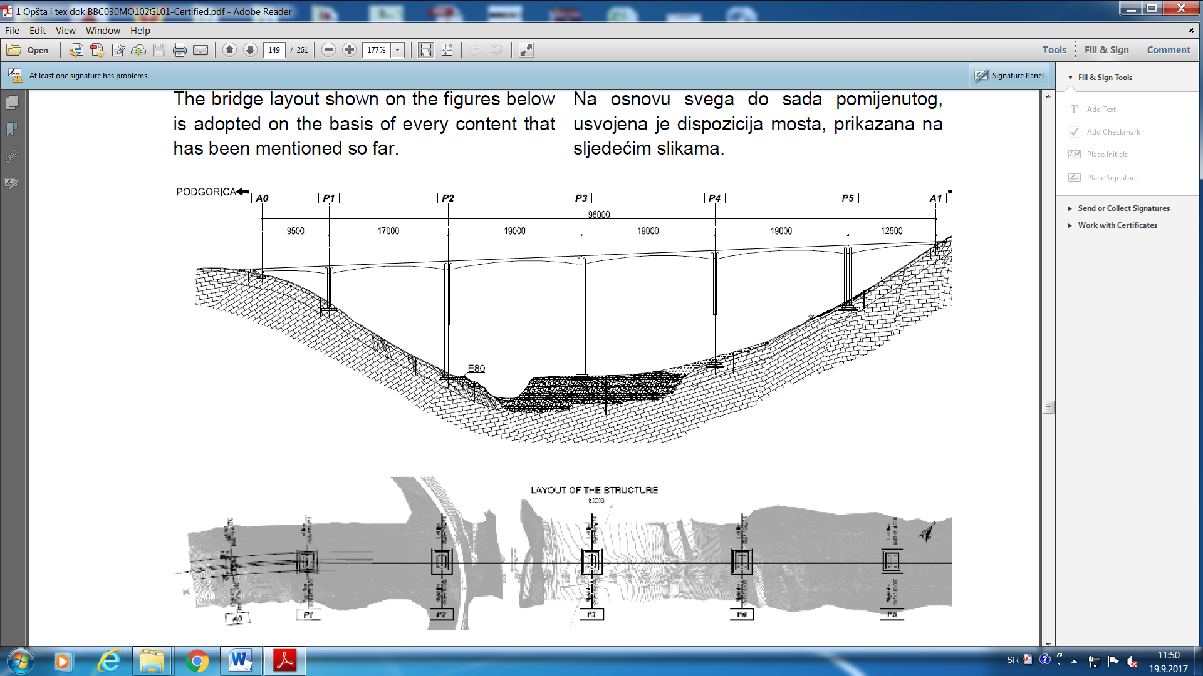

Figure 2: Layout of the bridge Moračica

The bridge is a continuous prestressed frame structure of variable cross section. The adopted solution has a range of 95 + 170 + 3 x 190 + 125 m, so that, axially, the length of the bridge is 960 m, and with the wing walls 988 m. This span ratio is favorable for continuous frame construction system whose bridge structure is constructed by the balanced cantilever method.

The piers P1–P5 establish rigid connection with the structure and abutments A0 and A1 are connected to the structure through bearings. This is how the horizontal impacts are divided onto a few piers. The system with larger inner spare bearing capacity is obtained on this way. From the aspect of construction technology, the rigid connection is favorable as well. Frame structure also requests smaller dimensions of foundation.

The bridge starts from a small incision in the mount, which then goes into a mound height of 10 m. Highway quickly enters the high cut behind the bridge. The terrain under the bridge on the right bank of the river Mora**č**a descends to the river canyon steeply. At the section of abutment A0, the gradient of terrain in longitudinal direction is still slight, that is, about 1:5 towards the river of Morača. In the transversal direction, it inclines to the left side. Furthermore, longitudinal and transversal gradient of terrain increase towards pier P1, so both, longitudinal gradient and transversal gradient of terrain is about 1:2. The terrain in the zone of pier P2 near the main road keeps steep longitudinal gradient towards Morača. Transverse gradient is getting lower and becomes relatively slight. The pier P3 is located on the plateau “Moračica. Transversally, the terrain around piers P4 and P5 is slightly inclined to the right side. Longitudinally, the gradient increases slowly around the pier P4 towards pier P5 and it reaches 1:2 (as well as on the right river bank). The abutment A1 is located under the top of the hill which the highway route comes in behind the bridge. The longitudinal gradient is very steep, that is, 1:2.

**1.2. Foundation structure**

Considering the geotechnical conditions, shallow foundation is chosen. All the piers are founded in limestone rock, except the pier P3 that is funded in terrace sediments, conglomerates. According to the reccommendations from geotechnical elaborate, it is adopted for the foundations to be located in geotechnical environment marked with “C” for at least 1–2m (glacio fluvial sediments – from weakly to well attached conglomerate and sandy gravel, a width of about 140 m with altitudes of 98 to 102 m above sea level).

The depths of founding of edges of foundation towards the hill are very high due to great longitudinal gradient and cross gradient of the terrain. Although the allowed stresses are extremely high even for the limestone, high degree of safety was applied during the defining of dimensions of footing because the rock is cracked and it can be locally unfavorable. Benched foundations of middle piers provide safe and uniform transfer of forces from pier into the soil. The gradient of force transfer is in accordance with valid regulations. The dimensions of foundations of piers P1 and P5 are 30x26 m and the dimensions of piers P2 – P4 are 33x26 m. The total height of all the foundations is 7.5m. The height and width of all the foundation stairs and distance of pier edge and foundation edge are 2.5m. There is an under layer concrete under the foundation whose thickness is 20 cm. It’s width is larger than foundation for 40 cm.

Bigger parts of foundations of end piers are set under the embankment. There are two reasons why this position is more favorable: the purpose of the relying of standing wing walls and the purpose of balancing of influences exerted from structure and soil pressure. On that way, eventually settlement is also controlled to be uniform. The upper area of the foundation is at longitudinal gradient. The height of footing at the section beside the wall sheet is 2.5 m. The thickness of under layer concrete that is applied at these foundations is 20 cm as well.

**1.3. The piers (substructure) of the bridge**

The great height of piers, wind as dominant influence and rather big differences in the pier heights caused kind, shape and law of change per height of the cross section. Shorter piers P1 and P5 that would receive more significant influences are less rigid in order to equalize the longitudinal influences on the middle piers. Higher piers are more rigid up to the height of rigid joints of shorter ones. Furthermore, the high piers are rigid up to the full height, their rigidity is the same as the rigidity of short ones. This is how the aesthetically favorable solution is accomplished, all the piers are laterally transparent up to the approximately same height. (the beginning of “fork” – two-part section).

Middle piers P1 and P5 consist of two box cross sections that are set parallel along the longer side, that is, transversely to the bridge axis. Both sections are identical, that is, both sections are two cell sections. The shape of the section is modified rectangular. The sections are stiffed with horizontal rib at the half of the height. (diaphragm). The sections which are separated in transverse direction and aerodynamically favorable shape of side areas reduce the wind influence on the piers. There is a recess on the longer sides which allows the efficient separation of air vortex and pier surface. External dimensions of these piers are 15x3.5 m. The thicknesses of walls are 80 cm and 170 cm. These thicknesses are constant per height. There are haunches planned on all the places of connections for horizontal slabs (ribs). There is a unique cross section of three meters height above the foundation as well as on the top. Full sections and large haunches enable right force transfer from the structure into the piers and from the piers into the foundation.

There is an inspection manhole in the top slab. There are two opposite ventilation shafts left in each cell of the section at each 5 m of height. There are also drainage holes in the bottom of the pier at the lowest point. Their diameter is 10 cm and they are left there to take away water that can possibly appear from the inside of the pier. The slope of these holes towards the exterior side is 5%. There are also inspection doors, stairs with safety hoops and rest platforms at each 10 m of height. All the openings in the structure must be protected with plastic mesh because of the birds.

Cross section on the upper part of the piers P2 – P4 is identic as the cross section of piers P1 and P5. Two box sections of the top part of the pier connect into one unique cross section of the bottom part of the pier. Outer dimensions of modified rectangular cross section formed on this way are 17.20x11 m. The thicknesses of walls are increased to 100 cm, the thickness of longitudinal walls reaches 120 cm. There is a rib in the middle, it’s thickness is 80cm. Outer edges of the sections keep the slopes and notches which are the same as the one on upper part of the section. The sections here are also full sections, just like the sections of piers P1 and P5. It’s thickness is three m at the top, bottom and crossing between two kinds of sections. Inspection chambers, inspection doors, inspection stairs, ventilation shafts and drainage holes are set as the ones at piers P1 and P5.

Main reinforcement of middle piers continues with mechanical splicing whose bearing capacity must be higher than the bearing capacity of main material of reinforcement. The way of setting the splicing enables that there is no more than 50% of splice reinforcement in one section. Splicing connected to construction segments which were planned is mainly 6 meters high.

End abutments are massive. Considering that wall sheets transfer the reactions from structures whose spans are 95 m and 125 m, their thickness is 2.5 m. Parapet wall is almost 6 m high, so it’s thickness is 80 cm. Sufficient rigidness of parapet wall which is supporter for expansion joint is the precondition of it’s durability. There are short elements on both sides of this wall. The purpose of one element is the supporting of crossing slab, the purpose of another one is supporting of expansion joint.

Parapet wall is connected to wall sheet by the means of strong haunch. This haunch and upper part of the wall sheet form hidden bearing beam. There better transfer of forces from bearing concrete cube will be achieved by stressing the beam concrete with stirrups and vertical tie-rods. There are two kinds of bearing concrete cubes on the bearing beam: bearing cubes for transfer of vertical forces and bearing cubes for receiving of horizontal forces (earthquake and wind forces, primarily). The height of bearing cubes for receiving of horizontal forces is about 140 cm and this is determined by the size of the necessary bearings. This height also defined the height of bearing cubes for the receiving of vertical forces. The height of the bearing cubes enables the strong reinforcement in bearing cubes to receive the tensile stress caused by local compressive stress under the bearing. The tensile stress is not transferred into bearing beam.

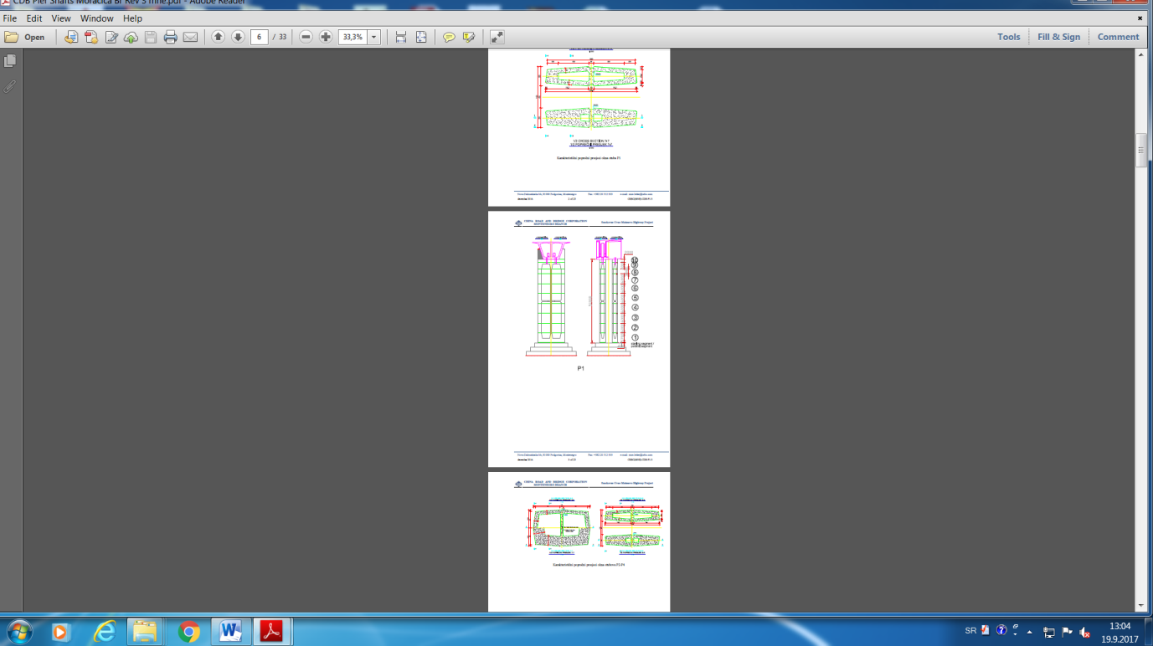 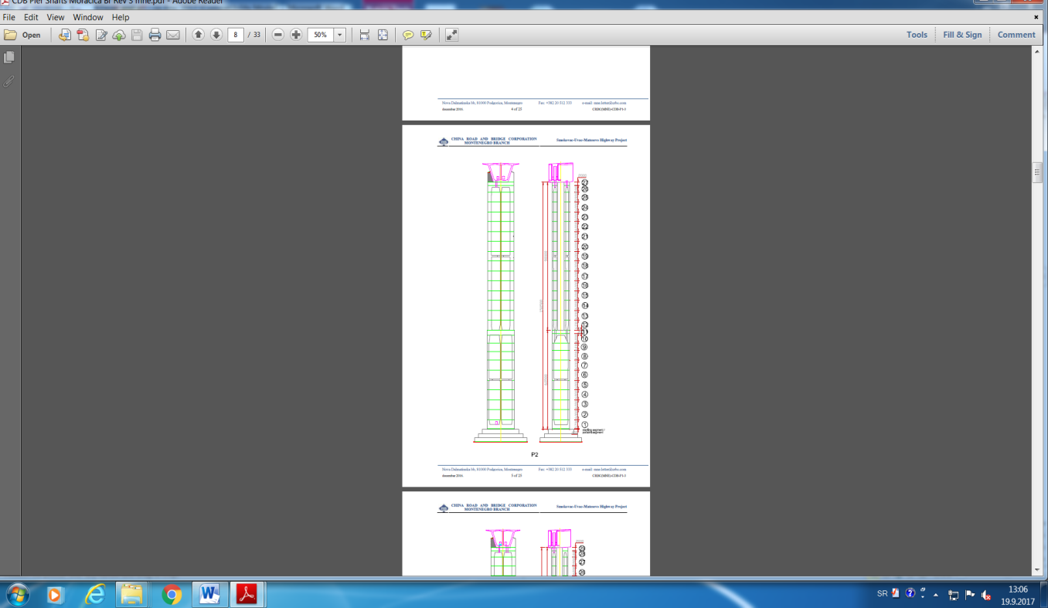 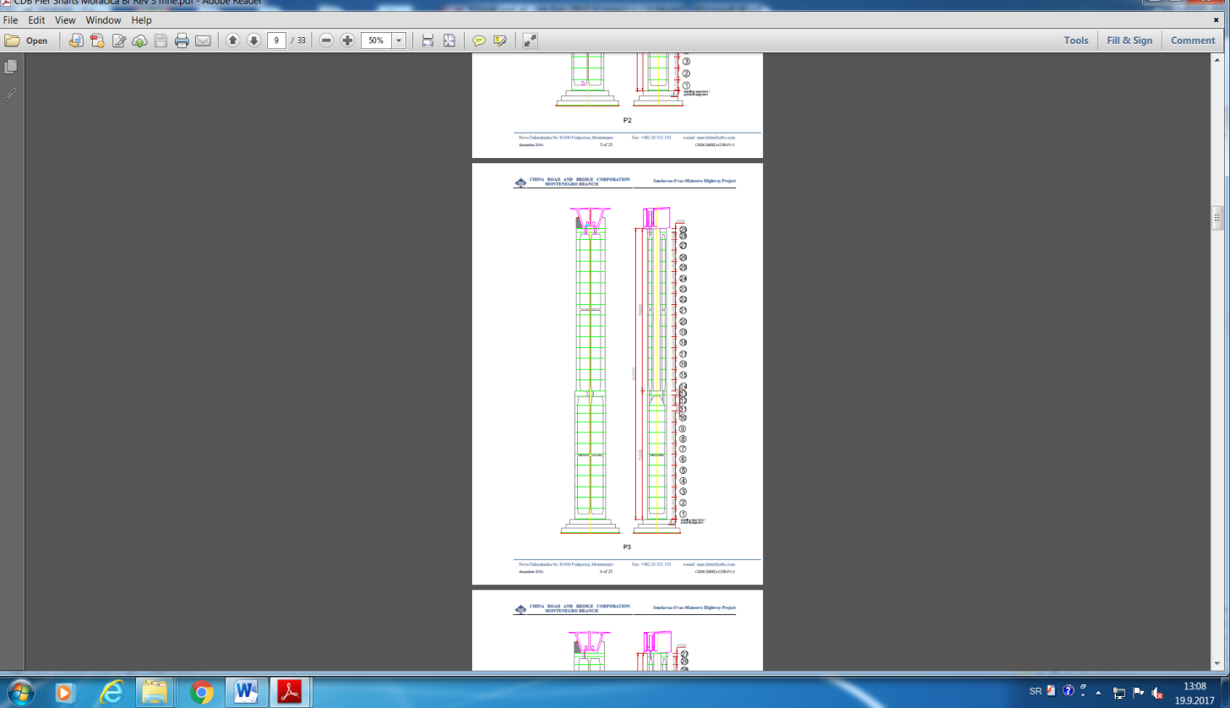 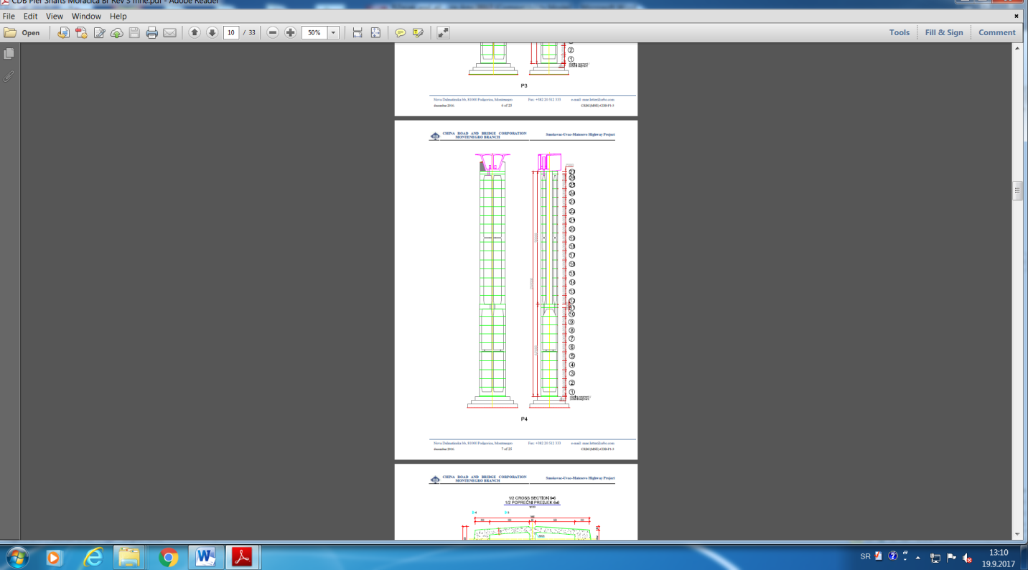 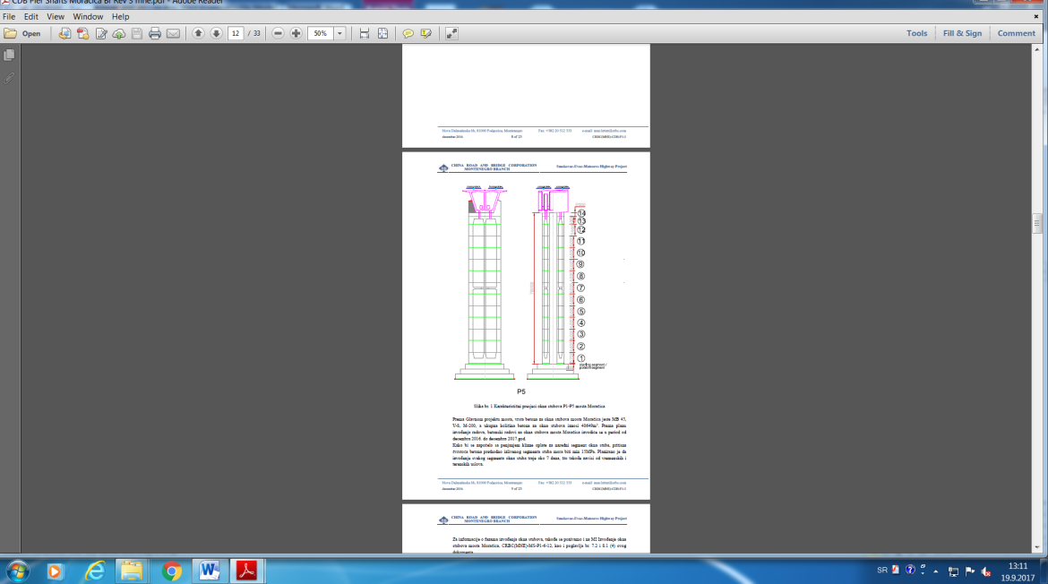

**P1** (150,5 m) **P2** (151,5 m) **P3** (161 m) **P4** (152 m) **P5** (78 m)

**Figure 3:**  Middle piers with footing of the bridge Moračica

Wing walls of the end abutments are 50 cm thick. Part of these walls are standing walls, part of them are hanging walls. It all depends on terrain gradient and possibility of forming of slope round heads. The walls are strengthened with beams because of the length. There are cantilevers on top edges of wing walls that carries the pedestrian walkways and installation channels inside it (with the same section as the one on the bridge). These cantilevers have statically favorable influence on wings because they stiffen the top edge. The length of crossing slab is 3.7 + 2.5 m and it is installed at the gradient of 10% in the relation to gradient of vertical alignment. Plain concrete is constructed under the slab.

There are protection walls on the bearing beam. They do not allow unauthorized person enter the area around bearings and expansion joints. Authorized person can access the area through the doors in protection walls and access stairs. Bottom surface is shaped in two-direction slope by the means of slope concrete due to possible water penetration into the inspection area within the abutments. It is side-shaped towards the apertures in face cover walls. The front top area of bearing beam is in gradient towards the parapet.

**1.4 Designed materials**

The used materials are given along. All the concretes belong to B II category. Main girder, aerated concrete C42/53 (MB 50), V–8, M–200, frost resistance and salt resistance “1”. Middle piers and bearing beams: aerated concrete C38/47 (MB 45), V–8, M–200. Abutments with wing walls: aerated concrete C25/32 (MB 30), V–6, M–150. Cornices with concrete safety fences: aerated concrete (C33/42) MB 40, V–8,M–200. Frost resistance and salt resistance “0”. Bearing concrete cubes, aerated concrete C42/53 (MB 50), V–8, M–200, frost resistance and salt resistance “0”. Foundations, C25/32 (MB 30), V–6, M–100, V–6, M–100. Transition slabs, C25/32 (MB 30), V–6,M–100. V–6, M–100. Slope concrete, C25/32 (MB 30), Underlayer concrete C17/21 (MB 20). Reinforcement B 500B for whole structure. a B 500B. According to EN 10138, cables belong to class Y1860. Nominal diameter is 15.2 mm and relaxation rate is low. The pipes of the cables are plastic. Prestressing system have to have ETA certificate (European Testing Approval). Steel elements on the bridge, such as pedestrian fence and safety fences, are all made of steel S235, and winds barriers of S355, also hot galvinizaded.

For all elements of the bridge structure preliminary tests of components, fresh and hardened concrete and other materials have been made. These documents represents a piece of the Concrete design [5] and are presented in the form of individual laboratory reports in attachment.

**2. CONSTRUCTION TECHNOLOGY**

Balanced cantilever construction determines the rational ratio between main and side spans ranging from 0.6 and 0.7, as it was stated in the widely used French guidelines for bridge designing „SETRA“ (bridges that apply balanced cantilever construction). This ratio is adopted in order to decrease the parts of structures next to the abutments that are constructed on the scaffold (as much as possible). In this particular case, this is extremely important because the slope gradients in the side spans are very steep, so the installation of scaffolds and their foundations is more difficult. In the final layout plan (variant) that was provided in this Design, the lengths of parts of bridge structure that are constructed on the scaffold are 18.5 m and 28.5 m.

Cantilever construction implies execution in the segments of piers, so that all scaffold with formwork anchor in pre–hardened (young concrete). At the same time the crane girder, the construction of the elevator for the transport of personnel and small equipment, pipes for transporting the pumped concrete as well as the necessary installations, continue and are anchored in the concrete of the constructed part of piers and this step by step.

The authors didn’t write in detail about the construction of scaffold and machine technology in this paper, noting that for synchronized replacement of the construction for concreting one segment of a height of about six meters take only about an hour and a half. Construction height, which includes all the platform above and below the segment which is concreted is about 18 meters. Specifically, the crane transport structure for casting concrete by troughs – "rice" and tubular extensions, so that the concrete would fall from a height less than one meter. This technology enables the time of 7 – 8 days so that the next segment would be concreted (cycle time).

Concreting the scheduled segment is always finished by without interruption, and thereafter, immediately after the start of the binding processing there’s an access of making so–called hinge, roughening. The steel structure of the L profiles – "skeleton", preceded by the reinforcement, and remains embedded in the structure although it is not calculated with its contribution to the calculation of the bearing capacity–of piers section. After supervising engineer reviews reinforcement, he allows rising of scaffold and setting the formwork which is also visually controlled and he approvs the next phase of concreting. It should be noted that for each section the geodetic survey is delivered before and after concreting. Sufficient high verticality of the piers is ensured in this way within the projected tolerance. The average amount of concrete for one section was slightly less than 400 m3, but mostly the effect was approximately 30 m3/h. On average, it was necessary approximately 13 hours per section, wherein the concreting was carried out mainly at night due to excessively high temperatures.

On the following diagrams (Figure 5) the dynamics of execution for middle piers with footing can be viewed, and by the end of Octobre 2017. the completition of all piers is expected (18 months). It should be noted that in addition to the results shown in the diagrams, also abutment A0 was finished where was spent about 1675 m3 and the abutment foundation A1 which was so far spent about 1130 m3. So far in the substructure of the bridge Moračica was over 60,000 m3 of concrete, which is approximately 3350m3/monthlys, or more than 100m3/day.

 

**Figure 4:** Graphic display of work executions on the substructure of the bridge Moračica (eight months)

At the site of the projected diaphragms in a complete cross–section of piers P2, P3 and P4, concreting is done subsequently, so that the concreted connection (coupler) was left for continuation of the horizontal and oblique reinforcement for the formation of haunches. Since this type of setting reinforcement is closer to real continuity in terms of the provisions of the Regulations for the continuation of the reinforcement, this methodology was accepted and reinforcement continuation of 100% in the close intersections.

At the site of the projected diaphragms in piers P1 and P5, as well as in the pillars P2 – P4, with double section section concreting of six meters was carried out with a break at the beginning or in the end of the haunches, so this problem with adjusting the reinforcement did not exist.

Applied dynamics of the work execution on the piers, give the ability of smooth roadway construction on multiple ranges. A special group of workers and engineers worked on each pier, and all of them had an independent equipment, and they’ve managed to finalize the work at the same time by planning the activities.

According to the Project, the monitoring, the entire process of construction was watched geodetic and the conduct of structure was overlooked with the progression. It can be already noted, on the basis of constructed substructure, that the structure was made very well in terms of geometry.

Stress – strain condition is also monitored in relation to the history of the construction and the possible effects on certain parts of the structure. This process will be of particular importance in the roadway construction ,whose final disposition depends on a number of influential parameters, so the experimental measurement of this condition is necessary in order to follow the direction of the cantilevers during the construction by heights and by basis and thereby meet the limit state usability in utilization.

**3. TECHNICAL REVIEW**

The Committee for comparative technical review has carried out regular checks during all phases of construction to be closed and which won’t be available later by visual control. At the same, the Committee continuously had access to all necessary documents, based on which partial reports of the technical review of certain phases could be written. After a while that Contractor needed to collect the other (missing) documentation (eg. attests for concrete and reinforcement, the general estimation of the concrete and the like.), The Committee has carried out partial technical reviews of the piers foundation, and reports will form part of the final report on technical review, which thus may be made significantly more efficient.

The next step is partial technical piers review and the preparation for partial reports is in progress. Superstructure (roadway structure) will represent the last stage for which the partial reports would be formed. After the load test, equipping, development of terrain and roadway structure, there’ll be the final report with the offer to the investor about the possibility of use.

During and after the construction a geodetic report will be formed, i.e. the structure review with the real position of the dimensions (a zero reading for the exploitation), by height and situational, and according to the surveying of soil and structure project, continuously geodetic observation during operation is necessary. Preparation of the design of buit structure represents the end point in the realization of such an important endeavor.

**4. CONCLUSION**

For the construction of large infrastructure and other important structures, it is necessary to carry out technical reviews during construction works in stages. This includes all the necessary procedures, as it is usual for the technical review of built structure with more quality, since the Committee has access to the hidden works. It seems that this approach can contribute significantly to the quality of construction, which can significantly reduce maintenance costs during exploitation. National authorities that establish regulations and standards, which must be in accordance with the latest European regulations – Eurocodes, should incorporate this approach in their national annex.

Technology of constructing large structures, often influences the choice of structural solutions, which must be adapted to the optimum and efficient construction conditions. Application of cantilever method in the construction of high bridges, can contribute significantly to cost–effectiveness, and systems which are the product of this approach present lean and aesthetically pleasing structures. The bridge Moračica which with its grandiosity exceeds the current limit within Montenegro and the region represents one example of such a. In support of this constatation is the fact that on this structure go over 10% of the total investment for the construction of a section of highway Podgorica – Mateševo, whose length is 41 km.

Applied construction technology with the scaffold exemplifies Moračica bridge, such that the large structures can be constructed more quickly and efficiently, as shown by the parameters presented in this paper, which are obtained from the dynamics of work execution. The presented data in this paper, may well serve to civil engineers while planning the construction of major infrastructure facilities, or facilities of particular national importance.

**REFERENCES**

1. ZEJAK M. R., *Contribution to the analyses of the biaxialy bended slender reinforced concrete element, doctoral thesi, University of Montenegr, Faculti of Civil Engineering, Podgorica 2003.* p. 118
2. VUJOVIĆ A. P., Deformational responce of inplan loaded plain and RC panels due to concrete ageing, *University of Montenegro, Faculti of Civil Engineering, Podgorica 2010 p. 66-72*.
3. Zejak M. R.,Quality Infrastructure in the Western Balkans and Turkey, Hands-on Training Eurocodes, Berlin, feb. 2013.
4. Main Design of Bridge Moračica – China Road and Bridge Corporation–Montenegro Branch, Tingjia Peng, dipl. inž. građ., Chief Designer, licenca: 01–73/2, april, 2016.
5. Dokument br: CRBC(MNE)-CDB-P1-3, Projekat betona za okna stubova mosta Moračica, dec. 2016. g.