PHYSICAL AND MECHANICAL PROPERTIES OF CONCRETE CURED AT LOW TEMPERATURES

Jelena Markićević¹, MSc; Marija Tošanović², Natalija Redžić³, Aleksandar Savić⁴, PhD
¹High Business Technical School, Trg Svetog Save 34, 31000 Užice, SERBIA,
jelenamarkicevic@yahoo.com
²Faculty of Civil Engineering, University of Belgrade, Bulevar kralja Aleksandra 73, 11000 Beograd, SERBIA, mtosanovic@gmail.com
³Faculty of Civil Engineering, University of Belgrade, Bulevar kralja Aleksandra 73, 11000 Beograd, SERBIA, natalijaredzic@gmail.com
⁴Faculty of Civil Engineering, University of Belgrade, Bulevar kralja Aleksandra 73, 11000 Beograd, SERBIA, sasha@imk.grf.bg.ac.rs,
Summary: The paper reports the results of experimental tests of physical and mechanical properties of concrete which hardened in cold weather conditions without curing, without protection against precipitation and also without protection from low temperatures. The samples were exposed to the climatic conditions at the location of Belgrade, from the moment of casting at low temperatures (January), and for the following 90 days. The influence of two chemical admixtures (a superplasticizer, and a setting accelerator) was also investigated in concrete, cured under these conditions. In the presented experimental research, particular attention was paid to the predominant properties of concrete: compressive strength ​​and water permeability.

Key words: concrete, low temperatures, chemical admixtures, compressive strength, water permeability

- INTRODUCTION

Concrete works mainly take place in the open, where the concrete becomes exposed to environmental influences immediately after the concrete works. The physical and mechanical properties of concrete, its quality and durability, are significantly affected by the environmental conditions in which the concrete hardens. The main influences are temperature and humidity, when concrete works take place on the construction site [1,2].
Even in our conditions, work dynamics often lead to the such scenario, where concrete works and concrete curing must take place in the winter months. On the other hand, there is a problem: for a large number of structural elements, any sort of additional care is not possible to be provided at the construction site [3,4]. In the case of winter concreting in our conditions, use of chemical admixtures is the most common, and usually the only measure applied [5].
The results of experimental research of the two types of concrete are presented and analyzed in this study. This research regards the physical and mechanical properties of these two types of concretes. They are designed for the purposes of execution of construction works in winter conditions, at low temperatures. Concrete mix without the admixtures - a mixture "A" and with chemical admixtures - a mixture "B" were formulated. A group of these samples was exposed to weather conditions outside, without any care, without protection against precipitation and no protection from low temperatures (series "A1" and series "B1"). The samples were, from the day of concrete mixing (January) and for the further 90 days, subjected to climatic conditions at the site of Belgrade. Parallel testing was done on the second group of the samples. The second group of the samples were cured in the laboratory, specifically in the conditions where the optimum temperature was 22±2°C. (series "A2" and series "B2"). The same amounts of aggregate, cement and water, and also a constant water/cement ratio were retained in all of the series.
The physical and mechanical properties of the two types of concrete were influenced by the conditions under which curing of samples took place. The analysis and comparison of these results was the goal of this research. The complete experimental research was conducted in the Laboratory for Materials, Institute of Materials and Structures, Faculty of Civil Engineering, University of Belgrade.

- COMPONENT MATERIALS

For the production of concretes, a commonly used cement designated as 42.5R PC 20S was adopted, produced by "Titan" Kosjerić. The mentioned cement is classified as composite Portland-cement with 80-88% of clinker, and 12-20% of mixed limestone and slag mineral addition (SEM II/AS). Table 1 presents data on cement, taken from the technical data sheet of the producer.
For mixing of these concretes, a natural aggregate "Dunavac" was used. The same type and quantity of aggregate was used for each of the mixtures. Three factions (I:0/4mm, II:4/8mm and III:8/16mm) with the participations of 38.4%, 27.9% and 33.7%, respectively, were used. Grading curves for all fractions of aggregate were obtained in the laboratory, in accordance with standards SRPS B.B2.010:1986, EN 933-1 and EN 933-2 [6, 7, 8]. The mixture of aggregate was determined based on the reference curves of Fuller and EMPA. For the preparation of the concrete mixes, tap water was used.
Table 1- Basic properties of the used cement
Titan PC 20S 42.5R
Specific density (kg/m³) | 2960
Density in loose state (kg/m³) | 960
Density in compacted state (kg/m³) | 1100
Fineness expressed by the residue on sieve 0.09 mm (%) | 0
Specific surface (Blaine) (cm²/g) | 4470
Water for standard consistency (%) | 29.8
Setting time start (min) | 220±20
Early age strength (2 days) (MPa) | 25,0±1,0
Standard strength (28 days) (MPa) | 55,0±2,0

In this case, due to the fact that concrete works at low temperatures were the subject of research, chemical admixtures from the group of the superplasticizers and the setting accelerator were used. Chemical admixture Adium 132 made by Isomat (Šimanovci) was used as superplasticizer. This is a new generation superplasticizer, based on polycarboxylate, specially developed for the production of ready-mix concrete, where properties such as: high workability, excellent long term maintenance of consistency (slump), high strength and durability are demanded. Setting accelerator Adinol-Rapid was the second chemical admixture used, produced by the same producer (Isomat). This chemical admixture was used in liquid state, and it reduces the setting time of concrete and provides beter results in the case when concrete works are conducted at low temperatures.

- CONCRETE MIX COMPOSITIONS

In order to perform successful tests, and to record differences in the behavior of concretes exposed to different weather conditions, two different concrete mixtures were composed: the reference mixture "A" and mixture "B", made with two chemical admixtures: superplasticizer and setting accelerator. Mix compositions for concrete "A" (reference) and mixture "B" (with the chemical admixtures) are given in the following table.

Table 2.- Mix compositions of the concrete series
Component materials (kg/m³) | Concrete „A“  (series A1 and A2) | Concrete „B“  (series B1 and B2)
Cement Titan PC 20S 42.5R | 400 | 400
Agregate (total) | 1947 | 1947
Fraction I 0/4 mm | 748 | 748
Fraction II 4/8 mm | 543 | 543
Fraction III 8/16 mm | 656 | 656
Adium | 0 | 2
Adinol-Rapid | 0 | 4
Water/cement ratio ω_{c} | 0.4 | 0.4
Water | 160 | 160

- PRODUCTION, PLACING AND CURING OF CONCRETE SAMPLES

Mixing of concrete was conducted with the aid of 50 lit capacity batch mixing pan, with vertical axis and two sets of blades [9, 10]. All of the mixtures were poured into molds and than compacted, using powerful vibrating table. Before the operation of placing, the molds were cleaned and covered with de-molding agent, to prevent adhesion between the mold and the setting concrete.
Samples of the series A1 and B1 were subjected to the influence of external conditions during the setting and hardening processes. Immediately after the compaction, samples (still in molds) were taken outside the laboratory, where relative air humidity of at least 86% at low temperatures (below 0°C) was recorded. Also, samples were not kept protected from the precipitation (snow, sleet, freezing rain etc.). After 24 hours from the time of placing of concrete mixtures in the molds, careful removal of the samples from the mold was done, followed by labeling of the samples, weighing the samples in the laboratory, and returning the samples outside. Samples were kept in that conditions, until the testing.
The diagrams (Figures 1, 2 and 3) show the ambient temperature changes to which these samples were subjected, through a period of 90 days, from January, until April, when the testing of the samples was done.

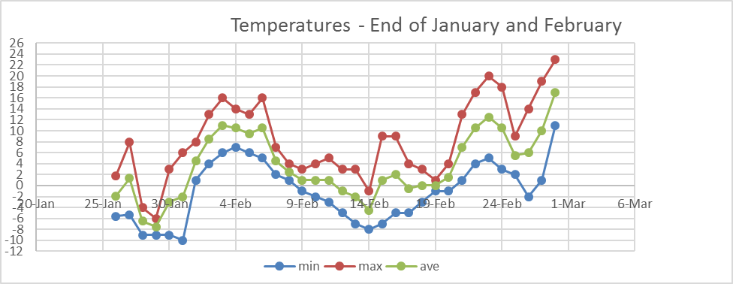
Figure 1 : Display of the minimum, maximum as well as average values of temperatures from the day of mixing of concrete until the end of February

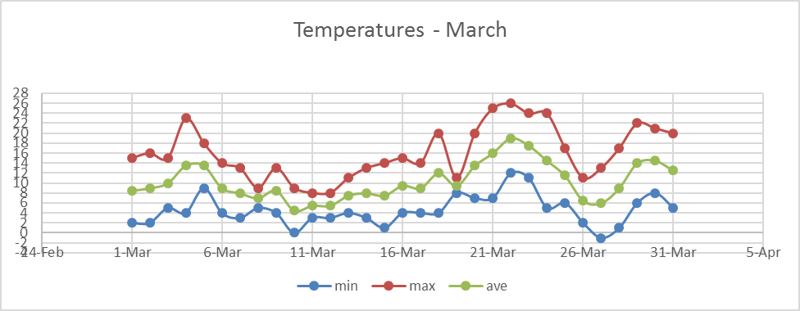
Figure 2: Display of the minimum, maximum as well as average values of temperatures during the month of March

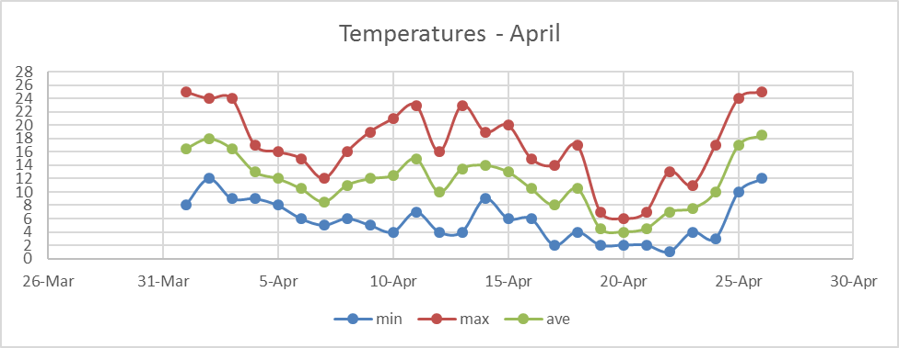
Figure 3: Display of the minimum, maximum as well as average values of temperatures during the month of April

The samples of the series A2 and B2 were cured in laboratory conditions. Immediately after the compaction with the aid of vibrating table, the concrete samples were stored (still inside the molds) in a place protected from vibration and shock, where relative air humidity of at least 95% and temperature of 20±2°C were recorded. The surface of the samples in the molds was covered with wet cloth and thus protected from rapid drying. After 24 hours from the placing time, careful removal of the samples from the mold was done, followed by labeling the samples, weighing and placing them in the pool. Samples were kept in the water, until the day of testing.

- RESULTS OF EXPERIMENTAL RESEARcH

  - Fresh concrete properties

Density of fresh concrete mixtures was determined immediately after the mixing of concrete series. The density of the fresh concrete mixture A was 2384 kg/m³, and for a mixture B it was 2333 kg/m³. One can notice the difference in densities between the reference A concrete, and concrete with chemical admixtures, concrete B. Mixtures were both stiff, and thus the different compaction levels led to different density values. The consistency of fresh concretes was determined by the Abrams cone method (slump method) [11], but since stiff mixtures were made, time of the Vebe method [12] was also recorded. The test results are given in Table 3.

Table 3: Consistency tests for concretes A and B
 | A |  | B
 | Abrams cone Δh (cm) | Vebe time  t (s) | Abrams cone (cm) | Vebe time  t (s)
Consistency values Δh [cm] / t[s] | 0 | 42.2 | 0 | 27.24
Description of the consistency | stiff | stiff | stiff | stiff

The temperature of the fresh concrete was measured in accordance with standard SRPS U.M1.032:1981 [13]. The test results are given in Table 4.

Table 4: Temperature of the fresh concrete
Series | A1 | A2 | B1 | B2
T (◦C) | 20.7 | 20.4 | 21.6 | 20.6

  - Hardened concrete properties

Testing of compressive strength f_{c} was carried out by gradually increasing load applied on concrete sample (15 cm cube), in a hydraulic press Amsler with capacity of 2500 kN. Rate of loading was 0.6±0.4 MPa/s, the test was carried out in accordance with standard SRPS ISO 4012:2000 [14].

Table 5: Compressive stregth of concrete cubes after 1, 7, and 28 days
Compressive strength (MPa) | Series
 | A1 | A2 | B1 | B2
f_{c,1} | 6.2 | 24.9 | 9.9 | 25.1
f_{c,7} | 27.0 | 43.9 | 34.3 | 45.2
f_{c,28} | 48.4 | 62.8 | 51.9 | 61.4

Results shown were obtained as average values ​​of at least two tests. On the basis of comparison of the characteristic compressive strength of concrete cubes, it can be concluded that concrete A1, B1 and B2 satisfy the strength class C50/60, while concrete A2 satisfies the strength class C55/67. Figure 4 shows the diagram of compressive strength increase over time up to 90 days.

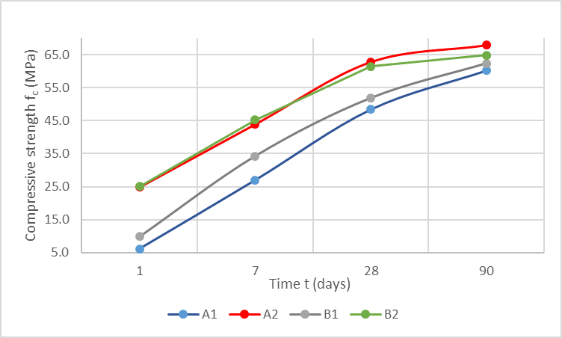
Figure 4: Compressive strength vs. time up to 90 days

Testing of the splitting tensile strength f_{st} was carried out at the age of 28 days according to SRPS EN 12390-6:2012 [15], on at least two cylinder shaped (diametar 15 cm and height 15 cm) samples, and the results obtained are given in Table 7. The flexural strength f_{fl} tests were conducted by three point test, on 12×12×36 cm samples, according to the standard SRPS ISO 4013:2000 [16]. Table 6 contains the results of the mentioned test.

Table 6: Splitting and flexural tensile strength (MPa)
Series | f_{st,28} | f_{fl,90}
A1 | 3.4 | 12.6
A2 | 3.5 | 6.9
B1 | 3.1 | 10.7
B2 | 4.4 | 8.8

The flexural strength f_{fl} tests were conducted by three point test, on 12×12×36 cm samples, according to the standard ISO 4013:2000. Table 8 contains the results of the mentioned test.

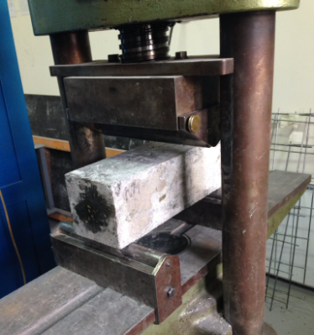
Figure 5: Testing of the flexural strength

Water permeability of the studied concrete series was tested on 15 cm cubes. A total of eight samples was tested (two cubes for each series) in the direction of placing concrete into the mold, with drinking water under pressure. The test results were obtained on the basis of the procedure prescribed by the standard SRPS U.M1.015:1998 [17]. Age of concrete in the time of testing was 28 days. At the same time, an average depth of water penetration was registered on each sample, see Table 7.

Table 7: Water penetration depth
Series | A1 | A2 | B1 | B2
 | mm | mm | mm | mm
h_{max} | 52.5 | 0.0 | 27.0 | 1.8

Based on the results, concretes A2 and B2 could be classified as waterproof, while the concrete A1 and B1, which were exposed to the weather conditions, had high water penetration values, and therefore they could not be classified as waterproof.

- CONCLUSIONS

Based on the tests presented and discussed in this paper, the following conclusions can be reached:
- A stiff consistency was achieved for all of the mixed series, which was the target. Naturally, proper and quality placing of concrete has to be applied on site, because it highly influences the physical and mechanical properties of the concrete;
- Concrete series designated with "B" were easier to place than the series "A", due to the presence of superplasticizer;
- Laboratory samples (they were cured) i.e. series A2 and B2 achieved higher strength increments through time in the first 28 days. It must be noted that all the tested concretes achieved approximately the same strengths at the age of 90 days;
- When the samples exposed to the weather conditions were compared, higher early strengths were recorded on concrete B1 (concrete with chemical admixtures), it reached 60% of the prescribed concrete strength (MB30) after 7 days, while A1 concrete reached the same target strength after 14 days;
- Based on the water penetration test, concrete series A2 and B2 were found to be waterproof, while the concrete A1 and B1, which were exposed to the weather conditions, had very high water penetration depth, and therefore they were not waterproof. Consequently, a conclusion can be reached that concrete series A1 and B1 didn’t have sufficient durability in terms of water and aggressive agents penetration.

The conclusion is that, in the winter months, concrete series "B" can be applied, which is designed with appropriate chemical admixtures, while the mixture "A", regardless of the achieved similar compressive strength, would not be favorable in terms of durability, as evidenced by a large water penetration. The general conclusion is that, although the chemical admixtures can’t guarantee achievement of the prescribed properties, their beneficial effect is evident, not only in terms of the mechanical properties, but also when it comes to durability.

REFERENCES

- MURAVLJOV, M.: Građevinski materijali 1, Udžbenik, Građevinski fakultet Univerziteta u Beogradu, Beograd 1999,
- MURAVLJOV, M.; JEVTIĆ, D.: Građevinski materijali 2, Udžbenik, Građevinski fakultet Univerziteta u Beogradu, Beograd 2003.g.
- MURAVLJOV, M.: Osnovi teorije i tehnologije betona, IRO Građevinska knjiga, Beograd 1999.g.
- Zakić, D., Savić, A., Radević, A., Aškrabić, M. (2016) Praktikum za vežbe i repetitorijum iz Građevinskih materijala 2.Univerzitet u Beogradu, Građevinski fakultet, Akademska misao.
- ARIZANOVIĆ, D. ; PETRONIJEVIČ, M.; BELJAKOVIĆ, D.: Tehnologija građevinskih radova - grubi građevinski radovi, Građevinski fakultet u Beogradu, Beograd 2015.
- SRPS B.B2.010:1986 Aggregate for concrete - Technical requirements
- SRPS EN 933-1:2013 Tests for geometrical properties of aggregates - Part 1: Determination of particle size distribution - Sieving method
- SRPS EN 933-2:2009 Tests for geometrical properties of aggregates - Part 2: Determination of particle size distribution - Test sieves, nominal size of apertures
- SAVIĆ, A.: Istraživanje svojstava svežeg i očvrslog samozbijajućeg betona sa mineralnim dodacima na bazi industrijskih nusprodukata, doktorska disertacija, 2015.
- JEVTIĆ, D.; ZAKIĆ, D.; SAVIĆ, A.; ŠERIFI, V.: Study of Fly Ash in Making Cementitious
Composites. Applied Mechanics and Materials., pp.127-134., 2015.
- SRPS EN 12350-2:2010 Testing fresh concrete - Part 2: Slump-test
- SRPS EN 12350-3:2010 Testing fresh concrete - Part 3: Vebe test
- SRPS U.M1.032:1981 Concrete - Measuring temperature of concrete
- SRPS ISO 4012:2000 Concrete - Determination of compressive strength of test specimens
- SRPS EN 12390-6:2012 Testing hardened concrete - Part 6: Tensile splitting strength of test specimens
- SRPS ISO 4013:2000 Concrete - Determination of flexural strength of test specimens
- SRPS U.M1.015:1998 Concrete - Hardened concrete - Determination of the depth of penetration of water under pressure

