**AN ALGEBRAIC MODEL FOR THE SUSTAINABLE DEVELOPMENT ASSESSMENT**

**Dr. Miodrag Popov1; Dr. Dušan Popov2**

1 Politehnica University Timisoara, Department of Architecture and Urban Planning, Timisoara, ROMANIA,

e-mail: [miodrag.popov@upt.ro](mailto:miodrag.popov@upt.ro)

2 Politehnica University Timisoara, Department of Phzsical Foundations of Engineering, Timisoara, ROMANIA.

e’mail: [dusan_popov@yahoo.co.uk](mailto:dusan_popov@yahoo.co.uk)

***Abstract:***In the paper we have proposed a new algebraic assessment method for the sustainable development potential, based on a nonlinear variation of the characteristic sustainability parameters. We have chosen an exponential (Gaussian) variation of parameters, since most of the natural phenomena are characterized by properties whose distribution is Gaussian (normal distribution). The selected characteristic parameters are normalized to the unit, so their range lies between 0 and 1, correspondint to the two practical cases: “higher is better” or “lower is better”. The result obtained (the "global sustainability score") was quantified in sustainability classes, which makes it possible to compare different situations or sustainable development projects. The method proposed by us is more "demanding" and allows a more accurate assessment compared to the method in which the parameters have a linear variation.

***Keywords:*** *sustanaibility, building, environmental parameters, quantification, Gauss distribution, architecture*

**1. INTRODUCTION**

As it is well known, the concept of sustanaible development is defined in several equivalent modes, its essence being such of a development of some geographical and economical regions that meets the needs of present without compromising the ability of future generations to meet their own needs. They two key concepts are: the concept of essentialneeds, particularly the needs of the world's poor, and the idea oflimitationsimposed by the state of technology and social organization on the environment's ability to meet present and future needs [1], [2].

It is clear that the concept of sustainable development should be seen as an interactive cause-effect process, between the economic development policy and the policy of preserving and improving the environment. Sustainable development must be designed and implemented in such a way as to achieve the following syntagms: ecological balance, economic security and social equity.

Particularly, e.g. with the aim to achieve a sustainable architectural and building project, various dimensions of sustainability must be taken into account, which in all situations are in interaction with each other. This interaction is even more difficult to evaluate because we deal with several phenomena with previously (often arbitrarily) established, but different, importance or weight.

On the one hand, most natural phenomena have a statistical behavior which may be characterized by different parameters and indicators. These indicators and parameters can be of two types: *quantitative* (linked to a certain physical characteristic, i.e. having a unit of measure or expressed in %) and *qualitative* (based on a subjective assessment of a property or characteristic of examined system, so not havinga unit of measure).

On the other hand, even at the macroscopic scale, the different properties of real systems can be “quantized”, i.e. their range of values can be divided into smaller intervals which can be generically named "quanta". Quantification will apply to both types of parameters (quantitative and qualitative). The quantification method is very useful and probably unique for comparing different situations or natural phenomena. This is the explanation why this method is increasingly taken into account also in the sustainable development issues.

Even if the geographic regions that are the subject of research related to sustainable development are different, each with its developmental traditions, they can highlight some common features. These concern the four dimensions of sustainability: environmental, social, cultural and economic, each of these being assigned by a certain index (a subunit number), generically called indicator, which reveals the relative importance of this dimension. However, each of these dimensions has certain sub-characteristics to which they correspond, by the same principle, are quantified by other subunit numbers called parameters. By concluding, a sustainable development project will operate, in a quantitative way, with two types of numbers: indicators and parameters, which are based on qualitative analyzes of the influences that environmental, social, cultural and economic characteristics can have on sustainable development.

There are several methods by which these indicators and parameters can be combined to achieve the "final mark", i.e. a „global sustainability score“, specific to each target region. Although no method of assessment is universally accepted, it seems that in the literature, the most popular is the method in which the parameters have a linear variation between a minimum value and a maximum value [3], [4], [5]. But, other evaluation methods are possible, in which the parameters have a non-linear variation. It is also possible to imagine combined methods, with both linear and nonlinear variations of parameters.

So, implicitly, e.g. the architectural and building sustainability can be assessed by taking into account specific indicators and parameters and eventually the interactions between them. In order to avoid the use of complicated calculations, only those indicators or parameters that are relevant for a sustainable development will be chosen. Generally, an indicator may contain some parameters with different weight of participation or importance. In this sense the parameters play the role of sub-indicators.

**2. AN ALGEBRAIC MODEL**

In the last decades the measurment of the concept of sustainability of ceratin natural systems or area, i.e. the evaluation of their quality or performance becomes an useful task. From a pragmatic point of view, many researchers and specilists in this domain believe that the most effective way is the use of a set of suitable and conveniently chosen indicators and sub-indicators (parameters). Generally, the indicators of sustainability development are developing at international, national and regional level. It seems, however, that the most significant impact is represented by regional or zonal indicators that take into account the specificities of the geographic area where they will be implemented. At the same time, a number of specific methods for implementing these indicators and parameters have been developed. An interesting review of such methods was made in [6]. In essence these methods are applications of different versions of mathematical average and error calculation methods.

In order to obtain an effective analysis and outcomes, the indicators chosen must meet certain requirements. These requirements were established by the United Nations Commission on Sustainable Development (UNCSD) in 1995 and then adapted as they were validated in practical use [7]:

1. primarily national in scope;
2. relevant to assessing sustainable development progress;
3. limited in number, but remaining open-ended and adaptable to future needs;
4. broad in coverage of Agenda 21 and all aspects of sustainable development;
5. understandable, clear and unambiguous;
6. conceptually sound;
7. representative of an international consensus to the extent possible;
8. within the capabilities of national governments to develop; and
9. dependent on cost effective data of known quality.

The particular parameters or indicators must be identified, analyzed their impact and, consequently, valued. Some comparative contextual and methodological tools of the sustainability assessements are made in [3]. Generally, the method should be lead to accomplish the eco- and cost-efficiency, as well as the social impact and to be easily addaptable to different building types and technologies. Lastly, the parameters and indicators to should ensure simultaneous the environmental, societal and economic performances.

Moreover, the assessement of the weight of each indicator or parameter in the global sustainability is still not consensual. The weights differ to one objective or project to another and it depends, among other, on the and local priorities. Therefore, even if the recommendations of international specialists are used (see, [8]), the solution must take into account the local conditions and goals.

Let us suppose that we deal with a natural system which must be evaluated from the point of view of the sustainability development and then compared in terms of sustainable development performances with other similar systems. We assume that the system in question is characterized by  indicators, and each indicator is evaluated according to  parameters or sub-indicators.

**Table 1:** Indicator’s and parameter’s indices and weights

|  |  |  |
| --- | --- | --- |
| Sustainable system  to be assessed | Indicator and  indicator’s weight | Parameter and  parameter’s weight |
| Natural system |  |  |
|  |  |
|  |  |
|  |  |
|  |  |

Suppose that we have choosed a set of relevant parameters, generically denoted by , which can be regarded as the continuous variables. Any of these variables is extended between a minimal , respectively a maximal values  corresponding to the most unfavorable, respectively favorable situations. This depends of their significance: the “higher is better” or “more is better” for parameters whose maximal value  is favorable (i.e. the ideal situation), respectively the “lower is better” or “less is better” for parameters whose minimal value  is favorable (i.e. the anti-ideal situation). But, in practical situations,  . In the next, for the shortening reasons we will denote the sequence  and similar.

Because the indicators and parameters of sustainability have different significance and, as a consequence, different measured units, it is necessary to perform a suitable normalization and to obtain the *dimensionless* parameters (i.e. simple numbers). The normalization of a certain parameter can be realized in different ways, but the same natural way is the following [4]:

, for the case “higher is better” (1)

, for the case “lower is better” (2)

As the consequence of normalization process, the parameters become simple numbers . From a mathematical point of view this normalization, regarded as a function , with  is is fact an ascendent linear function between the points  and  (for the case “higher is better”), and a descendent line between the points  and  (for the case “lower is better”). Consequently, the normalized parameters  and  represent the relative distance of the value  to , respectively to  .

In order to expose the proposed methodology and reveal the concrete calculations, we refer for the moment only on one dimensionless parameter, denoted by, uniquely for both cases (“higher is better” and “lower is better”) Then the generalization is straightforward.

In our algebraic model, instead of the linear dependence between dimensionless variable  and real physical variable  (see, Eqs. (1) and (2)) we adopt an *exponential dependence* of the following manner:

 (3)

Here  is the base of natural logarithm.

The above expression is in fact the probability density of the *normal* (or *Gaussian*) distribution.

The motivation of such a choice is the next:

* The Gaussian distribution is a very common representable distribution, applicable to a lot of physical (generally, natural) phenomena characterized by random variables whose distributions are not known.
* Generally, the probability realization of extreme values, respectively to  is small and the distribution of experimentally measured results regarded different parameters converge in distribution to normal.
* The linear probability distribution is only the first approximation of all real distributions.

The normalization of the Gaussian probability density is given by following integral [9] (Eq. 3.321.2, page 336):

 (4)

where the error function  can be evaluated through a Maclaurin series [10]:

 (5)

With a good approximation we can retain only the first term from the series. Consequently, we have

 . (6)

In order to illustrate the behavior of dependence  we present comparatively the graphs for the linear, as well as for the exponential dependence. As example we choose , and  .

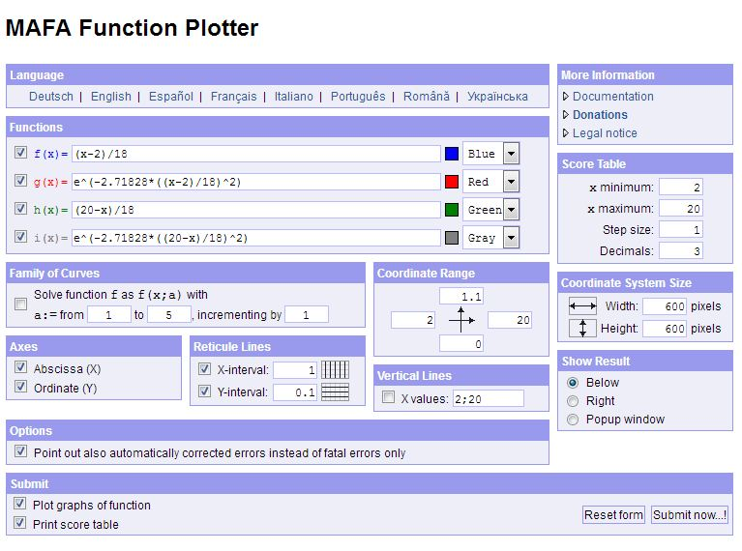

**Figure 1:** Graphical plotter dates

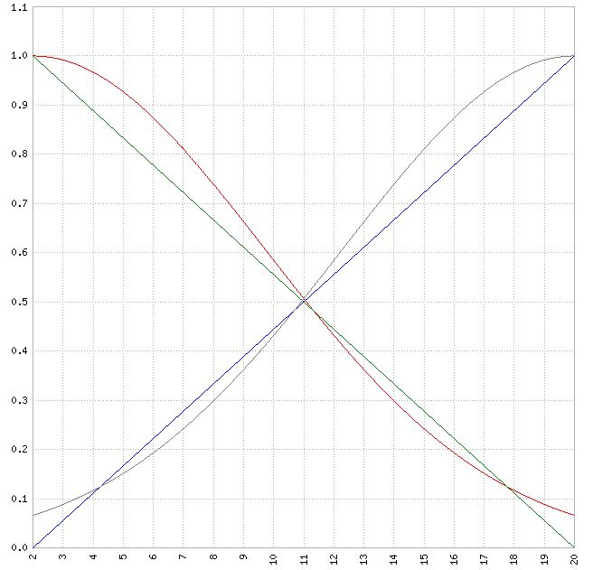 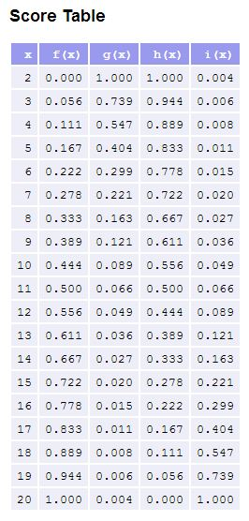

**Figure 2:** Graph of linear / expenential dependence **Figure 3:** Numerical values

The corresponding equations are:

* For linear dependence

, for the case “higher is better” (blue line) (7)

, for the case “lower is better” (green line) (8)

* For exponential dependence

, for “higher is better” (gray curve) (9)

, for “lower is better” (red curve) (10)

The sustainability assessment is resumed by calculating the global sustainable score . Their mathematical significance is a double weighted average: on the system’s indicators and on the parameters inside indicators. It goes without saying that the individual indicators may be of type “higher is better”  or “lover is better” .

The global sustainable score has the range between value 0 (an anti-ideal value, the most disadvantageous situation) and value 1 (the ideal value, the most advantageous situation). In practice, these two values are extremely unlikely, meaning that value 0 is eliminated from the start as undesirable, whereas value 1 is ideal, and therefore practically unrealistic. The global sustainable score can be represented as follows:

 (11)

where the notations have the following significance: - the global sustainable score characterizing the whole evaluated system;  - the weight of the  indicator characterizing the whole evaluated system;  - the sustainable score corresponding to  indicator of the evaluated system;  - the weight of the  parameter inside the  indicator of the evaluated system; - the probability density of the parameter  of the  parameter inside the  indicator, which can be of kind “higher is better”  or “lower is better” .

Evidently that the both types of weights must be normalized to unity, i.e. their sum must be equal to 1. This can be proved by integrating over all variables (parameters) , the integral being equal to 1:

 (12)

Here we taken into account that all integrals are equal to 1, as we showed in Eq. (6). Evidently, the sum of chosed weights, regarding individual parameters, as well as individual indicators, must be equal to 1.

**3. AN EXAMPLE**

In order to illustrate the utility of our proposed method suppose that we have obtained / measured a set of experimental values of normalized parameters  indicated in Table 2. As ellas, we used the parameter’s weights were indicated as in [11].

**Table 2:** Indicator’s and parameter’s indices and weights

|  |  |  |  |  |  |  |
| --- | --- | --- | --- | --- | --- | --- |
| Indicator | Indicator's  Weight | Measured parameters | Parameter's  weight |  |  |  |
| - environ  mental |  |  |  | 0.8437 | 0.2220 | 0.1021 |
|  |  | 0.4007 |
|  |  | 0.1403 |
|  |  | 0.5766 |
| - social |  |  |  | 0.1403 | 0.0307 | 0.0073 |
|  |  | 0.1106 |
| - econo  mic |  |  |  | 0.6473 | 0.1597 | 0.0479 |
|  |  | 0.2167 |

where, for shorteness, in the table we have used the following notations: , , and .

We point out that the cultural indicator is not included in this table.

The significance of above indicators and parameters is: - *environmental*; - *social* and - *economic*; - *pollution*, which include: low greenhouse gas emmision for the depletion of the stratospheric ozon layer and global warming; - *watter efficiency*, which include: potable water use; rain water use; water treatment; - *land use*, which include: ecological value and ecological enhancement of the site; protection of existing ecological characteristics; changing the ecological characteristics by introducing new species; ecological footprint of the building;- *materials resource depletion*, which include: impact of the materials used on the environment; the degree of used structural materials; optimal use of exterior and interior elements (doors, windows, roof); recycling of resulting waste;- *health*, which include: hydrothermal comfort (relative humidity, winter and summer thermal performance); visual comfort (use of dayligh, efficient artificial illumination); accoustic comfort (accoustic insulation, reverberation time); indoor air quality (air suspension of solid particles, carbon monoxide and dioxide concentration);- *management*, which include: compliance with the environmental performance guide; efficient building process; impact of the building on the environment; building security;- *energy*, which include: energy performance of the building; energy production; energy balance; CO2 emission;- *transport*, which include: location of the building in relation to the means of public transport; existence of supply points and services in the area (food, medical center, post office, playgrounds); pedestrian and mechanized access to the building.

**5.** **IMPLEMENTATION ALGORITHM**

There is no recommendation or limitation on the number of parameters considered. For each situation, an optimal number of relevant parameters must be found, because increasing the number of parameters does not automatically guarantee the improvement of the result.

The choice of parameters must satisfy several principles (systematization, consistency, independence, measurability and comparability) [8].

In order to apply the above proposed method to the concrete situations, it is necessary to perform the following operations:

1. to choose a set of relevant parameters (quantitative and qualitative)  which characterizes as faithfully as possible the the natural (sustainable) system we examined.
2. to establish the range of values  for these parameters.
3. to calculate the set of normalized values  using the rule “higher is better” or “lower is better”.
4. to measure or establish a set of experimental values  which correspond to real parameters characterized the sustainable system which needs to be assessed.
5. to calculate, according to Eq. (11), the probability density for individual parameters , the sustainable score corresponding to  indicator of the evaluated system as well as the global sustainable score characterizing the whole evaluated system.
6. As result of obtained numerical value for the , to include the examined situation corresponding to “experimental set of values”  into a “class of sustainable quality” or qualitative graded scale [8]:

**Table 2:** Conversion of the quantitative normalized parameters into a qualitative graded scale

|  |  |
| --- | --- |
| Values of sustainable global score | Qualitative graded scale |
|  | A |
|  | B |
|  | C |
|  | D |
|  | E |
|  | F |

In the example of the Table 2 we have , so the examined sustainable system belongs to *E* grade or class of quality.

We must point out that if we calculate the global sustainable score  according to the methodology used in [4] and [5], i.e. accepting a linear variation of the parameters according to the formula

 (13)

then we obtain the result . This result is more “optimistic” than ours, based on a Gaussian variation of parameters, but the final conclusion is the same, i.e. the system will still belong to the same quality degree, namely E.

**4. CONCLUDING REMARKS**

In the paper we have presented a new algebraic model for calculating the global sustainability score , which is calculated when starting a study for the implementation of sustainable development projects. As it is known, for the calculation of this global indicator (the global sustainability score ) we usually call for a weighted average of some sustainability parameters , characteristically for the project in consideration, as well as some weights established locally or by specialized international commisions.

However, instead of a weighted mediation of some parameters with *linear* variation, our method proposes a *non-linear* variation of parameters. As a function of nonlinearity for calculating the average of the normalized, i.e. non-dimensional parameters we have chosen the Gaussian probability density . The reason is because the Gaussian distribution (normal distribution) is the most widespread and natural probability distribution.

Since we are interested in normalized non-dimensional parameters, defined only on the [0, 1] range, of course we have limited to considering only one half of the Gaussian probability density graph: the left half for the parameters of type "higher is better", respectively the right half for parameters of type "lower is better".

Based on an example presented in the paper, we have shown that the global sustainability score we get is slightly lower than that obtained by weighing the linearly varying parameters. This means that the Gaussian method we propose is more demanding, which would lead to more secure practical results, according to real and not idealized expectations.

If the number of parameters increases, the method can be implemented through a calculation program.

In our opinion, the proposed method can be useful, in addition to justifying the "profitability" of a sustainable development project, as well as in the possibility to compare the potential for sustainability of the different (similar) regions in which these projects would start [12].

**REFERENCES**

[1] SOUBBOTINA, T. P.: [*Beyond Economic Growth: An Introduction to Sustainable Development, Second Edition*](http://www.worldbank.org/depweb/english/beyond/beyondco/beg_all.pdf), WBI Learning Resources Series, World Bank Institute, 2004, Available at:

<http://www.worldbank.org/depweb/english/beyond/beyondco/beg_00.pdf>

[2] HUI, S. C. M.: *Sustainable Architecture and Building Design (SABD)*, Available at:

<http://www.arch.hku.hk/research/BEER/sustain.htm>

[3] FORSBERG, A., von MALMBORG, F.: *Tools for environmental assessement of the built environment*, Building and Environment **39**, 223-228 (2004).

[4] DIAZ-BALTEIRO, L., ROMERO, C.: *In search of a natural systems sustainability index*, Ecological Economics **49**, 401-405 (2004).

[5] BRAGANÇA, L., MATEUS, R., KOUKKARI, H.: *Building Sustainability Assessment*, Sustainability **2**, 2010-2013 (2010).

[6] VUCICEVIC, B. S.: *Analysis and evaluation of suitable development of the energy systems in buildings*, University of Nis, Mechanical faculty, Doctoral dissertation, 2014 (in Serbian).

[7] UNITED NATIONS, *Indicators of Sustainable Development: Guidelines and Methodologies*, Second Edition, UN Sales Publication No.E.01.II.A.6 (New York, September 2001).

[8] MATEUS, R.: *Sustenability assessement and rating of Portuguese buildings*, Available at: <https://repositorium.sdum.uminho.pt/bitstream/1822/11796/1/SB08-3.pdf>

[9] GRADSHTEYN, I. S., RYSHIK, I. M.: *Table of Integrals, Series and Products*, Seventh Ed., Academic Press, 2007.

[10] <http://mathworld.wolfram.com/Erf.html>

[11] GRECEA, D., SZITTAR, M., CIUTINA, A.:  *Criterii si sisteme de evaluare ale mediului construit in contextul dezvoltarii durabile*, Buletinul AGIR, No. 2, 28-38 (2011) (in Romanian).

[12] POPOV, M., GRECEA, D., POPOV, D.: *Evaluation of the sustainable development quality level based on the Gauss distribution*, Scientific Bulletin of the University Politehnica Timisoara, Mathematics – Physics Series **60 (74)**, 1, 47 – 58 (2015).