**DYNAMIC SIMULATIONS OF THERMAL BEHAVIOR OF CONVENTIONAL AND GREEN ROOFS**

**Dr Snežana Dragićević1, Milan Marjanović, MSc2, Brankica Šutić, MSc3**

1 University of Kragujevac, Faculty of Technical Sciences in Čačak, Serbia, [snezana.dragicevic@ftn.kg.ac.rs](mailto:snezana.dragicevic@ftn.kg.ac.rs)

2 University of Kragujevac, Faculty of Technical Sciences in Čačak, Serbia, [milan.marjanovic@ftn.kg.ac.rs](mailto:milan.marjanovic@ftn.kg.ac.rs)

3 University of Kragujevac, Faculty of Technical Sciences in Čačak, Serbia, [brankica.sutic@ftn.kg.ac.rs](mailto:brankica.sutic@ftn.kg.ac.rs)

***Abstract:*** *Green roofs are used to cover buildings with a layer of vegetation above the watertight layer of the roof structure. This paper analyzes the application of green roofs at an office building in the city of Belgrade in order to reduce the energy for heating the building when compared with the conventional thermal insulated roof type. The application of two basic types of green roofs, extensive and semi-intensive, with different thicknesses of thermal roof insulation was analyzed. The thermal behavior of the object was realized using dynamic simulations through the DesignBuilder - energy modeling program. The results of the research show the positive effects of the green roofs when compared to the conventional roof from the aspect of heating energy savings. The obtained results show that it is necessary to increase the application of green roofs in the future because they have a positive impact on increasing the energy efficiency of the building as well as improving the microclimate in the cities.*

***Key words:*** *green roof, dynamic simulations, energy modeling, energy savings*

**1. INTRODUCTION**

The human population and worldwide economy is growing continuously. By changing the Technology can assist to extend the planet’s resources more, and make the global sustainable. Sustainability is a well-designed connection, which included and adapted ecology and technology. In a sustainable world, there is a balance between the public’s need on nature and nature's capability to meet that need [1].

A modern green roof, or a living roof, is roof that is partially or completely covered with vegetation and a growing medium. Green roofs can provide public benefits for the city, community, and private benefits for the building owner. Some public benefits include [2]:

* Improved Storm Water Management – The plants and soil can retain storm water. In urban areas, this assists in decreasing combined sewer overflows,
* Reduced “urban heat island” effect – A green roof reduces the level of absorbed heat in dense concrete areas,
* Extended life of the roof – Protects the roof from weather, reducing maintenance costs,
* Reduced heating and cooling costs – Provides extra roof insulation. And reduction in the building’s overall heating and cooling costs,
* Aesthetics – Makes the building attractive from aerial view, and provides building users a green space,
* Improved air quality – Plants can absorb carbon dioxide and other pollutants.
* Space for local food production.

Rooftop greening is a valuable strategy in order to make buildings more sustainable.

Green roofs types are generally identified as: extensive, semi-intensive and intensive [3]. A basic parameters and differences between mentioned types of roofs are given in Table 1 [4].

**Table 1:** Basic characteristics of green roofs

|  |  |  |  |
| --- | --- | --- | --- |
|  | Extensive | Semi-intensive | Intensive |
| Plant options | Sedum, moss, grass | Sedum, moss, grass, flowers, shrubs | Sedum, moss, grass, flowers, shrubs, trees |
| Soil Depth (cm) | 5÷13 | 13÷20 | >20 |
| Maintenance | Minimal | Occasional / Routine | Routine |
| First Cost | Low | Medium | High |

This paper investigates the benefits of the building energy consumption required for heating by comparing semi-intensive type of green roofs, and conventional roofs with different thicknesses. Semi-intensive green roofs require a bit more maintenance since the plants tend to need pruning, irrigation, and fertilization. However, maintenance requirements are generally no more than would be expected for sidewalk planters [4].

A green roof’s reflectance also enhances the roof’s durability since harmful ultraviolet radiation is not reaching the sub-surface materials. Furthermore, the substrate of a green roof provides thermal mass and inertia that reduces temperature fluctuations felt by the structural components [5].

Green roofs, are used to improve building energy efficiency and combat extreme consumptive energy use patterns that exist within urban areas. It has been reported in many studies that cities of the 21st century consume massive amounts of energy for everyday operations. The built-up environment, including the construction, use, and maintenance of buildings, consume around 40% of developed nations’ (USA, Europe) total energy budget [5].

Many studies show that green roofs are effective tools for reducing cooling energy demands in hot and sunny locations due to its natural passive cooling abilities i.e. shading, increased thermal insulation, and evapotranspiration. However, the thermal effectiveness of a green roof is closely related to climate and in cold climates, where heat energy demands dominate, there is a lack of research and uncertainty about how beneficial a green roof may be.

During cold seasons, where heating is the main source of a building’s energy consumptions, the green roof should mainly focus on being a good insulator, and include summer cooling as a secondary concern. An insulating material operate in a way of slowing down the natural tendency for a thermodynamic system to move towards a state of increased entropy. During cold periods, the interior of the building is heated to energy levels greater than the thermal energy outside of the building, a state of lower entropy. In order to achieve a state of greater entropy, energy is being transferred through the roofing layers, i.e. from the interior to the exterior. This heat transfer process occurs mainly through conduction of the roof materials [5].

The thermal performance of many common buildings and their ability to resist thermal losses has been well studied so far, however, the green roof and its individual components are an exception, and there is generally a small number of literature about it. Therefore, it is desirable to understand how well each layer and green roof in a whole resist heat transfers in cold climates.

The aim of this research was to determine how good green roofs and their components are as an insulating cover to a building, how effective they are at reducing heat flow from inside to outside, compared to a conventional roof structure, and how much the insulated capacity of green roof is able to reduce building energy demands.

**2. GREEN ROOFS**

A green roof is a part of top construction of building that is partially or completely covered with vegetation and a growing medium, planted over a [waterproofing membrane](https://en.wikipedia.org/wiki/Waterproofing#Construction_waterproofing). This type of roof increasing the aesthetic value of the building and also positively influence the improvement of global microclimate, noise reduction, rain and air purification inside the facility [6]. Green roofs are excellent thermal insulation of the building, they keep warm in winter, and cold in summer. They also provide extra space of green, which remind us like we staying in nature. The special benefits of green roofs are reflected through economic saving in terms of reducing energy consumption and as well as increasing the value of real estate. There is a many division of roofs, but according of the thickness of the substrate, intensity of use, the basic types of green roofs are an intensive and an extensive green roof.

**2.1. Extensive green roof**

Extensive green roofs are primarily characterized by the thickness of the substrate and plant species which in this case amounts from 7 to 12cm of the nutrient substrate and the surface mass of the load is about 150 kg/m² without plants. Plant species that are used for extensive green roofs are sediments or grasses of meadow type that do not require maintenance, which have small root systems and which tolerate drought easily. This type of roof can be installed on almost every flat roof or roof with inclination of maximum 30%. This system also have a function in the thermoregulation od object.

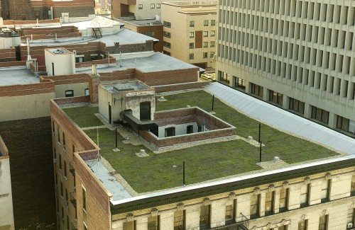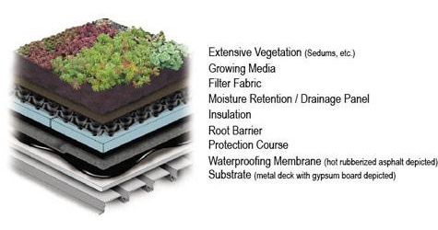

**Figure 1:** Layers of extensive green roof

**2.2. Intensive green roof**

Intensive green roof also called roof garden because thickness of the substrate allows the formation of real gardens and oases that would otherwise form in a conventional way. It is characterized by a large range in the use of plant species - from terrestrial plants to trees. The name of this type of roof indicates the possibility of intense and unlimited use - from urban gardens, recreational areas, garden restaurants, children's playgrounds, etc. The thickness of the nutrient substrate is in the range from 35 cm to even 80 cm, and the surface mass of the load is about 1200 kg/m² without plants.

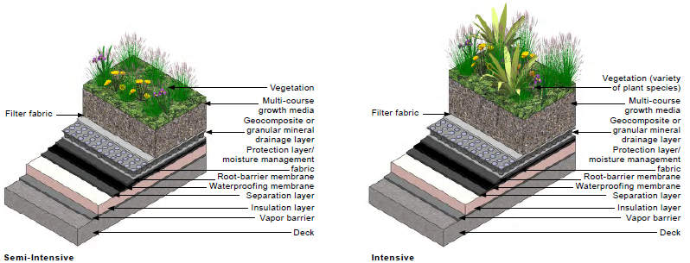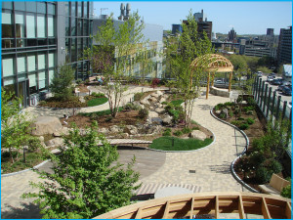

**Figure 2**: Layers of intensive green roof

The special type of green roof is semi-intensive roof which mean that physical accessibility to users and is based, in most cases, from grass surfaces, feather but also flabby forms that do not have a branched root system at a substrate thickness of about 30 cm with a surface mass of about 350 kg/m² without plants.

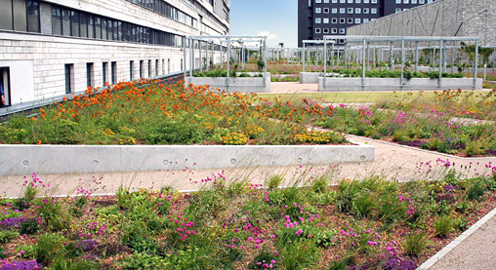

**Figure 3**: Layers of semi-intensive green roof

**3. DYNAMIC SIMULATION MODEL**

The available green-roof models for energy simulation programs are increasing in literature. They differ among them for being simplified or complicated mathematical model of heat and mass transfer, assuming the thermal properties of green roof constant or affected by latent heat and by water content [10-11], being one-dimensional or multi-dimensional model, having a higher or lower degree of detail.

In this paper, the energy modelling of a six-storey business facility, which is located in Belgrade in the *DesignBuilder* program, was performed [12]. The contribution of the green roof depends on the climate of the installation site. The application of this program realizes the calculations of the heat load of the building and the consumption of energy for heating and cooling, which is used for determining the energy characteristics of the building. *DesignBuilder* enables energy simulations of objects in their design, but also in the revitalization of existing buildings with the possibility of selecting local energy and construction regulations and standards and is a useful tool for analyzing energy performance of objects. Green roofs can be modelled in *DesignBuilder* by creating a roof construction using a Green roof material as the outer layer.

The main input parameters of the green roof model are:

• Height of plants;

• Leaf area index (LAI);

• Leaf reflectivity;

• Leaf emissivity;

• Minimum stomatal resistance;

• Max volumetric moisture content of the soil layer (saturation);

• Min (residual) volumetric moisture content of the soil layer;

• Initial volumetric moisture content of the soil layer.

**3.1. Building energy model**

The analyzed building is located in Belgrade, Serbia (Lat. 44,79 N, Long. 20,45 E, elevation 117 m ASL.). The building has six floors, each surface of 96.37 [m2] (Figure 4), and each floor is considered as one thermal zone [8]. All dimensions of the model are symmetric in order to reduce the influence of the orientation of the assembly of the object. The building is occupied during working days (Monday to Friday) from 7 a.m. to 7 p.m. The heating system is a hot water radiators. A heating (21 °C) and cooling (25 °C) set points are fixed. Finally, we considered a natural ventilation of nearly 0.5 [ac/h] and usage of electrical equipment. Lighting is provided with fluorescence lamps of various power.

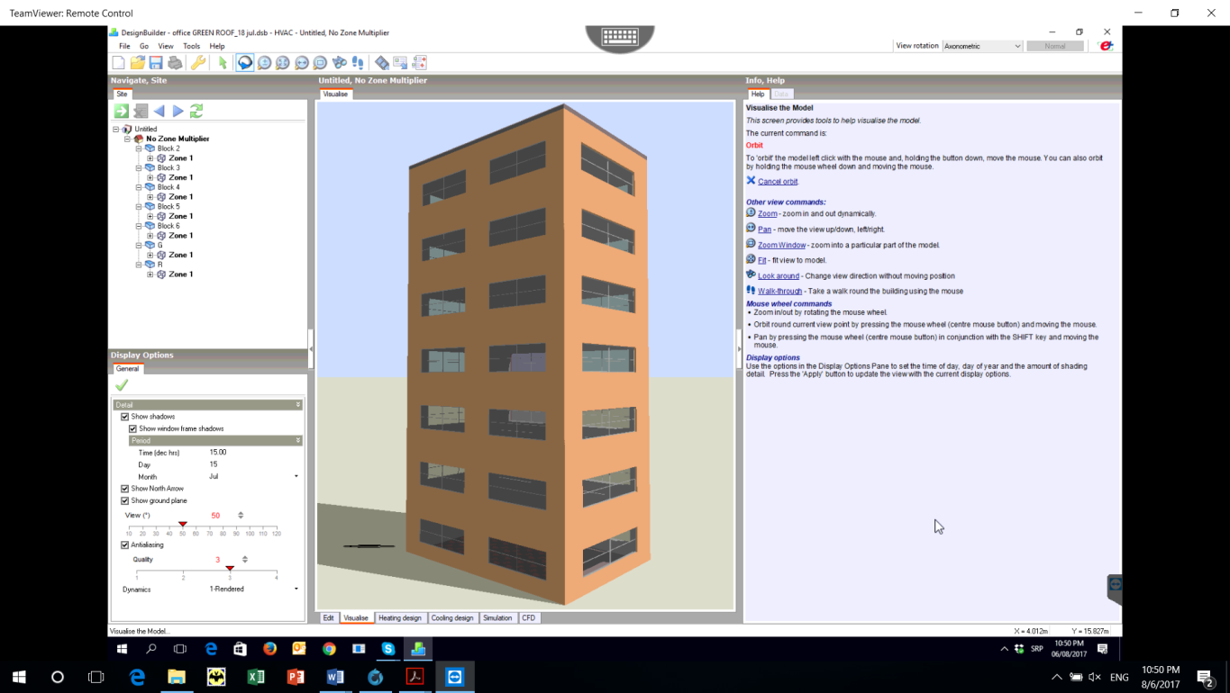

**Figure 4**: 3D model of the building

The thermal conductivity of outer walls thickness 36 [cm] is 0,292 [W/(mK)] while for the conventional roof with thickness 15 [mm] of mineral wool insulation is 0,390 [W/(mK)]. Openings are double glass with argon (6-13-6) with aluminum frame with thermal break and inner blinds. On the north and south side of the building are two windows of the same area of ​​6,266 [m2], and on the eastern and western sides there is one window of 8,478 [m2]. Windows blinds are located on the inside of the window and are used during the opening hours of the building. The heat transfer coefficient through the windows is 1,322 [W/(mK)] and the ratio of the total surface of the exterior walls and window is 30 [%].

Dynamic simulations of the energy behavior of the object were carried out for different structures of flat green roofs. Two types of vegetation roofs have been considered: an extensive and a semi-intensive one. As some intensive green roofs are rarely used because their high level of maintenance and cost, they haven’t been considered in the present work.

**3.2. Green roof model**

The green roof analyzed in this paper is a multilayer flat roof composed of a common structural layer made of concrete; a thermal insulation layer covered by a waterproof layer and laid on a moisture barrier; a drainage layer; a filter layer; a soil layer and vegetation layer as shown in Figure 5.



**Figure 5:** Layers of the considered green roof

Three different thicknesses of the thermal insulation layer have been considered: 0 [cm], 5 [cm] and 10 [cm], corresponding to a not insulated, a medium insulated and a highly insulated roof respectively. The thermal properties of the green roof layers are shown in Table 2 [9]. An extensive green roof is characterized by a thin soil layer on, which generally shrubs and grass grow, while a semi-intensive green roof is characterized by greater thickness of soil layers and higher plants. Input parameters of vegetation layer is given in Table 3.

**Table 2:** Thermo physical characteristics of green roof layers

|  |  |  |  |  |  |
| --- | --- | --- | --- | --- | --- |
| Green roof layers  (outside-inside) | | Thickness  δ [m] | Thermal conductivity λ [W/(mK)] | Density  ρ [kg/m3] | Heat capacity  cp [J/(kgK)] |
| 1. Vegetation layer | | See Table 3 | | | |
| 2. Soil layer | Extensive roof  Semi-intensive roof | 0,100  0,250 | 0,200 | 1020 | 1093 |
| 3. Filter layer | | 0,005 | 0,06 | 160 | 2500 |
| 4. Drainage layer | | 0,060 | 0,08 | 800 | 920 |
| 5. Waterproof layer | | 0,007 | 0,17 | 1200 | 920 |
| 6. Thermal insulation layer | | 0  0,050  0,100 | 0,035 | 90 | 990 |
| 7. Moisture barrier | | 0,003 | 0,055 | 2500 | 840 |
| 8. Concrete slab | | 0,050 | 1,16 | 2000 | 880 |
| 9. Concrete floor | | 0,200 | 0,39 | 1680 | 848 |
| 10. Plaster | | 0,015 | 0,35 | 1200 | 840 |

**Table 3:** Input parameters of vegetation layer

|  |  |  |
| --- | --- | --- |
| Parameter | | Value |
| Height of plant | Extensive roof  Semi-intensive roof | 15 [cm]  35 [cm] |
| Leaf area index (LAI) | | 1,5 [-] |
| Leaf reflectivity | | 0,22 |
| Emissivity | | 0,95 |
| Minimum stomatal resistance | | 180 [s/m] |
| Maximum volumetric moisture content at saturation | | 0,500 [m3/m3] |
| Minimum residual volumetric moisture content | | 0,010 [m3/m3] |
| Initial volumetric moisture content | | 0,150 [m3/m3] |

**4. RESULTS**

Two different simulations have been carried out on the considered building, i.e. as it is and with a green covering, as described in the previous section, installed on top of it. Simulation results are reported in Figure 6 and 7. We report the comparison in terms of energy lost from roof between the presented described configurations.

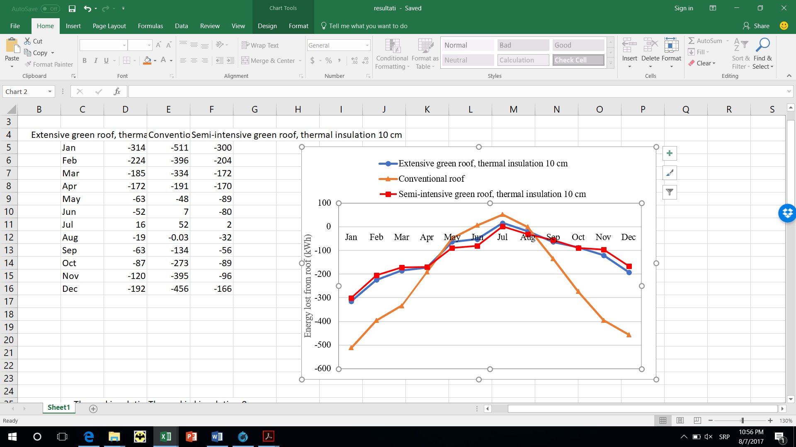

**Figure 6:** Energy lost from the roof

Heat loss through both types of analyzed green roofs is lower compared to the conventional roof. The results of the study show that heat losses are lower for the extensive green roof during the heating season (from October to March), while during the cooling season (July) losses are less when the semi-intensive green roof is installed. In Table 4, the obtainable energy savings by means of the installation of a green roof with respect to a conventional one both for heating and cooling season is reported. The results show that the application of extensive green roofs without thermal insulation has no positive effects during the heating season.

**Table 4:** Obtainable energy savings by means of a green roof

|  |  |  |
| --- | --- | --- |
| Green roof type | Season | Energy savings from roof [%] |
| Extensive green roof  thermal insulation 10 cm | Heating season  Cooling season | 52,6  69,2 |
| Extensive green roof  thermal insulation 5 cm | Heating season  Cooling season | 34,7  67,3 |
| Extensive green roof  thermal insulation 0 cm | Heating season  Cooling season | -  67,3 |
| Semi-intensive green roof  thermal insulation 10 cm | Heating season  Cooling season | 56,6  96,1 |

The influence of thermal insulation of extensive green roofs is shown in Figure 7. Application of 10 [cm] thermal insulation 27,3 % energy savings for heating can be obtained compared to the insulation thickness of 5 [cm] and 55,2% compared to the non-insulated extensive green roof.

**Figure 7:** Energy lost from extensive green roof with different thermal insulation

In order to evaluate the thermal conductivity trend versus the soil thickness, for the three thermal insulation levels and for extensive and semi-intensive green roof, Figure 8 is shown. The thermal conductivity values for all the considered green roof configurations are low because of the soil layer that is characterized by a high thermal inertia.

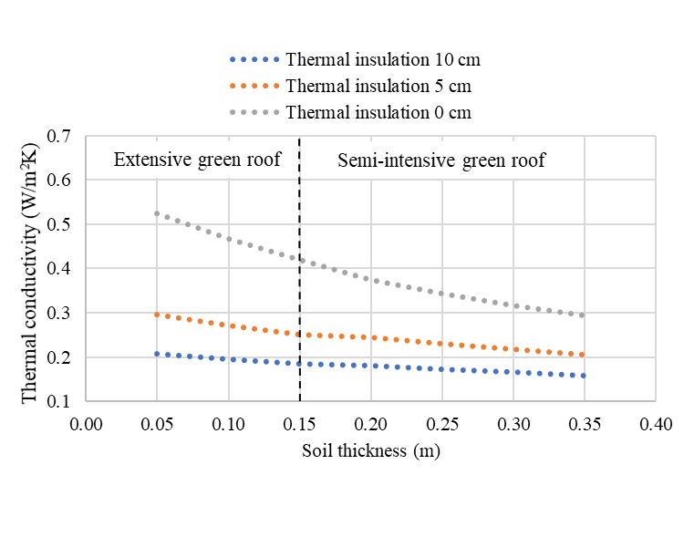

**Figure 8:** Green roof thermal conductivity versus soil thickness for three levels of

thermal insulation thicknesses

**5. CONCLUSION**

This paper analyzed the energy saving contribution of a green roof compared with a conventional one in the city of Belgrade, Serbia. The results obtained from the dynamical simulations point out a good rate of energy saving. Our results showed that the green roof induced a significant decrease in energy consumption for heating by 57 %, while energy savings for cooling is up to 96 %. Therefore, the green roof falls in the set of possible interventions to improve the energy performance of buildings.

**Acknowledgements**

We gratefully acknowledge to the Ministry of Education, Science and Technological Development of the Republic of Serbia for the financial support. This paper presents the result of the project "Improvement of energy characteristics and quality of the interior space in buildings of educational institutions in Serbia with impact on health", III 42008, Area: Energy and energy efficiency.

**LITERATURE**

[1] SAEID, E.J., *Effect of green roof in thermal performance of the building, An Environmental Assessment in hot and humid climate*, Faculty of Engineering & IT, The British University in Dubai, April 2011.

[2] BECKER, D., WANG, D*., Green Roof Heat Transfer and Thermal Performance Analyzis,* Civil and Environmental Engineering, Carnegie Mellon University, May 2011.

[3] RAKOTONDRAMIARANA, H.T., RANAIVOARISOA, T.F., MORAU, D., *Dynamic simulation of the green roofs impact on building energy performance*, Case study of Antananarivo, Buildings 2015, 5, pp 497-520, Madagascar, 2015.

[4] https://www.archtoolbox.com/materials-systems/site-landscape/green-roofs.html

[5] COLLINS, G.S., *Thermal behavior of green roofs in winter conditions,* Department of Environmental Sciences, University of Helsinki, January 2016.

[6] LUCKETT,K. LEED AP, *Green Roof Construction and Maintenance,* ,The McGraw-Hill Companies, Inc., 2009.

[7] JODIDIO, P., *GREEN Architecture Now!*, Taschen ISSN 978-3836535892, Italy, 2012.

[8] ŠUTIĆ B., DRAGIĆEVIĆ S., MARJANOVIĆ M., *Analysis of the application of modern energy efficient building materials,* Energy, Economy, Ecology, No. 1-2, Year XVIII, p. 155-160, 2016.

[9] CAPOZZOLI, A., GORRINO, A., CORRADO, A., *Thermal characterization of green roofs through dynamic simulation,* 13th Conference of International Building Performance Simulation Association, Chambery, France, 26-28 August, 2013.

[10] CHEN, P.Y., LI, Y.H., LO, W.H., TUNG, C.P., *Toward the practicability of a heat transfer model for green roofs*, Ecological Engineering 2015; 74: 266–273.

[11] TABARES-VELASCO, P.C., SREBRIC J., *A heat transfer model for assessment of plant based roofing systems in summer conditions,* Building and Environment 2012; 49: 310–323.

[12] DesignBuilder Software Ltd. http://www.designbuilder.co.uk.