**CAVITATION RESISTANCE OF ALUMINUM ALLOY**

**Marina Dojčinović1, PhD; Nada Jovičić2, MSc; Ljljana Trumbulović3, PhD**

1Faculty of Technology and Metallurgy, Belgrade, Serbia, e-mail: [rina@tmf.bg.ac.rs](mailto:rina@tmf.bg.ac.rs);

2Technical School, Uzice, Srbija, e-mail: 974[nada@gmal.com](mailto:nada@gmal.com)

# 3Business and Technical High School, Uzice, Srbija, e-mail: ljiljana.trumbulovic@vpts.edu.rs

***Abstract:*** *Cavitation erosion of aluminum alloy AlMg3 was investigated. Cavitation erosion test was applied using standard the ultrasonic vibratory cavitation test set up with stacionary test specimen. Mass loss and surface degradation of investigated specimen were monitored during the exposure to cavitation erosion. Mass loss was measured by an analytical balance. The morphology of the damaged surface with the change of the test period was analyzed using scanning electron microscopy (SEM).*

***Key words:*** *cavitation,**aluminum-magnesium alloy, cast*

**1. INTRODUCTION**

Cavitation can occur if the pressure on water is reduced sufficiently to cause formation of bubbles or vapor-filled voids. When the water is subsequently subjected to higher hydrostatic pressure, the bubbles can collapse suddenly and cause surface damage through microjet and shock waves. Cavitation erosion is a type of wear in hydraulic structures in contact with high-velocity water subjected to pressure changes [1].

Al-Mg alloys are very significant group of alloys, foremost from solidity standpoint achieved without thermal processing. In addition to high solidity, wide options of application of these alloys derive from good corrosion sturdiness, good weldability, etc.

Gases and non–metallic inclusions which appear or accumulate at certain locations in material have influence on the quality of cast ingots of aluminum alloys with magnesium, wich correspond to AlMg3 content. Decrease of inclusions and gases presence in cast ingots represents main condition for achievement of the desired quality of cast ingots, together with high-quality of rolled products on these alloys (strips, sheets foils). The role of the degasification, modification and filtration process is important to regulate the concentration and distribution of gases and inclusions [2,3].

The properties and manufacturing characteristic of metal alloys commonly used in the production of hydraulic machinery parts, depend on microstructure. The existence of impurities, inclusions and gases in the material reduces its resistance to the effect of cavitation.

In this paper, the cavitation resistance of AlMg3 alloy obtained by applying the optimum alloying regime of aluminum with magnesium was investigated. The cast ingot was produced by the method of semi-continuous casting.

**2. EXPERIMENTAL**

**2.1.Material**

Cavitation erosion of aluminum alloy AlMg3 was investigated. The optimum alloying regime of aluminum with magnesium was applied [4]. The cast ingot was produced by the method of semi-continuous casting. Chemical composition of the tested aluminum alloy AlMg3 is presented in Table I. Mechanical properties of the tested aluminum alloy AlMg3 are presented in Table II.

**Table 1:** Chemical composition of the aluminum alloy AlMg3 (weight %)

|  |  |  |  |  |  |  |  |
| --- | --- | --- | --- | --- | --- | --- | --- |
| Mg (%) | Mn (%) | Si (%) | Fe (%) | Ti (%) | Cu (%) | Zn (%) | Cr (%) |
| 2.83 | 0.25 | 0.1 | 0.35 | 0.01 | 0.009 | 0.025 | 0.001 |

**Table 2:** Mechanical properties of the aluminum alloy AlMg3

|  |  |  |  |  |
| --- | --- | --- | --- | --- |
| E  MPa | Rm  MPa | Rp 0.2  MPa | A50  % | HB  2.5/62.5/30 |
| 66650.2 | 195.19 | 71.06 | 27.38 | 48.65 |

Figure 2 shows the microstructure of the sample for testing the resistance to cavitation erosion. Microstructure of the AlMg3 alloy has a uniform cellular structure of phase α, intermetalic phase β (Al3Mg2), such as cast half-continuous phases of the eutecticum, without the presence of gas porosity.

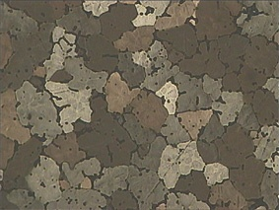

**Figure 1:** Microstructure of the AlMg3 alloy, (100x)

**2.1.Methods**

Cavitation erosion tests were performed using an ultrasonic device according to ASTM Standard G32-92 (the stationary specimen method) [5]. The device consists of: a high frequency generator of 360 W, an electro-strictive transducer, a transformer for the mechanical vibrations and a water bath containing the test specimen (Figure 2).

The frequency of vibration and the peak-to-peak displacement amplitude of the horn were 20±0.5 kHz and 50μm, respectively, with separation of 0.5mm between the specimen and the horn tip. The test liquid was distilled water maintained at 25±0.5°C.



**Figure 2:** Schematic overview of the cavitation test device [6]

Prior the test, the specimen was ground and polished to remove any work hardened layer formed during manufacture of the test specimens. Mass loss of the test specimen was measured with an analytical balance with an accuracy of 0.1 mg, after being rinsed in alcohol and dried in hot air. Measurements were taken every 60min for a test period of 180 min, in order to obtain the erosion curve.

Scanning electron microscopy technique was performed to analyze the morphology of the damaged surface and to interpret the results of the cavitation tests. Images of the surfaces were obtained by using FESEM Mira Tescan X3m scanning electron microscope. Analysis of the damaged surfaces was done after 60, 120 and 180 min of surface effects of cavitation.

**3. RESULTS AND DISCUSSION**

The behavior of AlMg3 alloy in conditions of cavitation is determined by mass loss measurements and the resistance is reported in terms of incubation period and cavitation rate. The results of the cavitation resistance testing of AlMg3 subjected to cavitation are shown in Figure 3. The diagram shows mass loss versus testing time as a straight line functions.The line was drawn by least-square method and data can be expressed by straight line.

The slope represents the cavitation rate and the point where the line intercepts the abscissa indicates the incubation period, i.e., time elapsed before the destruction of materials commences.

Incubation period for AlMg3 alloy was about 10 min (Figure 3). There was no separation of material particles under the effect of cavitation during this testing time. Calculated value of cavitation rate was 0.157 mg/min for AlMg3 alloy. Regarding the results presented in Figure 3, the strong correlation between mass loss and time of the experiment was observed. Regression analysis showed an excellent correlation, with the correlation coefficient of R2 = 0.9983.

**Figure 3**: Mass loss of AlMg3 alloy as a function of testing time

The morphology of the surface damage of the sample after the appropriate stages of the cavitation testing is shown in the Figures 4-6.

After 60 min of subjecting the specimen to the effects of cavitation, localized pits on the surface appear (Figure 4).

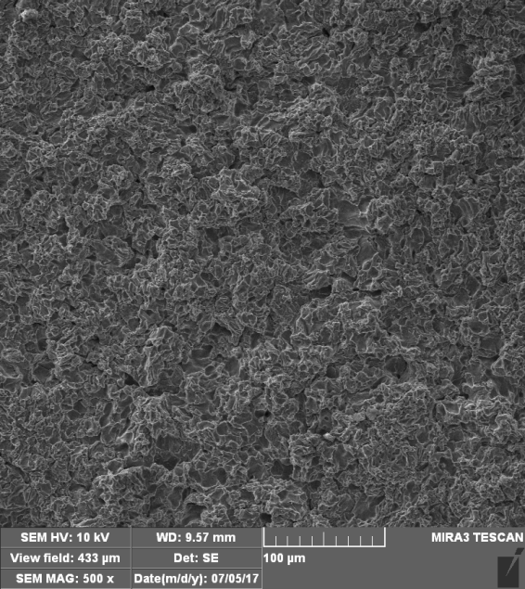

**Figure 4:** SEM micrographs of the surface after 60 minutes of testing time

Higher level of roughness of the specimen surface due to increasing number of pressure impacts generated by the implosion of cavitation bubbles can be seen after 120 min of cavitation action (Figure 5) . The surface morphology is characterized by increased number of pits as well as their size and depth. The microcracks can be observed on the surface initiated due to an increase of number of the pits and their interconnection. In some places of the surface microcraters are observed which are probably caused by microjets (Figure 5).

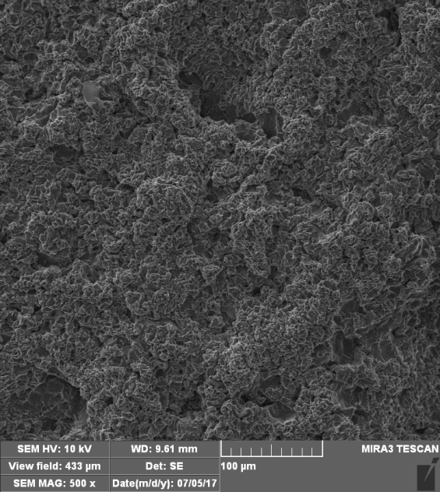

**Figure 5:** SEM micrographs of the surface after 120 minutes of testing

After the last test stage (180 minutes) the surface becomes deeply roughned as a result of higher level of surface damage during testing time (Figure 6). A large number of microcraters appear. Between the craters, there are deep cracks that connect them.

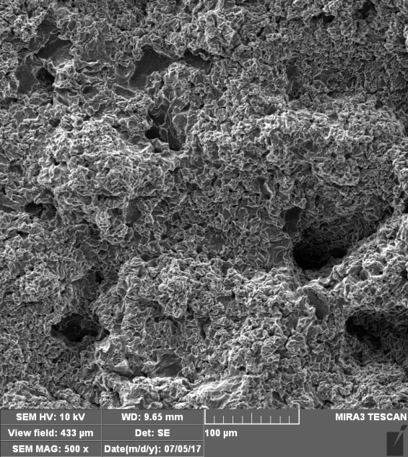

**Figure 6:** SEM micrographs of the surface after 180 minutes of testing

In the microstructure of the tested AlMg3 alloy, phase α, intermetalic phase β (Al3Mg2), such as cast half-continuous phases of the eutecticum occur. The occurrence of the eutectic phase in rapidly cooled alloy is caused by unbalanced crystallization in accelerated cooling. Due to rapid cooling, part of the Mg in excess is separated as Al3Mg2 in a discontinuous form at the grain boundaries. The phase α is soft because it contains a high content of aluminum while the other phases are hard (eutecticum and intermetalic phase β – Al3Mg2).

All the small particles of the brittle phases obtained from the impurities were removed in the first phase of testing time (60 minutes), after which only the hard intermetalic phase (Al3Mg2), hard eutecticum phase and the soft α phase remained. Since the alpha phase is soft, the prolonged effect of cavitation first leads to its damage.

**4. CONCLUSIONS**

In accordance with the obtained results, some conclusions can be drawn:

* Obtained results revealed that cavitation erosion of AlMg3 alloy was initiated by separation of brittle phases obtained from the impurities.
* After that, the degree of surface damage was increased because prolonged testing time causes damage of the soft phase.
* The reduced homogeneity of the damaged surface during testing time made it possible to begin the destruction of the hard phases in AlMg3 alloy.

**REFERENCES**

[1] HAMMITT, F.G.: *Cavitation and Multiphase Flow Phenomena*, McGraw-Hill, New York, 1980.

[2] KAINER, K. U.: *Magnesium Alloys and their Applications*, Wiley-VCH, Weinhein 2000.

[3] AĆIMOVIĆ-PAVLOVIĆ, Z., SIMOVIĆ, Đ.: *Production of Aluminum Alloys from Secondary Raw Materials*, TMF Belgrade (2005).

[4] JOVIČIĆ, N.: *Effect of Gases and Non-Metal Inclusions on Quality of Casted Blocks Made of Aluminum Alloys*, Master Thesis, University of Belgrade, TMF Belgrade, (2008).

[5] Standard Method of Vibratory Cavitation Erosion Test, G32-92. Annual Book of ASTM Standards, Vol. 03.02. Philadelphia: ASTM; 1992.

[6] DOJČINOVIĆ, M.: *Influence of the microstructure on cavitation erosion of steels*, PhD thesis,TMF, Belgrade University, Belgrade, Serbia, 2007.