HOW TO IMPROVE SUSTAINABILITY OF TEMPUS PROJECTS?

Milan D. Antonijević¹, PhD; Milan M. Djuricic¹, PhD; Milutin R. Djuricic¹, PhD;

¹University of Greenwich, United Kingdom; e-mail: m.antonijevic@gre.ac.uk

¹University "Union Nikola Tesla" Faculty of Business and Industrial Management Beograd, Serbia; e-mail: milandjuricic17@gmail.com

¹High Business Technical School of vocational Studies in Uzice, Serbia; e-mail: djurazo1@gmail.com

Summary: Compliance of Serbian educational system with the European educational system is of extreme importance for development of the country on its path toward the society of knowledge. Numerous TEMPUS and ERASMUS projects are exceptionally important for such enterprise, as they are jointly implemented by Serbian and European Union’s faculties. Sustainability of results stands for the quality of the results achieved through each of these projects. This paper indicates a series of recommendations to be used by future researchers at either preparation or implementation stage of future projects.

Key words: project sustainability, TEMPUS project, higher education

- INTRODUCTION

Purpose of each TEMPUS project is to bring a positive change not only during the duration of project but also in a long term basis. Proper implementation of project requires a Project Quality Plan [2]. A TEMPUS project must clearly indicate that the project activities are justified and necessary to reach the target, that the costs are taken into account, that these activities will add value to target groups and that the costs effectiveness can be established [7].
When selecting projects for funding, European Union (EU) pays special attention to the project impact on surrounding subjects as well as to specific plans for expansion and utilization of project results/outcomes. This feature is known as SUSTAINABILITY of the project. With this in respect, TEMPUS projects require development of Financial Sustainability Plan. It is a common practice to make a clear links between project sustainability and project activities upon completion of funding (long-term result sustainability), this however is insufficient and often wrong practice, since project sustainability is additionally related to the project funding (implementation) stage - risks, information & result dissemination during the project, preconditions and assumptions.
The aim of this paper is to indicate practical opportunities to improve sustainability of TEMPUS projects upon completion of funding made by EACEA Brussels, i.e. to improve availability of project products (generated results, lessons adopted and experience gained by project teams) to public over extensive period of time.

- TEMPUS PROJECTS IN SERBIA

Activities related to TEMPUS programme for improvement of higher education practices in Serbia are driven by Tempus Fondation founded in October 2002. It is general perception that Tempus = Reform of higher education, hence it represents one of the oldest and the most successful cooperation programmes introduced by European Union. Since 2007, this Fondation has been promoting the Erasmus Mundus Project with common study programmes and incentives for students, teachers and others employed at higher education institutions. In addition, the Fondation expanded its portfolio in 2011 when Lifelong Learning Programme was promoted to include pre-university levels of education. Furthermore, at the end of 2013, all these three programmes gave way to a new EU programme named Erasmus+. Tempus Fondation became an Office authorized to promote and monitor implementation of all educational projects [3].
TEMPUS projects are an important supporting tool for higher education reform in both Serbia and other surrounding countries of European Union that were or are included in the process of pre-joining the European Union. Tempus projects are mostly funded by means of grants (90%) and co-financing assets (10%). Serbia has taken an active part in Tempus programme since 2001, when it joined the first call for so-called Tempus III programme stage (2001–2007) and took part until the year 2013. This was the last call of Tempus IV stage (2008–2013) when the programme ceased as it merged into the Erasmus+ Programme. Total value of Tempus projects involving Serbian institutions as either partners or coordinators is estimated at around 45 million of euros.
Tempus programme had the initial impact on higher education institutions via joint projects for curricula reform, procurement of equipment and team building through study visits abroad. Taking into account Tempus priorities, other important parts of the programme were recognized as affirmative for improvement of institutional operations, quality norms, internal regulations, office work, students’ entities and governance of higher education institutions in general. “Such projects were named Governance Reform and had a structural character meaning that their solutions could be applied to all the universities in the country including even those that did not participate in these projects. Ever since 2007, the relation between higher education and society has been an important item of the common agenda for all Tempus projects. A great many projects were focused to make better relations with non-academic partners through development and provision of trainings for employees of commercial companies and other organizations and through other modes of cooperation. Likewise, each new curricula reform project emphasized that current curricula should be revised - or the new ones introduced – according to actual requirements of either commercial companies or labor market “[3].
Within the scope of Tempus III Project calls (2001-2007), 5 projects were implemented while during Tempus IV calls (2008-2013), 47 projects were implemented. As for Tempus IV Project calls, Serbian HE institutions were involved in 41 TEMPUS projects as coordinators and in 84 TEMPUS projects as partners. Over the given period, TEMPUS projects referred to: Higher education and society: 27 projects, Curricula reform 38 projects, Governance Reform: 19 TEMPUS projects. Statistics of performance of Serbian institutions and TEMPUS IV projects is shown in Table 1. It is shown that out of the total of 432 applications, 84 were adopted for funding and higher education institutions were coordinating 47 TEMPUS projects[3]. Majority of institutions participated in implementation of a single TEMPUS project: 88.80%, in 2 projects: 8.45%, 3 projects: 1.65%
4 projects: 0.70%, 5 projects: 0.25%, 6 projects: 0.15%[3].

Table 1.Performance of Serbian institutions and TEMPUS IV calls[3]
 | 2008 | 2009 | 2010 | 2011 | 2012 | 2013
Number of applications – Serbian institutions | 66 | 81 | 49 | 74 | 59 | 103
Number of funded projects | 17 | 13 | 12 | 11 | 13 | 18
Number of coordinated projects | 6 | 6 | 8 | 6 | 8 | 13

Tempus III and IV referred to the following topics: 1. agriculture/ forestry – 7, applicable sciences and technologies – 8, chemistry/ protection of environment - 5, engineering and ICT -17, foreign languages -2, inter/multidisciplinary studies -10, lifelong learning/open education -4, mathematics -2, medicine/pharmacy/ health care - 5, public administration /EU policies -6, quality assurance -8, tourism -2, social work - 1, sports - 1, veterinary medicine -2, education of teachers -12, governance over higher education institutions -15, HE institution offices -9, HE links with commerce-society -16, digital TV, multimedia -3, natural sciences 4, social sciences -1, law 2, economy and management -4 TEMPUS projects[3].
Tempus projects foresaw that up to 30% of total funds may be exclusively used to procure equipment for HE institutions. This opportunity was used for majority of projects so that first purchases referred to computer equipment and the subsequent ones to laboratory equipment, software, books and access to scientific magazines [3]. All these features significantly influence sustainability of TEMPUS projects.

- SUSTAINABILITY OF EU GRANT-FUNDED PROJECTS

Sustainability of a TEMPUS project means that project results and goals are made applicable after formal completion of the project. Sustainability is an important segment when applying for a TEMPUS project for the donator is thereby informed that the project to be financed will have an impact on the respective community even after it has been completed. To achieve the ultimate sustainability effect, above mentioned should be taken into account at TEMPUS Project both planning and implementation stages (Table 2).
EU wants that the grant-funded projects ensure that:
1. the project refers to the context and issues of the community concerned and
2. the positive changes to be encouraged by project implementation in EU-candidate-member countries are long lasting and permanent.

Table 2. Sustainability frame for planning and implementation of TEMPUS projects

1 | TEMPUS project planning | - To ensure that a TEMPUS project is based upon actual requirements of target groups and that these take an active part in the project,  - To ensure actual benefits for project partners,  - To include project partners in TEMPUS project planning,  - To ensure that project partners have the capacities required and to improve these if required  - To establish the resources required for further activities and result utilization,  - To make a plan for maintenance of the resources established and  - To ensure quality of the TEMPUS project management structure.  - Contextual issues to be discussed during TEMPUS project planning:  - To check if the TEMPUS project proposal is in line with the adopted development policies and future reforms:  - To secure political support if required and to adjust to political priorities:  - To secure sufficient support and commitment of other stakeholders of key importance for project results:
2 | Project implementation | - To monitor the situation progress and to estimate if there are any different requirements arising,  - To ensure continuous participation and commitment of project partners,  - To provide resources for further project activities.

In reference to above mentioned and to the rules for usage of assets from EU pre-joining funds, TEMPUS Project Sustainability includes[4]:
- Financial sustainability - referring to financing so-called follow-up activities - is required to maintain source of income for operative and maintenance costs upon completion of project.
- Institutional sustainability via formation of a structure that will enable continuance of project results after TEMPUS project funding has been finished. This target may be reached through institutional funding, marketing, cluster work and alike with an aim to continue the cooperation.
- Political sustainability (with regard to implementation of public and other policies) meaning that a user should – wherever possible - describe the project impact on policy as a project feature , i.e. to make a reference with staff training, legislation, new working methods etc. Not all project have this feature but it would be useful to discuss whether dissemination channels used in TEMPUS projects are sufficient to make changes on either local, regional or national level.
- Environmental sustainability – Basically, this feature is not in focus of the projects that do not deal with protection of nature. Nevertheless, it may be easily observed and included in projects through ‘green’ activities, such as utilization of renewable energy sources, reduction of CO2 emissions, efficient energy consumption etc (Figure 1) [1,12].
Sustainability of TEMPUS project results as required by tender conditions is dependent on numerous factors as follows:
• ownership over TEMPUS project goals and results ( referring to the extent of partners’ engagement in project implementation and goals and to their respective consent and involvement in the said implementation);
• compliance of TEMPUS project goals and results with relevant local, regional or national policies and political support for a TEMPUS project;
• institutional capacities (commitment level of partners and stakeholders, relations or involvement of project goals and activities with local institutions; capacities of new curricula (if accredited), long-term implementation prospects ( with regard to availability of skilled personnel, financial means, equipment etc and capacities of partners to continue implementation etc);
• adjustment of TEMPUS project budget to the project targets;
• social and cultural factors (accordance of TEMPUS project goals and results with local requirements and the means to meet the same; benefit distribution to all members of a community; conformity with social views and beliefs and acceptance of prospective changes by target groups and end users; connection of on-going activities and targets with prospective analyses of above mentioned factors ( including inclusion of target groups and end users into TEMPUS project development); relations between project members and local community);
• financial sustainability (availability of products and services to users upon completion of project; sufficiency of assets secured for the project, availability of sources sufficient for further activities;
• technical issues (suitability of technology, know-how, process or services created by a TEMPUS project for target groups’ cultural and traditional requirements as well as for their level of skill or knowledge; prospective discussions on alternative technologies; opportunities for end users to apply and use the technology upon completion of project);

Figure 1. Sustainability aspects for TEMPUS projects

• other issues, such as equality of sexes, the impact on environment , good management practices and alike.
In order to ensure sustainability, TEMPUS project implementation process should include systematic monitoring and reassurance of above goals and activities. In case of difficulties in dealing with certain aspects of sustainability, the following actions may be carried out [6]:
• as for financial sustainability, it is necessary to monitor cash flow, prospective hazards, additional financing opportunities, prospective issues with cost acceptance and reimbursement, generation of profit etc;
• as for technology, it is especially necessary to monitor whether the technological solution applied are acceptable and sustainable ( or usable on a long-term basis);
• it is necessary to adequately approach prospective issues related to environment protection and social aspects;
• it is required to monitor and encourage institutional strength and capacity improvement (acting at policy level as well as through educations and trainings);
• it is required to monitor plans for alternative aid provisions, i.e. plans for authorization assignments to other partners.
Particular attention should be paid to the fact that high-quality monitoring system must not ever be exclusively focused on donators or policy makers’ demands but on those of target groups, end users and project implementators with their partners. In this sense, it is very helpful to make a well-designed Plan for Dissemination & Exploitation of Results (DEOR Plan) providing answers to the following questions: Why? How? When? What? Whom? Where? (Figure 2).

Why?  To reach strategical targets:  - Maximum performance of TEMPUS project in reference to individuals, alike institutions, local and regional community etc.  - Spread of experience and results obtained may contribute to improvement of operations of partners from alike institutions included in TEMPUS projects  - Impact on decision-makers | What?  - Outcomes of learning (professional and personal knowledge, skills and competence; handbooks, IT tools, preceptorial modules...);  - Innovations | Whom?  Target group:  -new prospective mobile participants;  -new prospective users, qualified bodies, local community, business sector, decision-makers;  -media;  -public
How?  Types of activities that disseminate results to be subsequently exploited within the institution(s) - in the same or altered form, depending on given circumstances | When?  - Project elaboration in the beginning of the project;  - Implementation during and after the project time frame;  - DEOR activities do not cease once TEMPUS project is completed | Where?  To define the location for certain activities; adjust the area/premises to target group(s) and type of activities.
Figure 2. Plan for Dissemination & Exploitation of Results [9]

Final report on TEMPUS project implementation provides details of both project results and dissemination of project results (Figure 3).

FINAL REPORT
Project Summary | Dissemination of project results | Dissemination of project results | Dissemination of project results
• The main elements to be mentioned are:  • context/background of the project  • objectives  • number and type/profile of participants  • description of undertaken activities  • results and impact attained  • if relevant, longer-term benefits | •Which results of your project were worth sharing?  • Please provide concrete examples of good practices and success stories related to the mobility activities. | • Please describe the activities carried out to share the results of your project inside and outside your organisation(s). •What were the target groups of your dissemination activities? | • If applicable, please give examples of how the participants have shared their experience with peers within or outside your organisation
Figure 3. TEMPUS Project Final report [9]
Alike other projects from EU pre-joining funds, TEMPUS projects are subject to a stringent control pursuant to European Commission’s Strategy for Dissemination and Exploitation of Results – DEOR [11]. DEOR activities and project sustainability are pointed out for each TEMPUS project. European Commission developed the VALOR dissemination platform as a tool to support targets of Strategy for Dissemination and Exploitation of Results for the Erasmus+ programme. This platform was respectively applied in Round IV of TEMPUS project. For each of the approved TEMPUS projects, EACEA presented the following data on its web page:
- information on all projects approved for funding,
- summaries and contact details (automatically connected), project results (as posted by users and approved by AMPEU),
- examples of good practices – AMPEU,
- examples of successful projects - EK and
- broad visibility of projects and a powerful search engine[5].
EACEA had a constant communication with users through standard e-mail messages sent to the latter after signature of contract and, in case of any contact data changes, at the end of project. EACEA have defined the good practices criteria - taking into account quantity-wise criteria - based on the number of points given to particular project in the Final Report (min 75 out of 100 points).
75+ projects are deeply estimated in terms of quality according to the following criteria: 1. Project performance, 2. Project transferability, 3. Project innovations, 4. Project sustainability, 5. Communication and 6. Financial governance. Out of the chosen success stories in terms of good practices, European Commission and Executive Agency determine successful projects according to the communication potential with respect to: 1. Importance for policy, 2. Potential for further dissemination/communication, 3. Performance and sustainability, 4. Innovations and 5. Transferability [13].
Sustainability assessment for a TEMPUS project may also be carried out by means of the method of circulations of sustainability [10] enabling proper understanding of the project but also estimating its sustainability in terms of ecology, economy, politics or culture (Figure 4).

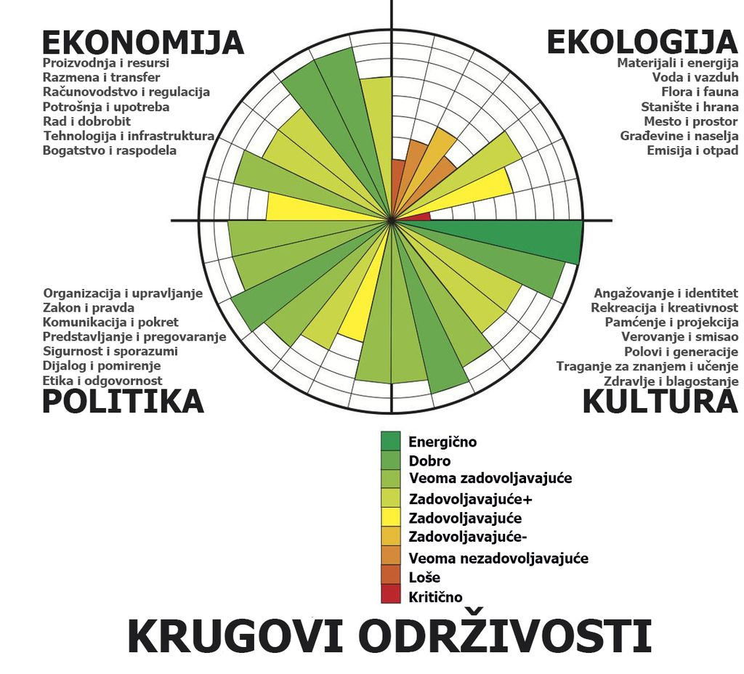
ECOLOGY
-Materials and energy
-Water and air
-Flora and fauna
- Habitat and food
-Money and space
-Buildings and settlements
- Emission and waste

ECONOMY
- Production and resources
- Exchange and transfer
- Accounting and regulation
- Consumption and use
- Work and well-being
- Technology and infrastructure
- Wealth and distribution
-Engagement and identity
-Recreation and creativity
-Memory and projection
-Belief and meaning
-Poles and generations
-Search for knowledge and learning
-Health and wellbeing
CULTURE

Energetic
Okay
Very satisfactory
Satisfactory +
Satisfactory
Satisfactory -
Very unsatisfactory
Bad
Critical
CIRCULATIONS OF SUSTAINABILITY
-Organization and management
-Law and Justice
-Communication and movement
-Presentation and negotiation
-Security and agreements
-Dialogue and reconciliation
-Ethics and responsibility
POLITICS

Figure 4. Circulations of sustainability[10]

PROJECT SUSTAINABILITY: CASE STUDY

This paper will present two examples of sustainability of TEMPUS projects as follows:
- Modernization and harmonization of Tourism study programmes in Serbia No 544543-TEMPUS-1-2013-1-1-RS-TEMPUS-JPCR (MHTSPS)
- Modernization of Post-Graduate studies in Chemistry and Chemistry related subjects in Serbia No 511044-TEMPUS-1-2010-1-UK-TEMPUS-JPCR (MCHEM)

1. Sustainability of TEMPUS project: “Modernization and harmonization of Tourism study programmes in Serbia No 544543-TEMPUS-1-2013-1-1-RS-TEMPUS-JPCR” – MHTSPS is accomplished at the project result exploitation stage through the following:
- Realization of curriculum at the total of 10 accredited study programmes of basic, specialized, master and PhD studies (at The University of Kragujevac – Faculty for Hotel Management and Tourism Vrnjacka Banja, Business – Technical College of Occupational Studies Uzice and Business College Leskovac).
- Accreditation of master occupational studies for Health & Safety at Work at BTC Uzice enabled by means of exploitation of the equipment procured via TEMPUS project MHTSPS(figure 5),
- Accreditation of a laboratory dedicated to climate and micro-climate parameter measurement at BTC Uzice,
- A training organized at BTC Uzice for the personnel from tourist sector,
- Exploitation of equipment with TEMPUS project labels at: The University of Kragujevac – Faculty for Hotel Management and Tourism Vrnjacka Banja, Business – Technical College of Occupational Studies Uzice and Business College Leskovac ,
- Notice boards and digital watches with TEMPUS labels at Business-Technical College Uzice,

- 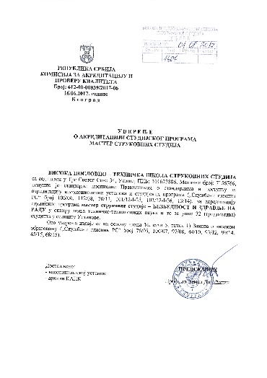 a) | 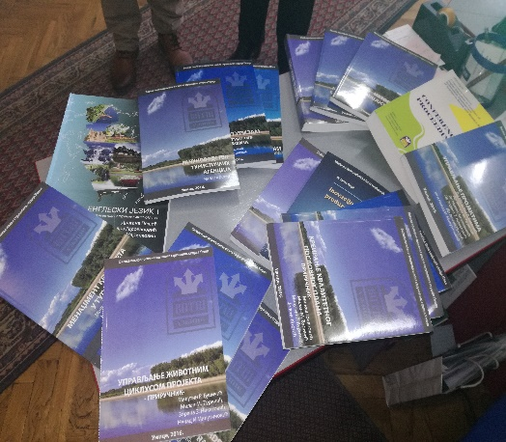b) | 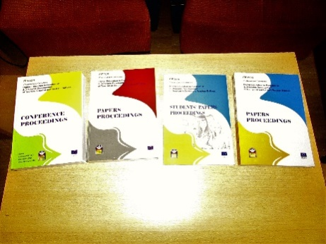 C)
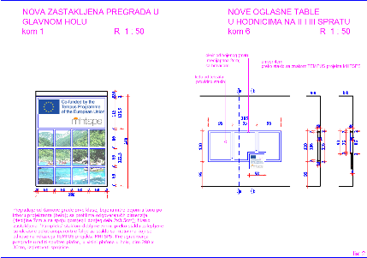  d) | 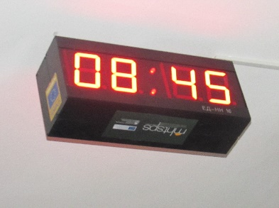  e) | 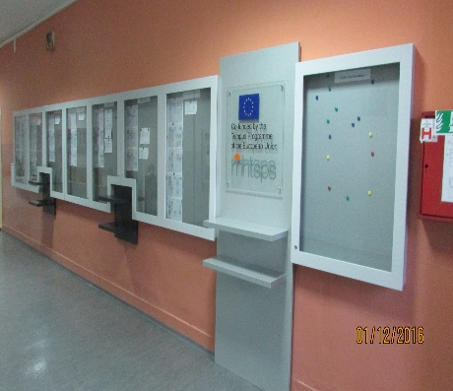  f)
Figure 5. Evidence of the sustainability of the TEMPUS project
a) Certificate of accreditation of master studies, b) Publish textbooks donated to secondary school libraries, c) Collection of papers from International conferences to the National Library of Serbia and the University Library Belgrade, d) Barrier board, e) Digital clocks arranged in the corridors of the School, f) Notice boards

- TEMPUS T-shirts and sporting gear worn by students at student competitions,
- Four Collections of Works from international conferences realized within the TEMPUS project MHTSPS No 544543,
- Free books for students also available from the web page of the TEMPUS project MHTSPS for future students.
- Free of charge distribution of several specimens of all publications to National Library of Serbia, University Library “Svetozar Markovic”, Libraries of the City of Uzice, Leskovac and Kragujevac and to libraries of high tourist schools in immediate vicinity to the partners from TEMPUS project MHTSPS,
- Via WEB portal Tourism of Serbia proceeding with the activity upon completion of the TEMPUS project MHTSPS and
- Via web pages of all the partners in the ‘Completed Projects’ section.

- Modernization of Post-Graduate studies in Chemistry and Chemistry related subjects in Serbia No 511044-TEMPUS-1-2010-1-UK-TEMPUS-JPCR (MCHEM)

Sustainability of the TEMPUS project „Modernisation of Post-Graduate studies in Chemistry and Chemistry related subjects in Serbia No 511044-TEMPUS-1-2010-1-UK-TEMPUS-JPCR” – (MCHEM) is accomplished at the project implementation stage
- Realization of curriculum at 9 higher education institutions with more than 12 accredited study programmes for master and PhD studies
- Many recently accredited programmes are an indirect product of MCHEM project
- The equipment purchased with the aid of the project added value to both tuition and research work. The University of Belgrade is performing better and better at the Shanghai List with the Faculty of Chemistry having been rated among the top three faculties in terms of published works. This Faculty that was the head of modernization of chemistry in Serbia.
- Students’ exchange programmes, framed by bilateral cooperations or interactions among Serbian and European research institutions.
- Development of benchmark standards in Chemistry – both high and higher education institutions are showing interest for these standards; in the meantime, their experts are setting the levels of knowledge required for certain subjects or occupations
- Participation in Envirochem conferences where there is a single session fully dedicated to education and promotion of lifelong learning and experience exchange among HE institutions.
- 3 research papers published in both national and international magazines
- A new project application – ERASMUS+ project – that have secured funding by EACEA and EU Commission.
- A new project - ICT networking for overcoming technical and social barriers in instrumental & analytic chemistry education – NETCHEM No 573885-EPP-1-2016-1-RS-EPPKA2-CBHE-JP
- A large number of presentations and transfer of knowledge to other projects and project teams
- Regular presentations during international conferences on project outcomes (Oslo, 2017)
- Through interaction and good cooperation with Serbian Chemical Society, lifelong learning process is attended. The lecturers trained during the MCHEM project are now involved in training their colleagues from commerce.
- All further activities within the NETCHEM project include reviews of the MCHEM project outcomes. Therefore, direct dissemination is still present and the outcomes of further works will be considered common as the first MCHEM project was the initiator to have the second NETCHEM project created. In addition, majority of colleagues involved in the first project are working on the second one as well.

SUMMARY

TEMPUS projects greatly contributed to harmonization of higher education of The Republic of Serbia with good practices in higher education of the European Union.
By means of good monitoring techniques, EACEA had an insight into implementation of each TEMPUS projects that was funded. In case of any non-conformities, it suggested adequate corrective measures.
Sustainability of TEMPUS project goals and results and their continuance after formal completion of the project is already an important part of the project application; EACEA is thereby informed at the very beginning that it would finance a project which results will have an impact on a respective community even after the project is completed. It means that sustainability is taken into account not only at the project result application stage, but already at the stage of planning and implementation of a TEMPUS project.
Case study showed some examples of good practice referring to sustainability of TEMPUS projects. These examples may serve as a tool for planning future projects while their implementation involved the authors of this paper as well, thus showing another component of sustainability of TEMPUS projects.

REFERENCES:

- ANTONIJEVIC, D.М., DJURICIC, M.M., DJURICIC, R.M., Development of eco-tourism its importance, challenges and students participation in educational processes, Papers Proceedings/ 2nd International Conference "Higher Education in Function of Sustainable Development of Tourism in Serbia and Westrern Balkans" within 8th International Conference "Science and Higher Education in Function of Sustainable Development - SED 2015, October 2015, Užice, Editors: Milutin R. Đuričić, Miloš Jovanović and Nenad Milutinović, pp.1-14.,
- ANTONIJEVIC D. M., ĐURIČIĆ R. M., ĐURIČIĆ M. M., MILUTINOVIC N., Tempus project quality plan (pqp) - an important management tool of project coordinator, Papers Proceedings/ First International Conference Higher Education in Function of Sustainable Development of Tourism in Serbia and Westrern Balkans within 7th International Conference "Science and Higher Education in Function of Sustainable Development - SED 2014, October 2014, Užice, Editors: Milutin R. Đuričić and Miloš Jovanović, pp15-24.
- DVANAEST GODINA PROGRAMA EVROPSKE UNIJE IZ OBLASTI OBRAZOVANJA U SRBIJI, (2014), Glavni i odgovorni urednik: Marija Filipović-Ožegović, Fondacija Tempus, Beograd – Erazmus+ kancelarija u Srbiji
- file:///C:/Users/User/Downloads/PJR-EDUCA-07.pdf
- http://ec.europa.eu/programmes/erasmus-plus/projects/
- http://pjr.hr/odrzivost-projektnih-rezultata-nakon-zavrsetka-finansiranja-projekta/
- https://www.vecernji.hr/vesti/detaljna-razdrada-aktivnosti-i-odrzivosti-563579
- http://projects.tempus.ac.rs/
- http://www.mobilnost.hr/cms_files /2015/09/1443184191_03-kick-off-upute-deor-vet-opce-odrasli.pdf)
- https://sr.wikipedia.org/sr-el/Krugovi_odr%C5%BEivosti
- JAMES, P., WITH MAGEE, L.; SCERRI, A.; STEGER, MANFRED B. (2015). Urban Sustainability in Theory and Practice: Circles of Sustainability. London: Routledge.
- LUTOVAC, M., DJURICIC, M.M., DJURICIC, R.M., MILUTINOVIC, I.N., Ecology and ecological problem – an important issue of man’s attitude toward the world, Papers Proceedings/ 2nd International Conference "Higher Education in Function of Sustainable Development of Tourism in Serbia and Westrern Balkans" within 8th International Conference "Science and Higher Education in Function of Sustainable Development - SED 2015, October 2015, Užice, Editors: Milutin R. Đuričić, Miloš Jovanović and Nenad Milutinović, pp.95-100.,
- SCERRI, A.; JAMES, P. (2010). "Accounting for sustainability: Combining qualitative and quantitative research in developing ‘indicators’ of sustainability". International Journal of Social Research Methodology 13 (1): 41–53. doi: 10.1080/13645570902864145.

Business-Technical Faculty of Occupational Studies from Uzice participated in 6 TEMPUS projects and is a coordinator in TEMPUS project MHTSPS No 544543. Authors of this paper are members of Project Management for the above project.
Sustainability refers to project capability to make the results and activities last and be functional upon completion of donators’ funding activities. Project results are continuously used on a long-term basis. A project might be considered sustainable if relevant activities are continued and if outputs are either retained or further developed upon completion of EU funding.(source: PJR-EDUCA-07.pdf)
Key DEOR-related words: Communication activities, Project sustainability, Dissemination, Project contributions, Exploitation of results of TEMPUS project(s).

