DEVELOPMENT OF TOURISM IN THE TERRITORY OF WESTERN SERBIA

Kotlajić Ana¹, student; Đuričić Milutin², PhD; Petrović Slobodan,MSc³

¹ High Business Technical School of Vocational Studies, Užice, SEBIA, e-mail:ana.kotlajic@yahoo.com
² High Business Technical School of Vocational Studies, Užice, SERBIA, e-mail:milutin.djuricic@vpts.edu.rs
³ High Business Technical School of Vocational Studies, Užice, SERBIA, e-mail: slobodan.petrovic@vpts.edu.rs

Abstract: Tourism as a fast growing economic branch is gaining increasing attention of development planners and Western Serbia. Numerous natural benefits (areas of idyllic spaces, fragrant and forested mountains, beautiful villages, harmonious and not too big resorts) and traditions of tourism are a good basis for its further successful and sustainable development. Mountain, spa and cultural tourism have a special place in the future development.
Key words: Tourism, sustainable tourism development, mountain tourism, spa tourism, cultural tourism.

1. INTRODUCTION
No better, God of a given place, no more generous people. That's what they say about the region of Western Serbia, which is in many ways unique. It is a landscape of idyllic spaces, scented and wooded mountains, beautiful villages, harmonious and not too large towns. Such an environment provides unlimited opportunities for the development of tourism, which can significantly improve the overall development of Serbia.
The aim of this paper is to draw on the basis of the physical geographical basis and social geographical characteristics of the region of Western Serbia, as well as the achieved state of development of tourism, on the perspectives of its sustainable development using the methods of theoretical and empirical research.

2. PHYSICAL GEOGRAPHICAL BASIS FOR THE DEVELOPMENT OF TOURISM IN THE FIELD OF WESTERN SERBIA

2.1. Geographical-tourism position of Western Serbia

Western Serbia is located in the center of the Balkan Peninsula, or occupies the western part of the Republic of Serbia (Figure 1 and Figure 2). It covers an area of 11,882 km2, which represents 13.45% of the territory of the Republic of Serbia. It has 797,227 inhabitants (according to the 2011 census), that is, 11.12% of the total population of the country, with an average population of 70.3 inhabitants per square kilometer. It borders with the Republic of Montenegro (the length of the border is about 112 km), and in the west with the Federation B and H (ie with the Republic of Srpska in the length of about 391 km).
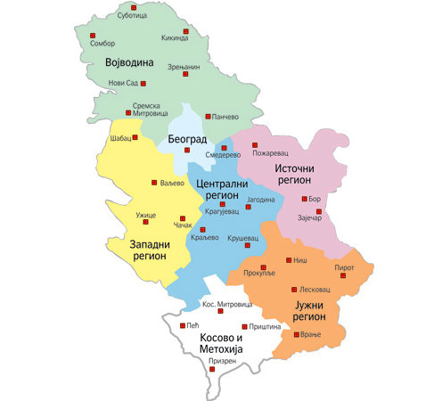 | 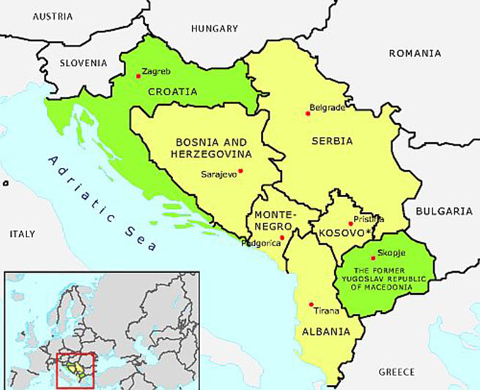
Figure 1: Regional division of Serbia | Figure 2: The position of Western Serbia in Europe

The tourist-geographical position of Western Serbia is very favorable, which is facilitated by numerous roads, of which a special place, in geographical sense, has a Drava valley, connecting Central and Eastern Serbia with Bosnia and Herzegovina, and a central tourist route that connects the north with the Adriatic By the coast.Traffic position of Western Serbia is, besides, insufficiently secured quality traffic - road infrastructure can be estimated as favorable, because it is located at the "intersection" between east and west. Through the territory of Western Serbia, important roads linking Western and Southern Europe, the Pannonian Basin and Belgrade, as our largest emitting zones, with the southern and middle seas are passing through. The closest international airports in the region are: Nikola Tesla Airport in Belgrade and Konstantin Veliki in Nis.

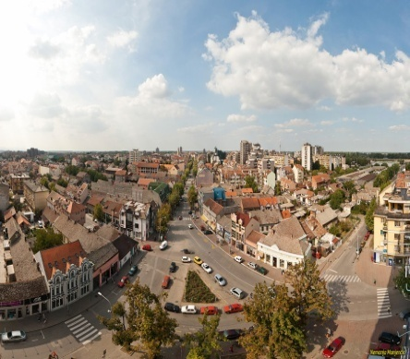 | 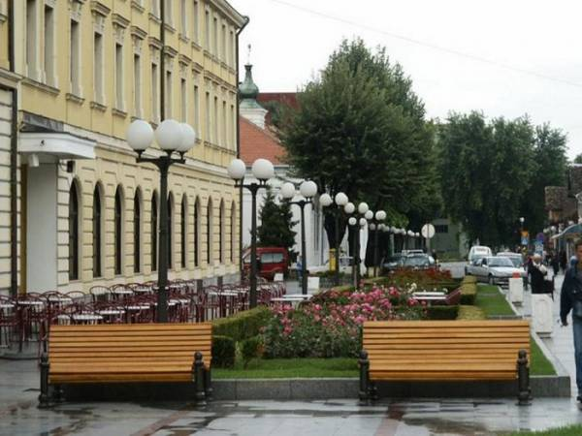 | 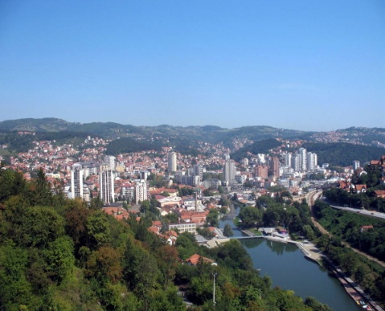
Picture 3: Grad Sabac | Picture 4: City of Valjevo | Picture 5: Panorama of Uzice

2.2. Relief of Western Serbia
The relief of Western Serbia is very diverse from the ravine hilly areas of Macva and Posavina to the highest mountain - Golija.
The mountain zone, the so-called "western zone of the younger venetian mountains", belongs to the Dinaric system and extends in the area of ​​Western Serbia in the form of a high arch separating the Panonski from the Adriatic basin. This belt is bounded by the Drina in the west, Dheinje and the western Morava in the north, the Ibar in the east and the southeast and Lim in the west. In this band of different geological composition dominate: shale, sandstone, dolomite, marl, clay. The Starovla-Rasa Mountains of Western Serbia include: Zvijezda, Tara, Zlatibor, Gilejeva, Zlatar, Javor and Golija, which is also the highest mountain of this group (1,833 m).
Mountain Cer represents the most isolated island of the south of the Pannonian basin in the north. The mountain is asymmetrical, with a slight inclination from the north and steep from the south.
The mountain is in Serbia, which is located south of Valjevo. It stretches east - west 25 km long. The most famous tourist place on the mountain Maljen is Divcibare, which is at a height of about 980 m.
Tara is in the northwestern part, surrounded by the Drina River canyon, while its branches reach the Kremen valley and the valley of the river Đetinje, where it relies on branches of Zlatibor. The base of the mountain consists of two surfaces: higher (about 1,200 m) and lower (1,000 m). Both surfaces are dotted with river valleys of cliff character, among which the valley of the Drina dominates. The special curiosity value of the morphological character on the Tara has speleological objects in the form of caves (Perućačka, Soviljačka, Gornja, Bezimena, Milinkova cave). On the basis of many years of investigation and investigation of this area, in order to protect the exceptional natural values ​​that the Assembly of Serbia has in 1981, Special law area Tara declared the National Park.
The Pešterska Visor with the Sjenica valley occupies the central part of the Old Vlach and is surrounded by mountains on all sides. The mountain of Gilea separates the Sjenica basin from the Pesterska Plateau and connects to Jadovnik and Ozren to the northwest and Bihor in the south. The entire surface is wavy with an average height of 700 - 1,300 m, and in the mountains up to 1,700 m.

3. HYDROGRAPHICCHARACTERISTICS OF WEST SERBIA
The hydrographic characteristics of Western Serbia are represented by rivers, lakes and thermomineral springs. In this area there is a large number of hydrological facilities, due to the volume of work, in the further text we will process those that are most significant both for the hydroelectric potential and the number of tourists who visit these tourist attractions.

3.1. Rivers
All watercourses in the area of ​​Western Serbia belong to the Black Sea basin. The Sava River basin belongs to the Drina and Kolubara hydrological region, while the rivers of southwestern Serbia mostly belong to the West Morava hydrological region.
Sava is formed from two mountain rivers: the Sava Dolinka and Sava Bohinjka, which originate on the territory of the Republic of Slovenia. Since their merger, near Radovljica, until its impact on the Danube near Belgrade, the total length is 940 km, while along with its long leg Sava Dolinka, the total length is 990 km. The average flow rate at the mouth of Belgrade is 1,700 m3 / s. The Sava River Basin is the largest river basin in Southeast Europe, with a total area of ​​approximately 97.713 km2 and represents one of the most important sub-basins in the Danube region, with 12%.
The Drina River is the largest and most important of all tributaries of the Sava. Its landing area extends to four countries: Montenegro, Bosnia and Herzegovina, Serbia and very small part in Albania. In the area of ​​Western Serbia, next to the Drina river, this basin belongs to the major rivers: Uvac, Lim and Jadar with tributaries. When it comes to cross-section profiles, it is necessary to say that Drina, penetrating through mountain massifs, the basis of which is predominantly Triassic limestone , Used a deep and narrow valley, which in some places has the appearance of a canyon. Crossing the mountain massif of Tara-Zvijezda, Drina used one of the most beautiful canyons, 25 km long and about 800 m deep. "

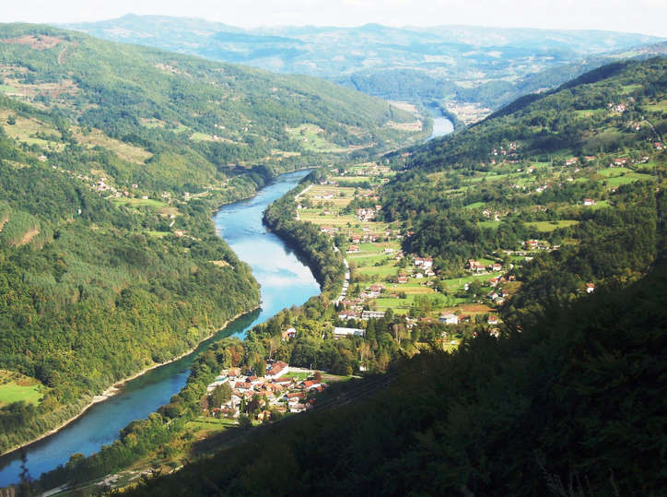 | 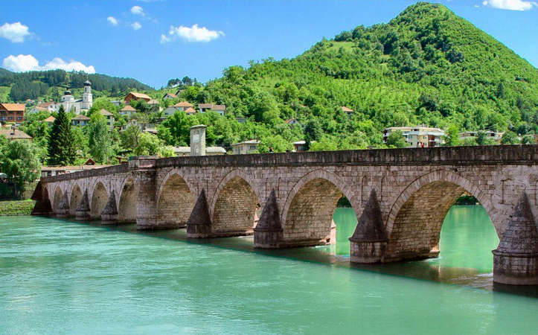
Figure 5: Part of the Drina river flow | Figure 6: Drina near Visegrad

Lim is an international river spanning 220 km in Albania, Montenegro, Serbia and Bosnia and Herzegovina (Republic of Srpska) and is flown into the Drina River. It springs from Plav Lake in Montenegro, and flies to the Drina between Gorazde and Visegrad. Two hydroelectric power plants Potpeć (54 MW) and Bistrica (104 MW) were built on it, among which is the artificial reservoir Potpećko jezero. The river itself forms a composite valley in which the gorges and basins alternate, and the area around it is calledPolimlje.The river Uvac springs at 560 m altitude on Mount Ozren, 16 km south of Sjenica. The length of the stream is 119 km and the area of ​​the basin is 1,334 km². Medium flow, for the period 1960-1990. It is 11 m³ / s. The water gets from the slopes that make up the dilapidated catchments of the Uvac and Javor basins towards Rzav and Moravica (the Western Morava Basin), Golija to Raska (the Ibar Basin), and the Zlatar to Lim. Uvac has the character of distinctly mountainous rivers in the phase of active erosion. It has significant hydro potential, and three hydropower plants were built on its course, due to which three artificial lakes were created: Uvac, Zlatarsko and Radoinjsko, so that the river Uvac practically does not exist today.
Kolubara is formed from Obnica and Jablanica, 1 km upstream of Valjevo. It flows east from Obrenovac in the Sava River. It is 86.4 km long and its surface area is 3.641 km. It has a wide alluvial flat, which reaches a width of up to 3 km. The small general fall of the Kolubara River of 0.15% and the large amount of application cause the unstable river flow. The product of this was frequent river meandering, creating a large number of dead and frozen terrains.
The river Gradac is being built in Kolubara, in the territory of Valjevo. Gradac is a river sink which springs below the Povlen mountain and has a cliff-canyon valley of 22.7 km long. To Celija, Gradac flows through the gorge, makes a certain arch around the monastery, and goes to Valjevo, where it flows into Kolubara. The depth of the gorge is on average 150 - 200 m, and the highest in the upstream part, which is over 300 m
The river Jetinja belongs to the Black Sea basin of the Danube River hydrographic system, and represents its tributary of the third row. The total area of ​​the basin is 486 km2. The length of the river, counting the spring line, Bratishina River, is 75.4 km. The girl has a large drop, on average, for the whole stream of 14.3 ‰. The average annual water level is 49.73 cm

3.2. Lakes
Lakes represent depots in the country, filled with water. The most important artificial lakes in the territory of Western Serbia are built for the needs of the economy, agriculture and electrical industry. There are no natural lakes in this region. In addition to these, artificial lakes have a tourist-recreational function. The most important limnological objects in the area of Western Serbia are: Lake Peru, Lake Zaovine and Zvornik Lake.
Perucac Lake, a surface of 12.5 km², 54 km long, was obtained by rebuilding the Drina with a concrete dam of length 461 m and a height of 93 m with a accumulation of 340 million m3 of water. The length of the lake is about 54 km, the smallest width is 150 m, and the largest width is about 1,000 m. The Peruvac Lake is at 290 m. The largest part of the lake is located in the Drina canyon that starts 7 km from the dam of the hydroelectric power plant "Bajina Bašta". Due to the steepness of the coast, the depth of the lake at only a few meters from the coast itself reaches an average depth of 3 to 8 m.The Zvornik lake has an area of ​​approximately 8.1 km² (1,300 ha), a volume of 90,000,000 m³ of water, and it is deeper than 39 m. The average depth of the lake is 5 to 8 m. The length of the lake is about 25 km, the smallest width is 200 m, and the width is about 3 km. The Zvornik lake is 140 m high. The lake with the Drina canyon extends upstream from Zvornik and Mali Zvornik to the mouth of the Velika Reka in the village of the same village of Mali Zvornik. It is also suitable for rafting, rafting, sailing and swimming. The lake, along with the river Drina, is a habitat of trout, grapes, gulls, clans, barbell, scallops, pine and pike. The lake is a habitat and wild ducks.Lake Uvac is a hydrocumulative lake created by raising. Dam between the villages of Akmachići and Bukovik. The dam is 160 m long and 110 m high. At maximum water level, the lake reaches a length of up to 20 km (accumulates 212 million water). At a minimum water level, when the lake accumulates 42 million m³ of water, it has reached 12.3 km. The area of ​​the lake is 6.1 km². Its width is 500 m, and the maximum depth is10m.

4. SOCIETY-GEOGRAPHICAL BASIS OF TOURISM DEVELOPMENT ON THE WEST SERBIA
4.1. Population of Western Serbia
According to the first reports of the 2011 census, West Serbia inhabits 756.935 inhabitants (10.6% of the population of the Republic of Serbia). Compared to the previous census in 2002, the number of inhabitants decreased by 9.37% (78,290 inhabitants). In Western Serbia there is a more pronounced downward trend in the number of inhabitants than the average for the Republic of Serbia (the number of inhabitants in the country decreased by 5.03% between these two censuses).
According to the census data in 2011, the population density in Western Serbia is 64 inhabitants per km², which is below the republican average (81 st / km)
4.2. Nazeland of Western Serbia
In the territory of Western Serbia, there are a total of 880 settlements, of which four are urban settlements. The largest area is covered by municipalities: Sjenica with 1059 km2, Valjevo 905 km2, then Prijepoljje 827 km2, Sabac 729 km2. The area of ​​the smallest municipality is Mali Zvornik 184 km2 and Lajkovac 186 km2. The largest number of settlements are in the municipalities of Sjenica (101), Prijepolje (80) and Valjevo (78), while the smallest municipalities are Mali Zvornik (12), Bogatić (14) and Koceljeva (17).
.
4.3. Material tourism base in the area of Western Serbia
4.3.1. Traffic and traffic means

The material base of the development of tourism in Western Serbia is a very important element of the overall tourist offer. Therefore, it is necessary to observe the state of tourism in Western Serbia and the strategy of further development in accordance with the existing material base, which includes roads and transport means as well as tourist and catering capacities for accommodation and food.

4.3.1.1. Door traffic

Today, there is no existing highway through the territory of Western Serbia. The E70 road (Sid - Belgrade - Pancevo - Vrsac) passes through the northern part of the territory of Western Serbia, while the distance of the territory of Western Serbia from E75 (Subotica - Novi Sad - Belgrade - Niš - Leskovac) is considerably higher. The construction of the Belgrade-Adriatic highway is planned, according to the Spatial Plan of the Special Purpose Area of ​​the Infrastructure Corridor Belgrade-South Adriatic, the Belgrade-Pozega section passes through the territory of the municipality Ub, Lajkovac, Ljig, Gornji Milanovac, Cacak, Lučani and Pozega.
In the last ten years there has been a significant expansion of the road network in Western Serbia. Over 910 km of new roads were built, an increase of 11.4% compared to 2000. There is also an increase in the number of vehicles used in road traffic. According to official data, for the transport of passengers in Western Serbia2010. 155,774 passenger cars and 631 buses were registered

4.3.1.2. Railway traffic

Sabac and Valjevo were the first lines of narrow track in 1908 (Šabac-Koviljača and Zabrežje-Valjevo), while in Uzice, the first train arrived in June 1912. The railway line Stalac - Užice - Sarajevo, was put into operation in 1925, after the construction of the famous Šargan Eight. The railroad was functioning until 1974 when it was abolished due to non-economy. Complete reconstruction andThe revitalization of the Šargan Eight for tourist purposes began in the autumn of 1999 and is today one of the most important tourist attractions in Serbia. The narrow track of Šarganska osmica, 15.4 km long, is a part of the railway infrastructure of JP Železnica Srbije.Today, the rail network of Western Serbia is part of the Belgrade-Bar railway, in the length of 259 km, part of the Šabac - Mali Zvornik railway line, in the length of 77 km, and part of the Užice - Čačak - Stalic railroad, in length of 18 km.
4.3.1.3. Real traffic
After the Danube, the Sava River is the most important public transport route of Serbia. Sava flows north of the Macvan district and connects Sabac, across the Danube, with most river navigable routes in Europe and further with the Black Sea. The harbor has rail infrastructure and its own locomotives ... Today, water transport on the Drina is not developed and has no significance. The shore does not sail even smaller boats due to numerous meander, "beech" and high speed. Šabac was the third river port in Serbia in the 19th century (behind Belgrade and Smederevo). Since 1890, the steamboat line Belgrade-Sabac has been introduced, and since 1912 Šabacje has been connected to Odesa. At the end of the 19th and early 20th centuries, the Sabac Customs House was first in terms of income in Serbia. This contributed to her borderline position towards Austria and Turkey (BiH). At that time on Sava near Sabac, there were harbors of steamers who transported agricultural products and brought merchandise. When the iron bridge was built (1934), the transport of goods increased sharply. Today, water traffic on the Drina is not developed and has no significance. The shore does not sail even smaller boats due to numerous meander,"beech"and =high speed.
4.3.1.4 Air traffic
On the territory of Western Serbia there are military airports Ponikve (12 km northwest of Uzice), Valjevo (12 km from Valjevo to Divcibare) and Sjenica. The construction of a project that will enable the Ponikve airport to be used for civilian purposes is underway. The Valjevo airport is used for training and flying sports pilots, sailors, parachutists, motor hangers and paragliders. Training existing airports and putting them in civil service would have a significant impact on increasing the volume of tourism flows, trade and foreign trade in Western Serbia.

Tabela 1.Udaljenost gradova Zapadne Srbije od većih aerodroma u (km)
Airport - City | Sabac | Loznica | Valjevo | Ужице
Belgrade | 85 | 135 | 100 | 135
Nis | 310 | 340 | 265 | 235
Podgorica | 450 | 400 | 330 | 300
Sarajevo | 219 | 165 | 230 | 190

5. OTHERS AND STRUCTURE OF TOURIST TRAFFIC
The realized turnover of tourists in the territory of Western Serbia (Macvan, Kolubara and Zlatibor administrative districts) can be monitored on the basis of scientific statistics at the annual level.The largest number of tourists was recorded in 2007 (347,997) and at least 1999 (only 237,419), which is understandable given the political situation in the country and the period of the NATO bombing of Serbia. The growth of the number of tourists after 1999 has a low growth rate, since tourism as an economic branch is most sensitive to changes in the political and economic nature. It is important to point out that in sum, the number of tourist arrivals increases from year to year, ie, It has an upward trend.

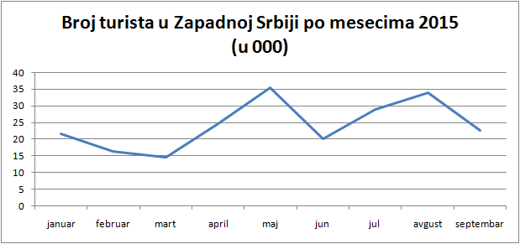
Figure 7. Number of tourists in Western Serbia by months in 2015

The number of domestic tourists in the observed period ranges from 226,441 to 324,563 and follows the trend of overall tourism trends, i.e. It grows from year to year. According to the data, Western Serbia annually visits 281,678 domestic tourists.
The number of foreign tourists ranges from 10,987 tourists (1999) to as many as 73,905 tourists (1998). It is necessary to emphasize that the trend of the number of foreign tourist arrivals follows the trend of overall arrival and increases with time. In 2010, the number of foreign tourists increased 2.5 times compared to the first observed year, but has not yet reached the number of arrivals in 1998. The average number of foreign tourist arrivals in the observed period is 27,060.The number of tourist nights spent and the average length of stay of tourists in Western Serbia indicate that in this area there is a growing number of transit tourists and / or that people are increasingly choosing shorter breaks, that is, the trend of several shorter holidays during the year, Different destinations.

6. Perspectives of tourism development in the area of Western Serbia
6.1. Possibilities of tourism development
The natural beauties of the Drina River, especially its gorge, Medejanska and Klitojevačka are unique and famous. They do not lag behind the Drina, if not the predominant beauty of its tributaries of Lim, Uvac, as well as the lakes. Very attractive and artificial lakes: Zvorničko, Perućačko, Pribojsko and others. High mountain Zlatibor, Zlatar, Golija, to Maljen and Cera. There are also rich mineral water sources in Koviljaca, Banji near Priboj, Badanji, wealth of flora and fauna is well known and recognized in the world, many cultural and historical monuments, ancient fortresses, churches, monasteries, memorials and ethno houses. On the Drina and its tributaries and lakes, rare types of tourism can be developed, such as: rafting, which on the Drina has an eternal tradition, kayaking on fast (wild) waters, and cruises to all smaller boats, boats and light boats. With the sport-technical characteristics of these activities, the beauty and diversity of the landscapes, where the new attractions and experiences are changed every few kilometers. Particularly interesting is sporst fishing on the Drina.
6.2. Planine tourism

One of the forms of tourism that is affirmed in the area of ​​Western Serbia is certainly mountain tourism. Mountain tourism in this area is affirmed on the mountains: Tara, Zlatar, Zlatibor, Golija, Divcibare.Tara is a mountain that has recorded constant growth in tourist traffic in recent years, because it is characterized by a large number of tourist sites that attract a significant number of tourists. The most important sites are: Kluđerske Bare in a touristic view maybe the most beautiful part of Tara. They are located at an altitude of 1059 m. There are well-organized pedestrian paths, as well as trails for skiing and sledding.
Mitrovac is a children's resort located at 1,080 m above sea level. It is especially distinguished for specific climatic conditions that are suitable for children, with a large number of sunny days. And at this site there is a lot of terrains for sports and recreation.
Zaštine represent a wooded, mountainous and mountainous area that includes Zaovina village with 28 hamlets, Lake Zaovine and Mali Rzava canyon. It is located in the southern part of Tara, on tksv. "Ravna Tari". By forming the Lazići dam at Mali Rzav, a lake was created in the village of Zaovine, by which it was named. This is an ideal place for recreation on water, rest, fishing, orienriring, etc.Predov Krst is a site at 1,075 m above sea level, which is reached through Bajina Bašta and Perućac through the narrow canyon of the river Derventa. It is located on the farthest part of Tara, in the far west of the mountain.The wet mountain is a valley in western Serbia, located between the mountains of Tara and Zlatibor. It is connected with the Šarganski prevoj, which to the north makes it a natural link with the Assembly, the highest peak of Tara, and to the south with Zlatibor. Nature Park "Shargan - Mokra Gora" covers an area of 10,813 hectares. Also, a great attraction is the ethno village "Drvengrad", on the elevation of Mećavnik, which was built according to the idea of our famous film director Emir Kusturica. For the construction of villages, authentic chambers from this region were used, which were transferred to this location. The oldest of them dates from 90 years ago. The city is clearly formed within the rectangular square, whose main axis is determined by the entrance gate and the position of a small wooden church. The square, which is paved with wooden cubes and cut sills, forms chambers, and in each of them there is something of urban content, pastry shops, local folk art shops, picture gallery, library, restaurant and cinema.
Zlatibor mountain with the longest tradition of organized tourism in Serbia. Tourism in Zlatibor has a tradition of 120 years. Real tourism developed only when one came to Zlatibor In the beginning, the most interesting ones were the Royal Water, the place where His Royal Highness dined, but other golden heights were soon heard: Palisad, Ribnica, Oko. And then, in 1905, another king of Serbia came to Zlatibor for health, Petar Prvije Karađorđević. After his stay, the first large buildings were built: hotel "Kraljeva voda" - today's congress center "Srbija" - villa "Čigota" and bakery. Zlatibor is located in the very center of Serbia. The distance from this mountain to Belgrade is 230 km, and 300 km to Novi Sad - just as far as the Adriatic Sea. Through Zlatibor it leads a bus from Belgrade to the coast, direct bus lines have been established with Novi Sad, Belgrade, Nis, Jagodina and other cities.
Divcibare is a city settlement and well-known tourist place of the city of Valjevo Kolubara district of the mountain Maljen. The Visor was given the name Divcibare or "girl's pub" in the tragic death of a young girl. According to the folk tradition, a young shepherd is unhappy
Drowned in the crumbling Black Rock. Divcibare has a long history of spa tourism. The name itself is mentioned as early as 1476 in the Turkish list of the Smederevski sandžak. Significant data for the history of the spa is that Prince Miloš Obrenović after the Second Serbian Uprising\

6.3. Spa tourism
Serbia's banqueting rarity has an extraordinary tradition. The Romans also used the bathing and hogging properties. In the area of Western Serbia, there were a number of sources of thermomineral and mineralnevide, but the most numerous of them were not valorized. We will mention the spa with the most important tourism tourist in this region: Banja Koviljaca, Banja Vrujci, Pribojska Banja, Banja Ljig.
Banja Koviljaca - - Royal Spa is one of the most beautiful and most luxurious spa in the Balkans. The history of Banja Koviljaca is very rich and dates back to the period of Illyrians, ancient Romans, Turks, and to this day. The first written sources, dating back to 1533, point out that the people go through massive medicinal resources. The first building for accommodation of guests, with ten rooms, was built in 1858, and the spa was placed under the protection of the state in 1867, during the reign of Mihailo Obrenovic. Suspended water Cormorants and mud wraps are used to treat rheumatic diseases. The water temperature is from 15 to 32 ° S, and accordingly, Banja Koviljača belongs to hypothermia. The waterfalls of Koviljače are mineralized hydrocarbonate-sodium, sulfur water. Following the modern trends, the wellness center with the "Kovilje" center opened in the hospital. A center dedicated to rest and recreation is one of the largest in the Balkans, with the latest equipment and numerous body care treatments. A special hospital for rehabilitation with a children's department in Koviljaca is well known outside the borders of our country. Due to the favorable position in Koviljaca, the excursion and transit function is emphasized, and with the dominant health role, it is considered a more visited spa in Serbia.
In Banja Badanji there are several sources of small variety registered. For the needs of Spa, "sulfur" and "iron" sources are used. It lies at 530 to 550 m above sea level, surrounded by the mountains of Starovlaška visi, which makes it an air-sanctuary. In the center of Banja there are several thermomineral springs with a water temperature of about 37 ° S. Spa water is used as an auxiliary therapeutic agent for bathing and drinking, in all forms of chronic articular and extra-glandular rheumatism, peripheral nervous disorders, in all forms of post-traumatic conditions, spinal column disease, peripheral circulation disorders, gynecological diseases, skin diseases, Welding.

6.4.Cultural tourism
Numerous elements of the culture of Western Serbia, such as material and psychoanalysis, institutions, manifestations, represent a significant potential for the development of a cultural and tourism economy. However, as the Republic of Serbia has still not been affected by cultural tourism because the resources of culture have not been transformed into well-designed cultural-tourism products, Western Serbia has only potentials for cultural tourism to become an important segment of the cultural industry.

6.4.1. Archeological sites
In the territory of Western Serbia, there are a large number of archaeological sites and sites, some of which are protected and declared as immovable cultural property. Archaeological sites are most often from the Neolithic period, but also from the period of antiquity and the Middle Ages. We will mention only some: the locality of Šalitrenna cave, the site of Anina, the medieval church and the cemetery in Dići, the Jerinin town in the village Brangović, the archaeological site in Petnica, the archaeological site in Slatina.
6.4.2. Manifestation values
The manifest values are very diverse. They include all the performances that appear on the scene, which include observation, contact between the creator, the performer, and the observer. Manifestations can be defined by content as artistic, entertainment, educational, cultural, ethnographic, economic, political, historical, sports-recreational, etc. Of course, some manifestations have such a character that they have a greater number of motifs, so they can be classified into several categories at the same time.
The Drina regatta is held every August in August. The start of the 18 km long regatta is in Mali Zvornik, and the goal is Žiča's beach in Banja Koviljaca. The manifestation is accompanied by numerous sports and musical contents, and gifts for all participants and competitors are provided. The main event is the defilement of the participants from Banja Koviljača to six kilometers away from Loznica. During the duration of this three-day event, concerts are held, and a campsite is provided for the visitors. These motorbikes are visited by bikers from all over Serbia and surrounding countries.
Riding on Rajac is a tourist event that symbolically represents the mob and the ceremonious finish of the mowing of mountain meadows. The old custom of gathering mushrooms to accomplish an important job and the competition of the best mowers on the mountain meadows of Rajac, along with the traditional cultural-artistic program, national business and exhibition of agricultural mechanization. The event is held in mid-July.
Traditional Zlatibor wolf's wolves grew out in 1989 in a much larger content of a more diverse-tourist manifestation called the Hunters' Assembly of Serbia. The hikes were organized in the second half of February, at the end of the winter tourist zones, indicating the desire to extend it for a few more days. The event that aroused the greatest attention and interest was always a hunting ball. In the second half of January, the International Film Festival Kustendorf, organized by Rasta International and sponsored by the Ministry of Culture of the Republic of Serbia, is taking place in Drvengrad on Mokra Gora. It is held every year in Drvengrad on Mokra Gora, with the participation of a large number of famous people from the country and abroad.

7. CONCLUSION
According to the latest strategy and trends in the development of international tourism, priority will be given to unpolluted natural environment, unexplored or poorly known ethnographic and historical heritage and recreational health programs. Just relief, hydrography, thermal water, climate, plant and animal world, gastronomy of the basic truistic value of the region of Western Serbia. In addition to these there are also predispositions for recreational, sports, health, rural and ornithological tourism. If all of this would not be left "dead letter on paper", a great initiative of state authorities is needed in order to promote tourism in this area.
Based on the analysis we can conclude that the region of Western Serbia has a relatively favorable geographical position and that the observed area is rich in hydrographic and biogeographical values ​​that can contribute to the development of specific types of tourism. The area of ​​Western Serbia, on the basis of its potential values, has the potential to develop specific types of tourism. This fact reinforces, above all its morphological diversity, the richness of river flows, a suitable altitude, a favorable climate, a forest oasis rich in floral composition with outstanding aesthetic values as well as a diversity of anthropogenic tourist values ​​expressed through cultural and historical monuments,
For the very end, we will use a quote from the study of the European Commission for Tourism: "For you Serbs, it will be necessary for decades to understand what unique potential you have in terms of the Drina River flow, as well as other natural rarities specific not only for this part of Europe, But also unique in the world."

LITERATURE
[1] .VUJOVIĆ, J., Tourist Valorization of the Municipalities of Titovo Užice, Serbian Geographical Society, Belgrade, 1984.
[2] GAJIĆ, M., Geographical arrangement and possibilities of using thermomineral waters in the Podrinje-Kolubara region, Faculty of Geography, Belgrade, 1999
[3] GRČIĆ, LJ., GRČIĆ M., Mačva, Šabačka Posavina and Pocerina, Faculty of Geography, University of Belgrade, Belgrade, 2002.
[4] GAVRILOVIĆ, LJ., Klima, Zavod za udžbenike i nastavna sredstva, Beograd, Srpsko Sarajevo, 2005.
[5] GROUP OF AUTHORS., Memorial settlement of the Kolubara and Macvan districts, Institute for the Protection of Cultural Monuments Valjevo, Valjevo, 2006
[6] .www.planinatara.com
[7] .ww.zaprokul.org.rs

