GUCA TRUMPET FESTIVAL ASLEADER OF DRAGACEVO TOURISM GROWTH

Slađan Milekić¹, student; Milutin R. Djuricic², PhD; Mr Slobodan Petrovic³
¹ High Business Technical School of Applied Studies, Uzice, SERBIAe-mail:sladjanmilekic1991@gmail.com
² High Business Technical School of Applied Studies,Uzice, SERBIA,e-mail: milutin.djuricic@vpts.edu.rs
³ High Business Technical School of Applied Studies, Uzice, SERBIA,e-mail: sloboda.petrovic@vpts.edu.rs

Abstract: In modern society increasing importantce is given to the events in tourism, as a way of reproduction of human work abilities. Coming from Serbia, especially famous is Trumpet Festival, which takes place in Dragacevo – Guca.This paper presents the tourist offer of Dragacevo with special reference to the influence of the Trumpet Festival on tourism development in Dragacevo and Serbia as a whole.

Key Words:Dragacevo, Festival, Trumpet, Guca, Tourism, Development.

1. INTRODUCTION

Today, there is no country that in greater or lesser extent is not developing national or international tourism. Intensive development of civilization influences modern humanity in a way that it is caught in a trap of its own fatigue and aging. Tourism has become a need and a necessity of modern man, which presents complex phenomena (Đuričić, R.M., 2015). We can also acknowledge the growing demands of consumers – tourists for better, more functional, complementary needs, informations (Đuričić, R.M.,i dr. 2015).
Serbia sees its opportunity in the tourism developing, where event tourism has special significance. Guca Trumpet Festival has become a brand that attracts hundreds of thousands of visitors.Dragacevo is an area that can provide a break from the usual way of life, peace and enjoyment in the well-preserved ecosystems, visits tomonasteries and many other ways for a break from the everyday life. For the development of tourism in Dragacevo, there are many resources that are not sufficiently exploited. In addition to the potential for tourism, Dragacevo is home to the Trumpet Festiva in Guca each year, which represents a unique tourism brand.Having this brend should be used for the development of other forms of tourism, which are underdeveloped in Dragacevo.
The goal of this work is to examine the role of Trumpet Festival in Guca in tourism development of Western Serbia.

2. GUCA

Guca is located in the central part of the municipality of Lucani and Dragacevo. It extends on both sides of the river Bjelica, completely surrounded by village Guca and the hills: in the west - Drac (641 meters), in thenorthwest - Krstac (509 meters) and in the east Gusterovica (382 meters). Guca is situated at an altitude of 340 meters and covers an area of 1.2 square kilometers and has a population of about 3,000 inhabitants.For the first time, Guca is mentioned in the Turkish cadastral census from 1476., as a village within the kaza Brvenik, in principality of knez Pavle.According to the census, Guca had 14 houses. The process of creating village of Guca began in 1831. with the construction of the church.When we talk about origin of the name Guca, we can talk about two legends.According to one legend, name originated because Serbian people withdrew, concealed from Turks during their occupation (or in serbian„Gučio”), another legendindicates that the name originated after pigeons, doves, and sound they make (in serbian „Guču”) (www.turizamdragacevo.org).

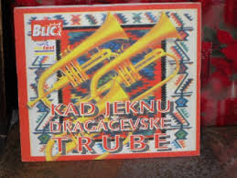 | 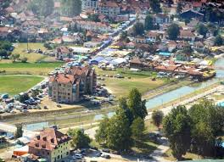
Picture 1:Dragacevo Trumpets | Picture 2:Panorama of Guca.

3. IMPORTANT FACILITIES IN GUCA

People from Dragacevo have always been great builders, sought both in Serbia and abroad. Some of the most important buildings in Guca are: building „Staro Načelstvo“ (where is seat of local government unit), Centre for Culture, Sport and Tourism of municipality of Lucani, hotel „Zlatna Truba“, church„Sveti Arhangel Mihailo i Gavrilo“. In addition to these facilities, there are alsobuildings as: post offices, banks, hospitals, primary and secondary schools, kindergartens. Recentlyin Guca, there was built a magnificent sports center with an olympic swimming pool and helipad. In town there is a large number of boutiques, restaurants and a museum of trumpet.„Lapidarijum“, museum of „krajputaša“ (roadside symbolic gravestones)includes several dozen grave stones, including those who are considered the most beautiful examples of these monuments(www.cksguca.rs). They weretransferred here in 1984. - to be preserved and presented in a way suited to modern science. Within the center of the town is a monument „Trubač”.

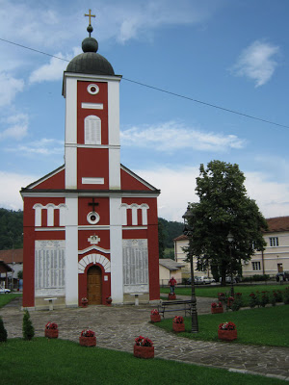 | 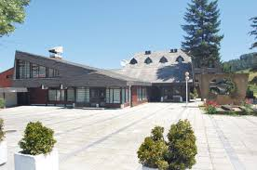
Picture 3:Church „Sveti Arhangel Mihailo i Gavrilo“. | Picture 4:Hotel „Zlatna Truba“
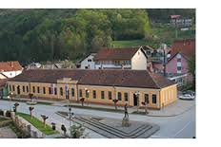 |  | 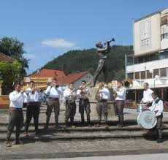
Picture 4.Building „Staro Načelstvo” |  | Picture 5. Monument„Trubač“.
4. FORMS OF TOURISM WHICH CAN BE DEVELOPED IN DRAGACEVO

Based on the presented, available natural tourist values, on the territory of Dragacevo there are the conditions for development of following forms of tourism:
• Event Tourism.
• Eco-Tourism.
• Countryside Tourism.
• Excursion Tourism.
• Hunting and Fishing Tourism.
• Winter Tourism.
• Sports and Recreation Tourism.
Some of these forms of tourism are,in certain amount, already developed, and some only remained in plans for future development. Of all mentioned forms of tourism, the most developed form in Dragacevo is event tourism. Many traditional events are being held, which are of great importance for Dragacevo tourism, andwhich by the cultural significance, value and volume of tourist visits transcend the limits of local. Dragacevo Trumpet Festival is one of the largest, most famous cultural - artistic manifestations of traditional folk creativity in Serbia and the Balkans.

5. INFLUENCE OF TRUMPET FESTIVAL ON SERBIAN AND DRAGACEVO TOURISM

5.1. Influence of trumpet festival on serbian tourism

Serbia is a country that occupies the central part of the Balkan Peninsula, therefore represents the intersection of roads from north to south and east to west, which makes a very positive effect on its tourism. In addition to attractive tourist locations, which Serbia has planty of, event tourism is very important, and events that are organized in our country. One of the biggest events held in Serbia is Dragacevo Trumpet Festival in Guca. First Trumpet Festival was organized in 1961. in much modest edition then today, when the first winner was Desimir Perišić, in whose honor monument was built at the entrance in Guca(Tadić, A. 2010). Trumpet Festival,during the first week of the month august, is visited by hundreds of thousands of domestic and foreign tourists. Because of fact that at the time of festival Guca and Serbia are visited by many foreign tourists, we can conclude that the Trumpet Festival has a very favorable impact on the development of tourism and Serbian economy. Guests of festival are mostly young people, and the basic characteristic of young tourists is active holiday, which means that after the festival vast majority of these tourists will also visit other tourist sites and thus speed up and encourage their development.
Tourists who come to the festival pay local taxes, from which the budget of the Republic Serbia benefits, andfrom that budget the funds would later be spent on improving and developing tourist attractions of Serbia, which will lead to the arrival of new tourists and will lead to improvement of life standard of the local population. Taking all this into consideration, we can say that from this complex manifestation country of Serbia and all its citizens have immense benefits, because during the festival foreign tourists in Serbia spend several hundred million euros, which has extremely positive effect on the life standard of the population.

5.2. Influence of trumpet festival on dragacevo tourism

Dragacevo is located in western Serbia. His central area is occupied by town of Guca, where each year Dragacevo Trumpet Festival is being held.
Dragacevo Trumpet Festival has a huge impact on all spheres of life in Dragacevo, especially on tourism and economy. Guca - town hosting the festival, has only 3000 residents, but during festival through town passes nearly million domestic and foreign tourists.Hotels and private accommodation capacities are not enough for needs during the Trumpet Festival. Tourists reserve accommodation in hotels and in private apartments in Guca months ahead, and when accommodation capacities are filled then tourists seek accommodation in surrounding villages, and in hotels in Cacak, Pozega, Ivanjica, Kraljevo, and so on. Tourists who come to the festival in private vehicles pay a parking ticket in the amount of 1.000 dinars, which is direct income of municipality Lucani. All of this speaks clearly about influence of Trumpet Festivalon tourism and the economy of Dragacevo, because for a small municipality such as Lucani, funds that municipal budget earns from the festivalconstitute large part of that same budget.
Trumpet Festival have indirect affect on tourism of Dragacevo, because tourists, who for various reasons were not able to visit the festival, are coming to Dragacevo to visit others, less known, tourist attractions because of the name and importance of Trumpet Festival.

6. CONCLUSION

More and more countries in the world recognize the importance of tourism and among them is Serbia. Serbia is a country with huge tourism potential in all aspects of tourism, especially in the event tourism. Events such as the Trumpet Festival in Guca and Exit in Novi Sad have enormous significance for the entire economy of Serbia. Guca Trumpet Festival becomes more influential in the world every year, because people from whole world plan their vacations around the date of Trumpet Festival. This is a chance for Serbia,and especially for citizens of Guca who areearning from the festival. The rapid development of the Dragacevo Trumpet Festival, and the arrival of an increasing number of foreign tourists, have positive effect on economy of Serbia and will improve the lives of us all.

REFERENCES

- Đuričić, R.M., Đuričić, M.M., Menadžment kvaliteta u turizmu, VPTŠ, Užice, 2015,
- Đuričić, R.M., Đuričić, M.M., Integrisani menadžment sistem u turizmu, VPTŠ, Užice, 2015,
- Stojić, N., Bojović, N., Lukić, J., Slavković J. M.: “Trubačka budilica od Guče do večnosti“ Beograd, TV Galaksija - Čačak, Radio Dragačevo - Guča i Tifanny Print - Čikago (SAD), 2006.
- Tadić, A., Slavković, J. M., Stojić, N., Marinković, R.M.: “Guča, pola veka sabora trubača“ (1961–2010), Guča/Beograd, Centar za kulturu, sport i turizam opštine Lučani „Dragačevo/Princip Pres, 2010.
- www.turizamdragacevo.org.
- www.cksguca.rs.

