STOCK EXCHANGE OPERATIONS ON THE EXAMPLE OF THE BANJA LUKA STOCK EXCHANGE

Milosav Ikonić¹, Student, Milutin Đuričić²; PhD,
¹Rogatica, Serbian Republic, Bosnia and Herzegovina, e – mail:milosavikonic@gmail.com
²High Business Technical School of Applied Studies, Uzice, SERBIA, e-mail: milutin.djuricic@vpts.edu.rs

Summary:Through this work is explained the notion of stock exchange and its functions, as well as the short history of the stock exchange and stock exchange businesson the example of the Banja Luka stock exchange market. It is described work of the Banja Luka stock exchange market, strategic objectives, systems of business, calculation and the settlement and the cost of trading. The work of the Banja Luka Stock Exchange is compered with stock exchange in the other entity of the same state and that is the Sarajevo Stock Exchange market. It was pointed out that the rights and the proper decision in the right time means good business move. Whether the decision is correct is usually later learns but in a moment before she must be taken.

Key words:Stock Exchange, Stock market business, the Banja Luka Stock Exchange market, fees,

1. INTRODUCTION

Transitional changes face us with the numerous and diverse, more or less the new phenomens. One of these phenomensis stock exchange. Stock Exchange, before all financial stock exchange and Stock market businessfor the majority of us are newness that enters in our lives and our business.
SinceStock Excange is relatively new concept in our area, their emergence was connected to the end of the civil war in America. People was saying it was occurred spontaneous. During the war in Bosnia and Herzegovina, there was issued different securities with the aim of collecting funds for financing war. Unregulated trade with these securities created the problems of the participants in the trade. To avoid problems, traders agreed to be compiled on a certain place and in the correct scheduled time to marketed.
The key functions of the stock exchange is to ensure continuous market of securities at prices which do not deviate significantly from those for which they previously sold.
The existence of the stock exchange, respectively the stock trade in a market, indicates that the market is the safe and that it is not under the influence of the external risk in business. Strengthening the finances business points to the rise of security in a certain economy.
All Stock market crisis through history related or for the failure of the market effects, or for the breakdown in the money market, and the latest experience can show us that the crisis mortgage market may cause the crisis of world proportions. Because of all of this stock exchange are a serious topic on which we will consider the facts through this work.

2.THE NOTION OF STOCK EXCHANGE AND ITS FUNCTIONS

There is more definition of the term stock exchange. Stock Exchange, often, defined as a space in which we can trade with long-term financial instruments. It is organized as secondary market securities from the value of the (SECURITIES) with a completely precise and strictly defined by the rules of the trading, rules of the receipt of the market of the material on the stock exchange and completely precise criteria which define the conditions and the way for EU membership on the stock exchange [1]. The stock exchange is institutions of the financial market related to the correct place on which the trades standardized market material, according to the defined with rules of trading.
From the beginning, the stock exchange was in connectionwith a specific place - meeting place of traders/mediators, who are among themselves in within a certain period of time and according to the rules that are found. In the marketsit is possible to trade with effects and goods, and according to the case of the stock exchange, stock exchange are divided in effective, store and mixed. On the first marketit is possible to trade with securities, foreign exchange information and financial products, on the second market with goods, and on the third with one and other.
The subject of the trading on the stock market must be standardised. Another feature of the stock market is the absence of a trading item from the place where it is trading. The rules of the trading on the stock exchange have a dual function - The rules of trading on the stock exchange have a dual function - to provide for an ever more detailed standardization of the subjects and rules of trade for which the turnover is carried out, as well as to provide protection to participants in trading. Protection from market risks is the main reason for the establishment of a stock exchange institution, so the organization of trade in it is subordinated to it [2].
The stock exchange can not trade itself, but it provides the conditions for others to trade in quality and safe.. Considering the specificity of the organization and the way of doing business on the stock exchange, the stock market as an inseparable part of the market and the market economy in general is an extremely important segment, from whose business and success depends the performance of other markets, that is, the market economy of a given country and the world economy as a whole. Because of that stock exchange is considered most important market institution [3].
The basic functions that each stock exchange has to ensure to the market are:
- Information of all market participants on securities to be traded on stock exchanges before commencement of trading (prospectus) and after trading (exchange rate list).
- Listing- ensure that the issuer meets the prescribed conditions by the stock exchange.
- Trading, as a process of determining the price on the market by facing the supply and demand according to the rules of trading and in the trading system of the stock exchange.
- Reporting after completion of the trading process about the price, volume of trading and about other elements from the trading process [4].

3.THE BANJA LUKA STOCK EXCHANGE

The Banja Luka stock exchange of securities a.d. Banja Luka was established on May 9,2001 in Banja Luka. It is made of the 11 shareholders, and the largest participation –has the NLB bank a.d. Banja Luka with 503 actions. Stock Exchange has its Managing board, supervisory board, Commission for quotation and the Berza court.
The mission of the Banja Luka stock exchange is ensuring the efficient infrastructure for the connection of the offer and demand on the capital market of the Republic of Srpska.
The vision of theBanja Luka stock exchange has become an efficient and modern service of the investor who is integrated in the regional capital market.
On picture 1 are presented last 10 transactions the Banja Luka stock exchange related to the end of October 2016.

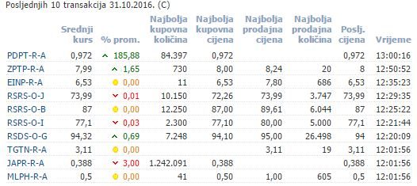
Middle course | % of traffic | Best Buy Quantity | Best Buy Price | Best selling price | The best sales quantity | last price | Time

Picture 1. – Last 10 transactions on Banja Luka stock market
(Source: https://www.blberza.com/Pages/Default.aspx)

3.1.Strategic objectives

The Priority strategic goals of the Banja Luka stock exchange are: the promotion of the primary market of securities, development of the corporate governance, the education of the participants in the capital market and the population, the creation of preconditions for the improvement of the liquidity of the market, technological improvement in connection with the sign system of trading, the international promotion of domestic capital markets and attracting foreign investorsand development new technological service.
The Promotion of the primary market of securitiesincludes:
- improvement of the regulations related to the primary offer of securities
- education of private company management regarding the possibility of raising capital on the stock exchange and support for the listing of shares of private companies on the stock exchange
- professional support to issuers of municipal bonds
- support to the securitization of public sector debt
- development of the primary market of bonds and treasury bills of Republika Srpska.
The development of the corporate governance includes:
- promotion of good practices of corporate governance and continuous preservation of new projects
- supporting the introduction of corporate governance standards in public enterprises and
- improvement of the regulatory environment for business operations of companies.
The education of the participants in the capital market and the population includes:
- development of teaching contents related to financial markets and personal finances for secondary school students and students and improvement of curricula in this field
- organizing special seminars for educational institutions, company administrations, judicial institutions, associations of accountants and other professional associations
- Continuous education of the management and employees at the stock exchange in connection with modern trends in the capital markets in the world.
Creating the preconditions for improving the liquidity of the market encompasses:
- Continuous improvement of trading rules and balances
- creating a stimulating environment to support liquidity of the market
- Support to the reform of the pension system in connection with the establishment of voluntary pension funds
- support to the development of the investment fund industry
Technological improvements in the stock exchange trading system include:
- continuation of the implementation of the FIX protocol in the trading system of the stock exchange
- enabling direct access to the market for investiture
- development of electronic systems for connection with members of regional stock exchanges
The international promotion of the capital marketincludes:
- international investment conferences in cooperation with regional stock exchanges
- improvement of the Internet portal of the Banja Luka Stock Exchange
- cooperation with regional stock exchanges (data distribution, joint indexes, promotion and marketing)
- improvement of the content from the domestic capital markets, which are forwarded through the leading world vendors.
The development of new technological serviceincludes:
- Multilateral compensation system, cession and factoring
- The Platform for coverage and valuation of the securities portfolio for the needs of investment funds
- The platform for the stock of goods

The partnership relationship with the realization of the strategic objectives of the Banja Luka Stock Exchange is realized in cooperation with the Government of the Republic of Srpska and the competent ministries, the Securities Commission of Republika Srpska, members of the stock exchange and trade association of stock exchange intermediaries, the Central Securities Depository, the companies whose shares are listed on the official Stock Exchange, Central Bank of BiH, Insurance Agency of the Republic of Srpska, Association of Banks of Bosnia and Herzegovina and the Banking Agency of Republika Srpska, Regional Securities Stock Exchange and, in other partner institutions (Union AAARS, National Institute pedagogical RS et al).

3.2.Trading Systems

Trading on the Banja Luka Stock Exchange takes place through stock exchange brokers, members of the stock exchange. An electronic trading system developed at the Ljubljana Stock Exchange. Members of the stock exchange may be companies for securities trading and a bank based in the Republic of Srpska. Stock market members do not have to be shareholders of the stock market. The Banja Luka Stock Exchange is traded with the continuous method and method of periodic auctions with the prevailing price. It trades five times a week: Monday, Tuesday, Wednesday, Thursday and Friday. The continuous method is traded with shares of issuers on the stock exchange listing. Continuous trading method is also traded with free market shares that meet liquidity criteria.
The number of possible trading days must be greater than 30. The trade is divided into three phases. Discounted auctions last from 15 to 20 minutes. Daily price fluctuation is limited to ± 20%. Dynamic limits are at ± 3%.
The opening price is calculated according to the following algorithm:
- Quantity the largest volume of transactions,
- The minimum rest,
- if the remainder exists on the purchase side, the highest price is taken, and if the side of the sale is taken the lowest price,
- average price between the two selected prices according to the previous criteria.

Auction trading method
- The auction method is traded on the shares of free-market issuers that do not meet the liquidity criteria. Trading is divided into three phases:
- In the period from 08:30 to 12:00 + "random time" (random number selected from 0 to 120 seconds), entry, modification, retention, release and withdrawal of sales and purchase orders in BST is permitted..
- at 12:00 + "random time" opening the market.
The opening price is based on the following criteria:
- the largest volume of traffic,
- minimum residue,
- if the remainder exists on the purchase side, the highest price is taken, and if the lowest price is taken on the sales side,
- the average price between the two selected prices according to the previous criteria..
When the prevailing price is formed, the jobs are made according to the following priorities: price, and older timestamp. The following types of orders are allowed: limited orders, orders with additional terms of execution (order all or nothing, order with minimum amount of all concluded jobs) and orders with additional terms of execution time (daily, to a certain date, open). Discontinued auctions takes 60 minutes. Dynamic limits are at ± 3%.

Exchange members can conclude block transactions outside the organized market if the following conditions are met:

1. the value of the transaction amounts to at least 500.000 KM,

2. the object of the transaction is a block of securities, and a member of the Exchange concludes such a business for his account and for the account of one client or account of two clients.

3.3.The Calculation and the settlement

After the end of the trade, the Banja Luka Stock Exchange sends a report to the Central Registry about the activities that were concluded that day. The report from the Banja Luka Stock Exchange, which the Central Registry receives in electronic form, contains the following data:
- a security label that is the subject of a trade,
- the amount of the security,
- the price reached on the stock exchange,
- the code of the brokerage house of the seller and the brokerage house of the buyer,
- account number of the seller's client and the customer's account number
Upon receipt of the reports from the Banja Luka Stock Exchange, the Central Registry individually for each brokerage house performs clearing and settlement of monetary liabilities arising from transactions concluded on the stock exchange, ie determines the total value of sales activities, the total value of purchases and the difference between these two amounts, or the amount of net debt or the amount of net receivables.
Cash obligations arising from transactions concluded at the Banja Luka Stock Exchange are executed through a clearing and settlement account, which brokers have opened with one of the commercial banks, exclusively for this purpose. The settlement of the financial liabilities of brokerage houses is done through the account for settlement and settlement of the Central Registry, which is open with the Central Bank.

3.4.The costs of trading

3.4.1. The fee paid by the members of the stock exchange

Members of the Exchange pay a membership fee, access to a stock exchange trading system, fees for concluding deals and fees for organizing auctions for a package of shares.
A member of the stock exchange pays membership fee when joining the membership in the amount of 8,000 BAM once, while the monthly membership fee is 400 BAM, per month. In case of status changes of the members of the Exchange (merger, merger), the legal successor pays a one-time fee in the amount of 2,000 BAM. The special authority and the direct participant in the money market do not pay the membership fee.
Access to the stock exchange trading system is charged at the monthly level for the use of the trading center 200 BAM for the first station, or 100 BAM for the second and each subsequent trading station. One-time fee for introducing an integral approach to the trading system through FIX protocol is 1000 BAM. Monthly fee for integral access to the trading system for trading through FIX protocol is 600 BAM. A member of the Exchange with special powers and a direct participant in the money market does not pay the fee for access to the stock exchange trading system.
The transaction fee is charged to the buyer and the seller of securities on the value of the concluded transaction and amounts:
- 0.10% for action
- 0.02% for bonds
- 0.01% for Treasury Operations Section records and other short-term Securities
- 0.01% for REPO Operations
- 0.10% for other Financial Instruments
The amount of the fee for concluding a business can not exceed 20,000 BAM per transaction.
The amount of the fee for concluding deals in the public offer of securities for the issuer (seller) can not be higher than 5,000 BAM.
T-bill deals are charged only on the secondary market.
Refund for REPO jobs is paid by the seller of securities for jobs that are concluded for a period longer than a month.
Expenses for termination or correction of work are paid by the applicant in the amount of 10 BAM per transaction.
For the organization of the auction, the package action package, the package of shares, pays 200 BAM per package of shares, while for repeated auctions for the same package of shares it amounts to 50 BAM

3.4.2. Fees paid by issuers of securities
The fee for admission of securities to the official stock exchange market is 3,000 BAM for shares. The fee for admission of securities to the free market is 300 BAM.
Annual fee for trading in shares on the official stock exchange market:

Total capital of the issuer in BAM | feeinBAМ
up to 5.000.000 | 1.000
од 5.000.001 up to 10.000.000 | 2.000
from 10.000.001 up to 20.000.000 | 3.000
from 20.000.001 up to 50.000.000 | 4.000
from 50.000.001 up to 100.000.000 | 6.000
from 100.000.001 up to 200.000.000 | 8.000
from 200.000.001 and more | 10.000

For emitente who have less than 200 shareholders compensation may not be higher than 1,500 BAM. Issuers whose shares are listed on the official stock exchange market - the initial market (List C) are reduced by 25% of the annual fee.

Annual fee for trading bonds on the official stock exchange market:

Emission value in BAM | Fee in BAМ
up to 1.000.000 | 500
from 1.000.001 up to 2.000.000 | 1.000
from 2.000.001 up to 5.000.000 | 1.500
from 5.000.001 up to 10.000.000 | 3.000
from 10.000.001 up to 50.000.000 | 6.000
from 50.000.001 up to 100.000.000 | 8.000
over 100.000.000 | 10.000

The annual fee for the stock in the free market:

Total capital of the issuer in BAM | Fee in BAМ
up to 10.000.000 | 200
over 10.000.000 | 500

The annual fee for the trade of the bonds in the free market is 200 BAM.

4. THE COMPARISON WITH THE SARAJEVO STOCK EXCHANGE

Banja Luka, Sarajevo and Vienna Stock Exchange signed a tender 05.11.2009. on the basis of which the Vienna Stock Exchange will create, calculate and publish an index that includes shares from Banja Luka and Sarajevo Stock Exchange. Index name is: BATX (Batex) - Bosnian traded index. BATX includes six most liquid stocks, two from Banja Luka and four from the Sarajevo Stock Exchange. The shares of Telekom Srpske a.d. have the highest share in the initial composition of the index. Banja Luka, and beside Telekom Srpske, from the Banja Luka Stock Exchange, the shares of Nova banka from Banja Luka are included in the index.
BATX is the first "investment" index calculated for shares listed on the Banja Luka and Sarajevo Stock Exchange, ie the index will be able to serve as a basis for the creation of derivative securities (structured products, futures and options). The index is calculated and published in real time, in three currencies, (BAM, EUR and USD). BATX will further increase the visibility of the capital markets of the Republic of Srpska and Bosnia and Herzegovina with international investors, and enable them to invest in Banja Luka and Sarajevo Stock Exchange. The index is calculated and published as of December 1, 2009.
In 2015, the total turnover of BAM 1,219,583,580.59 was realized on the Sarajevo Stock Exchange, which makes 68.57% of the total turnover realized on the BH stock exchanges. Within 7,015 transactions, 35,718,506 securities were traded. Using the infrastructure of the Sarajevo Stock Exchange - the stock exchanges in this year, 24 public offers have been successfully concluded, in the total amount of 615.302.962,73 BAM.
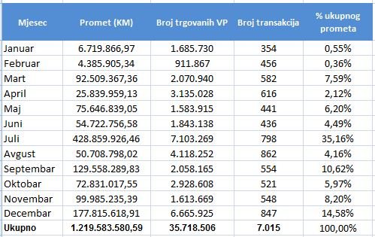
Moon | Traffic (KM) | Number of TS | Number of transactions | % of total traffic

Picture 2.Annual report of the Sarajevo Stock Exchange
(Source: http://www.sase.ba/v1)
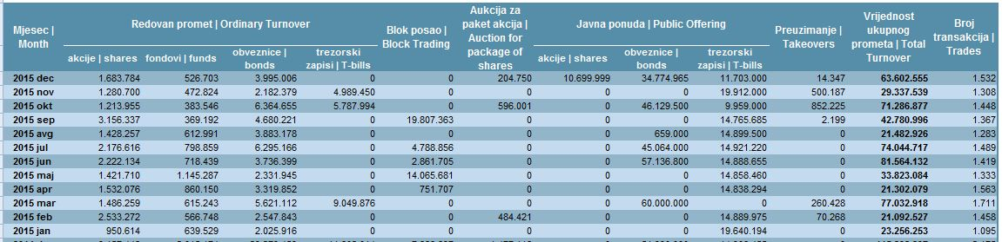
Picture 3. - Annual report of the Banja Luka Stock Exchange
(Source:http://www.blberza.com/Pages/default.aspx)
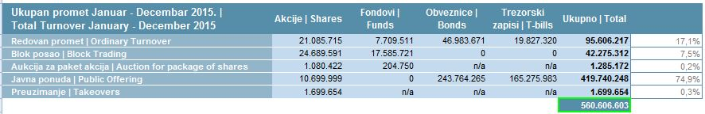
Picture 4. The total annual report of the Banja Luka Stock Exchange
(Source: http://www.blberza.com/Pages/default.aspx)

From the information provided, we can see that the Sarajevo Stock Exchange achieved turnover twice higher than the Banja Luka Stock Exchange in 2015. Total turnover on the Banja Luka Stock Exchange in 2015 amounted to 560,606,603 convertible marks, while the turnover on the Sarajevo Stock Exchange amounted to 1,219,583,580.59 Convertible Marks.

5. CONCLUSION

Stock exchanges will be in the future and will be the place where the supply and demand relationship will be met, which can be expected to greatly improve their business through new information innovations achieved through software and hardware. Stock market and stock exchange operations are part of modern business. At the stock exchange it is important to make a good decision at the right time, which means a good business move. Whether the decision is correct is usually found later, but at some point it must be made.
Through the form of its stock market, the form of business changed, but the essence was the same. They were meeting offers and demand. At the present time, the stock market can serve as an indicator of potential new economic crises and bad business in the world. The Banja Luka Stock Exchange is a young stock exchange, which has greatly helped the development of the securities market in the Republic of Srpska and Bosnia and Herzegovina.

REFERENCES:

- ДОСТАНИЋ Г., Тржиште капитала, Београдска пословна школа, Београд, 2007,.
- БОГДАНОВИЋ М.,ШЕСТОВИЋ Л.,Економија од А до З, Београдска отворена школа и Досије, Београд, 200.,
- УНКОВИЋ М., МИЛОСАВЉЕВИЋ М., СТАНИШИЋ Н., Савремено берзанско и електронско пословање, Универзитет Сингидунум, Београд.2009,
- ЈЕРЕМИЋ З., Финансијска тржишта, Универзитет Сингидунум, Београд, 2008,.
- https://www.blberza.com/Pages/Default.aspx,
- http://www.sase.ba/v1/,
- http://www.blberza.com/Pages/default.aspx,
- http://www.blberza.com/Pages/default.aspx.

