SPECTROPHOTOMETRIC DETERMINATION OF NITROGEN OXIDE IN AIR
Ana Kremić¹; PhD Snežana Aksentijević²
¹ Business and Technical College of Applied Sciences, Užice, Serbia, ana.kremic983@gmail.com
²Business and Technical College of Applied Sciences, Užice, Serbia, , snežana.aksentijevic@vpts.edu.rs

Abstract: Air pollution is an important risk factor for people's health in Europe and around the world. The main pollutants in the air are: sulfur dioxide, suspended particles, CO, NO2, suspended particles (soot), photochemical oxidants (terrestrial ozone). The goal of this paper is to determine the concentration of nitrogen dioxide by the spectrophotometric method in ambient air, and compare the measured values with the allowed daily limit values prescribed by the regulation. Sampling was carried out in two measuring points.
Key words: air pollution, monitoring, nitrogen dioxide, spetophoretometric method

1. INTRODUCTION
The quality of air in the Republic of Serbia is conditioned by the emissions of SO₂, NO_{x}, CO, powder materials and others, which originate from thermal power plants and industrial plants, and especially critical periods are in the heating season. Air quality monitoring is carried out all over the world at local, regional, continental and global level. The basic air quality monitoring program should provide essential data necessary for the development of air quality standards and enable the development of an acceptable air quality protection program [1].
According to performance, measurements can be: mobile, periodic, continuous periodic and continuous. The program includes monitoring the contents of the main substances in the air: sulfur dioxide, suspended particles, CO, NO₂, suspended particles (soot), photo-chemical oxidants (terrestrial ozone). The goal of the basic air quality monitoring program is to monitor long-term air pollution trends in order to determine the degree of improvement or deterioration of air quality in urban and industrial environments. Other pollutants may also be included in this program, depending on the local industry.

2. AIR POLLUTION AIRCRAFT (NOx)

Ambient air is a very important factor in the environment in terms of the potential impact on human health, because it represents a matrix through which different chemical compounds reach the organism. One of the pollutants is nitrogen oxides, especially nitrogen (IV) oxide, which is particularly dangerous because its volume in the air does not decrease.
There are three types of nitrogen oxides in the atmosphere: nitrogen (II) - oxide (NO), nitrogen (IV) -oxide (NO₂) and nitrogen (I) - oxide (N₂O). The most important forms of reactive nitrogen in the air are nitrogen (II) - oxide (NO) and nitrogen (IV) - oxide (NO₂), which are commonly referred to as NO_{x}. Natural sources of nitrogen oxides are the combustion of biomass (forest fires), as well as during lightning.
All anthropogenic NO_{x} melt into the atmosphere as a result of combustion of a fossil fuel containing nitrogen compounds. For example, combustion of coal in thermal power plants and oil (containing nitrogen compounds) in factories and vehicles. Although the emissions of nitrogen oxides of anthropogenic origin make up about 1/10 of total emissions, it is very important for air pollution, especially urban and industrial areas, where nitrogen oxide production is mainly concentrated.
Azot (II) - oxide is a colorless odorless gas that is oxidized in the atmosphere by forming nitrogen (IV) -oxide which is scarlet, acidic, highly corrosive gas, strong and sharp odor. Azot (IV) - oxide, in addition to sulfur (IV) - oxide, is the biggest culprit for acid rain formation. Its emissions are related to industrial activities and motor vehicles. It is transformed into air into nitrite and nitric acid, thereby reducing the pH of the precipitation [1].
The Public Health Institute of Uzice has done measurements and determination of the concentration of nitrogen dioxide.
Sampling was performed at 2 measuring points for the period from April 13, 2017. - 05/08/2017. year: measuring place no. 1 - P Green Market, ul. Lipa bb, Užice; measuring place no. 2 - S Sevojno Clinic, Heroja Dejovića bb, Sevojno

Table 1: Limits of parameters for protection of human health, according to the Regulation on conditions for monitoring and requirements for air quality ("Official Gazette of RS", No. 11/10, 75/10 and 63/13)[4]

Contaminated matter μg/m³ | Period of time  Averaging | GV (limit value) | It must not be exceeded more than X times in a calendar year
Azot  dioxide (NO₂) | 1 h | 150 | 18 x
 | 24 h | 85 | -
 | calendar year | 40 | -

3. METHODS AND MEASURING DEVICE

Measurement procedure is in line with the Regulation on conditions for monitoring and air quality requirements ("Official Gazette of the Republic of Serbia", No. 11/2010 and 75/2010 and 63/2013)[4].
To determine the nitrogen dioxide concentration, a UV-1800 spectrophotometer manufactured by Shimadzu Japan was used. Spectrophotometers are photometers that use prisms or grids to obtain monochrome light. Principle of work: white light from a certain source passes through the inlet and diffracts through the diffraction grid. One part of this decayed light containing similar wavelengths (monochromatic light) passes through the second slit and comes to a sample containing sample sample to be determined (analyzed). The part of the light absorbed in the solution passes through the solution and falls on the photoconductor of the instrument which measures the amount of light that has been transmitted [2].

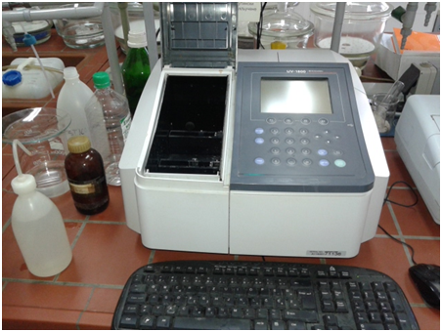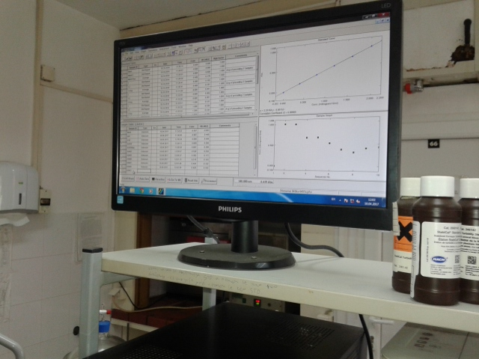
Figure 1: UV-1800 spectrophotometer
Applied standard for - determination of mass concentration of nitrogen dioxide in air ISO 6769: 1998 Modified Griess-Saltzman method.
Principle of the method: The air sample is collected in the absorption triethanol amine spectrophotometric method Griess-Saltzman. The nitrite ion (NO₂) with N- (1-naphthyl) - ethylenediamine hydrochloride, NEDA-reagent, creates red coloring with an intensity of 540 nm.
Analysis procedure: Air is passed through a gas washer in which an aqueous solution of triethanolamine is used for nitrogen dioxide sampling. At the end of the twenty-four-hour sampling period, the flow on the device and the sampling period are recorded on the ground. With the sampling record, the gas flusher for NO₂ (abrasive scrubber) is brought to the laboratory (Figure 2), where it receives a laboratory number (the number of samples) that is monitored during all trials.
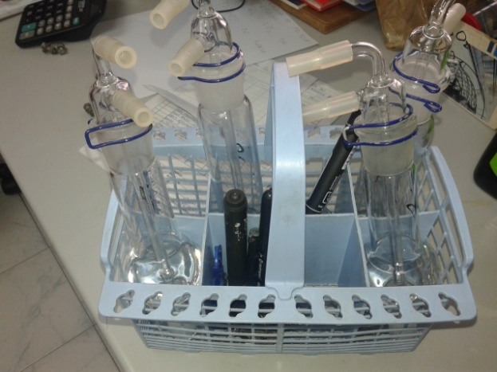
Figure 2: Gas coolers for NO₂
From the gas washer, 10 ml of the extraction solution (alkotype) is pipetted into a normal vessel of 25 ml volume. In parallel, it is done blank, under the same conditions. 1.0 ml of hydrogen peroxide H₂O₂, then 10.0 ml of the sulfanilamide solution and 1.4 ml of the NEDA reagent solution are added. Fill with distilled water to a line in a normal vessel. It is strong after the addition and it is allowed to stand for 10 minutes, due to complete separation of the color (Figure 3).
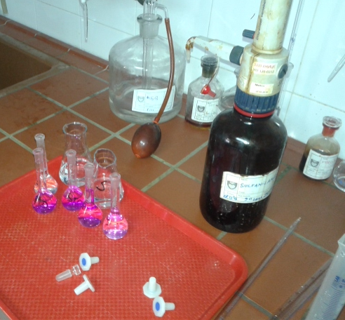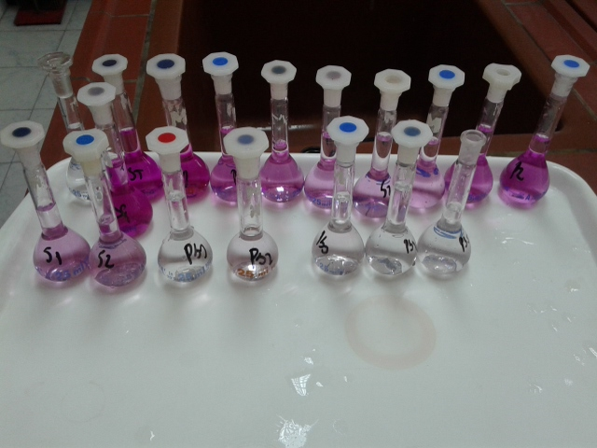
Figure 3: Preparation of measurement samples
The determination of the concentration is performed on the spectrophotometer, where the wavelength is set to 540 nm. Set off zero with a blank, dip the prepared sample, pour into a quartz cuvette 1x1 cm, and record absorbency. The amount of nitrogen dioxide is determined based on the calibration curve, made from a series of standard nitrium nitrate solutions.
Table 2: Measured values of nitrogen dioxide at measuring site no. 1 - P (Green Market)
MEASURING POINT:  Market |  |  | ANALYTICAL DATA
 |  |  | Nitrogen dioxide
Number of samples | Sampling Period | Date of receipt | Flow | Measured values
0459/A | 13.04.2017 | 18.04.2017 | 0,735 | 0,609
0462/A | 14.04.2017 | 18.04.2017 | 0,696 | 0,529
0465/A | 15.04.2017 | 18.04.2017 | 0,722 | 0,382
0466/A | 16.04.2017 | 18.04.2017 | 0,734 | 0,318
0467/A | 17.04.2017 | 18.04.2017 | 0,742 | 0,404
0471/A | 18.04.2017 | 19.04.2017 | 0,673 | 0,277
0473/A | 19.04.2017 | 20.04.2017 | 0,778 | 0,574
0475/A | 20.04.2017 | 21.04.2017 | 0,747 | 0,367
0477/A | 21.04.2017 | 22.04.2017 | 0,742 | 0,420
0478/A | 22.04.2017 | 23.04.2017 | 0,741 | 0,547
0479/A | 23.04.2017 | 24.04.2017 | 0,761 | 0,641
0491/A | 24.04.2017 | 25.04.2017 | 0,715 | 0,849
0493/A | 25.04.2017 | 26.04.2017 | 0,707 | 0,813
0495/A | 26.04.2017 | 27.04.2017 | 0,657 | 0,629
0503/A | 27.04.2017 | 28.04.2017 | 0,887 | 1,047
0525/A | 28.04.2017 | 29.04.2017 | 0,612 | 0,893
0526/A | 29.04.2017 | 30.04.2017 | 0,695 | 0,337
0527/A | 30.04.2017 | 01.05.2017 | 0,701 | 0,252
0531/A | 01.05.2017 | 02.05.2017 | 0,616 | 0,384
0532/A | 02.05.2017 | 03.05.2017 | 0,675 | 0,451
0535/A | 03.05.2017 | 04.05.2017 | 0,677 | 0,424
0547/A | 04.05.2017 | 05.05.2017 | 0,684 | 0,360
0554/A | 05.05.2017 | 06.05.2017 | 0,747 | 0,367
0557/A | 06.05.2017 | 07.05.2017 | 0,742 | 0,420
0562/A | 07.05.2017 | 08.05.2017 | 0,741 | 0,547

Table 3: Measured nitrogen dioxide values at measuring site no. 2 - S (Sevojno)
MEASURING POINT:  Sevojno |  |  | ANALYTICAL DATA
 |  |  | Nitrogen dioxide
Number of samples | Sampling Period | Date of receipt | Flow | Measured values
0460/A | 13.04.2017 | 18.04.2017 | 0,680 | 0,428
0463/A | 14.04.2017 | 18.04.2017 | 0,673 | 0,215
0468/A | 15.04.2017 | 18.04.2017 | 0,674 | 0,218
0469/A | 16.04.2017 | 18.04.2017 | 0,704 | 0,207
0470/A | 17.04.2017 | 18.04.2017 | 0,696 | 0,191
0472/A | 18.04.2017 | 19.04.2017 | 0,698 | 0,159
0474/A | 19.04.2017 | 20.04.2017 | 0,729 | 0,017
0476/A | 20.04.2017 | 21.04.2017 | 0,718 | 0,098
0480/A | 21.04.2017 | 22.04.2017 | 0,722 | 0,165
0481/A | 22.04.2017 | 23.04.2017 | 0,705 | 0,236
0482/A | 23.04.2017 | 24.04.2017 | 0,722 | 0,167
0492/A | 24.04.2017 | 25.04.2017 | 0,714 | 0,335
0494/A | 25.04.2017 | 26.04.2017 | 0,715 | 0,437
0496/A | 26.04.2017 | 27.04.2017 | 0,657 | 0,402
0504/A | 27.04.2017 | 28.04.2017 | 0,686 | 0,285
0528/A | 28.04.2017 | 29.04.2017 | 0,675 | 0,208
0529/A | 29.04.2017 | 30.04.2017 | 0,690 | 0,160
0530/A | 30.04.2017 | 01.05.2017 | 0,691 | 0,186
0533/A | 01.05.2017 | 02.05.2017 | 0,603 | 0,192
0534/A | 02.05.2017 | 03.05.2017 | 0,670 | 0,203
0536/A | 03.05.2017 | 04.05.2017 | 0,670 | 0,238
0548/A | 04.05.2017 | 05.05.2017 | 0,653 | 0,265
0555/A | 05.05.2017 | 06.05.2017 | 0,726 | 0,367
0558/A | 06.05.2017 | 07.05.2017 | 0,749 | 0,420
0563/A | 07.05.2017 | 08.05.2017 | 0,745 | 0,547

4. CONCLUSION
The results of the investigation of the concentration of sulfur dioxide, nitrogen dioxide and soot in the air showed that the air of the city of Uzice in the period from April 13, 2017 to May 8, 2017. year. was good or moderately good quality. At no single measuring point, there were no exceeding of the limit values of these pollutants for all 25 days. The contribution of NO₂ to the increase in the air quality index was recorded for 1 day at the measuring point number 1 and one day at the measuring point number 2.
In the winter period, the concentration of pollutants in the air is increased, given the large number of individual fireplaces in the city, poor air flow, the position of the city (basin) and other factors, and air quality often drops to a level that is characterized as very unhealthy or even dangerous. Which is why constant monitoring of air quality is of the highest importance.

LITERATURE
[1] Đarmati Š., Pollution and air pollution, Belgrade Polytechnic - College of Professional Studies, Belgrade, 2007.
[2] Aksentijevic S., Methods of Pollution Analysis, Visoka poslovno-tehnička škola strukovnih studija, Užice, 2015.
[3]http://zavodue.org.rs/AZ%2027april%20-%2028april%202017.htm
[4] Decree on requirements for monitoring and air quality requirements ("Official Gazette of RS" No. 11/10, 75/10 and 63/13)

