**LANDFILL GAS UTILIZATION FOR ELECTRICITY GENERATION**

**Milena Tomić, Ivana Radmilović, Darinka Gluščević, Ljiljana Trumbulović**

Visoka poslovno-tehnička škola, Užice e-mail (milenatomicue@gmail.com)

***Abstract:*** *The paper presents the design idea of ​​utilization of landfill gas to generate electricity at the Regional Center for Waste Management "DUBOKO". This process is becoming increasingly popular because it provides a convenient way of converting the waste to electrical energy, thereby reducing the amount of waste, and the use of biogas for energy purposes, does not increase the amount of CO2 in the atmosphere.*

***Keywords:*** *landfill gas, electric power, renewable energy*

**1. INTRODUCTION**

Northeast of the city of Uzice is the Regional Depot "Duboko". It started working in 2011. Landfilling is carried out from 2 cities and 7 municipalities.

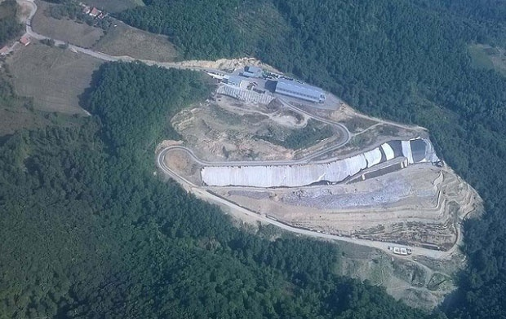

Figure 1: Deep Depot

The landfill body of JKP Duboko Užice has significant quantities of landfill gas (up to this year, 8.276.000 m³, or 10.330 t of gas), which is currently the source of pollution. Landfill gas is created as a result of decomposition of organic waste in aerobic and anaerobic conditions. The composition of the landfill gas is CH4 (the largest part), CO2, sulfur compounds, nitrogen ...

CH4 is a greenhouse effect gas, and its global warming potential is about 20 times greater than CO2. It is estimated that about 18% of the methane emissions in the atmosphere come from landfills.

The landfill body of JKP Duboko Užice has significant quantities of accumulated landfill gas (up to this year, 8.276.000 m3, or 10.330 t of gas, larger quantities predicted in the following years), which is currently the source of pollution. The subject gas also represents the energy potential that can be valorized. (There are reports from an accredited facility for testing the composition of the landfill gas, as well as studies of the quantity and quality of the discharge thereof.)

By decomposing organic waste materials in the depth of the landfill, methane is degraded to the environment, but with the use of this gas, energy is obtained.

Estimates show that in 2021, at the "Deep" landfill, the formation of the landfill gas reached the maximum value with the generated quantity of 16.580 and the flow of the utilized part of the gas from 1136.8 m3 / h.

The legal obligation of collecting and burning landfill gas imposes the right solution: combustion of gas for energy purposes with the creation of economic profit.

This process is becoming more and more popular because it provides an appropriate way of converting waste into electricity, which reduces the amount of waste. By using biogas for energy purposes, the amount of CO2 in the atmosphere does not increase

**2. PROJECT PHASES OF USE OF DEPOSITION GAS IN THE REGIONAL WASTE MANAGEMENT CENTER "DUBOKO"**

Setting up biotrns

Biotrns were placed at the "Duboko" landfill - a total of 28 (on the second floor 5, on the third 10 and on the fourth 13)



Figure 2: Biotrn

***Distributor for landfill gas collection***

Gas is taken to a facility for the utilization of landfill gas.

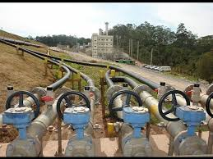

Figure 3: Gas distributor

**Piping system for gas collection and transport**

Gas is collected from biotrn through a pipe and leads to a central distributor. After that, the water drain siphon is installed, which will be discharged into the flow water collection system.

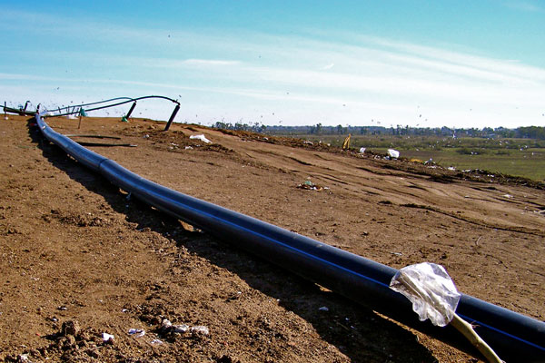

Figure 4: Pipes for gas collection and transport

**Gas engine**

With the application of engines with generators it can be produced 6.400 MWh. Engine efficiency depends on gas quality, combustion conditions and cooling equipment. Methane burns considerably cleaner than coal! The expected utilization of energy is about 1.75 kWh / m³.

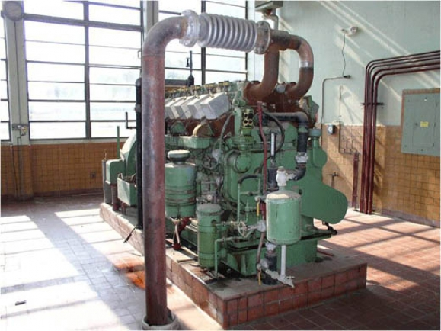

Figure 5: Gas engine

**Connection to the network**

Electricity generation will be delivered to the distribution network and, in accordance with the provisions of the Decree on incentive measures for the production of electricity from renewable sources, the feedin tariff will be charged for this type of energy of 8,44 cE / kWh.

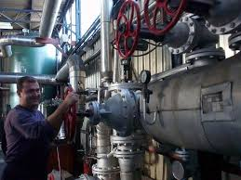

Figure 6: Electrical network

**3. ENERGY BALANCE BUDGET**

For an annual amount of 50,000 t of deposited waste and the landfill time of 20 years at the landfill, 200 million m³ of landfill gas will be generated. The effect of potential investments on local economic and regional development.

This quantity of gas with a heat output of 5 kWh / Nm3, through gas engines, allows annual production of 9 million kWh of electricity and 12 million kWh of heat!

The produced amount of electricity covers the needs of 2,500 family homes.

With this production of electricity, about 18,000 tons of lignite is saved in one lignite plant.

In this way, 300 Nm³ / h of methane contained in the landfill gas is not transferred to the atmosphere, which is an important ecological aspect in the preservation of the ozone layer.

**4. ADVANTAGES OF THE PROCESS**

The obtained heat energy will be used in households, industrial plants and greenhouses in the surrounding area, for the heating of residential and office space, technical water in production and processing processes. It will heat the residential and production areas, then the technical water, but will also be used in production and processing processes.

Preserving healthy natural resources used for energy production, primarily forest savings. The production of landfill gas requires labor in terms of collection, storage, production and maintenance of the system.

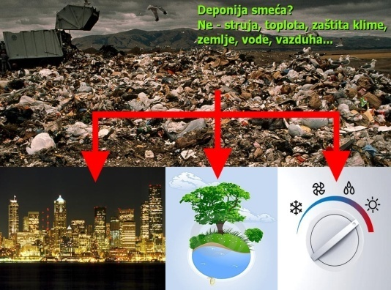

By developing and applying the system for the utilization of landfill gas, we primarily improve the energy balance of the Zlatibor district. The energy value of the landfill gas ranges from 16-30 MJ / m3.

The use of landfill gas is of a cogeneration character, and thus also affects the quality development of local agriculture.

Treatment of landfill gas is of great importance in terms of environmental protection. Methane belongs to a group of gaseous greenhouse gases, and its global warming potential is about twenty times higher than carbon dioxide. It is estimated that about 18% of the methane emissions in the atmosphere come from landfills.

As the production of landfill gas requires labor in terms of collection, landfilling, and then the production and maintenance of the system, the application of this technology contributes to the creation of new jobs.

**5. CONCLUSION**

As a starting point: 200 million m3 of landfill gas will be generated for the annual quantity of 50 000 t of deposited waste and the time of the landfill of 20 years at the landfill. If a gas collection system and gas quality control system would be available for gas engines, about 50% of the gas quantity would be covered, this would mean that the energy balance budget could be estimated at about 100 million Nm3 of landfill gas, or an average of 5 million Nm3 per year. This quantity of gas with a heat output of 5 kWh / Nm3, through gas engines GE Jenbacher, enables annual production of 9 million kWh of electricity and 12 million kWh of heat. The produced amount of electricity covers the needs of 2,500 family houses. With this generation of electricity, about 18,000 tons of lignite is saved in one lignite plant. In this way, 300 Nm3 / h of methane contained in the landfill gas is not transferred to the atmosphere, which is an important ecological aspect in the preservation of the ozone layer.

Based on such an electrical and thermal balance and the necessary investments, an economic calculation can be carried out which shows that the investments are quickly compensated, and the further operation of the plant generates profit. So, we come to the right goal of every ecological object (landfill), which is to sustain itself.

The new Energy Law defines authorized producers of electricity and heat with the right to appropriate subsidies and privileges, which are those producers who use renewable energy sources (including landfill gas) and unload the products electricity and heat energy while meeting the requirements in terms of energy efficiency, or environmental protection.

**LITERATURE**

1. Study of the quantity and quality of landfill gas discharge of JKP Regional waste management center "Duboko" Užice (TMF, Belgrade, 2015)
2. Lj.Trumbulović, Z.Aćimović-Pavlović, Lj.Andrić, V.Milošević: Menagement of Waste, XIII International Scientifc and Professional Meeting Ecological Truth, 2014.
3. Lj.Trumbulović, Đ.Mihajlović, Z.Čeganjac, J.Konstatinović: Integralni sistem menadžmenta komunalnim otpadsom, International Conference Dependability and quality menagement, Beograd, 2012.
4. [www.duboko.rs/lat](http://www.duboko.rs/lat)
5. [www.deponijskigas.rs](http://www.deponijskigas.rs)