RESEARCH INTENSITY OF UV RADIATION AT WORK OUTDOORS

Vladimir Mirković¹, Student; Milutin R. Đuričić², PhD;

¹Visoka poslovno-tehnička škola Užice, e-mail: vladimirmirkovic.ue94@gmail.com
²Visoka poslovno-tehnička škola Užice, e-mail: milutin.djuricic@vpts.edu.rs

Abstract: This paper presents the results of measurements of ultraviolet radiation in Gorobilju- Požega 08.27.2016. and in Cajetina 08/28/2016. years. The cause of the reduction of the ozone layer is hlorofluorovodonika release into the atmosphere as a result of human activities. Ozone depletion increases the level of UV radiation on the earth's surface, thereby adversely affecting the living population, and the most vulnerable are the people who work outdoors.

Key words: UV radiation, UV radiation measurement, outdoor operation, safety and protection when working outdoors.

INTRODUCTION

Most people man's impact on nature related to the period, when people left living in hunter gatherer societies and began to cultivate the land (Djuricic, RM, 2015). Since then, the man began to destroy their environment. This led to the fact that the world has realized that the issue should be to find a solution and management of environmental protection has become imperative and rated the ISO 14000 series of standards (Djuricic, R. M. et al, 2015). Accordingly now the focus of attention to all aspects of protection of man and the environment. Harm to the environment from the point of impact of radiation on humans is a significant segment of protection, especially the reasons that many jobs, a man and existence take place outdoors. The aim of this study is to investigate the impact of UV radiation on humans when working outdoors at two locations in Western Serbia (Gorobilje - Požega and Čajetina) apart, about 25 km as the crow flies.

2. ULTRAVIOLET RADIATION

Ultraviolet radiation forms part of the electromagnetic spectrum that lies between visible light and X-ray wavelengths largest. It covers an area of ​​100 nm to 1 mm. This range covers three areas: infrared, visible and ultraviolet.

Table 1. Distribution of optical radiation (Jeremić M., 1995)
Vrsta zračenja | Frekvencija | Talasna dužina
UV zračenja | 3000-750THz | 100-400nm
Vidljiva svetlost | 750-385THz | 400-780nm
IC zračenje | 385-0,35THz | 780nm-1mm

The existence of ultraviolet radiation was discovered by German physicist Johann Ritter in 1901, when in the course of studies on the effects of light on substance odrerđene noted that there is energy in the dark end of the spectrum, beyond the purple brightness (V Milovanovic, 1999).
Sources of UV radiation may be natural or artificial. In the natural resources belonging to the sun - solar UV radiation, and the artificial - various appliances and devices that are used in biology, medicine and cosmetics.
Factors affecting the intensity of UV radiation at the Earth's surface are:
- Absorption by gases in the atmosphere;
- The height of the sun;
- The concentration of aerosols;
- clouds;
- Altitude;
- Dissemination;
- Reflection and absorption of the surface.
The International Commission for the lighting, submitted in 1963, the division of ultraviolet radiation on three areas depending on the biological activity.
Table 2. Distribution of ultraviolet radiation (adapted from: F. Pohl, 1993)
UV –  area | Wavelength  (nm) | Effects on Humans
UV – A air | 315-400 | - It works on the pigment of the skin and allows for its immediate tanning, penetrates deeply into the skin, creating free radicals that damage the skin and cause premature aging.  -Long-term UV-A radiation can damage the eyesight. It is used in medicine and industry because it evokes the photochemical and photobiological processes.
UV – B air | 280-315 | - It has the most pronounced biological effect on the human-body.  - Causes redness and by prolonged exposure and burns.  - Prolonged exposure to UV-B radiation leads to damage to the skin, the skin becomes wrinkled and strewn with multiple pigmented spots.  - Most of the air from the radiation spectrum has a carcinogenic effect. Some scientists believe that the only cause of solar radiation that causes skin cancer.
UV – C air | 100-280 | - Particularly dangerous radiation, completely absorbed by atmospheric ozone and oxygen does not reach the earth's surface.  - According to research Faber, one percentage point reduction in the thickness of the ozone layer, the likelihood of skin cancer increases by 3-5%.

3. AND SECURITY WHEN WORKING OUTDOORS

Exposure to UV rays leaves consequences for the human body. The greatest danger from radiation and disease threatens people who are by nature of work, the majority of working hours exposed to direct sunlight.
Natural ultraviolet radiation power is very limited. This may explain why the most important biological effects occur primarily in the skin and the body of sight. Numerous studies there is a correlation between the wavelengths, or absorbed radiation energy and morphological changes in the structures of irradiated tissue.
Each of the following specified UV range is characterized by the appropriate type of reaction: pigmentation, erythema and bactericidal effect.
Workers in welding, working with artificial sources of ultraviolet rays, often receive eye diseases such as cataract and conjunctivitis, if you are working without proper protective equipment.
When working outdoors workers must be provided with adequate protection and personal protective sredsatva. When working, working people are obliged to use appropriate protection as to the number of diseases to prevent or reduce to a minimum.
Safety and protection equipment:
- Longer breaks;
- Reducing direct exposure to the sun, if the nature of work permits;
- Avoidance of outdoor work between 11 and 15h, when the greatest intensity of radiation;
- Use of personal protective equipment - shirts with a collar, long pants, protective helmets and sunglasses.
Stay in the shade is the best protection from the sun. Bright surface - metal, water, snow, reflect and increase UV radiation. Although each type of clothing does not provide adequate protection from the sun, it helps reduce radiation. Parts that are not covered with clothing to be protected using protecting compositions comprising compounds which absorb UV-A and UV-B radiation.

4. MEASUREMENT RESULTS
To measure the power of ultraviolet light radiation used is a professional high-quality instrument YK-35UV. The instrument is designed to measure UV-A and UV-B radiation, wavelength 290-390nm. With increasing altitude, increases the intensity of UV radiation for 6-8% for every 1000m. This increase is due to reducing the amount of absorber with increasing altitude.

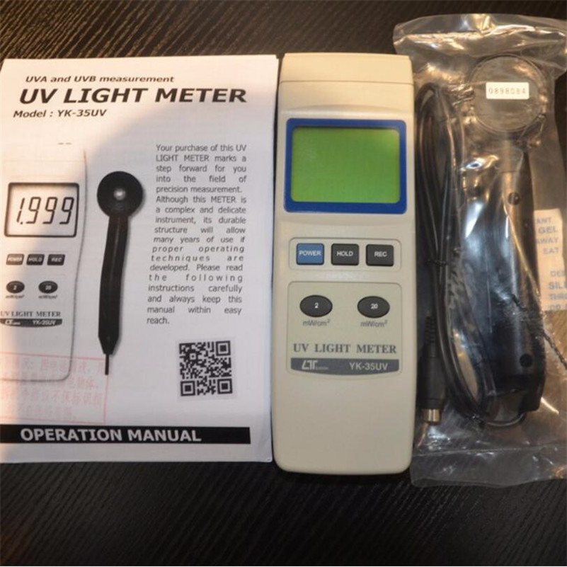

Figure 1. high-quality instrument YK-35UV

Table 3 shows the results of measurements of ultraviolet radiation:
1. 27.08.2016.godine on a sunny day vremunu in Gorobilje - Pozega, at an altitude of 370 mnv, and
2. day 08.28.2016. the sunny weather in Cajetina, at an altitude of 830 mnv.
Figure 2 shows the diagram power UV radiation changes depending on the time and Figure 3 shows the diagram of temperature change over time (measuring point Gorobilje). In Figure 4 shows the diagram changes power UV radiation depending on the weather and Figure 5 shows the diagram of temperature change over time (measuring point Čajetina).

Table 3. Results of measuring UV radiation and temperature

TIME (h) | Measuring point Gorobilje |  | Measuring point Čajetina
 | UV  (POWER mW/cm²) | T  (temperature °C) | UV  (POWER mW/cm²) | T (temperature °C)
7 | 0,212 | 18,1 | 0,105 | 17,1
7:30 | 0,399 | 18,6 | 1,19 | 17,4
8 | 0,752 | 18,9 | 0,353 | 17,6
8:30 | 1,037 | 19,7 | 0,535 | 18,3
9 | 1,428 | 23,4 | 0,945 | 19,6
9:30 | 1,841 | 24,7 | 1,053 | 20,9
10 | 2,13 | 25,9 | 2,02 | 21,4
10:30 | 2,42 | 26,9 | 2,34 | 22,5
11 | 2,74 | 28,4 | 2,67 | 23,9
11:30 | 3,11 | 29,5 | 2,81 | 24,3
12 | 3,28 | 30,3 | 3,01 | 24,4
12:30 | 3,32 | 31,9 | 3,23 | 25,1
13 | 3,36 | 32,5 | 3,34 | 25,3
13:30 | 3,24 | 32,9 | 3,12 | 27,3
14 | 3,19 | 33,6 | 3,1 | 26,8
14:30 | 2,95 | 33,8 | 2,98 | 25,6
15 | 2,73 | 32,4 | 2,83 | 25,3
15:30 | 2,19 | 32,1 | 2,54 | 24,8
16 | 1,84 | 31,8 | 2,18 | 24,6
16:30 | 1,36 | 31,1 | 1,84 | 24,4
17 | 0,856 | 29,8 | 1,087 | 24,2
17:30 | 0,39 | 29,6 | 0,73 | 23,7
18 | 0,323 | 29,1 | 0,392 | 23,1
18:30 | 0,127 | 28,5 | 0,148 | 21,8
19 | 0,061 | 27,8 | 0,096 | 20,9

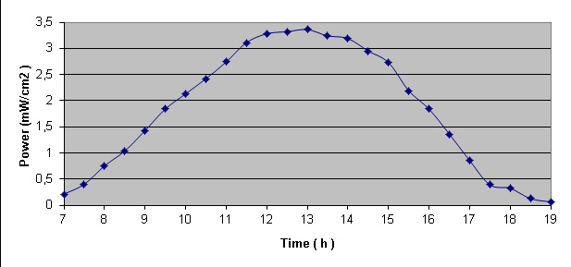 | 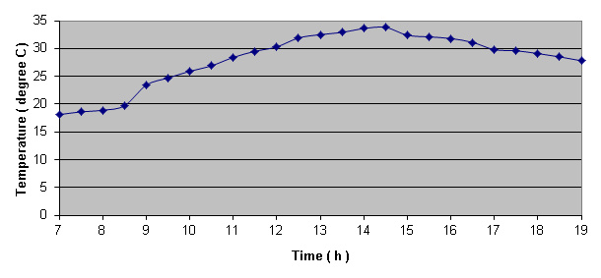
Figure 2. Changing power UV radiation over time (measuring point: Gorobilje - Pozega) | Figure 3. The temperature change over time (measuring point: Gorobilje - Pozega)
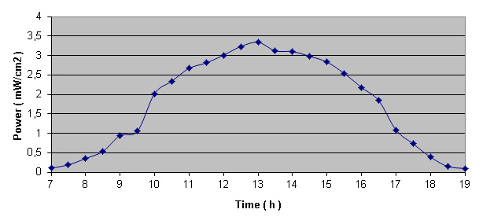 | 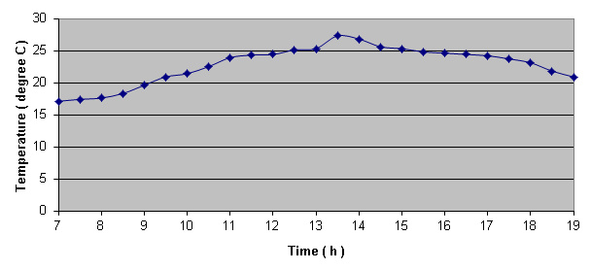
Figure 4. Changing the power UV airy me over time (measurement location: Čajetina) | Figure 5. The temperature change over time (measurement location: Čajetina)
The analysis of the obtained measurement results can be concluded that the strength of UV radiation approximates (Figure 6) on the observed measuring points, which proves that the elevation
Time
Figure 6. Comparative overview of measurement data for the power of UV radiation in Gorobilje and in Čajetina

is not of significant influence. This can and connect the proximity of the measuring points, which are about 25 km as the crow flies. It can be concluded that the approximate impact of UV radiation on humans on the observed locations. On the other hand elevation significantly affect the ambient temperature, the difference over 7 degrees Celizusa at 14:30.

Figure 7. Comparative review of temperature measurement data in Gorobilje and in Čajetina

5. CONCLUSION

The results of recent scientific research shows that ultraviolet radiation can have a negative impact on health. Therefore, it is necessary to measure the power of the radiation ultračjubičastog to health risks at work in the open air decreased. This paper presents the results of measurements show that the power ultaljubičastog radiation from 11h to 15h and the fact that during this period should be avoided work outdoors if possible, but if you do not use adequate protective equipment.

LITERATURE
[1] ĐURIČIĆ R.M., ĐURIČIĆ, M.M., Integrisani menadžment sistem u turizmu, VPTŠ, Užice, 2015.,
[2] ĐURIČIĆ R.M., ĐURIČIĆ, M.M., Menadžment kvaliteta u turizmu, VPTŠ, Užice, 2015),
[3] JEREMIĆ M.:Nejonizujućas zračenja i zaštita, Medicinska knjiga, Beograd 1995.ISBN 86-311-0252-0
[4] MILOVANOVIĆ V.:Elektronika,Visoka poslovno tehnička škola, Užice 2009.ISBN 978-86-908785-6-7
[5] POHL F.: Ozone realities, Omni, New York 1993.

