**PRINCIPLES OF DESIGN SPRINKLER INSTALLATION FOR FIRE FIGHTING IN THE UNDERGROUND GARAGES AND SUPPLEMENTARY LEGAL ACTS**

**Dragomir Aćimović1, Nebojša Panić2, Damnjan Radosavljevic3**

1VPTS, Uzice, SERBIA, [dragomir.acimovic@vpts.edu.rs](mailto:dragomir.acimovic@vpts.edu.rs) , 2 Emergency Situations Department, Preventive Protection Administration, Belgrade, SERBIA, [nebojsa.panic@yahoo.com](mailto:nebojsa.panic@yahoo.com) ,3VPTS, Uzice, SERBIA, [damnjan.radosavljevic@vpts.edu.rs](mailto:damnjan.radosavljevic@vpts.edu.rs)

***Abstract***  *The paper presents a design solution for a stable sprinkler fire extinguisher system in an underground garage. The display contains basic design elements, sprinkler type selection, description of the installation components and description of how to operate. The paper also provides an overview of the accompanying legal regulations, which stipulates the conditions for designing, performing and maintaining the sprinkler system.*

***Key words: Fire, Fire fighting, Stable fire extinguishing systems, Sprinkler installations***

**1. INTRODUCTION**

There are two interconnected parts in the process of designing a stable fire extinguishing system. One is a design technician based on generally valid design rules, while the other one is legally based on applicable laws, regulations, standards and other by-laws.

The basic task of a stable fire sprinkler sprinkler is to extinguish the resulting fire and prevent its further spread. In this way, people and material goods are protected. Legislative and by-laws are defined as determining whether a certain space or object is needed by a Serbinkler installation. Appropriate calculations, based on legal requirements, define the need for the introduction of the sprinkler system, perform its dimensioning and select the necessary equipment.

The baseline is given in the Fire Protection Act (Official Gazette of RS No. 111/09, 20/15), defining the request for the development of the necessary fire safety planning document (ZOP Art.31). The main fire protection project is an integral part of the technical documentation for execution (construction) and has a well defined content (ZOP Art.31).

Design and implementation of special fire protection systems and measures include the design and implementation of: 1. Stable fire extinguishing systems; 2. Stable fire alarm installations; 3. Stable systems for the detection of explosive gases and vapors; 4.Analysis and determination of the danger zone; 5.Electric installations and devices in explosive environments; 6.System for smoke and heat (ZOP Art.38, Art.39).

Also, the legal requirements that must be fulfilled by individuals and companies, who deal with the design and implementation of the aforementioned special systems as well as for the development of the Main Fire Protection Project (ZOP, Art.32), are clearly defined.

**2. MATERIAL AND METHOD OF WORK**

**2.1. Underground garage**

Underground garage is a garage: 1. Which is below the level of the terrain, 2. Garages whose level is buried in the ground more than one meter, 3. garages below other buildings (buildings, streets, squares, lawns, etc.). The technical requirements that must be fulfilled by the garage are given in the regulations entitled "Ordinance on Technical Requirements for the Protection of Garages for Passenger Cars from Fire and Explosion", hereinafter "the Regulations on Technical Requirements for Garages". The garage seen in this case, intended for the accommodation of 35 cars, is underground ("Rules on Technical Requirements for Garages", Article 6), a clean height of 3.0m, a medium size with an area of ​​821m2 ("Rules on Technical Requirements for Garages", Art. .14.). A stable sprinkler fire extinguishing system is designed for the garage ("Rules on technical requirements for garages", Art.34). The system is designed with a backup power supply, which is given in the electroproject ("Rules on technical requirements for garages", Article 36).

According to the category of the facility according to the fire hazard, the garage facility approaches the OH2 group (SRPS EN 12845: 2004 + A2: 2009). According to this membership, the effective area is 180m2, and the operating time of the system is 1h.

To the technical conditions, a water supply system with an overpressure in the water meter boiler of 4.5 bar was brought into the building. Dry sprinkler installations (without water in the grid above the protected area) have been adopted, because it is not possible to provide temperature in the garage higher than + 5oC during the winter period. At temperatures below 0oC, in the event of a wet sprinkler installation (with water in the grid) there would be water freezing, system failure and damage. In a dry sprinkler installation, the water is located only in the sprinkler header to the sprinkler valve, and further in the network is the air under pressure. The air is pressurized by a compressor.

**2.2. Installation principle**

When a fire occurs, the temperature increases. Activating the system begins by spraying the ampoules on a closed nozzle. The ampoule is sprayed under the influence of an elevated temperature (when the temperature exceeds 68 ° C) and opens the nozzle. This leads to a sudden drop in pressure in the installation from the alarm dry sprinkler valve to the pipe network. The valve opens automatically. A quick opening accelerates the opening of the alarm sprinkler valve. In this way, the arrival of the water to the nozzle is accelerated. Water spills and extinguishes the nozzle in the nozzle. If the fire spreads and the temperature rises, other nozzles will also be activated.

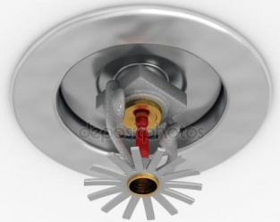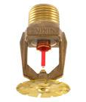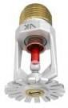

**Figure 1.** Sprinkler nozzle

In addition to extinguishing, the installation, while activating, simultaneously performs a fire alarm by giving an alarm signal. The signal is audible and is given via an alarm ring. The bell is driven by a water trumpet, penetrating the water into a turbine. The turbine starts to rotate and the bell starts.

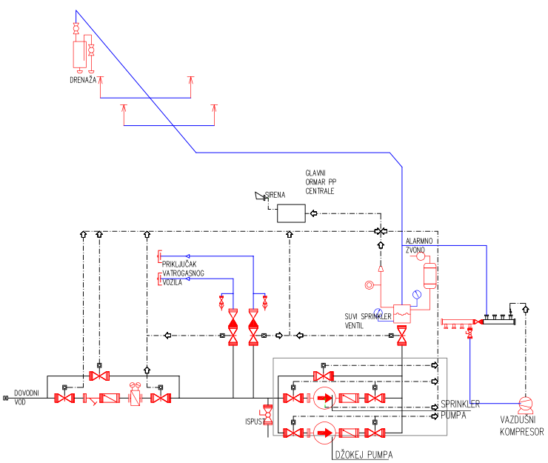

**Figure 2.** Scheme of a dry sprinkler installation

For initial fire extinguishing when a small number of nozzles are activated, the so-called. Jockey pump. In case when a larger number of nozzles are activated and the jockey pump fails to deliver the appropriate amount of water to the place of fire, and thus to achieve the necessary pressure, the main sprinkler pump is started.

The installation consists of a dry alarm sprinkler station and a piping system with nozzles.

The alarm sprinkler station has the task of allowing a fire warning at the time of opening any nozzle. The dry alarm sprinkler station consists of:

• Alarm dry sprinkler valve DN100

• DN100 lock

• Water drain valve

• Alarm for testing and alarm alarm

• Manometers 0 - 16 bar (2 pcs)

• Pressure switch (hydroelectric pressure switch)

• Alarm bell

The alarm dry sprinkler valve divides the pipe network with nozzles from the water source. The valve is water, and the air is pressurized from the valve to the nozzle. In the valve housing, the lower and upper chambers are located. These chambers are separated by a flap. The control valve R1 (1 ") is connected to the lower alarm valve sprinkler chamber. With its opening, the water penetrates the hydraulic ring turbine and toward the hydroelectric pressure switch. In doing so, the valve is raised in the alarm sprinkler valve. If the total volume of the pipeline above the valve (in which the air is airborne) exceeds 4m3, two compressors for air are required, and therefore two dry sprinkler valves. One sprinkler valve is designed because the volume of the pipeline Vuk = 0.76m3 <4m3.

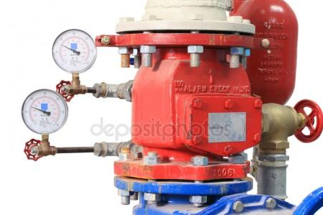

**Figure 3.** Alarm valve

The presostat (hydroelectric pressure switch) is mounted on the part of the pipeline leading from the alarm valve sprinkler to the hydraulic ring. By approaching the water from the alarm valve to the hydraulic ring, the water pressure closes the circuit of the fire alarm system, ie the water pressure closes the circuit leading to the fire alarm system. Through the fire alarm system, after the activation of the sprinkler installation, other consumers are excluded.

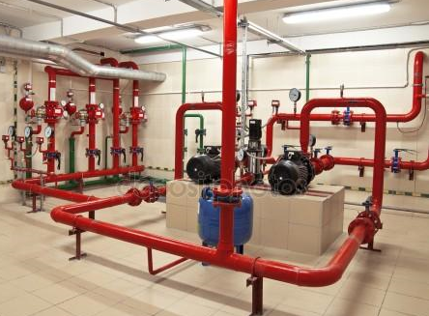

**Figure 4.**Sprinkler station

The pipeline to the alarm valve is filled with water and must be in a room where the temperature is such that water can not be frozen. The pipe net behind the alarm valve is filled with air at a pressure of 2-3 bar. This air maintains a balance in the dry sprinkler valve housing, which prevents the passage of water into the dry part of the net. In normal condition, air consumption does not exist. Accidental loss in places of poor sealing is regulated by a compressor (with a pressure switch). The pressure switch that regulates the operation of the compressor (start, stop) is adjusted to the recommended pressure.

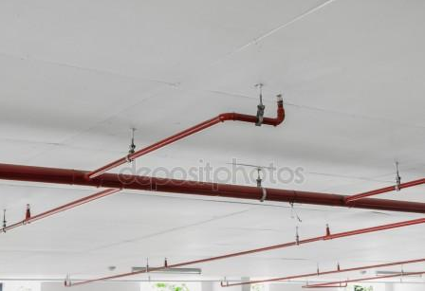

**Figure 5.** Dry sprinkler installation



**Figure 6.** Detail of the base with a sprinkler system

Nozzles are standard, standing and facing up. The nozzle consists of: enclosures, gasket sealing, ampoules (68 ° C) and spray guns at the top of the housing. The distance from the ceiling nozzles is from 75 to 150 mm.

The sprinkler nozzle has two functions:

• Extinguishing fire by spraying water into drops

• Fire detection (as an indication of a fire, a pressure drop is due to an ampule burst at an elevated temperature)

The installation is supplied with water from the city water supply network, which has been adopted as an inexhaustible source. The alternative way of supplying water is via two DN100 connectors located on the outer wall of the building.

**2.2.** S**prinkler station room**

Mechanical (technical) room - the sprinkler station inside the building is separated from the rest of the building. The position of the station must be safe in relation to the extinguishing zone, but as close to the escape zones. ("Rules on Technical Requirements for Garages", Art. 20).

Electricity supply of the room is made of: public electric lighting, own electric generator, diesel-electric generator, electric generator for the necessary supply of electricity.

**2.3. Choice of sprinkler nozzles in a protected area**

The selection of the type of nozzle is done according to the following criteria:

• By choosing temperature-sensitive materials (ampoules, easily soluble alloys)

• The shape of the jet

• Size - flow (three dimensions 3/8, 1/2, 3/4)

• Activation temperature

The number of nozzles depends on the amount of water needed for quenching, size and layout. The prescribed distance between each other and the wall must be respected. The outlet pressure on the most unfavorable nozzle must be at least 0.5 bar. In this project, one garage place is protected with two nozzles. The nozzles are positioned in the middle of the parking lot. The average opening time of the nozzle is 2-3 minutes. The average water volume per nozzle is 0.1 l / sec / m2. The total number of designed nozzles is 95.

**2.4. Dimensioning of the pipe installation of the sprinkler system**

It is based on a certain methodology with the knowledge of the initial hydraulic values: the minimum and maximum allowable pressure on the nozzles and the entire system, the required amount of water, according to the degree of fire hazard, the number of nozzles and the length of the pipeline. The minimum pressure in the pipelines is 0.5bar and the maximum is 5 bar. The speed of movement of water between the alarm valve and the nozzle must not exceed 10 m / s, and in the fittings and fittings of 5 m / s. Table 1 can serve as a quick dimensioning of the pipeline.

**Table 1.** Approximate dimensioning of the pipe network

|  |  |
| --- | --- |
| **pipe diameter** | **Number of nozzles on the pipeline** |
| DN 25 | 2 |
| DN 32 | 3 |
| DN 40 | 5 |
| DN 50 | 10 |
| DN 65 | 20 |
| DN 80 | 40 |
| DN 100 | 100 |
| DN 125 | 160 |
| DN 150 | 275 |

The pressure drop in the installation is calculated as:

∆puk = ∆p1 + ∆p 2 + ∆p geo , bar (2.4.1)

where:

∆p1 , bar – Pressure drop due to resistance in pipes

∆p 2 , bar – Pressure drop due to resistance in the fitting

∆p geo , bar- Pressure drop due to geodesic height

Sum ∆p1 + ∆p 2 is calculated according to Heisen - Williams formula that reads:

∆p12 = ∆p1 + ∆p 2 = 6,05 ∙ 10 5 ∙ C −1.85 ∙ d −4.87 ∙ Q1.85 ∙ l , bar (2.4.2)

where:

C - constant for pipes and amounts:

C =100 for cast pipes

C =100 for steel tubes

C =100 for copper pipes

C =100 for pipes with cement covering

d , mm – internal pipe diameter

l , m – pipe length + equivalent length of piping for fittings and fittings

Q , l/min – flow of water through the pipeline

equivalent to the length of the tube, in meters, are given in the appropriate tables, depending on the pipe material

The formula also applies:

Qm = K ∙ √ pm , l/min (2.4.3)

where:

K - factor of the line of the pipeline

Qm , l/min – flow of water through the pipeline

pm , bar- water pressure in the pipeline

In this project, pressure is required for the branch pipe supplying the sprinkler system to 5.17 bar. According to the data in the project task, the water pressure at the point of the object's attachment is 4.5 bar. Pritsak does not meet the condition required for proper operation of the sprinkler system on the connection.

For the functioning of the sprinkler system, the following pumps are designed:

-JPG pump: CR 3-5, effort 15.1mVs, flow 4.03m3 / h,

- main (operating and spare) pump: CRE 120-1, 8.0mVs, flow 120.96m3 / h,

The pipe net is mounted under the garage's ceiling. It consists of the main main pipeline and pipe branches. Alongside the branches, there are twisted nozzles on their ends. The main divorce and branches are made of black steel seamless pipes. Connecting the pipeline to the nozzle is done with a galvanized fitting.

**2.5.** **Activating the sprinkler system**

The method of activating a stable system must be such as to ensure the effectiveness of quenching. Criteria for selecting activation methods are:

• the speed of fire spreading,

• Spatial accessibility to fire,

• the value of the facility,

• human and technological security and you.

With stable systems, there are two basic mode of activation, manual-remote and automatic.

For manual - remote activation, there is a case where, from the outburst of fire, it is allowed for some time. If this is not the case, it is necessary for the system to have a signal system for some indication of fire. The basic condition for manual-remote activation is the presence of fire extinguishing, people who will activate the system.

Automatic activation, depending on the selection of the fire warning and the sensitivity of the activating elements, has a wider time gradation. But in the same mode of automatic activation, as is the case with the sprinkler system, the crucial criterion for selecting one of these two will be the speed of spreading - the transmission of fire.

Light and smoke are the earliest indications of fire, and the temperature is later. Therefore, the brightness and smoke are used in signaling systems when information about the initial stage of the fire is desired.

**2.6.** **Documentation of quality of installed equipment, devices and installations**

The contractor is obliged to provide suitable installation instructions for installation and maintenance, certificates, certificates or certificates of conformity for all installed equipment, devices and installations.

Review of the standards that provide recommendations and requirements that need to be fulfilled by the installed equipment, devices and installations is given in the DECLARATION of the responsible designer on the applied laws, regulations, regulations and technical regulations and standards.

**ZAKLJUČAK**

The basic tasks set before a stable sprinkler fire extinguishing system are: extinguishing the fire, preventing its spread and preserving human lives and material assets. From design to release of the system into operation knowledge of engineering knowledge for calculations, drawing, execution, commissioning and delivery of the system is necessary. In addition, it is equally important to apply the applicable legal regulations defined in the Fire Protection Act and the relevant Regulations in all the aforementioned activities. It is also necessary to use and know the appropriate standards that define the process of designing, performing and maintaining the installation, as well as the knowledge of the necessary documentation that follows the projected and installed equipment. In this way they are avoided and reduced to a minimum, possible uncertainties and problems in relation to the designer / contractor / competent authority for issuing consent for the similarity of the facility for use, as well as any material and other victims and costs.

**LITERATURE**

[1] Law on Fire Protection Sl.glasnik no.RS 111/09, 20/15.

[2] Law on Technical Requirements for Products and Evaluation of Compliance, Sl.glasnik RS no.36/2009

[3] Rulebook on Technical Norms for the Protection of Garages for Passenger Cars from Fire and Explosives Official Gazette of SCG no.31/2005..

[4] Fire extinguishing installations, Z.Sekulović, M.Damnjanović, M.Bogner , ETA, Belgrade.

[5] Professional exam, Specific part of the program, Activity B.1., Dragomir Aćimović, Uzice 2016.