**ORIGINAL DRYING SOLUTIONS OF SMALL CAPACITY USED FOR RENEWABLE ENERGU SOURCES**

**Topic M. Radivoje1, Goran R. Topic2, Dragomir M. Acimovic3, Jelena R. Tasic4,**

1Faculty of Meshanical engineering,Kraljice Marije 16, Belgrade Serbia, [rtopic@mas.bg.ac.rs](mailto:rtopic@mas.bg.ac.rs) , 2Srbijagas,, Autoput 11, Novi Beograd, Serbia, [goran511@gmail.com](mailto:goran511@gmail.com), . 3VPTŠ, Uzice, Serbia, [dragomir.acimovic@vpts.edu.rs](mailto:dragomir.acimovic@vpts.edu.rs), 4Energoprojekt, Bulevar Lenina 12, Belgrade, Serbia, jelenat@gmail.com

***Abstract:*** *The paper presents a brief overview of the original, mobile or stationary, drier solutions, low capacity, using renewable energy sources, individually or as hybrid, combined, solutions.*

***Key words: Drying, Dryers, Sun energy, Eco dryer, The solar energy receiver***

**1.INTRODUCTION**

The acquisition of a unique technology for drying biological materials is almost impossible since it is a very different material, and the most diverse parts, such as root, tree, flower, blossom, seeds and fruit, are exposed to drying. The costs of drying these crops are significantly high and range between 25 and 30%, and even 50% of the total cost of production. Liquid fuels are not always easy to deliver to the regions of ever-growing cultivation of medicinal, aromatic and spicy herbs, and if their price is higher compared to the prices of alternative energy sources. The high costs and reduced supply of liquid fuels in agriculture, the intensity of the solar radiation, the possibility of using the energy of the Sun for low-temperature drying, and the fact that the period of more intense solar radiation coincides with the period of harvesting most of these cultures make up the sun's energy for drying biological materials (fruits, vegetables , Medicinal, spice and aromatic herbs) justified.

**2. MATERIAL AND METHOD OF WORK**

**2.1. Mobile, universal, ecological, chamber solar dryers**

Преведи са језика: [босански](javascript:void(0))

The basic characteristics of the dryer are:

• Dryers are chamber type with periodic mode of operation,

• All components of the dryer and devices are fixed on one specially designed one-axle trailer and represet a compact moving unit,

• The dry er solution allows woking at any place,

• Complete dryers are transported to the work site, and quickly and easily transferred from the transport to the working position,

• The material in the drying process is stationary on the frying pans placed in the height of the drying chamber,

* Drying agent is purely heated air that is heated in solar flat receivers, whose position, inclination is variable,

• Solar receivers for air heating are placed side by side of the dryer and are articulated to the frame structure of the drying chamber, so that they can rotate around the horizontal axis and place in a vertical position for transport,

* A drying agent stream through a layer of material that is located on the frying pan,

• The movement of the drying agent is compulsory (provided by fans) or natural,

• The construction of the boundary surfaces also provides the recirculation of the drying agent,

• Two rechargeable batteries are installed on the rear of the trailer for powering the electric motor to drive the fan.

• Modular system,

• Possibility of regulating the regime of the drying process,

• the most favorable reception of solar energy and a smoother drying regime,

• small escalation costs,

• universal solution, drying different materials,

• ecological, does not pollute the environment,

• ekološka, ne zagadjuje okolinu,

• Provides a period of material aging during the drying process.

The dryer, whose disposition is shown in Fig. 1, is a chamber type with the forced flow of the drying agent. All drying elements and associated devices are mounted and fixed to a specially designed one-axle trailer so that they represent one compact moving set. The moving part of the solution allows the complete dryer to be transported to the working place, and the specificity of the construction allows very fast and easy transfer of the dryer from the transport to the working position. Preparation of the drying agent is provided in a solar flat air receiver set on the side.

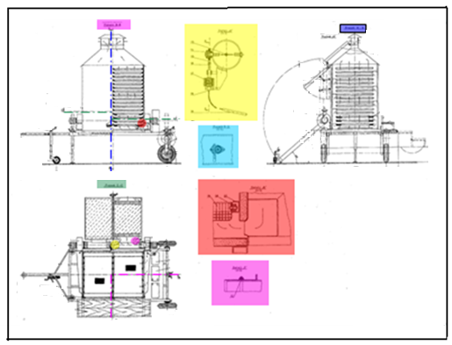

**Slika 1**. Disposition of mobile, universal, ecological, chamber solar dryers

for drying biological materials*[Topić]*

The solar receivers are articulated to the suction tube of the centrifugal fan, so that they can rotate around the horizontal axis. This rotation allows the receiver to be positioned at an angle that corresponds to the latitude value. By this rotation, the collectors can be lifted and fixed in the vertical position for transport and also lowered to an angle of 40 ° below the horizontal. The rotation is carried out with the telescopic support at the end of which is a wheel that also serves to rotate the entire dryer. On the rear of the trailer, a telescopic curtain jacket with a small wheel is rotated around the vertical axis. With this system, the trailer platform can be lifted or lowered to a height corresponding to the optimum angle of the receiver's operating position. Using the front wheel, the turntables can bring the receivers to the most favorable position in relation to the angle of the sun's sunset depending on the time of the day. At the rear of the trailer, two rechargeable batteries are installed, which provides the required voltage on the output poles, with which power motors are used to drive the fan. In addition to the battery, there is a distribution cabinet in which the instruments of the remote thermometers are located and a complete distribution circuit with a rectifier for charging the battery. Thermometer thermometers are installed so that the temperature of the drying agent can be controlled at the input in the dryer and in the middle of the drying chamber. A special valve with a valve is installed on the inlet pipe between the fan, which, through a gas thermostat, mixes the secondary air with heated air from the receiver, while maintaining the required temperature of the drying agent at the drying port. In order to perform the operation of filling and discharging the dryer, a staircase platform has been constructed which provides sufficient space for smooth operation, and can be assembled during the transport due to the hinge connection. To ensure that the drier can be protected against weather, the trailer is welded with appropriate elements for setting the cage. Two photovoltaic modules were also installed on the side of the dryer. The task of one of the photovoltaic modules is to charge the accumulator batteries for the operation of two fans during the period of operation of the dryer (during the drying period) during the solar radiation period. The second photovoltaic module is used to charge the battery batteries in order to ensure the operation of the electric motor during the period when the dryer does not use the solar energy, which lasts 14 hours, in order to provide active ventilation. If there is no Sun radiation and there is cloudiness, active ventilation can last about five days.

On Figure 2 shows a module of mobile, universal, ecological, chamber solar dryers for drying biological materials.

***2.2.* Drying solution with combined use of solar energy**

The dryers in Fig. 3, is mobile chamber type whose constructive solution allows drying by direct and indirect use of solar energy. In the lower part of the drying chamber there is a dish for the storage of drying materials. The taverns are made of wire mesh with built-in rolls, which can be easily inserted into the guides on the walls of the chamber in the operation of charging and discharging. The upper area of ​​the drying chamber above the pan is covered with flat glasses set at an angle of 45 ° in relation to the horizontal plane of the chamber.

The damping system, draining of the humid air (generated vapor) from the drying chamber consists of an axial fan, a system for the distribution of the drying agent with valves and airbags (side anchors) with built-in reflection surfaces. Drying of the material is done by heat from solar reflected radiation from the flat

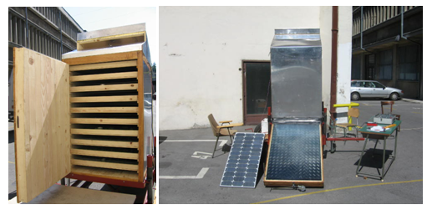

***Slika.2.***Modular mobile, universal, ecological, chamber solar dryers for drying biological materials  *[Topić]*

mirrors whose position should be accompanied by the Sun, so that the material on the frying pan is constantly covered with reflected radiation. Moisture removal and flow protection in the drying process of the material is carried out by an axial fan that receives a wind turbine drive, or a natural discharge when there is no wind. The air supply is carried out over the side anchorages (airbags). From the anchorage through collector knees, the air enters the space under the pan, and through the material and the vertical channel goes into the environment.

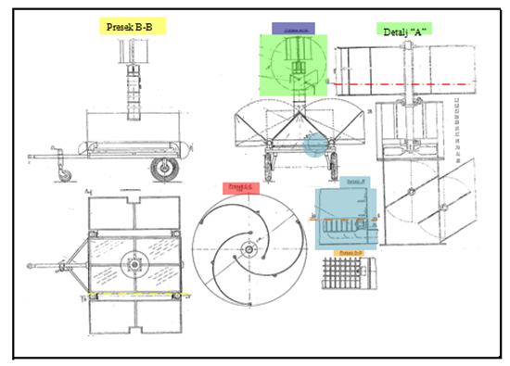

**Slika 3.** Pokretna solarno, eolska, ekološka sušara [Topić]

The task of airbags, however, is to preheat the air for drying and to prevent the heat from being released by the material into the environment during the night and ensure the period of aging and sweating of the material. In cases where the intensity of the wind is higher, attenuation by means of the valve with the valves adjusts the flow rate according to the drying regime. In the preparation for transporting the lateral anchors, they rotate 90 ° around the collector elbows. Side anchorages are brought to the same position during the night.

.

2.3. Solar direct indirect indirect passive drying solution

On Figure 4 shows the solution of a mobile dryer for drying fruits and vegetables (at higher temperatures - dryers work as direct) and medicinal and aromatic plants (at lower temperatures - drier working as indirect) using solar energy. Dryer is a chamber type, periodic mode, mobile, direct - indirect, radiative - convective, passive with reflector (concentrator) on a flat absorbent surface. The drying chamber is a rectangular cross-section, with two layers to accommodate drying materials. The basic elements of the dryer are a drying chamber, a reflector, a channel for the introduction of air for drying, one side of which is the absorption surface on which the radiation is reflected reflected from the reflector. The peripheral walls of the drying chamber are non-transparent (from a sandwich panel). The roof is translucent in one case, when the dryer operates as a direct, radiative convective, while in the other case it is impervious, which is ensured by lowering the movable roof (chimney) when the dryer is working as an indirect convective passive. The drying agent, which is a heated air generated by the passage of fresh air through a channel where it is heated by a part of the radiation reflected from the reflector. The roof slope is 30˚, which corresponds to the recommendations for the location of the dryer operation. The airy roof of the drying chamber is a glass of thickness of 3 mm. The reflector is made of aluminum sheet thickness of 1 mm. The upper side of the ducting duct - the drying agent is perforated. Through the perforations, the drying agent passes through the pan and spreads the layer of drying material. Unsaturated humid air - drying agent, exits through the canal located at the top of the chamber and goes all over the width of the dryer. The reflector has a transparent glass with a thickness of 3 mm. The channel is made of airborne material. When the dryer operates as a direct, radially convective, the movable roof is placed alongside the channel for the removal of the drying agent made. Bearing in mind the existence of a transparency of the drying chamber, a reflector of the reflector, a reflector and an absorber, an appropriate budget is given. The total amount of heat required is defined on the basis of the material and thermal balance.

.

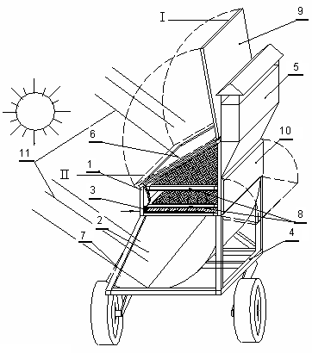

**Figure 4.** Solar indirect direct passive dryers [Topić]. I - in this position of the dryer, it works as a direct, II - in this position of drier works as an indirect:

1. drying chamber, 2. reflector, 3. input channel and absorber, 4. ram, 5. outlet channel ("chimney"), 6 chambers with transparent cover, 7. transparent, 8. dish with drying material, 9. rotary deck of the drying chamber - reflector, 10. door of the drying chamber, 11. solar radiation

Based on the drying capacity of the dried material, the specific load of the wafers surface with the wet material, the adopted dimensions of the pan, the required number of pans are determined. By adopting the layout of the pan over the drying chamber, the dimensions of the drying chamber are defined..

**2.4. Solar stationary dryers with heat pump and integrated biomass combustion device**

On Figure 5, a stationary solution of a solar drier with a heat pump and an integrated biomass furnace is shown.

1. **CALCULATION OF THE DRY COMPONENTS**

**3.1Dimensioning basic elements of mobile solar, universal, ecological, chamber solar dryers**

The value of the working surface (which absorbs solar radiation) of the absorption surfaces of the receiver for the heating of the air can be determined from the heat balance:

 (1)

The heat flux absorbing the surface of the receiver is:

 (2)

Since the heat fluxes depend on the constructive characteristics of the specific receivers, the term for the coefficient of useful effect of the receiver, the current efficiency of the receivers can be used for preliminary designing:

 (3)

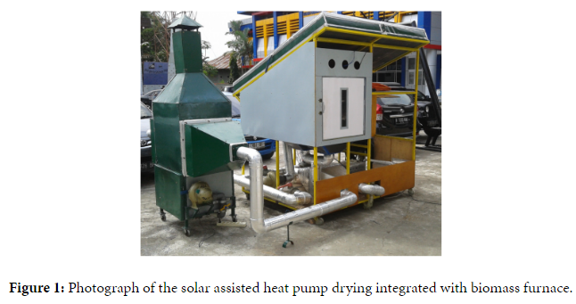

**Figure 5.** Solar drying dryer with heat pump and integrated biomass fired

For the known temperature of the air in the receiver, the useful heat flux is:

 (4)

The mass flow rate of the drying agent is :

 (5)

By introducing the expression (4) into (3) and replacing the obtained thermal flux expression in the equation (2) and solving the resulting term by F, we obtain:

 (6)

By inserting expression (5) into expression (6), the expression for the surface of the form is obtained:

 (7)

The term for the surface of the receiver shows that the surface value depends on the parameters of the drying material, the receiver design itself, and the climatic and weather conditions.

For these reasons, it would be useful to perform an impact analysis on the value of the surface of the receiver of the type of culture that is dried, because of the desire for more cultures to dry in the same drier, the design of the receiver and weather conditions and to compare these effects.

The surface of the absorption surface of the receiver can also be determined by the expression:

 (8)

If known, the yield, the amount of dried material mm, the drying agent mass per unit area of ​​the receiver, and the flow rate of the drying agent per unit mass of the dried material, as well as the number of n cultures that can be dried in the farms with one droplet.

Based on the defined power of the fan, the manufacturer's recommendation and the characteristics of the module, the surface of photovoltaic systems is defined. The electricity of the photovoltaic system is defined from

 (9)

And is defined by the repeatability of the bright skies, the mean value of the intensity of radiation and the average daily duration of solar radiation for the area of ​​work.

* 1. **Dimensioning of channels for the input and output of drying drying agent, mobile, universal, ecological, chamber solar dryers**

The values ​​of the surface of the inlet and outlet openings, for the known value of the rate of flow of the drying agent, are determined from the value of the volume of the drying agent:

• for the input duct:

 (10)

* for the output duct:

 (11)

* 1. Defining the surface of the absorbent surface and dimensioning the surface of the transparency (glass), directly indirect dryers

Heat balance of dryers:

 (12)

Heat reflected by the feflector to the channel (apsorber) for the preparation of the drying agent.

 (13)

where:

*ρ*–spectral reflection factor, reflectance, in this case,Al – Reflector material and amounts 0,043;

*γ*–part of the reflected energy from the reflector, arrives at the absorber;

α–absorption.

According to literature for R = 2 i T = 350 K and non-selective absorber product

.

Concentration ratio:

 (14)

The ratio of absorber and glass surfaces is:

 (15)

Angle of 30o corcresponds to the slope of the roof for the conditions of Serbia.

Heat that rises to the surface of the absorber:

 (16)

where:

*ρ*–spectral reflection factor, reflectance, in this case glass, for single glass *ρ = 0,16 – τs* transmission:

 (17)

where:

*k*–coefficient of attenuation of radiation in the layer, for window glass

*k* = 0,16 cm-1;

*n* –number of layers of glass;

*δ*–thickness of glass;

*Hdsr*–daily irradiation, irradiation W/(m2 day);

*τ*–drying time, two days.

The total energy received is

 (18)

Transmittance of glass in the interval of wavelength radiation 0,3 μm < λ < 2 μm Is generally constant, about, 0,8–0,9 depending on the type and thickness of the glass). For infrared radiation of wavelengths *λ* > 3 μm, he transmittance is very small. Usually the window glass: *δ* = 2 mm , *α* = 3%, *δ* = 3 mm, *α* = 5%, the glass with a little iron has a absorption

*α* very small and the transmittanc *τ*  is not a function of glass thickness *δ*.

For the geographical width of the work location (Belgrade) φ = 44,78o during the operation of the dryer (months of May, June and July) inclination of transparent surfaces from *β* = 30o and albedo value ρ = 0,2, irradiation value of the horizontal surface *Hdir* = 32,14 MJ/(m2 day) and diffuse and total irradiation ratio *Hdsrd* / Hdsr = 0,316.

It is possible to calculate the total daily irradiance of the horizontal surfaces according to:

 (19)

In order to determine the required expression (19), the hourly angle of the Sun starts from the expression for the angular height of the Sun:

 (20)

For the conditions of the Sun exodus, which means for A = 0 it follows that sinA = 0, the expression is given:

 (21)

where:

 (22)

or

 (23)

For the value obtained, the hourly angle of the Sun is calculated Hdsr for every month, and then :

 (24)

where N is the number of months of drying (May, June and July).

Then the mean irradiance value for the period of operation of the dryer for the tilted surface of the receiver is calculated:

 (25)

Term for *Hmsrβ* is:

 (26)

where:

 (27)

where:

 (28)

(For an inclined plane at the edge of the atmosphere). Next, it is necessary to calculate the corresponding values

*δ*, *ωsi*, *ωsβ*.

The angle of declination (for months of work) is

 (29)

where N is the number of days per year.

The values ​​of the hourly angles of the Sun (for the horizontal surface) can be calculated according to:

 (30)

For a tilted surface the hourly angle of the Sun is:

 (31)

**CONCLUSION**

The main requirements for the drying process are: the lower the "consumption" of the energy, the more intensive drying process and the highest quality of the dried material. And the main requirements that are asked when constructing a dryer for drying fruits and vegetables from the aspect of the quality of the material are: color, odor, taste and as much content as useful ingredients of dried products. The historical development of processes and solutions shows that this issue has always been of great importance to both the local population and the state. Great possibilities are in this area from the aspect of the diversity of processes and solutions. In particular, great opportunities arise in the application of solar energy in the drying process. Combined solutions of solar dryers are possible: with heat pump and other sources of energy: biomass, natural gas, geothermal energy, biogas, etc. The original solutions of the drying device are presented, whose characteristics and construction solutions enable the conquest of the family of these solutions. The acquisition of a unique technology for drying biological materials is almost impossible since it is a very different material, and the most diverse parts, such as root, tree, flower, blossom, seeds and fruits, products, etc., are exposed to drying.

**LITERATURE**

[1] Topić, M. R. Mobile driers for the drying of biological matrices with combined use of solar energy, Federal Institute for Intellectual Property, Application 138/04.

[2] Topić, M. R .: Final report for the project, Research and development of mobile universal solar dryers for drying biological materials, NPEE 216068, Ministry of Science and Environmental Protection of the Republic of Serbia, Belgrade, 2005.

[3] Topic, M. R.; (2003), *Small capacity Mobile Dryers for Drying Biological Materials*, Drying technology an international journal, volume 21, number 6,, Marcel Dekker, New York, Dedicated to professor Chong – Wen Cao on the occasion of his 75 th birthday.

[4] Topic M. R., “*Direct use of Solar Energy for Drying medicinal herbs, Aromatic plants and spices”*, International Conference Energy saving technologies for drying and hygrothermal processingSETT – 2002 of Mocow, Rusia, Diploma Lauerata za rad

[5] R. M. Topić and G.R. Topić. (2006), *Solar dryer for biological materials and drying kinetics* (C 1655). International Drying symposium, IDS Hungari, Budapest.

[6] R. M. Topić *Mathematical model of the process solar drying of Biological materials*,International Conference Energy saving technologies for drying and hygrothermal processingSETT – 2004 of Mocow, Rusia,

[7] Topić M. R., *Sušenje i sušare,* SMEITS, Beograd, Srbija, 2014.

[8] [Yahya](http://www.hindawi.com/39548160/) M.,Design and Performance Evaluation of a Solar Assisted Heat Pump Dryer Integrated with Biomass Furnace, International Journal of Photoenergy, Volume 2016 (2016), Article ID 8763947, 14 pages.