CORDIERITE CERAMICS IN FOUNDRY

¹LjiljanaTrumbulović, ²Marko Pavlović, ³Nada Jovičić, ²Zagorka Aćimović Pavlović

¹High technical school Uzice, ²Faculty of Technology and Metallurgy, Belgrade, ³Technical school Uzice,
(ljiljanatrumbulovic@gmail.com)

Abstract: Standard raw materials, kaolin and talc, were used in synthesis of cordierite ceramics.Cordierite mass corresponded to 2 MgO- 2 Al₂O₃- 5SiO₂compositions.Sintered cordierite was used as a refractory filler in the ceramic coating for evaporative polystirene patterns in the new casting technology,the Lost Foam process.Cordierite characterization was carried out by means of x-ray structure analysis.The characteristic temperatures for carrying out solid state reactions in the three component system of 2MgO-2Al₂O₃-5SiO₂ were determined differentially by thermal analysis in the range from ambient temperature to 1200⁰C.The obtained ceramic coatings were applied by the “full mould” casting method.For the purpose of realistic evaluation of possible cordierite application in the production of evaporative pattern ceramic coating, concurrent analyses with talc-based coating were carried out.Cordierite has wide application in electrothermic, electronics and engineering industries, however, it has not been used in casting yet.

Key words: Lost Foam process, ceramic coating, cordierite, casting qualitz

INTRODUCTION

The Lost Foam process is relatively new technology which offers numerous advantages in relation to the sand casting – better use of metal, decrease of elimination of nucleus in formation of internal surfaces, cleaning and machine processing of castings. In contrast to casting in sand moulds, models and pouring systems, which are commonly made of polystyrene in this process, remain in the mould ( after it has been made) till the metal has been poured. For successful production of castings by this method, it is necessary to establish balance in the system:evaporative pattern- ceramic lining-liquid metal- sand.

Cheramic linings for application in Lost Foam procedure must satisfy a number of specific demands as follows:
- corresponding refractorness of linings;
- permeability should be compatible to that of sand which is used for mould making:higly permeable lining is used for rougher sand while medium and low permeable linings are used for finer sand;
- quick drying;
- dried layer should be visible on the model;
- lining should easily stick to the model;
- there should be a possibility of controlling and adjusting lining layer thickness;
- appropriate strength, resistance to abrasion resistance to cracks during storage, resistance to bending and deformation during mould making;
- if rougher sand is used for mould making and a high casting temperature, then the refractory lining layer should be thicker.

Accoding to the data, the world known companies engaged in ceramic linings production and application invest considerable resources in systematic research on various ceramic materials for refractory fillers,selection of suitable materials for additives which keep suspension stable, and materials for binding system.

One of the main tasks of ceramic linings is to enable removal of desinteration products and evaporation of polystyrene patterns ,which is carried out in the pattern contact with liquid metal during pouring.They also have to prevent metal penetration into the mould.

Selection of ceramic lining is carried out in accordance with the types of metal and alloy to be casted,i.e.casting temperature.Higher casting temperatures enable faster process of pattern desintegration and evaporation,as well as more gas accumulation which has to be removed from the mould.This calls for thicker lining layers and higher lining perviousness.Acccording to the researches,lining thickness is in the range of 0.1-0.7mm.When thicker linings are used,their imperviousness decrease ,which can cause a series of faults in obtained castings.

Ceramic coatings presented in this project are the subject of long – lasting research and are given on the basis of original recipes. It should be pointed out that cordierite has not been applied in the process of casting so far.

Cordierite is classified as a special ceramic insulating material. It is a finely porous material, composed of oxides MgO, Al₂O₃ and SiO₂. Cordierite as a mineral 2MgO⋅2Al₂O₃⋅5SiO₂ is very rarely found in nature so it is generally obtained synthetically for industrial needs. Synthesis of cordierite can be obtained directly from oxides MgO, Al₂O₃, SiO₂ or from natural raw materials which carriers of these oxides. For these purposes, raw materials such as kaolin, talc and technical clay material are used. Cordierite melts at temperatures 1460 – 1550ºC. Cordierite masses have a short baking interval and this is on of the basic problems in the production of cordierite ceramics. If baking is performed below the optimal temperature, a sufficient quantity of cordierite will not be formed, and if it is performed above the optimal baking temperature, part of the formed cordierite will be decomposed to mulite and metasilicate of magnesium. In both cases, this will have negative effects on the technical characteristics of cordierite [7-9].

In the aim of expanding the interval of the synthesis condition and improving a number of properties within these experiments, an additive for the cordierite mixture was used – feldspar in the amount 5%. In the way, the interval of the synthesis condition was expanded to 40 – 60ºC. The widespread application of cordierite ceramics is a result of, firsty due to its properties – low inductive capacity, low thermal expansion coefficient, high resistance to thermal shock and good mechanical properties. Cordierite ceramic belongs to the group of materials which has a very low thermal expansion coefficient, thermal stability and is used as an insulating element and detail in electrothcermics [8-11].

Talc is a magnesium hydrosilicate of which the general formula can be show as H₂Mg₂(SiO₃)₄ or Mg₆(OH)₄(Si₈O₂₀) with Al₂O₃, FeO, NiO, CaO as impurities. Hardness according to the Mohs scale is 1, and density is 2,6 – 2,8 g/cm³. Talc is used in many industrial branches due to its properties of low hardness, sticking ability (surface lining), high melting point, chemical inertness, low electrical conductivity, distinct capability to absorb greases, dyes resins and low electrical conductivity, distinct capability to absorb greases, dyes, resins and low hydroscopicity [1].

- EXPERIMENT
For research, polystyrene models in the form of stepped tests and plates were used. After casting, test bars were cut out from a particular places on the castings and used for investigation of structural and mechanical properties. Castings were carried out in the form of ″clusters″, i.e., with greater nubmer of models located at the central conductor, in order to get greater number of castings under the same conditions.

After drying, the lined patterns were placed into steel moulding boxes,and covered with free quartz sand of 0,26 grain size.Casting was carried out after moulding.The alloy AlSi10Mg was used for testing at casting temperature 730ºC.Preparation of the liquid metal was done by rafination of salt,RAFALIT S,supplied by TERMIT,Domzale,0.1º/o of the casting mass, followed by degasification with 0.3 º/_{o} briquetted C₂Cl₆(Termit, Domzale) and modification with 0.05º/_{o} natrium.After hardening and cooling ,the castings were shaken out of moulds and tested.

The refractory linings for the Lost Foam process were made on water base, and within their composition they had (table 1) :
Table 1: Composition ceramic linings
Designation of lining |  | Composition (%)
 | refractory powder | binder | agents for keeping suspension stability
T | Talc: 88 | Bentonite: 5-6  Bindal H: 6-8 | Dextrin: 0,5-1  Lucel: 0,5-1
C | Cordierite: 92 | Bentonite: 1-2  Na₅P₃O₁₀: 6-10 | carboxymethil cellulose :0,5-1

Parameters of pattern polymer lining,20kg/m³ density:
- suspension density: 2g/cm³,
- temperature: 22 ºC,
- slow suspension mixing during lining application to the pattern,at 10min.rate,
- layer thickness after drying: 0.2, 0,5 and 0,7 mm,
- lining technique:immersion,pouring, brush application,
- drying: first layer: 1.5^{h}, final layers: 24^{h} in the air,

For valid evaluation of the Lost Foam process application, some parallel investigation on the samples obtained by sand casting (mark: S) were carried out.
Structural and mechanical investigations were carried out on obtained samples. Ultrasonic EHO METHOD was used for establishment of possible failures.

3. RESULTS AND DISCUSSION

After casting AlSi10Mg alloy,and shaking the castings out of moulds,it was found that the castings were accurate copies of the pattern. There were neither piercing of ceramic lining,metal penetration into sand, norsand sintering.Casting surfaces were bright and clean so that no machining was necessary. Results of structural and mechanical investigations show that within boundaries predicted by the standard fort his type of the alloy, it could be seen that there are no basic differences in values of mechanical properties between samples cast with coating based on cordierite and the samples cast with coating based on talc, showing that cordierite, as fire resistant loader, can successfully replace talc in manifacture of aluminium parts.

Figure 1. shows the dependence of mechanical properties on the thickness of coating layer based on cordierite and talc. At the same time, a slight decrease of S sample properties could be noticed (fig.2). It is caused by the presence of corrosion in castings, which is characteristic for the Lost Foam process.

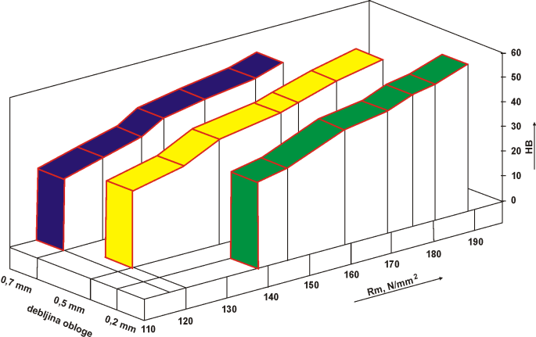 |  | 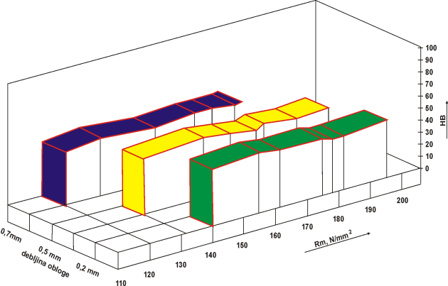
sample T |  | sample C
Figure 1: Mechanical characteristics

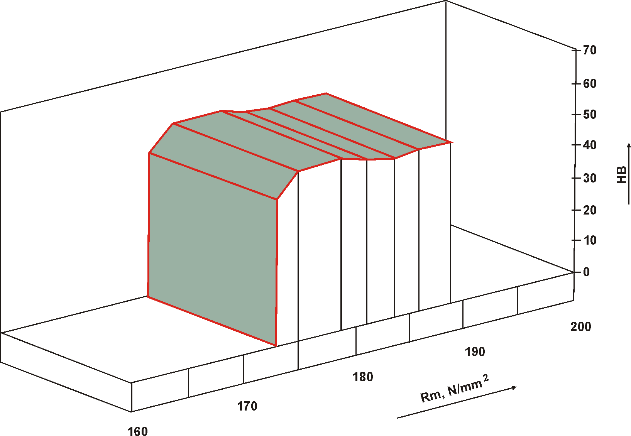
Figure 2: Mechanical characteristics of sample S

Ticker coating layers influence the slight decrease of mechanical properties, which is explained by decreased porosity due to lesser permeability of the coating. Ultrasonic testing, with thick coating samples, showed the presence of porosity over the whole sample volume.In the bottom part of the sample, porosity was slightly lower. The coating thickness of 0,7 mm affects reduced gas permeabilty.

The microstructure of tested samples consists of a-solid solution and multicomponent eutectic in which intermetallic phases, based on AL,Fe,Mn,Si, are separated. The structure is dendritic-cellular over the whole section, in such a way that, in the surface zone, dendritic cells and interdendritically separated phases are finer than those in the central zone, which is a direct effect of cooling rate.The samples produced by casting with cordierite-based coating, show coarser structure, compred with those produced by casting with talc-based coating, which is the result of higher insulation effect of the coating (Figure 3. and 4.). Further research in this field should be directed to studying modification process in order to moderate the insulating effect of ceramic lining, which causes grain growth in the structure.

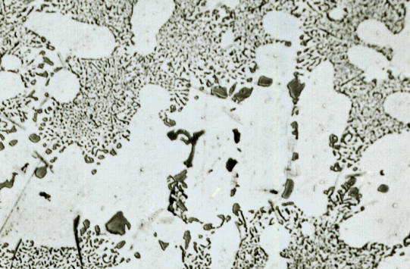 |  | 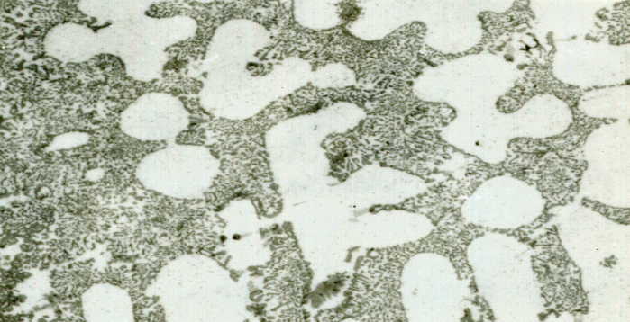
Microstructure of casting series T |  | Microstructure of casting series C
a-layer thickness 0,2 mm; |  | a-layer thickness 0,2 mm;
b-layer thickness 0,5 mm) |  | b-layer thickness 0,5 mm
c-layer thickness 0,7 mm) |  | c-layer thickness 0,7 mm
Figure 3: Microstructure , DAS of casting series T Figure 4: Microstructure , DAS of casting series C

Measuring geometrical structure parameters of the samples produced by EPC procedure, with cordierite and talc-based coatings, shows that the application of talc and cordierite-based coatings had influence on decreased structure dispersion (higher DAS), while the volumetric part of eutectic remained unchanged,which means that cooling rate affected structure dispersion, but not the part of eutectic. It can be also concluded that coating thickness had slight effect on the change of cooling conditions, which shows slight increase of the DAS value, as well, with increase of refractory coating thickness (Figure 3,4).

4. Conclusion

For the purpose of obtaining castings by the Lost Foam process, it is necessary to adjust technological parameters of the process in order to enable complete decomposition and evaporation of the model and avoid the appearance of casting failures such as porosity and short pouring. Because of that, models of smaller density (under 20 kg/cm³) should be used with finer polystyrene gain and with thinner coating layers. Application of cordierite samples as refractory fillers during manufacture of refractory coatings for sand moulds and cores as well as of refractory linings for the Lost Foam foundry process showed positive effects. Futher investigations should be continued towards production of more efficient suspension binder concentrates with a new suspension binder. Development of the cordieritebased refractory lining can contribute to the development of Lost Foam process, which represents one of the newer foundry technologies intended to the production of responsible parts in automotive and air craft industries.

REFERENCES
[1] Lj. Trumbulovic: Effects of the application cordierite ceramics in foundry, Disertacion, Faculty of Technology and Metallurgy Belgrade, (2003).
[2] Lj.Trumbulović Bujić, Z.Aćimović Pavlović: Kordijeritna keramika u livarstvu, monografija, Savez inženjera metalurgije Srbije (2010),s.110,ISBN 978-86-87183-11-7 Beograd 2011.god.
[3] Z.Aćimović: EPC Method, monograph, Faculty of Technology and Metallurgy, Belgrade (2000).
[4] Lj.Trumbulović, Z.Aćimović, Z.Gulišija: "Correlation of technological parameters and quality of castings obtained by the EPC method", ELSEVIER , Materials Letters 58 Issue 11, (2004) , Netherlands, pp.1726-1731. ISSN 0167-577X, (IF=1,186, 60/177)
[5] Lj. Trumbulović, Z. Aćimović, S. Panić: Tehnika 53 (2003), 6, p.7-12.

