TECHNOLOGY READINES LEVEL (TRL)
Zorica Tanasković¹ PhD, Vesna Vasović² PhD, Katarina Roganović³, PhD
¹Western Serbia Academy of Applied Studies, Užice, SERBIA, zorica.tanaskovic@vpts.edu.rs
²Western Serbia Academy of Applied Studies, Užice, SERBIA, vesna.vasovic@vpts.edu.rs
³ International University of Novi Pazar, 36300 Novi Pazar, naumovic.katarina@gmail.com

Abstract: The last decade has seen the emergence of a diverse set of digital technologies, platforms and infrastructures that have changed the way we live and work. Organisations from both the private and public sectors and almost all industries have been driven to explore –and often have had no choice but to adopt, cutting-edge technology and its applications. Exploration, integration and exploitation of new digital technologies have thus become one of the biggest challenges for businesses and society in the current environment, with no sector or organisation considered to be immune to its effects. Digital transformation has been broken into three categories, technology readiness (e.g. ICT investments), digital technology exploration (e.g. research and development) and digital technology exploitation (e.g. patents and trademarks). The purpose of the TRL (level of technological readiness) is to assist management in making decisions regarding the development and transition of technology, which this paper will address.
TRL is one of several tools needed to manage the progress of research and development activities within an organization.

Keywords: digital technologies, tehnology readiness level, metric technology, maturity of a technology

- INTRODUCTION

Technology readiness levels (TRLs) is a measure of estimating technology maturity of core technologies in a program during the selection process and in subsequent monitoring and evaluation phases until these technologies, or products utilizing them, attain market readiness. Originally introduced by NASA, the TRL scale is a metric with nine technology readiness levels for describing the maturity of a technology from ideation stage (TRL-1) to highest degree of application/commercial readiness (TRL-9). Levels in between covers establishment of proof of concepts, prototype developments, functional validations from models to real operational environments and clearances of mandatory regulatory barriers between levels towards market introduction of these technologies/products.
- TRL BACKGROUND
Originally developed by NASA in 1970 for Space Explorer Technologies, TRLs measured the level of maturity of a technology in its research, development and name phase of progression. TRL is based on a scale of 1 to 9, with 9 being the most mature technology.
Many organizations have always had TRLs for their own needs, and certain organizations, instead of the European Union (EU), further normalize NASA's skill level definitions, making translation easier in multiple sectors, in the industrial industry.

Tabela 1 Technology readines level (trl)
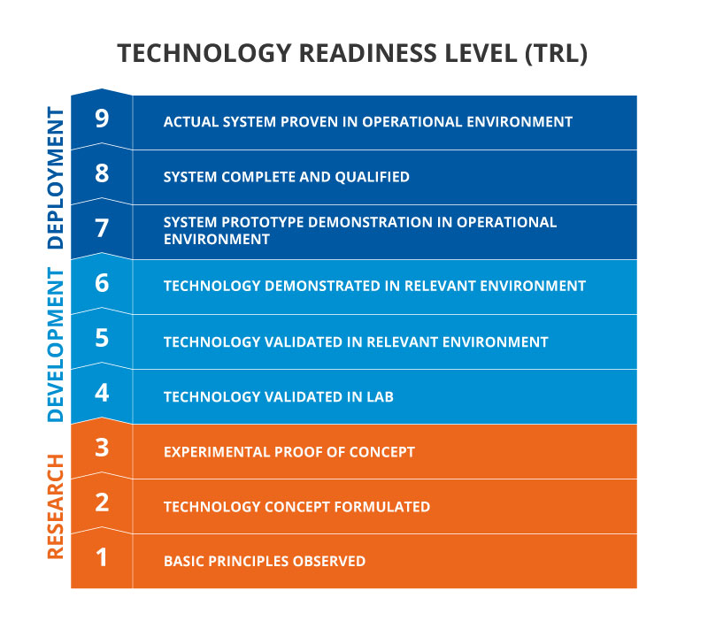
TRL 1 Definition | TRL 1 Description
Basic Research. Initial scientific research begins. Examples include studies on basic material properties. Principles are qualitatively postulated and observed. | Basic principles are observed. Focus is on fundamental understanding of a material or process.
TRL 2 Definition | TRL 2 Description
Applied Research. Initial practical applications are identified. Potential of material or process to satisfy a technology need is confirmed. | Once basic principles are observed, practical applications can be identified. Applications are speculative, and there may be no proof or detailed analysis to support the assumptions. Examples are still limited to analytic studies. Supporting information includes publications or other references that outline the application being considered and that provide analysis to support the concept. The step up from TRL 1 to TRL 2 moves the ideas from basic to applied research. Most of the work is analytical or paper studies with the emphasis on understanding the science better. Experimental work is designed to corroborate the basic scientific observations made during TRL 1 work.
TRL 3 Definition | TRL 3 Description
Critical Function, i.e., Proof of Concept Established. Applied research continues and early stage development begins. Includes studies and initial laboratory measurements to validate analytical predictions of separate elements of the technology. Examples include research on materials, components, or processes that are not yet integrated. | Analytical studies and laboratory-scale studies are designed to physically validate the predictions of separate elements of the technology. Supporting information includes results of laboratory tests performed to measure parameters of interest and comparison to analytical predictions for critical components. At TRL 3 experimental work is intended to verify that the concept works as expected. Components of the technology are validated, but there is no strong attempt to integrate the components into a complete system. Modeling and simulation may be used to complement physical experiments
TRL 4 Definition | TRL 4 Description
Laboratory Testing/Validation of Alpha Prototype Component/Process. Design, development and lab testing of technological components are performed. Results provide evidence that applicable component/process performance targets may be attainable based on projected or modeled systems | The basic technological components are integrated to establish that the pieces will work together. This is relatively "low fidelity" compared with the eventual system. Supporting information includes the results of the integrated experiments and estimates of how the experimental components and experimental test results differ from the expected system performance goals. TRL 4-6 represent the bridge from scientific research to engineering, from development to demonstration. TRL 4 is the first step in determining whether the individual components will work together as a system. The goal of TRL 4 should be the narrowing of possible options in the complete system.
TRL 5 Definition | TRL5 Description
Laboratory Testing of Integrated/Semi-Integrated System. Component and/or process validation in relevant environment- (Beta prototype component level). | The basic technological components are integrated so that the system configuration is similar to (matches) the final application in almost all respects. Supporting information includes results from the laboratory scale testing, analysis of the differences between the laboratory and eventual operating system/environment, and analysis of what the experimental results mean for the eventual operating system/environment. The major difference between TRL 4 and 5 is the increase in the fidelity of the system and environment to the actual application. The system tested is almost prototypical. Scientific risk should be retired at the end of TRL 5. Results presented should be statistically relevant
TRL 6Definition | TRL 6 Description
Prototype System Verified. System/process prototype demonstration in an operational environment- (Beta prototype system level). | Engineering-scale models or prototypes are tested in a relevant environment. This represents a major step up in a technology’s demonstrated readiness. Examples include fabrication of the device on an engineering pilot line. Supporting information includes results from the engineering scale testing and analysis of the differences between the engineering scale, prototypical system/environment, and analysis of what the experimental results mean for the eventual operating system/environment. TRL 6 begins true engineering development of the technology as an operational system. The major difference between TRL 5 and 6 is the step up from laboratory scale to engineering scale and the determination of scaling factors that will enable design of the final system. The engineering pilot scale demonstration should be capable of performing all the functions that will be required of a full manufacturing system. The operating environment for the testing should closely represent the actual operating environment. Refinement of the cost model is expected at this stage based on new learning from the pilot line. The goal while in TRL 6 is to reduce engineering risk. Results presented should be statistically relevant.
TRL 7 Definition | TRL 7 Description
Integrated Pilot System Demonstrated. System/process prototype demonstration in an operational environment-(integrated pilot system level). | This represents a major step up from TRL 6, requiring demonstration of an actual system prototype in a relevant environment. Final design is virtually complete. The goal of this stage is to retire engineering and manufacturing risk. To credibly achieve this goal and exit TRL 7, scale is required as many significant engineering and manufacturing issues can surface during the transition between TRL 6 and 7.
TRL 8Definition | TRL 8 Description
System Incorporated in Commercial Design. Actual system/process completed and qualified through test and demonstration- (Pre-commercial demonstration). | The technology has been proven to work in its final form and under expected conditions. In almost all cases, this TRL represents the end of true system development. Examples include full scale volume manufacturing of commercial end product. True manufacturing costs will be determined and deltas to models will need to be highlighted and plans developed to address them. Product performance delta to plan needs to be highlighted and plans to close the gap will need to be developed.
TRL 9 Definition | TRL 9 Description
System Proven and Ready for Full Commercial Deployment. Actual system proven through successful operations in operating environment, and ready for full commercial deployment. | The technology is in its final form and operated under the full range of operating conditions. Examples include steady state 24/7 manufacturing meeting cost, yield, and output targets. Emphasis shifts toward statistical process control.

Systematic addressing of TRLs is needed, allowing technology to evolve from conception to research, development and implementation. Universities, together with government funding sources, focus on TRL 1-4, while the private sector focuses on TRL 7-9.

  - TRL advantages and disadvantages

Among the advantages of TRL are:
• Provides a common understanding of technological status
• Risk management
• Used to make technology financing decisions
• Used to make decisions about technology transition
Some of the characteristics of TRLs that limit their usability
• Readiness does not necessarily correspond to suitability or technological maturity
• A mature product may have a greater or lesser degree of readiness for use in a particular system context than a product of lower maturity
• A number of factors must be taken into account, including the importance of the operational environment of the product for the system located, as well as the architectural mismatch of the product system
Current TRL models ignore negative and obsolescence factors.

For complex technologies involving different development phases, a more detailed scheme has been developed called the Readiness Path Matrix for technology that goes from basic units to application in society. This tool aims to show that the level of readiness of technology is based on a less linear process, but on a more complex path through its application in society.

- CONCLUSION

The effect that digital transformation can have on value creation is significant through the study of technology entrepreneurship and the expansion of the technology market, both of which are part of the dynamic capabilities that help embrace digital innovation.
Digital transformation is a concept not limited to particularly innovative businesses, digital start-ups or hightech giants. It is a process that embraces companies of all sizes, operating in the most diverse industries as well as their stakeholders.
The papers on this topic aim to formulate and explore new perspectives of digital entrepreneurship through indicators of development and business of the organization, guided by the concepts of digital transformation and entrepreneurship.
The TRL tool should be introduced into our environment as soon as possible, because of the many benefits it has, because the readiness and knowledge of information technology, information technology research and exploitation of information technology, the connection between digital transformation and entrepreneurship and market expansion are necessary for competitiveness organizations.

- REFERENCES

[1] Vahid Jafari-Sadeghi, Alexeis Garcia-Perez , Elena Candelo, Jerome Couturier, Exploring the impact of digital transformation on technology entrepreneurship and technological market expansion: The role of technology readiness, exploration and exploitation, Journal of Business Research, 2021: 100-111
[2] Fernando Martínez-Plumed, Emilia Gomez ´, Jos´e Hernandez-Orallo, Futures of artificial intelligence through technology readiness levels, Telematics and Informatics,2020:498-525
[3] https://www.twi-global.com/technical-knowledge/faqs/technology-readiness-levels
[4] https://innovationsfonden.dk/sites/default/files/2019-03/technology_readiness_levels_-_trl
[5] https://www.cloudwatchhub.eu/exploitation/brief-refresher-technology-readiness-levels-trl

