ECONOMY OF MYCOTOXINS: LEVEL OF WELL-BEING OF CEREALS PRODUCERS DUE TO MYCOTOXIN CONTAMINATION

dr Jelena Jevtić¹, MSc Ivana Jevtić², dipl.oec. Tamara Jevtić³
¹ Academy of Professional Studies Šabac, Šabac, Republic of Serbia, jelenajevtic@vmpts.edu.rs
² Faculty of Natural Sciences and Mathematics, Novi Sad, Republic of Serbia, ivana.dabic@yahoo.com
³ Faculty of Economics Subotica, University of Novi Sad, Republic of Serbia, jevtic.tasa.98@gmail.com

Abstract: Mycotoxins are secondary metabolites of molds of the genera Aspergillus, Penicillium, and Fusarium that contaminate various agricultural and food products as well as animal feed. One of the consequences of contamination is economic losses for food producers. The aim of this paper is to determine the impact of mycotoxin contamination on the level of welfare of cereal producers in the Republic of Serbia. The paper identifies potential market losses associated with mycotoxins and crops that result in the identification of a critical point for prevention. The findings of this paper can be of great benefit to farmers and the community as a whole.
Key words: mycotoxins, food producers, well-being, economic losses, cereals

1. INTRODUCTION

Mycotoxins are secondary metabolites of fungi, mainly produced from the Aspergillus, Penicillium, and Fusarium genera, which can contaminate a large number of different agricultural and food products, as well as animal feed [1] [2]. Fungal infections and mycotoxin production can occur in the field and/or during grain storage, with environmental conditions having the greatest impact on mycotoxin synthesis [2]. According to the literature, there are more than 400 species of mycotoxins produced by about 350 species of fungi [3], with research mainly focused on toxic and/or carcinogenic substances including aflatoxins (AF), ochratoxins OT, fumonisins B groups (FB), zearalenone (ZEA), patulin (PAT), and trichothecenes (deoxynivalenol-DON, T-2, and HT-2 toxin) [4]. The synthesis of molds and the production of mycotoxins is mostly influenced by environmental conditions, with fungal infections most often occurring in the field and / or during storage [2]. Due to the negative impact of the presence of mycotoxins in the environment on human and animal health, it is necessary to collect as much data as possible that defines the risk points for mycotoxins, as well as their behavior in the environment [5]. Mycotoxins most often contaminate cereals and animal feed, and the frequency of samples contaminated with at least one of the mycotoxins per year is up to 64% [2] leading to large economic losses and serious human and animal health problems [6].
The economic damage caused by food contamination with mycotoxins is very difficult to assess due to the unpredictable presence of mycotoxins in food. Conditions for infection, mold development and toxin synthesis change depending on climatic and other factors. Humans and animals are long-term, constantly exposed to the simultaneous action of several mycotoxins, most often in low concentrations. Feeding animals contaminated with mycotoxins can lead to large economic losses and serious health disorders that are reflected in increased mortality and morbidity, impaired productive and reproductive abilities and consequently increased treatment costs [7].

2. OCCURRENCE AND DETERMINATION MYCOTOXINS IN CERIALS

Cereals production, especially of wheat and maize, is an important social and economic activity and accounts for 68% of all land used for agricultural purposes [8]. Cereals are consumed through a variety of foods, with the largest fraction belonging to bread consumption. Wheat, primarily intended for human consumption, is the dominant crop in many regions of the country and is the most important staple food in Serbia. It accounts for approximately 17% of the total sown surface [9]. Overview of the incidence of predominant mycotoxins, mainly in cereal and dairy products, in Serbia, in the 2004–2016, for AF are 62.9% (n-number positive of simples; n = 12,517) with 26.2% of the samples exceeding the EU limits during this period. Results obtained for T-2/HT-2 (n = 523), DON (n = 2907), FB (n = 998), ZEA (n = 689) and OT A (n = 740) indicated the prevalence of 45.5%, 42.9%, 63.3%, 39.3% and 28.1%, respectively. For these mycotoxins, the EU limits were less frequently exceeded [9].
Analytical methods for rapid, sensitive, and accurate determination of these mycotoxins in unprocessed cereals and cereal-based products are highly needed in order to properly assess both the relevant risk of exposure and the relevant toxicological risk for humans and animals, as well as to ensure thatregulatory levels fixed by the EU or other international organisations are met. Analytical methods for mycotoxins in cereals and cereal-based products generally require toxin extraction from the matrix with an adequate extraction solvent, a clean-up step intended to eliminate interference from the extract and, finally, detection/determination of the toxin by suitable analytical instruments/ technologies. Chromatographic methods commonly used for quantitative determination of mycotoxins in cereals include high-performance liquid chromatography (HPLC) coupled with ultraviolet (UV), diode array (DAD), fluorescence (FD) or mass spectrometry (MS) detectors, and gas-chromatography (GC) coupled with electron capture (ECD), flame ionization (FID) or MS detectors. In addition, commercial immunometric assays, such as enzyme-linked immunosorbent assays (ELISA) or membrane-based immunoassays, are frequently used for screening purposes. Recently, a variety of rapid methods that are emerging have been proposed for mycotoxin analyses [10].
The assessment of economic damage must take into account epidemiological data, including clinical and laboratory research, direct and indirect damage caused by food contamination, the use of additives in order to reduce the harmful effects of mycotoxins. A very important economic loss is, first of all, the loss of consumer confidence in food safety [7].

3. CEREAL YIELDS IN THE REPUBLIC OF SERBIA

For the time being, there are not enough valid, reliable data based on scientific research for the scientific assessment of risks in the field of mycotoxins in the territory of the Republic of Serbia. Part of the reason for that lies in the fact that in the past twenty years there have been drastic changes in the structure of the population and eating habits, and part that no systematic research has been conducted in the field of mycotoxins. The available data are partial, unsystematized and do not cover a sufficient period of time for risk assessment [7].
Tables 1 and 2 show FAOSTAT data showing the yield and Gross Production Index Number (2014-2016 = 100) for cereals in the Republic of Serbia. During the observed period in the Republic of Serbia, according to the data of the Food and Agriculture Organization (FAO), the highest yield per hectare was achieved by maize green with 205,102 hg / ha. While the lowest yield was 7,264 hg / ha per millet [11].

Tabela 1. Cereal yields in the Republic of Serbia for 2019. [11]
Item | Unit | Value
Barley | hg/ha | 37290
Cereals nes | hg/ha | 21420
Grain, mixed | hg/ha | 27816
Maize | hg/ha | 76340
Maize, green | hg/ha | 205102
Millet | hg/ha | 7264
Oats | hg/ha | 24810
Rye | hg/ha | 25690
Sorghum | hg/ha | 30716
Triticale | hg/ha | 39740
Wheat | hg/ha | 43890

Tabela 2. Gross Production Index Number (2014-2016=100) fof cereals in Republic of Serbia [11]
Item | Unit | Value
Barley | index | 103.61
Cereals nes | index | 110.99
Grain, mixed | index | 84.14
Maize | index | 106.02
Millet | index | 75.49
Oats | index | 68.99
Rye | index | 99.31
Sorghum | index | 102.42
Triticale | index | 112.74
Wheat | index | 98.75

According to estimates by the Food and Agriculture Organization (FAO), 25% of total annual world crop production is contaminated with mycotoxins, while a large portion is contaminated with mycotoxins that have not been identified. Global food losses due to the presence of mycotoxins are estimated at billions of dollars. Annual losses due to crop contamination with alpha-toxins in the United States are estimated at one billion dollars. Meanwhile, the damage in the production and export of animal feed from Serbia caused by the contamination of corn is estimated at around 100 and 125 million euros [7].
Mycotoxins can enter the food chain through direct or indirect contamination. In direct contamination, food material is the basis for the growth of toxic mold. Almost all foods can be good hosts for mold growth. Cereals can be exposed to mold growth during their growth in the field, as well as during storage and processing [12].
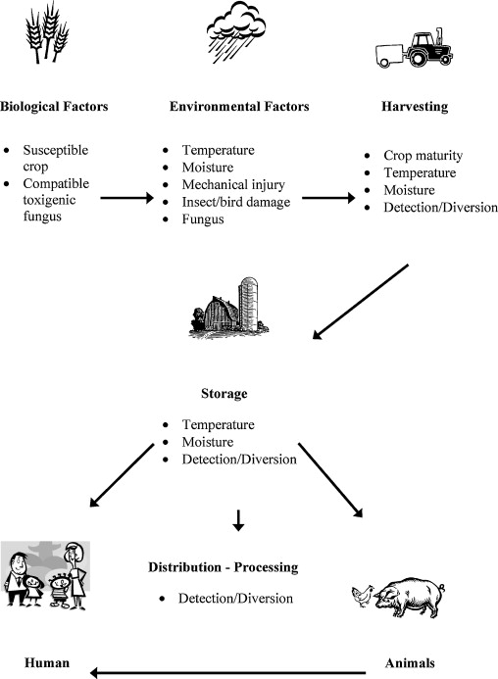
Picture 1. Factors affecting mycotoxin occurrence in the human food and animal feed chains [1]

Molds contaminate cereals before and after harvest, during inadequate storage, and can be found in animal and human food. Mycotoxins can enter food through direct contamination, caused by the development of mold on food. Also, contamination can be indirect, through the use of contaminated ingredients in food processing or through the consumption of food that contains mycotoxin residues [13]. It is not uncommon to find data on mass poisonings of humans and animals associated with the consumption of food contaminated with fungi and mycotoxins [14]. Several mass poisonings of humans and animals have been known throughout history, the most important of which is from 1962, when 100,000 turkeys died in England as a result of mycotoxin poisoning, and since then the term mycotoxins has been used.

4. LEVEL OF WELL-BEING OF CEREALS PRODUCERS AND CONSUMER

Crop production is the primary production in agriculture and is particularly exposed to the effects of weather risks. The amount of precipitation is of special importance for plant production. The fact is that always after a flood, drought or a strong storm, the discussion about crop and fruit insurance intensifies, which can compensate for the loss in production [16].
Corn is one of the most important sources of food for human and animal consumption and raw materials for industrial processing. In the Republic of Serbia, maize was grown on about 1.2 million hectares with an average yield of 5.4 t ha-1 and a production of 6.5 million tons in 2011. The nutritional value of stored maize grain could vary significantly due to interactions between physical, chemical and biological factors. Grain infection in the field can result in the production of mycotoxins during cultivation, harvesting, storage, transport and processing. Contamination of corn with mycotoxins can occur after harvest, during the storage period and further in the food chain. The reasons for mycotoxin contamination are found in climate change, the cultivation of high-yield hybrids susceptible to infections by toxigenic fungi [17].
The primary way in which mycotoxins can affect the market is to reduce the value of traded goods. This can happen at different levels of trade, from local to international levels. The party bearing the burden of losses caused by mycotoxins may be individual farmers, processors, distributors, consumers or the government.

Graph 1. Dynamics of supply and demand for food when supply decreases
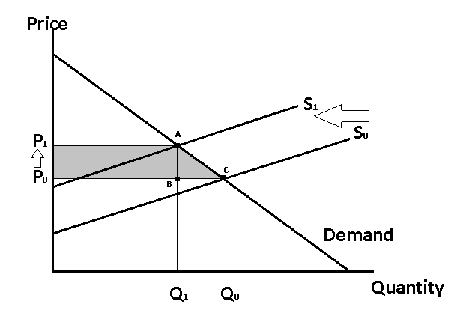
Microeconomic theory explains mycotoxin contamination by total costs. Mycotoxin contamination reduces the supply of acceptable food that can be sold and bought, in this case, cereals. Graph 1 shows the dynamics of supply and demand for food when supply decreases. The demand curve represents a certain amount of food that consumers are willing to buy at a certain price. In accordance with the law of demand, at very high prices there will be less demand for food, while at lower prices the demand will be higher. The supply curves are marked S0 and S1 and represent the amount of food that producers will provide at different prices. Thus, the original equilibrium is at the intersection of the demand curve and the supply curve S0, at the amount of food Q0 and the price P0. The supply curve shifts to the left, to the C1 level when food supplies are reduced due to excessive levels of mycotoxins. By moving the curve to the level of P1, a new equilibrium is achieved, the intersection of the demand curve and the new supply curve S1. A reduced quantity to the level of Q1 requires a higher price of P1. Thus, both producers and consumers bear the costs related to mycotoxins. Producers sell less food, reducing their income, and consumers have to buy food at a higher price. In particular, the reduction in the well-being of food producers due to mycotoxin contamination is represented by a shaded surface. The shaded area is the difference between the initial well-being of producers and their resulting well-being. The equilibrium quantity is the quantity Q0, and the equilibrium price is the price P0. By moving the supply curve to the left, the quantity decreased to the level of Q1 and the price increased to the level of P1. The triangle formed at the points ABC represents a loss. In this way, food producers who are sensitive to mycotoxins can suffer direct market losses. On the other hand, consumers suffer indirect market losses in the face of reduced supply and high prices. In addition, consumers may suffer direct health-related losses [18]. Thus, farmers may suffer a complete financial loss when the yield contains toxins above certain regular limits [19]. Grain that contains toxins is unsuitable for food and animal feed.

5. CONCLUSION

Mycotoxins reduce the value of traded goods, resulting in economic losses for food producers. Cereals with mycotoxin levels above the maximum allowed were rejected for sale or sold at a lower price for other uses. The reduction in the welfare of food producers may be the result of contamination of cereals with mycotoxins, but also the loss of consumer confidence in food safety. Various studies have quantified the potential market losses associated with mycotoxins. This paper provides an overview of potential market losses associated with mycotoxins and crops that lead to the identification of a critical point for prevention.
It has been identified that unfavorable conditions for the development of fungi and toxinogenesis can be minimized by applying appropriate agricultural practices, as preventive measures in the field. In addition, early planting of maize that prolongs the growing season and selection of hybrids with manpower, tolerance to biotic and abiotic stress are considered important measures to reduce pathogenic and toxigenic fungi. In addition to these measures, it should be noted that preventive measures such as fast drying of corn and long-term storage in hygienically maintained warehouses, without the presence of insects and microorganisms and proper regulation of grain moisture, can significantly reduce contamination of corn grain with mycotoxins and consequently increase yield.
Processes of preventing contamination with fungi and mycotoxins are performed at critical points before the expected fungal infection [20]. This can be done in 3 phases: before harvest, during harvest or in the handling and after storage phases [20]. As preventive measures in the field are often insufficient or can fail [21], additional procedures are needed to reduce mycotoxins after harvest [22]. It is assumed that they cannot be completely removed by decontamination methods (physical, chemical and biological) [21].

REFERENCE

[1] Bryden W.L. Mycotoxin contamination of the feed supply chain: Implications foranimal productivity and feed security, Anim. Feed Sci.Technol, 173; 2012: 134–158.
[2] Streit E, et al. Mycotoxin occurrence in feed and feed raw materials worldwide: long-term analysis with special focus on Europe and Asia, J. Sci. Food Agric, 93, 2013: 2892–2899.
[3] Nielsen K., Smedsgaard J. Fungal metabolite screening: database of 474 mycotoxins and fungal metabolites for dereplication by standardised liquid chromatography–UV–mass spectrometry methodology. J. Chromatogr. A, 1002; 2003: 111–136.
[4] Hussein H.S., Brasel J.M. Toxicity, metabolism, and impact of mycotoxins on humans and animals. Toxicology, 167; 2001: 101–134.
[5] Jevtić I, et al. UV-induction of photolytic and photocatalytic degradation of fumonisins in water: reaction kinetics and toxicity, Environ. Sci. Pollut. Res. Int, 2021: Online a head of print.
[6] Bräse S, et al. Chemistry and biology of mycotoxins and related fungal metabolites. Chem. Rev, 109, 2009: 3903–3990.
[7] Milićević D., Nedeljković-Trailović J., Mašić Z. Mikotoksini u lancu ishrane–analiza rizika i značaj za javno zdravstvo. Scientific journal" Meat Technology", 55(1); 2014: 22-38.
[8] Pavlović P., et al. The Soils of Serbia. World Soils Book Series. doi:10.1007/978-94-017-8660-7; 2017.
[9] Udovicki B, et al. Overview on the Mycotoxins Incidence in Serbia in the Period 2004–2016. Toxins, 10 (279), 2018.
[10] Pascale M.N. Detection methods for mycotoxins in cereal grains and cereal product, Proc. Nat. Sci, Matica Srpska Novi Sad, 117, 2009: 15–25.
[11] Food and Agriculture Organization of the United Nations. Data about of Agricultural Production. [accessed: 15.8.2021]; available at: http://www.fao.org/faostat/en/#data
[12] Furlan I. Određivanje mikotoksina u stočnoj hrani–kukuruz u zrnu, Doctoral dissertation, Josip Juraj Strossmayer University of Osijek, Faculty of agriculture, 2016.
[13] Šumić Z. Mikotoksini. Tehnologija hrane. [accessed: 18.8.2021]; available at: https://www.tehnologijahrane.com/enciklopedija/mikotoksini
[14] Kocić-Tanackov S. D., Dimić G. R. Gljive i mikotoksini–kontaminenti hrane. Chemical Industry/Hemijska Industrija, 67(4), 2013: 639-653.
[15] Bennett J.W., Klich M. Mycotoxins. Clin. Microbiol. Rev., 16; 2003: 497–516.
[16] Marković T., Jovanović M. Uticaj količine padavina na prinos pšenice i kukuruza kao proizvodni bazni rizik. Ratarstvo i povrtarstvo, 48(1); 2011: 207-212.
[17] Krnjaja V, et al. Moulds and mycotoxins in stored maize grains. Biotechnology in Animal Husbandry, 29(3), 2013: 527-536.
[18] IARC. Economics of mycotoxins: Evaluating costs to society and cost‐effectiveness of interventions. IARC Sci Publ, 158; 2012: 119-129.
[19] Szabo B, et al. A new concept to secure food safety standards against Fusarium species and Aspergillus flavus and their toxins in maize. Toxins, 10 (9), 372, 2018: 1-25.
[20] Hojnik N., et al. Mycotoxin decontamination of food: cold atmospheric pressure plasma versus “classic” decontamination. Toxins, 9 (151), 2017.
[21] Peraica M., et al. Prevention of exposure to mycotoxins from food and feed. Arh. Hig. Rada. Toksikol, 53, 2002: 229–237.
[22] Humer E, et al. Effects of citric and lactic acid on the reduction of deoxynivalenol and its derivatives in feeds. Toxins, 8 (285), 2016.

