Natural spring waters quality indicators in the Požega and Lučani vicinity

¹dr Nataša Ćirović, ²Teodora Karić, ³Aleksandar Mićić, ⁴dr Vesna Marjanović
¹Western Serbia Academy of Applied Studies, Užice, SERBIA, natasacirovicvv@gmail.com
²Western Serbia Academy of Applied Studies, Užice, SERBIA, teodorakaric1998@gmail.com,
³Western Serbia Academy of Applied Studies, Užice, SERBIA, aleksandarmicic9829@gmail.com,
⁴Western Serbia Academy of Applied Studies, Užice, SERBIA, vesna.marjanovic@vpts.edu.rs

Abstract
Natural spring water is groundwater intended for human use in its natural state, which meets the quality requirements prescribed by the Ordinance on quality and other requirements for natural mineral water, natural spring water and table water (Sl. list SCG 53/2005 and Sl. glasnik RS, 43/2013). The aim of this paper is to examine the quality of natural spring waters, regarding to examine physical (temperature, color, smell, taste and turbidity of water) and chemical indicators of water quality (alkalinity, acidity, pH, electrical conductivity, determination of lead, cadmium, ammonium and fluoride ions and chloride, as well as the determination of carbonate hardness) on 4 samples of spring water in the vicinity of Lučani and 7 samples of spring water in the vicinity of Požega.

Key words: natural spring water, physical indicators of natural spring water quality, chemical indicators of natural spring water quality.

INTRODUCTION

During its circulation, water is enriched with various substances which it comes into contact, dissolving some substances and carrying some in suspended form. Thus, water in nature always contains certain gases, some salts and other substances in dissolved form and very often various microorganisms. According all waters in nature, atmospheric waters contain less of these foreign substances. It usually has oxygen, nitrogen and carbonic acid, sometimes dust, and near the industry also sulfur dioxide, carbon monoxide and other ingredients from factory flue gases. These waters are very soft. [1]
Surface waters are more mineralized and its properties depend on the composition of the terrain, catchment area and the content of spring and wastewater that flows into surface waters. Therefore, these waters almost regularly contain suspended solids, organic and inorganic in nature, which vary considerably in quantity. Some surface waters (seas) contain especially many different salts.
If it is cracked groundwater, it is slightly different from the surface water from which it originates and its composition varies considerably. It is usually more turbid after rain and melting snow. It is always polluted in bacteriological terms. Its temperature is variable and mainly depends on the season. It often contains so many pathogenic germs. [2]
In contrast, the groundwater in the aquifers is completely clear and free of bacteria and its temperature is stable and ranges between 11 and 13⁰C. If these waters originate from alluvial and alluvial layers, it is usually highly mineralized and hard and almost regularly contain more iron and manganese. From the layers of older formations, these waters can be soft and free of iron and manganese. The composition of spring waters corresponds to groundwater from which these originate. [3,4,5]
All the mentioned types of water that are in nature, in addition to pollution caused by their contact with various environments in circulation in nature are also polluted artificially with various substances that carry polluted water from households (fecal water) from washing streets and squares, from various institutions (hospitals, barracks, etc.) and from many industrial plants. The ideal drinking water is one that contains a balanced ratio of minerals - calcium and magnesium in a ratio of 2: 1. In addition, it should take care of sodium when there should be the least in the water. [6]

2. EXPERIMENTAL RESEARCH
In this paper, the pH - values of spring water samples, electrical conductivity, the presence of cadmium, lead, fluoride and ammonium ions as well as the presence of chloride were performed in the vicinity of Lučani and Požega. The procedures were performed on a SevenExcellence™ pH/Conductivity/Ion device, a digital multimeter to which three modules for determining pH - value, electrical conductivity and ion concentration can be connected: lead, cadmium, ammonium ions and fluoride.
The pH electrode owned by the Western Serbia Academy of Vocational Studies, in Užice Department, Laboratory for Safety and Health at Work is not with a temperature sensor and works in the pH range from 0 to 14.
The operating range of the electrical conductivity electrode is from 0.001µS/cm to 2000µS /cm (+/- 0.5%) and the temperature range is from -30 to 130°C (+/- 0.1 ° C) and is not with temperature sensor.
The range of concentrations that can be measured with ion selective electrodes is from 0 to 999,999mg/L, ppm, 0 to 100mol/L, %, 0 to 100,000mmol/L (+/- 0.5%).

2.1 Analysis of water samples
Samples are labeled as follows:
Lučani:
- Sample 1 – Well water from the Aleksić household, Figure 4.
- Sample 2 – Spring water Studenac, Figure 5.
- Sample 3 – Karić fountain, Figure 6.
- Sample 4 – Spring water Bjeloševac, Figure 7.
Požega:
- Sample 5 – Spring water near Monastery Godovik, Figure 8.
- Sample 6 – Rzav water (taken from the household from the Rzav supply system), FIgure 9.
- Sample 7 – Spring water of Godovik fountain, Figure 10.
- Sample 8 – Spring water Mićić hill (Najdans water), Figure 11.
- Sample 9 – Spring water from Gorobilje (Počeča), Figure 12.
- Sample 10 – Spring water from the Šojić household, Figure 13.
- Sample 11 – Water from the Bogdan Mićić well, Figure 14.

 | 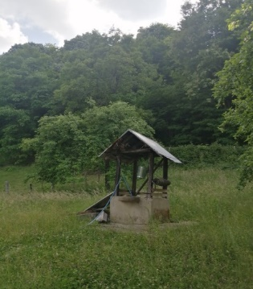  Figure 4.Well water from the Aleksić household | 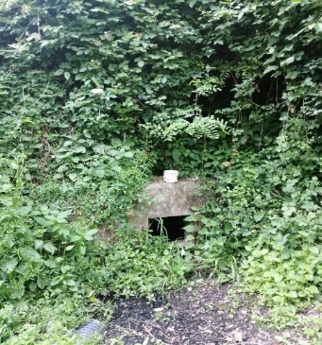  Figure 5. Spring water Studenac |  | 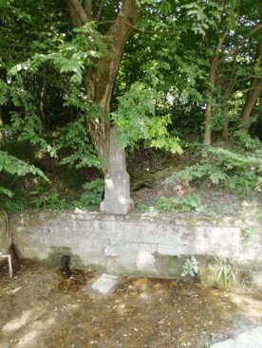  Figure 6. Karić fountain
Figure 7. Spring water Bjeloševac | Figure 8. Spring water near Monastery Godovik |  |  | Figure 9. Rzav water
Figure 10. Spring water of Godovik fountain |  |  | Figure 11. Spring water from Mićić hill  (Najdans water)
Figure 12. Spring water from Gorobilje (Počeča) |  | Figure 13. Spring water from the Šojić household |  |  | Figure 14. Water from the Bogdan Mićić well

3. RESEARCH PROCEDURE AND RESULTS
3.1 Determination of рН - value
3.1.1 Procedure for determining рН – value:
Weigh 100ml of the water sample into a laboratory beaker. Immerse the measuring probe in the solution. Press the READ function key and read the value for the pH – value, Figure 15., Tables 1. a and 1. b show the measured pH – values from the examined samples of water sources in the vicinity of Lučani and Požega.
Table 1.а рН – values of water sources in the vicinity of Lučani
Sample 1 – Well water from the Aleksić household | 6,68
Sample 2 – Spring water Studenac | 6,89
Sample 3 – Karić fountain | 6,87
Sample 4 – Spring water Bjeloševac | 6,52

Table 1.b pH – values of water sources in the vicinity of Požega
Sample 5 – Spring water near Monastery Godovik | 7.29
Sample 6 – Rzav water (taken from the household from the Rzav supply system) | 7.34
Sample 7 – Spring water of Godovik fountain | 7.15
Sample 8 – Spring water Mićić hill (Najdans water) | 6.92
Sample 9 – Spring water from Gorobilje (Počeča) | 6.79
Sample 10 – Spring water from the Šojić household | 6.97
Sample 11 – Water from the Bogdan Mićić well | 6.90

3.2 Determination of electrical conductivity
3.2.1 Procedure for determining electrical conductivity:
Weigh 100ml of the water sample into a laboratory beaker. Immerse the measuring probe in the solution. Press the READ function key and read the value for the electrical conductivity, Figure 15.
The measured values of electrical conductivity of the examined samples of water sources are given in Tables 2. a and 2. b.
Таble 2.а Electrical conductivity of examined samples in the vicinity of Lučani
Sample 1 – Well water from the Aleksić household | 90 µS/cm
Sample 2 – Spring water Studenac | 464,1 µS/cm
Sample 3 – Karić fountain | 431,1 µS/cm
Sample 4 – Spring water Bjeloševac | 562,4 µS/cm

Таble 2.b Electrical conductivity of examined samples in the vicinity of Požega
Sample 5 – Spring water near Monastery Godovik | 515.9 µS/cm
Sample 6 – Rzav water (taken from the household from the Rzav supply system) | 362.8 µS/cm
Sample 7 – Spring water of Godovik fountain | 511.0 µS/cm
Sample 8 – Spring water Mićić hill (Najdans water) | 687.6 µS/cm
Sample 9 – Spring water from Gorobilje (Počeča) | 724.6 µS/cm
Sample 10 – Spring water from the Šojić household | 630.2 µS/cm
Sample 11 – Water from the Bogdan Mićić well | - µS/cm

3.3 Acidity and alkalinity
3.3.1 Procedures for determinig the acidity and alkalinity:
- Pipette 100,0ml of water sample,
- Add 10 drops of phenolphthalein indicator (ff), (the solution is colorless),
- Add 1% NaOH solution to the burette and set to zero (read or estimate the NaOH volume level),
- Titrate the sample until the solutin changes color to purple, Figures 16. and 17.,
- Read the level of NaOH volume in the burette, after the end of the titration, Tables 3.а and 3.b,
- Calculate and enter the value for the consumed volume of NaOH for neutralization of acidic species in aqua solution in the appropriate table.
Таble 3.а Cosumption NaOH during titration of spring water samples in the vicinity of Lučani
Sample 1 – Well water from the Aleksić household | 2,2 ml
Sample 2 – Spring water Studenaac | 0,4 ml
Sample 3 – Karić fountain | 1 ml
Sample 4 – Spring water Bjeloševac | 2,5 ml

Таble 3.b Cosumption NaOH during titration of spring water samples in the vicinity of Požega
Sample 5 – Spring water near Monastery Godovik | 0.5ml
Sample 6 – Rzav water (taken from the household from the Rzav supply system) | 0.7ml
Sample 7 – Spring water of Godovik fountain | 0.7ml
Sample 8 – Spring water Mićić hill (Najdans water) | 0.8 ml
Sample 9 – Spring water from Gorobilje (Počeča) | 1.2ml
Sample 10 – Spring water from the Šojić household | 1 ml
Sample 11 – Water from the Bogdan Mićić well | 0.9 ml

3.3.2 Procedure for determining water alkalinity:
In erlenmeyer flask of 300 cm³, weigh 100 cm³ of the water sample with a belly pipette and add 2 to 4 drops of phenolphthalein. If the sample is colored pink, it contains hydroxide or carbonate and titrate with 0,1mol/dm³ HCl until the solution is discolored. Two tests are done and the mean is taken. Table 4.

Таble 4. Presence of hydroxide or carbonate
Sample 1  Well water from the Aleksić household | Sample 2 Spring water Studenac | Sample 3  Karić fountain | Sample 4  Spring water Bjeloševac
not presence of hydroxide or carbonate | not presence of hydroxide or carbonate | not presence of hydroxide or carbonate | not presence of hydroxide or carbonate

In the samples of spring water in the vicinity of Požega, which were tested in the same way, the presence of neither hydroxide nor carbonate was also registered, Table 4.

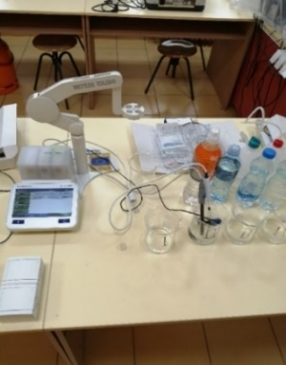  Figure 15. Probes for рН - value, electrical conductivity and ion selective electrodes |  | 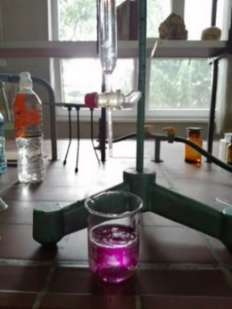  Figure 16. Titration of sample | 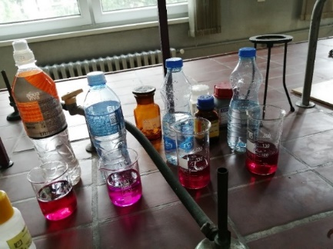  Figure 17. Completion of sample titration

3.4 Determination of chloride

3.4.1 Procedure for determining chloride in water:
Weigh a 100 cm³ of the spring water sample with a belly pipette or dilute a suitable aliquot to that volume. Samples with a pH – value of 7-10 are titrated directly, without prior preparation. If the pH – valey is not in that interval range, it is adjusted with a solution of H₂SO₄ or NaOH depending on the pH - value of the sample using the phenolphthalein indicator until the pink color disappears. Add 1 cm³ of K₂CrO₄ to the sample prepared in this way and titrate, Figure 18., with a standard solution of AgNO₃ to a pinkish-yellow color (titration endpoints). Repeat the procedure three times and calculate the mean consumption of AgNO₃ solution, Tables 5.a and 5.b. It is necessary to perform a blank analysis by repeating the same procedure, but also with 100 cm³ of distilled water.

Таble 5.а Mean value of consumed AgNO₃, cm³, in water spring samples in the vicinity of Lučani
Sample 1  Well water from the Aleksić household | Sample 2  Spring water Studenac | Sample 3  Karić fountain | Sample 4  Spring water Bjeloševac
3 | 4,5 | 4,7 | 4,9

Таble 5.b Mean value of consumed AgNO₃, cm³, in water spring samples in the vicinity of Požega
Sample 5 Spring water near Monastery Godovik | Sample 6 Rzav water (taken from the household from the Rzav supply system) | Sample 7 Spring water of Godovik fountain | Sample 8 Spring water Mićić hill (Najdans water) | Sample 9 Spring water from Gorobilje (Počeča) | Sample 10 Spring water from the Šojić household | Sample 11 Water from the Bogdan Mićić well
4.2 | 3.9 | 4.1 | 4.8 | 4.7 | 4 | 4.5

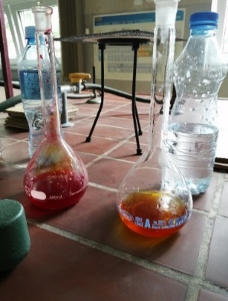  Figure 18. Endpoints titration for determining chloride | 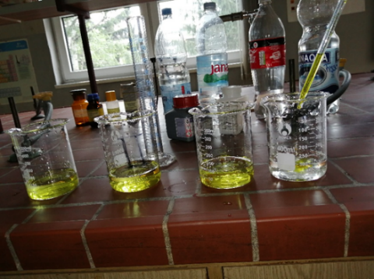  Figure 19. Titration with HCl solution | 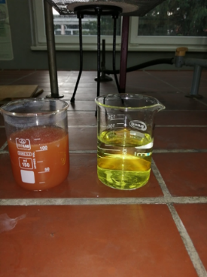  Figure 20. Endpoints titration for determining carbonate hardness

3.5 Determination of ion concentration (Cd, Pb, ammonium and fluoride ions) with ion selective electrodes
3.5.1 Procedure for determining concentration of ions (Cd, Pb, ammonium and fluoride ions)
Weigh 100 ml of the spring water sample into a laboratory beaker. Immerse the measuring probe in the solution. Press the READ function key and read the value for the concentration of individual ions.
The presence of cadmium, lead, ammonium ions and fluoride was not registered in the examined samples of spring waters in the vicinity of Lučani and in the vicinity of Požega.
  - Determination of carbonate hardness
    - Procedure for determining carbonate hardness
Weigh 100 ml of the spring water sample into a laboratory beaker, add 2-3 drops of of methyl red (the indicator changes color when pH = 4.5) and titrate with 0.1 mol/dm³ HCl solution, Figures 19. and 20., until the yellow color turns orange. Note the consumption of HCl solution.

Таble 6.а Consumption of HCl solution (cm³) in water samples in the vicinity of Lučani
 | Sample 1  Well water from the Aleksić household | Sample 2  Spring water Studenac | Sample 3  Karić fountain | Sample 4  Spring water Bjeloševac
9,3 |  | 9,4 | 3,1 | 8,3

Таble 6.b Consumption of HCl solution (cm³) in water samples in the vicinity of Požega
 | Sample 5 Spring water near Monastery Godovik | Sample 6 Rzav water (taken from the household from the Rzav supply system) | Sample 7 Spring water of Godovik fountain | Sample 8 Spring water Mićić hill (Najdans water) | Sample 9 Spring water from Gorobilje (Počeča) | Sample 10 Spring water from the Šojić household | Sample 11 Water from the Bogdan Mićić well
1 |  | 1,5 | 0,5 | 2,3 | 8,2 | 1,9 | 0,8

According to calculation and certain water characteristics based on German degrees for carbonate water hardness, [4], Tables 7.a and 7.b, show the results of testing the carbonate hardness of spring waters in the vicinity of Lučani and Požega. Including that base the characteristic of water is determined.

Таble 7.а Determination of water type based on water hardness of spring water samples in the vicinity of Lučani
Sample 1 – Well water from the Aleksić household | very hard
Sample 2 – Spring water Studenaac | very hard
Sample 3 – Karić fountain | medium hard
Sample 4 – Spring water Bjeloševac | very hard

Таble 7.b Determination of water type based on water hardness of spring water samples in the vicinity of Požega
Sample 5 – Spring water near Monastery Godovik | soft water
Sample 6 – Rzav water (taken from the household from the Rzav supply system) | very soft water
Sample 7 – Spring water of Godovik fountain | very soft water
Sample 8 – Spring water Mićić hill (Najdans water) | moderately hard water
Sample 9 – Spring water from Gorobilje (Počeča) | very hard
Sample 10 – Spring water from the Šojić household | moderately hard water
Sample 11 – Water from the Bogdan Mićić well | very soft water

4. CONCLUSION
According to the Ordinance on the hygienic correctness of drinking water, [4], the allowed pH - value of drinking water ranges from 6.8 to 8.5. The upper limit value of electrical conductivity, according to the same ordinance is 1000µС/cm at 20°C, and in emergency situations, values ​​up to 2500μС/cm are allowed. The results of the pH value and electrical conductivity research of spring water samples from 4 springs in the vicinity of Lučani and 7 springs in the vicinity of Požega, Tables 1.a and 1.b and Tables 2.a and 2.b, show that all samples have allowed pH - values (within the allowed interval for pH - value) and electrical conductivity values, which are below the maximum allowed value for drinking water (1000μs/cm).
In order to determine the acidity of spring water samples in the vicinity of Lučani, and based on the used values ​​of NaOH volume, for neutralization of acidic species in aqua solution, it is seen that the largest amount of NaOH solution (2.5 ml) was used for the sample whose pH - value is the lowest (6,52), which is Bjeloševac spring water. In the case of spring waters in the vicinity of Požega, the largest amount of NaOH solution (1.2 ml) was used for the sample whose pH - value is the lowest (6.79), which is sample number 5, i.e. the water from Gorobilje spring. Special attention should be paid to the highest measured values ​​for electrical conductivity of these samples, 562.4µС/cm, springs Bjeloševac and 724.6µС/cm, Gorobilje. As it is known, waters with a higher salt content, such as hard and polluted waters, have a higher electrical conductivity, while soft waters have a lower electrical conductivity. According to the results obtained on the characteristics of water based on water hardness, Tables 7. a and 7. b, it can be seen that the waters from the springs Bjeloševac and Gorobilje are very hard waters.
The results obtained by direct measurement in spring water samples, on the Seven Excellence device, combined with ion selective electrodes, show that lead (Pb²⁺) and cadmium (Cd²⁺) ions, as well as ammonium ions and fluoride were not registered in the spring water samples in the vicinity of Požega. Since the presence of any of these ions in spring water, which is used as drinking water, indicates pollution and potential danger to the human body, it is important that they were not registered during the examination:
Ammonia can be present in two forms in water, as ammonium hydroxide or as ammonium ion. When the pH - value of water is less than 7, ammonia is present as an ammonium ion. When the pH – value is greater than 7, more ammonia is present as ammonium hydroxide. The presence of ammonium ions, most often, indicates the existence of fecal pollution in spring waters. Fluoride is rarely found in the elemental state in natural waters, in most cases it is bound to other elements, thus building fluorides, which are placed in toothpastes. Fluorides do not exhibit extreme toxicity like elemental fluoride. The fluoride content in rivers is a consequence of the discharge of industrial waste.
Lead comes from lead water pipes in drinking water, PVC pipes that contain a lead component or from a tap, house connections or fittings. Lead and its inorganic compounds are classified in the second group of carcinogens, which means that it is probably carcinogenic to humans as well. The presence of cadmium in spring waters indicates the contamination of soil and plants, which are the starting link of the diet and the basic source of cadmium for animals and humans. The fact that in the examined samples of spring waters in the vicinity of Požega the presence of these ions was not registered, shows that the results of researching these ions are of great importance.
By determining the alkalinity or the amount of HCl required for titration of the solution, the presence of hydroxides and carbonates was not determined in the tested samples, Table 4.
The mean value of consumed AgNO3 (cm³), during the determination of the presence of chloride in the tested samples, has the highest value in sample number 4, i.e. in spring water from Mićić hill (Najdans water). The AgCl(s) precipitate has a lower solubility than Ag₂CrO₄, so AgCl precipitates first and the permanent reddish hue corresponds to the presence of Ag₂CrO₄, Tables 5. a and 5. b.
According to the results of water hardness, expressed in German degrees of hardness, Tables 7. a and 7.b, samples from springs in the vicinity of Lučani and Požega, mainly, can be used in households, without technical softening because their hardness values ​​are below 12°N (maximum allowed values). Waters from springs number 4 and 5 (springs Bjeloševac and Gorobilje) need to be softened before use in the household, because the results indicate that these are very hard waters.
Based on the complete analysis of water samples from springs in the vicinity of Lučani and Požega, it can be concluded that the waters have a satisfactory character.

Literature
[1] Др Марина Стојановић, Распрострањеност воде природи, припремна настава
[2] Др Марина Стојановић, ВОДОСНАБДЕВАЊЕ И КАНАЛИСАЊЕ ВОДА, I део
[3] Pravilnik o kvalitetu i drugim zahtevima za prirodnu mineralnu vodu, prirodnu izvorsku vodu i stonu vodu: SCG 53/2005-7, RS 43/2013-130 (dr. pravilnik) (pravno-informacioni-sistem.rs), Прилог 1
[4] Pravilnik o higijenskoj ispravnosti vode za piće: 42/1998-4, 44/1999-19, 28/2019-114 (pravno-informacioni-sistem.rs)
[5] Zakon o fluorisanju vode za piće: 35/1994-1080, 38/1994-1192 (ispravka), 25/1996-793, 101/2005-28 (dr. zakon) (pravno-informacioni-sistem.rs)
[6] Влатко С. Рукавина, Драган Дамњановић, Технологија воде и технологија напојне воде, Савез енергетичара Србије, Београд, 1984.

