ASSESSMENT OF THE QUALITY OF WORK ORGANIZED BY THE
NURSING SERVICE

Slavka Mitricevic¹ MD; Zeljko Karganovic² MD; Mirjana Jesic ³ APRN;
1.Cabinet of the Minister for Development of Underdeveloped Municipalities, Belgred, Serbia
drsmitricevic@gmail.com
2. Academy of Vocational Studies Western Serbia, Uzice, Serbia
zkarganovic@gmail.com
3. Health Center Uzice, Public Health Center, Uzice, Serbia
dzuzice@gmail.com

Abstract:
Aim: The aim of this research is to analyze the satisfaction of employed nurses in the Health Center in Uzice in order to raise the quality of primary health care to a higher level.
Introduction: Health services provided by nurses in various areas of primary health care should be in continuous improvement and regular evaluation of the quality of their work and in light of meeting the needs of users for health care.
Material and method: A targeted questionnaire on satisfaction and sociodemographic factors was conducted in 2019 at the Uzice Health Center, involving 42 nurses from various services.
Results: 95% believe that good work organization affects the quality of their work; 64% voted for teamwork; 26% of them are satisfied with adequate work equipment; 59% suggest their ideas in order to improve the quality of work; 74% attend professional and educational seminars, 69% of nurses are under great stress at work; 76% of them havsecondaryeducation; 40% between 20-30 years of service; 50% are aged between 40-50 years and 5% between 20-30 years working; 14% are in managerial positions.
Conclusion: The analysis of the satisfaction of employed nurses in the Health Center in Uzice aimed to achieve a higher level of efficiency and effectiveness in their work, meet the needs of health care users and raise the quality of work to a higher level.

Key words: nurse, quality of work, primary health care, users of health services.

1.INTRODUCTION:
Modern world policies respect the principles of a holistic approach to health, pointing out that the quality of health care, as well as differences in the provision of health services in different regions, are synergistically influenced by numerous demographic, socio-economic, environmental factors and clinical practices and health service organizations. In this way, they point to the responsibility of the whole society, which is reflected in the phrase "health in all policies" [1,2].
One such policy is the United Nations Agenda for Sustainable Development until 2030, and world leaders have reaffirmed their readiness to provide access to quality health services in the light of sustainable development, through activities of the third goal, which focuses on health. "Medicine, through the prism of the goals of sustainable development, leaves no one behind!" ("Leaving no one behind") [3].
Improving the quality of work of health care institutions, ie health care, as an integral part of daily activities of health workers and all other employees in the health care system, is a continuous process aimed at achieving higher levels of efficiency and effectiveness, as well as greater satisfaction of health care users. Health care is also assessed through the concept of the health care program, to what extent it is in line with modern knowledge of the provision of nursing services, the quality of medical practice and the provided health services [4].

1.1.Definition and concept of quality
The word quality comes from the Latin word "qualitis" which means that something has good properties, properties or values. When it comes to health care, it must be stated that in this area there is no single, generally accepted definition of the concept of quality. In other economic-industrial sectors, the definition from the ISO 9000/2000 standard is used, in which quality is defined as "fulfillment of requirements". This meaning, however, cannot be applied in the field of medicine without significant changes. In general, quality can be defined as "the degree to which the health care system and the provision of health services to users need to comply with applicable professional standards in the field of health care, thus increasing the likelihood of a positive health outcome." The mission, vision and value system is the starting point for defining the quality policy, through standards and criteria.

1.2.Standards and criteria
Standards and criteria of health care, as special categories in nursing, have been considered more intensively since the 1970s. However, from the first steps in the development of the nursing profession, numerous ethical and humane aspects of this professional activity have been accepted. In the mid-nineteenth century, Florence Nightingale set out a number of principles regarding patient care and the way nurses approached and worked, which could be considered the first standards of professional nursing practice. In 1858, she drafted the first Code of Professional Ethics. In it, he sets high ethical norms and emphasizes that "patients should be cared for by respected women". Based on a deep understanding of the nursing profession, Florence Nightingale formulated the position that "a sick person should be treated with care, not a disease", on which the authentic field of work of nurses is based - a holistic approach in health care [5].
The first steps in this regard were made by the American Nurses Association in 1973 with the publication of the Standards of Nursing Practice, which represent a general model and basis for developing standards adapted to different levels of care, specific areas of nursing practice and individual health care institutions [6]
The standards in this model and content follow the steps of the health care process, set the minimum criteria for evaluating the care provided to the patient and the user. They can also serve as a starting point for developing standards in nursing education and for researching nursing practice.
In the early 1980s, nurses from European countries, assisted by the World Health Organization's Regional Office of Nursing (SZ0) in Copenhagen, worked to introduce standards. In line with the European strategy for achieving the goal of "Health for 2020", organized several consultations related to the introduction of standards in the countries of the European region [7].

1.3. What are standards and what are criteria
In health care, according to the WHO Nursing Bureau, "Standard is a professionally agreed level of care, appropriate to the population concerned, can be observed, measured, achieved and is worth having. Standards, therefore, should determine the quality, quantity and type care appropriate to the needs of a particular population.
Standards in nursing practice act as guides, reminders for all participants whose work they refer to, contribute to the quality of health care, facilitate the organization and conduct of practical classes for medical students, and help young nurses to develop more safely and faster through their professional practice. The standard is an instrument that serves as a model for the nurse, a measure when evaluating the achievement of goals in the care of sick and healthy people.

1.4. Components of the standard
According to Kemp and Richardson, in the mid-1960s, A. Donabedian suggested that when evaluating the quality of health care, three key components are considered and evaluated: structure, process, and outcome.
In the nursing literature, this attitude is accepted as a model that includes all the essential elements for developing standards in accordance with the health care process.The structure refers to the conditions that are necessary for the realization of certain activities. This component includes: number, qualification structure, knowledge and experience of nurses and other participants in care, then equipment, space, organizational structure, rules and regulations, communications and other factors in the environment.The process is a component that refers to the elements of the work of nurses and other participants in care (who, what, how and when to work), to documenting and evaluating work, as well as to respecting the value system in nursing and applying personal standards of nursing in professional practice .
The outcome relates to the achievement of goals in the patient. It shows the quality and overall success that is expected in patients, if the activities provided by the standard and criteria are implemented. The outcome is the most important and delicate component of the standard because it shows the expected quality and degree of achievement of goals in care, ie the extent to which it is possible, with the planned nursing activities, to meet the needs of patients for care. This component of the standard is the most difficult to develop and evaluate, as some aspects of it are difficult to measure with the instruments used by nurses.

1.5. Quality assessment and health care standards
1.5.1. The quality of work of nurses, the care they provide and the outcome (results) of care are most often assessed by:
• the sisters themselves and their colleagues - directly
• patients and other users of family and community health care
• other health professionals with whom the nurses work, most often doctors
• narrower and wider professional public (including sisters)
• the local community through its institutions
• the general public
• expert commissions

1.2. How nurses evaluate themselves and the quality of their work
The method of assessment of nurses primarily depends on the level of their professional development and the existing parameters for assessment. The basis for assessing the personal relationship that nurses have with people during their work in professional practice is in professional ethics, as well as in the entire body of knowledge that is acquired through professional education, upbringing and work in practice. In addition, each health institution has its own specific written and unwritten norms, which are implemented by leading nurses through professional referral and control. In this way, every nurse has a chance to build her personal standards in relation to people, and especially to patients during the care process.

1.5.3. Evaluation of patients and other health care users
All health care users evaluate the quality of nurses' work in some way, most often on the basis of how they perceive them as people and communication experts - mostly on the basis of emotional criteria.
• kindness, especially in the first contact and good communication
• personal contact - addressing by name
• interest in problems and willingness to help - to meet the basic needs that make care users independent
• understanding, sensitivity, empathy
• good mood sister, easy joke whenever it makes sense
• preparation, careful attitude and comfort in painful interventions, also skilled in work that reduces pain
• non-abandonment in crisis situations
• patient information, mediation and protection
• helpfulness towards the patient close to the person, etc.
Therefore, nurses are professionally obliged to take care of all issues that patients easily perceive and control, as well as to enable them to "control", because it is a matter of their sense of security and developing trust in nurses, which for them is a confirmation of its quality. work.

1.5.4. How doctors evaluate the quality of nurses' work
Healthcare professionals and other professionals in the healthcare institution with whom nurses cooperate, in an official or unofficial way, give their assessments of the quality of work of nurses.
They, above all, assess:
• how kind the nurses are to them and how much they help them in their part of the work around the sick
• whether they receive feedback from the nurses on the performance of their work, if possible positive
• whether they "call" them for small jobs, or they solve it themselves, etc.
When it comes to doctors and their assessments of the quality of work of nurses, the situation is somewhat more complicated. In addition to the listed parameters, which also apply to them, doctors price:
• the expertise of the nurse in working together
• effective and efficient execution of doctor's orders, loyalty, provision of safety for the patient
• care for the orderliness of patients and wards
• informing, mediating, harmonizing, reminding, and even performing the work of a doctor that he considers he can leave or entrust to a nurse, etc.
As can be seen, doctors appreciate professional nurses, but also their willingness to be "at hand" in their jobs. As business partners, they regulate their relationships themselves as long as they are based on mutual professional respect and human dignity.

- RESEARCH OBJECTIVES
The goal of the work is
1.Examine what nurses think about the quality of work in the organization of the nursing service.
2.Examine the level of satisfaction of nurses with the quality of work of the nursing
service in the service of occupational medicine, general medicine and pediatrics of the Health Center Uzice.
3. Compare work quality systems, standards and norms in each department separately.
4. Examine whether the standards, criteria and quality of health care are implemented according to the envisaged quality system.

3.RESEARCH METHODOLOGY

3.1. Place of research
The research was conducted in the services of occupational medicine, general medicine and pediatrics at the Uzice Health Center.
3.2. Population and sample
The sample consists of employed nurses from the service of occupational medicine, general medicine and pediatrics at the Uzice Health Center.
3.3. Research instrument
Socio-demographic questionnaire and survey questionnaire.
The socio-demographic questionnaire and the survey questionnaire, which was conducted in the period from June 1, 2019, were used as an instrument in the research. to 06/19/2019 years in the Health Center Uzice.
3.4. Statistical methods
In order to analyze the results of the collected survey and sociodemographic questionnaires, the statistical method of graphical representation was applied.

4. RESEARCH RESULTS AND DISCUSION
4.1. Analysis of sociodemographic data

CHART 1. Number of nurses
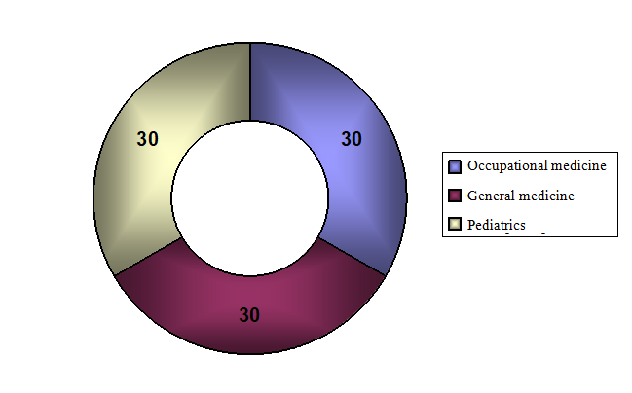
The survey questionnaire included 30 nurses from the service of occupational medicine, general medicine and pediatrics at the Uzice.

CHART 2. Gender of nurses
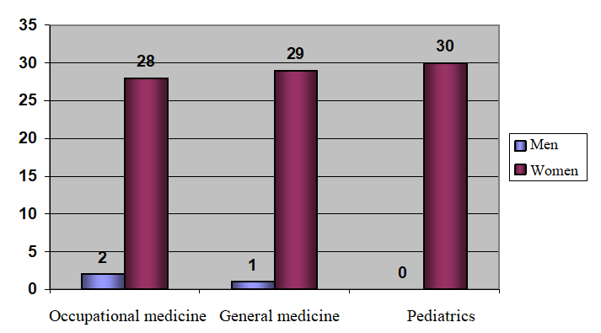
Of the total number of surveyed employees in occupational medicine, 28 are female and 2 are male; in general medicine 29 are female, 1 male; in pediatrics all nurses are female.

CHART 3. Educational level of nurses
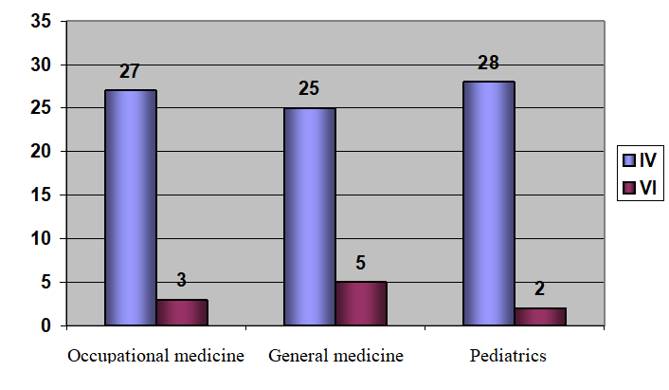
From the graph we conclude that there are 27 nurses with IV SSS, 3 with VI SSS in occupational medicine; in general medicine 25 are with IV SSS, 5 with VI SSS; in pediatrics there are 28 with IV SSS and 2 with VI SSS.

CHART 4. Yures of nurses 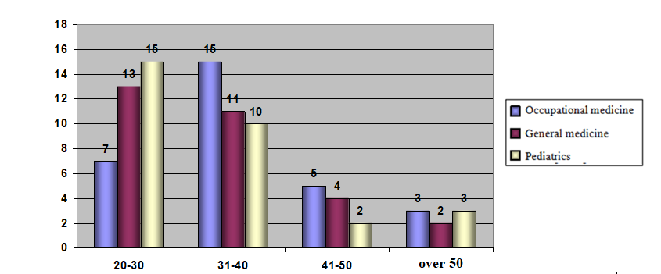
Over 70% of nurses in all services are under 40 years of age. Only 30% of nurses in the occupational medicine service are over 40 years of age, while 20% of nurses in the other two services are over 40 years of age.

CHART 5. Yures of nursing internship
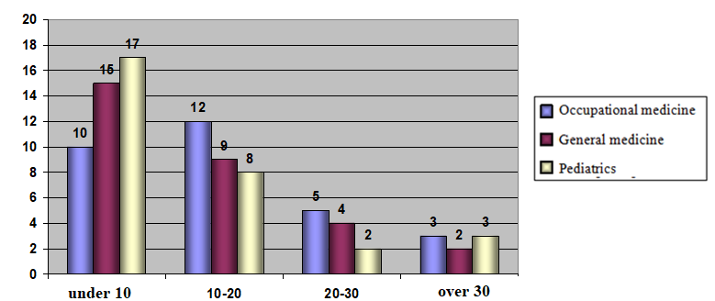
The highest percentage, over 50%, is in the service of prediatrics with less than 10 years of experience, 50% is in general medicine, and 30% is in occupational medicine. The average length of service of nurses in all departments is under 15 years
CHART 6. Are you currently performing one of the menagment
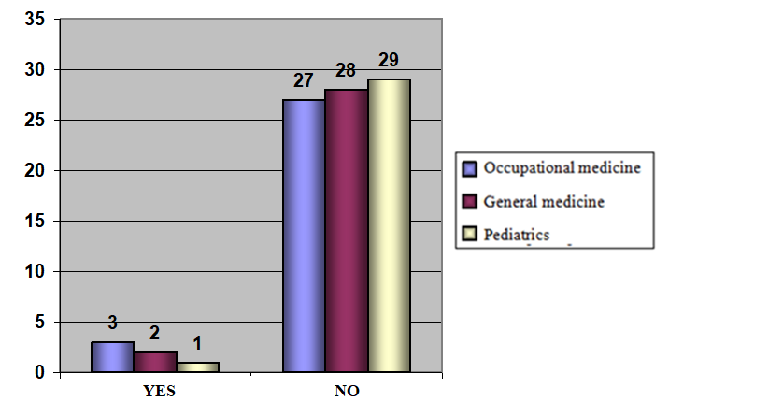
We conclude that the largest number of managerial functions is in the service of occupational medicine, namely 3 nurses with VI SSS, 2 are in general medicine, and only 1 is in pediatrics

3.2. RESULTS THE OF SURVERY QUESTIONNAIRE IN THE WORK OF THE NURSING SERVICE

CHART 7. Are you satisfied with the number of employees in your service
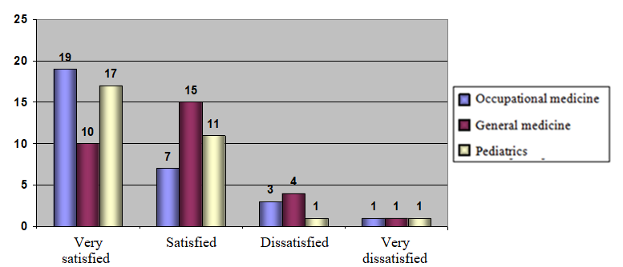
We conclude that in occupational medicine and pediatrics, over 60% of nurses are very satisfied with the number of employees, and in the general medicine service it is only 30%. Only 1 employee is very dissatisfied with the number of employees, which is a negligible percentage.

CHART 8. Are you satisfied with adequate equipmentfor work in your service
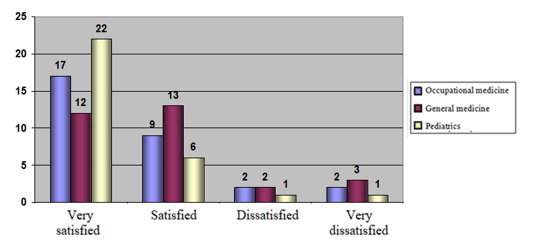
We conclude that the largest number are very satisfied and satisfied with the equipment they have for work, over 80% in all services. About 20% of all services are dissatisfied and very dissatisfied.
CHART 9. Your work space is in the service
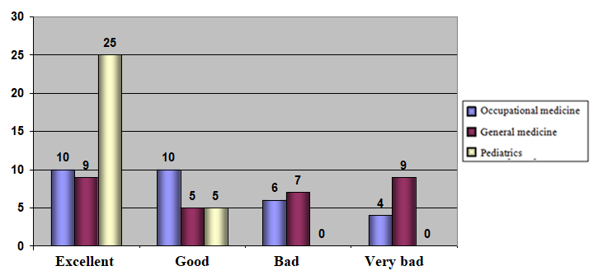
We conclude that the best working space is in the pediatric service, while the space in the general medicine service is bad and very bad based on the attitude of the surveyed nurses employed in that service.
CHART 10. Do you think that good business organization affects quality of work
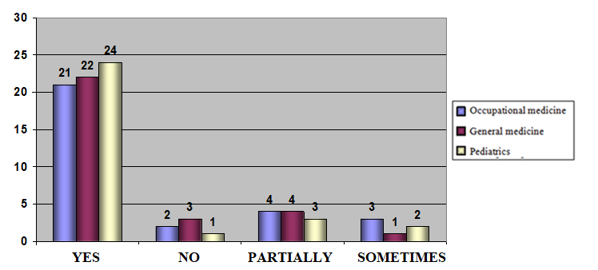
In all surveyed services of the Health Center Uzice, over 70% of nurses are of the opinion that good work organization affects the quality of work.

CHART 11. How you organize your business
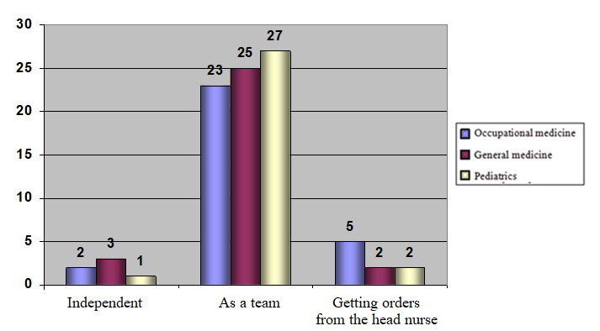
The largest number of nurses in all surveyed services of the Užice Health Center work as a team, which, in their opinion, achieves a high quality of work.

CHART 12. Conduct during work
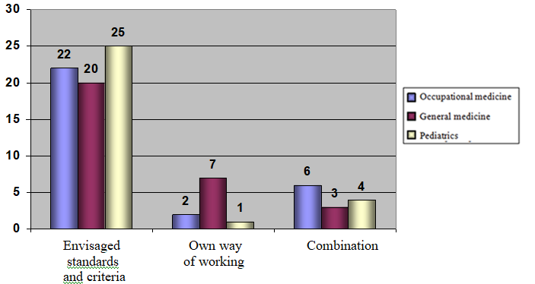
We conclude that the highest percentage of 70% and 80% of nurses during their work adhere to and implement the prescribed standards and criteria, all in order to achieve quality work.
CHART 14. Do you have an opportunity to propose your ideas in order to improve the quality of work
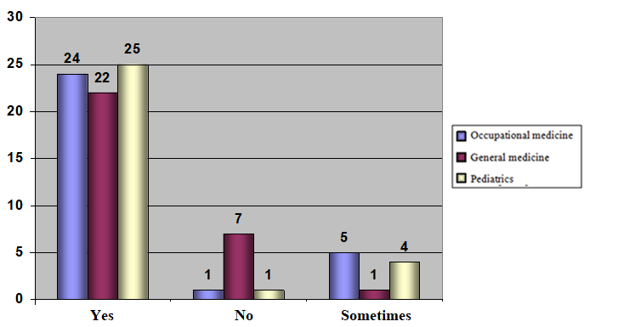
SHART 13. Do you have support from yourself in order to improve the quality of work
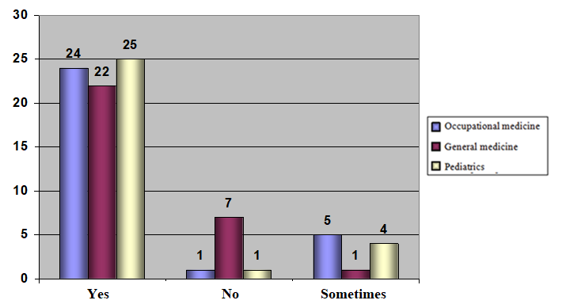
There is great support from superiors in order to improve the quality of work.

CHART 15. Do you get regular information about the most important changes relating to your servicee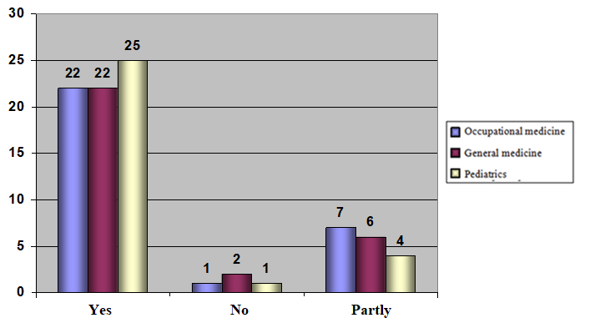The most important information about the changes related to the services, all in order to improve the quality of work, is obtained regularly.
CHART 16. Evaluate satisvaction with the work you are doing now
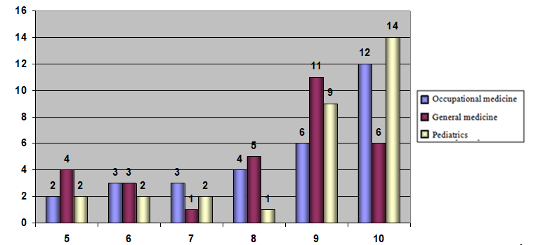
The largest number of surveyed nurses from all three services gave grades 9 and 10 for the job they do, that is. he is satisfied with the work he is doin

5.CONCLUSION

In health care, quality is indicator of how a nurse performs her professional duties in her professional practice.
When we say effective work, we mean that we should do the right things, and when we say efficient work, we should do them in the right way.
The following contribute to the achievement of high quality work:
• professional and educational seminars
• standards and criteria
• teamwork
• own experience and ideas.
Quality is one of the basic cornerstones of the successful functioning of health institutions, which is represented by the institution of the head nurse

6.LITERATURE

[1] WHO. Health 2020. A European policy framework and strategy for the 21st century. Copenhagen: WHO Regional Office for Europe 2013.
[2] CSDH. Closing the gap in a generation: health equity through action on the social detrminants of health. Final Report of the Commission on Social Determinants of Health.Geneva:WHO2008. Available online: http://www.who.int/social_determinants/final_report/en/index.html(accessed 24 May 2021).
[3] UN. Sustainable Development Goals-The Sustainable Development Agenda. 2030. New York: UN. 2015. Available online: https://www.un.org/sustainabledevelopment/development-agenda/ (accessed 24 May 2021).
[4] WHO, (2016). Global Strategy on Human Resources and Health:Workforce 2030. World Health Organization, 2016.Availableonline:https://www.who.int/hrh/resources/globstrathrh-2030/en/19(accessed 24 May 2021).
[5] Tijanić M., Rudić R., Đuranović D., Milović Lj., "Zdravstvena nega i savremeno sestrinstvo",Naučna knjiga, Beograd, 2004.
[6] Marinković Lj. "Menadžment u zdravstvenim organizacijama", Beograd, 2001.
[7] WHO, (2013). Health-2020-A European policy framework and strategy for the 21st Century. WHO regional Office for Europe: Copenhagen. Denmark. Availablefrom:http://www.euro.who.int/en/publications/abstracts/health-2020.-a-european-policy-framework-and-strategy-for-the-21st-century-2013(accessed 29 May 2021.

