**FLOOD RISK ASSESSMENT USING GEOGRAPHIC INFORMATION SYSTEMS**

**Msc Jelena Zlatković1 dipl. inž. građ.; dr Danijela Zlatković2 dipl. inž. građ.**

**1**JP Zavod za urbanizam, Niš, Srbija, jelena.zlatkovic@zurbnis.rs

2Akademija tehničko-vaspitačkih strukovnih studija odsek Niš, Niš, Srbija,danijela.zlatkovic@akademijanis.edu.rs

***Summary:*** *This paper will present the disposition of the rain sewer system and the possibility of floods in the City of Nis, in separate parts bordered by streets Vojvode Mišića and Sremska, Nemanjić Boulevard and Dr. Zoran Đinđić Boulevard. The aim of this paper is to analyze the possibility of floods in the observed area and display it using Geographic Information System. By using the geographic information system as a software tool, adequate data on catchment areas, terrain falls, the content of line infrastructure systems can be obtained, as well as further prediction and analysis of the possibility of flooding in the observed area. Based on the observed results, the paper will give the conclusion of the possibility of alternative solutions that are most adequate for the given problem of floods in the current area.*

***Keywords:*** *Floods, geographic information system, line infrastructure systems.*

**1. INTRODUCTION**

Natural disaster risk assessment is defined as an assessment of the probability of occurrence of an individual natural disaster and the degree of danger of natural disasters. It can be said that natural disasters are the result of the interaction between physical impact and endangerment of people and the environment. The occurrence of high waters, and the occurrence of floods have become very frequent natural disasters, with a great impact on the endangerment of people, material goods and natural resources. The risk associated with flooding for any region is the product of the region's exposure to high waters and the vulnerability of the observed area to danger. There are three main factors that contribute to flood risk in the region:

* danger of high waters,
* exposure and inability to protect people and resources and
* degree of endangerment and vulnerability to dangers.

The expansion of impermeable surfaces in the basin as a consequence of urbanization is the primary driver of hydrological changes and leads to an increase and acceleration of stormwater runoff, as well as a deterioration of its quality. The urban environment has different biophysical characteristic compared to rural areas. These are, first of all, the changed energy exchange and the change of the hydrological regime, that is, the increased surface runoff of rainwater and the deterioration of their quality. Such biophysical changes are partly the result of a change in the urban areas.

It is very important, especially in large cities, to take measures to avoid a situation in which a large-scale flood leads directly to catastrophic losses, both human and material. In order to deal with the growing vulnerability of cities, especially urban areas, and to avoid or mitigate catastrophic flood risk, it is very important to implement flood risk management in an integrated way, so-called, integrated flood risk management. However, both floodplain mitigation and flood insurance projects need a detailed flood risk assessment. From this point of view, this paper presents a methodology and procedure for flood risk assessment using GIS and flood occurrence models. Taking the floodplain as the target field instead of the river channel, the concept of micro-zoning should be included where the entire floodplain is divided into numerous areas.

**2. CLIMATE CHARACTERISTICS OF THE RESEARCH AREA**

The city of Nis is characterized by a predominantly moderate continental climate with moderately cold winters and hot summers. In order to more fully understand the general and hydrological characteristics of the research area, as well as to provide a basis for defining the hydrological flow regime on the key profile, the basic elements of the climate, such as rain precipitation, have been processed and analyzed. Probabilistic analyzes of the probability of occurrence were performed for characteristic annual values using Normal, Log Normal, Gumbelov, Pearson III and Log Pearson III distribution laws.

**2.1. Rainfall regime**

The precipitation regime was analyzed for the rain station Nis, which can fully represent the precipitation regime in the considered area. Atmospheric precipitation was used in the form of the dependence of "maximum rain height - duration - probability of occurrence" (H-T-P curve) for rains of strong intensity and short duration.

**Table 1**: The ordinates of the probability distribution of the maximum rain heights H(mm), duration Tk (min) and probability p(%), for rain station Niš T(оС)

|  |  |  |  |  |  |
| --- | --- | --- | --- | --- | --- |
| Table for H-T-P curve construction - Niš (RHMZ) | | | | | |
| Raun duration - T (min) | H-rain height (mm) | | | | |
| P-return period (year) | | | | |
| 100 | 50 | 20 | 10 | 2 |
| 10 | 27 | 24.3 | 20.7 | 17.9 | 10.5 |
| 20 | 37.5 | 33.6 | 28.5 | 24.5 | 14.0 |
| 30 | 43.3 | 38.9 | 32.8 | 28.2 | 15.9 |
| 60 | 50.1 | 44.9 | 38 | 32.7 | 18.8 |
| 120 | 53.6 | 48.2 | 41 | 35.5 | 21.0 |
| 180 | 55.1 | 49.7 | 42.5 | 37.0 | 22.5 |
| 360 | 58.8 | 53.4 | 46.2 | 40.7 | 26.1 |
| 720 | 70.1 | 64 | 55.7 | 49.4 | 32.8 |
| 1440 | 71.2 | 65.1 | 57.1 | 50.8 | 34.5 |

**2.2. Influence of urbanization on the hydrological cycle**

The process of urbanization is transforming the social and economic geography of almost every country in the world. Today, more than 50% of the world's seven billion people live in cities, and by 2050 that number will rise to over 70% of the total global population, which is projected to be nine billion people. Due to the absolute growth of the total population, as well as the absolute and relative growth of the urban population, cities are physically expanding, which means expanding residential zones, business, commercial and industrial zones, road and railway networks to natural and agricultural lands around cities. This usually includes the removal or reduction of vegetation and the extensive construction of impermeable surfaces in the form of buildings, sidewalks, parking lots, roads.



**Picture 1**. Atmospheric water flow on built and unbuilt land

The expansion of impermeable surfaces in the basin as a consequence of urbanization is the primary driver of hydrological changes and leads to an increase and acceleration of atmospheric water runoff, as well as deterioration of its quality. These are, above all, increased surface runoff of rainwater and deterioration of their quality. Such biophysical changes are partly the result of a change in the curtain of urban areas.

Swelling in urban areas is different from swelling in natural areas. In natural environments, most of the water infiltrates underground, while in urban areas the surfaces of different purposes (buildings, roads, parking lots and other watertight surfaces) change the basic components of runoff, so that a smaller part of water infiltrates underground, groundwater level decreases, decreases surface and underground runoff, and due to the lack of greenery, the amount of fallen water that evaporates into the atmosphere is reduced. Accordingly, depending on the degree of construction of an area, the surface runoff increases several times. As a rule, the volume of surface water increases 1.5-2 times, and the peak runoff 2-5 times.

**3. RESULTS**

The observed area of township Mediana in Nis is limited to Vojvode Mišića, Sremska, Bulevar Nemanjića and Bulevar dr Zoran Đinđića. In this paper, a more detailed elaboration of the location with hydrological analysis of the catchment area will be presented using the GIS software package.

Using the GIS software package, the subject location was highlighted on an orthophoto. 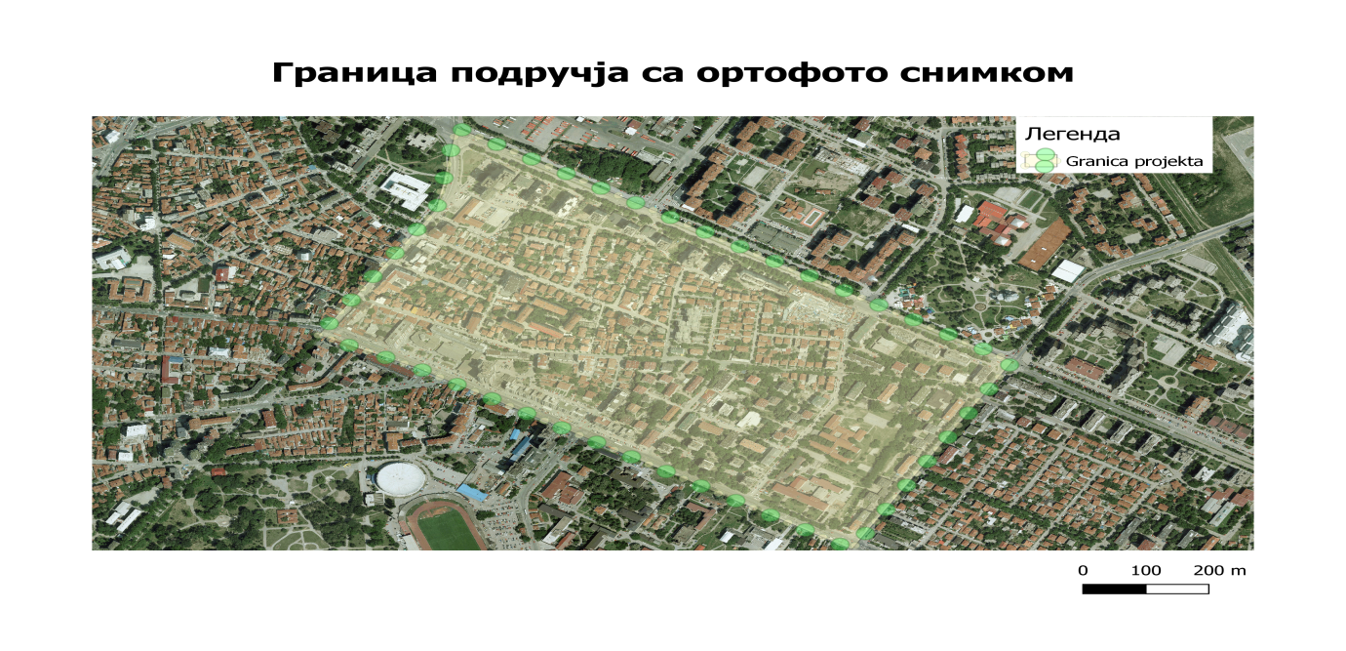

Using GIS the defined area was separated and terrain analysis was performed.

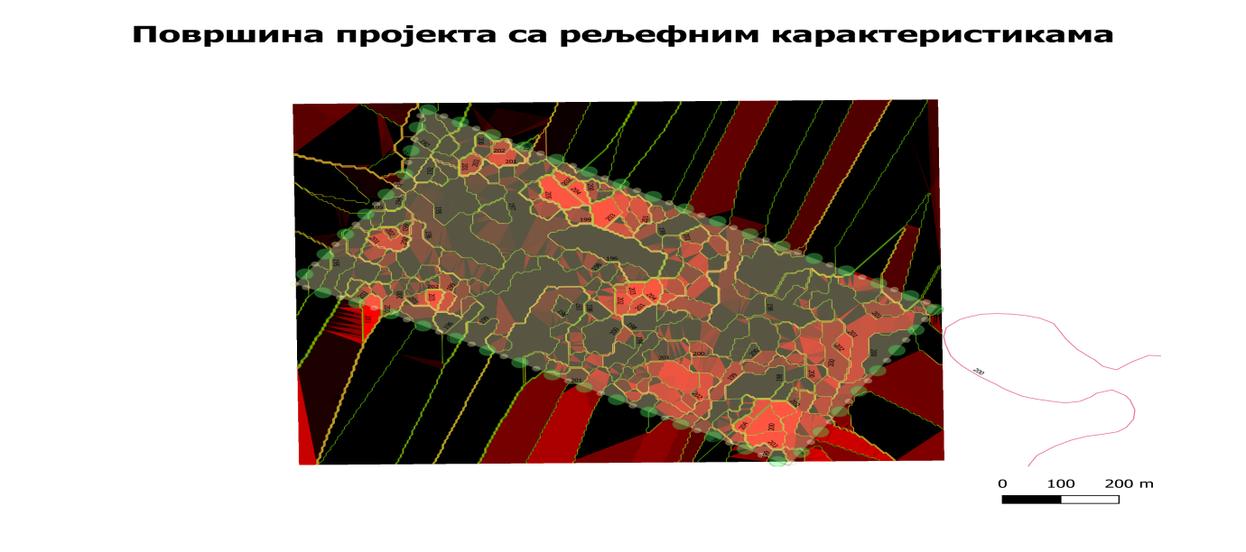

**3.1. Hydrological analysis**

Observing the data obtained from the Hydrometeorological Institute, a return period of 10 years is adopted as the most optimal. Accordingly, the hydrological analysis of the given area is focused on the topographic characteristics divided into two micro-basins. A rational method was used to determine the hydrological analysis of the basins.

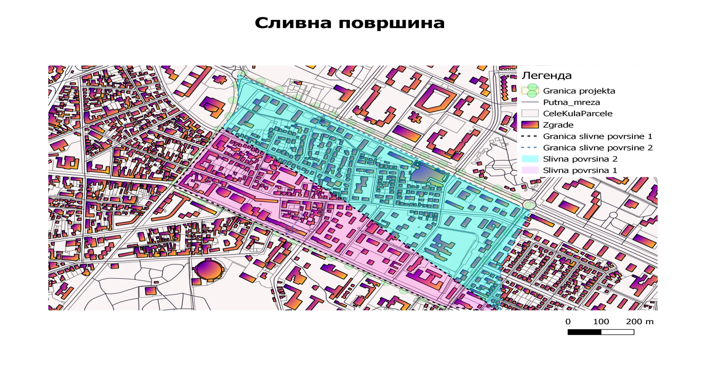

**Picture 3**: Micro-basins

Hydrological analysis of micro-basin 1 is given by graph.

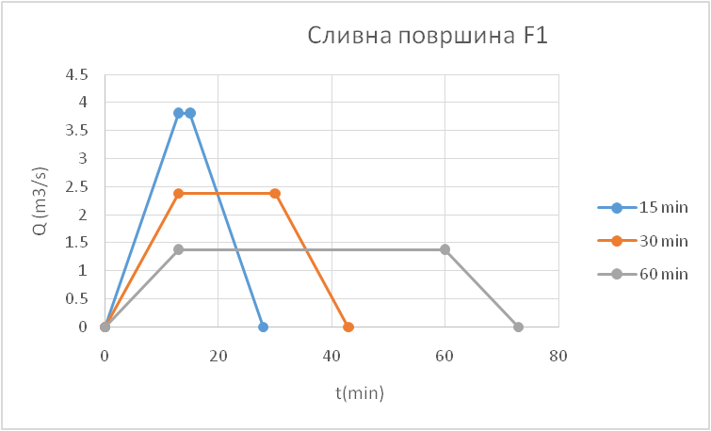

Hydrological analysis of micro-basin 2 is given by graph.

**4. CONCLUSION**

Due to the topographic structure of the terrain in the GIS software package, the observed area of Mediana in Nis, limited by Vojvode Mišića, Sremska, Bulevar Nemanjića and Bulevar dr Zoran Đinđića streets, is divided into two micro-locations in order to determine the risk of floods. By comprehensive analysis of hydrological and hydraulic parameters, and activation of the model, the program generated a high risk of flooding in the observed area. Due to the large presence of watertight surfaces, which amounts to 95% of the observed area, there is a large surface runoff of rain, and also due to the configuration of the terrain, water is retained in micro-basins and thus endangers facilities in the observed area. Also, due to the proximity of the Nisava River, the groundwater level is high and due to the larger amount of rain, there are additional problems of water infiltration into the ground. Therefore, the GIS software package generated the vulnerability of the observed area as very high, which can be seen on the map of the area classification. Analyzing the data obtained using GIS, we can make a proposal to reduce the possibility of internal floods by a combination of several alternative methods:

- By building a separate type of sewerage network that could accept a larger amount of water.

- Increasing green areas in the form of rain gardens or green roofs.

- Construction of retentions that would retain flood waters and enable their later application.

**5. LITERATURE**

1. Blagojević, B., 2020. Prediction of mean runoff in a small ungauged basin using raster climatological data, Glasnik Srpskog geografskog drustva.

2. S Soni, AD Prasad, 2021. Detection of Flood Hazard Using QGIS. Springer, volume 77.

3. General urban plan of Niš 2010-2025

4 General Regulation Plan GO Medijana

5. RHMZ data for the rain gauge station Niš