The Tourist potential of architectural heritage of the region of Uzice
Gordana Lazic, Ph.D.
Akademija Zapadna Srbija, Uzice, SERBIA
e-mail: lazicgordana5@gmail.com

Abstract: Even if Tourism is one of the important activities of the region of Uzice today, its beginnings in Serbia goes back only a hundred years ago. Industrial development and modernization of country lead to higher social standards and desires of population for travelling. It is very common to visit The old Fortress of Uzice, The Church of St. Marco, The Church of St. George, The National Museum, The Monument Complex Kadinjaca and Potpec Cave. But some monuments are important also because they show the continuity of growth of the town of Uzice. The value of ambiental unity such as Carina, the parts of Uzice's centrals streets (with civil architecture conservated from the second half of 19th century), hotel Palas, Old Municipality, Old Tkacnica (as the first industrial object in Uzice) represent poweful tourist potential and they are the indicator of continuity of the town's development. Categorisation and preservation of those objects, providing hygienic-technical standards and active use with adjustment of needs of urban tourism are some of most important assignments.
Кeywords: Cultural Tourism, Ambiental unity, Civil architecture, Conservation, Heritage

1.INTRODUCTION
The tourist potential of the Uzice region in terms of the development of mountain and spa tourism, the beauty of nature and folk tradition has already been mentioned in numerous publications. The aim of this paper is to promote urban tourism, primarily in the city of Uzice and point out the values ​​of architectural heritage, which, in addition to artistic and historical, has a great tourist significance. The city of Uzice in its tourist offer takes into account the continuous cultural development. From archeological artifacts kept in the National Museum, through ancient Roman finds and monuments (in the museum and in the gate of the White Church in Karan), the medieval fortress Stari grad, to modern monuments, the origin and development of the city of Uzice are presented in professional works but insufficiently recognized in terms of tourism potential.

Uzice was declared as tourist place in the narrow sense in 1936, along with Sarajevo, Travnik and
Valjevo. [1] It was part of the general social currents, which began in the middle of the 18th century when the British aristocracy launched the idea that the change in the rhythm of time was conditioned by a change of residence, which during the 19th century, under the influence of the industrial revolution,among the bourgeois and working class it grew into a mass culture . Staying in nature, in the fresh air, playing sports, trips by train or boat around, summer vacations at the sea or going to one of the spas, visits to distant lands for an exhibition or event, touring cultural and historical monuments - all this becomes a new kind of social obligations in Serbia at the end of the 19th and the beginning of the 20th century. [2] Uzice also fit into the general trends and a great contribution was made by the construction of the railway in 1912. and then the introduction of the popular Cira train. The beauty of the nearby mountains, Tara and Zlatibor, as well as folk tradition and local products and handicrafts were given the opportunity to be shown to the inhabitants of Europe at the World Exhibition in 1889. in Paris, where shown various items of wool, rugs, cereals, herbs, folk musical instruments, famous Uzice cloth, handicrafts, prosciutto, brandy, opanci (type of footwear), men's and women's suits… [3]
Even today, the tourist image of Uzice is based on natural beauty, culinary specialties and folk tradition. However, the times in which we live, redefining tourism and overall social relations require us to make an evolutionary step through the design of new and different content that would contribute not only to the expansion and profiling of the tourist market but also cultural and spiritual progress of the local population.

2. OPPORTUNITIES FOR THE DEVELOPMENT OF URBAN TOURISM IN UZICE

The first condition for the development of cultural tourism in Uzice is the definition of its cultural identity. The fact is that today the recognizable symbols of the Uzice region are the nearby mountains, a „complete of buns“ and trumpets and these elements will certainly be the first association to our region in the future. But if we stay on the natural beauties, cuisine and folk tradition, without a clear strategy for future development, time will soon overtake us and the bizarre tourist market will turn into something more interesting overnight, forgetting the deafening noise and to greasy food. Uzice is a region rich in history, inhabited since prehistory and then through the Ancient and Medieval period. It also has a turbulent and rich history of the new century, a period of liberation from Turkish rule and a slight introduction to the processes of modernization and democratization of society, all as part of the pursuit of European standards. In this sense, the development of industry in the early 20th century, the construction of a hydroelectric power plant and a weaving mill, the construction of a railway, the development of trade, crafts and banking as well as a certain rise of the bourgeoisie between Turks and Germans (1862-1941) are important. [4] This period, due to political and ideological circumstances after the Second World War, was systematically suppressed and excluded, not only in Uzice but in the whole country. And it was the process of creating a civil society in those eighties that was a necessary link in the maturing of a city and its population.

That is why the first and most important stage is to define the cultural identity of the city and the goals to be achieved in future development. When it comes to the tourist potential of the architectural heritage from this period, you should first identify and list all facilities and wholes of importance, categorize and conserve them, provide appropriate hygienic and technical standards and then design their active use and adaptation to the needs of both, the city and the owner. In that sense, the establishment of the City Institute for the Protection of Cultural Monuments in Uzice, announced for decades and never realized, would be of great importance. Of course, some steps have already been taken and examples of good practice exist. An example of identification, conservation, restoration and active use of a building is certainly the Jokanovica house, which within the National Museum, in addition to its artistic and historical significance, has become an important part of the tourist offer of the city. [5] The same applies to the adapted space has the Old Municipality in which the City Gallery is located today. On the other hand, many valuable objects are, due to negligence, ignorance or profit, destroyed forever. We remember the Sokolana, work of architect Momir Korunovic [6], some buildings of the architect Miladin Prljevic, the author of the Palace of Albania in Belgrade [7], the birth house of Ljubomir Stojanovic, an academic born in Uzice, and a similar fate awaits, if something is not done urgently, the administrative building of Old weaving mill which is the first large industrial facility in our area. It was built from 1900-1903. under the influence of the style based on the German variant of neo-Gothic, while the designer was probably Emilio Kralovec. [8] One of the possibilities of salvation from oblivion of this building is an example of the presentation of a key part of the replica of Smederevska banka in Nis, which is incorporated into the facade of a modern building. [9] Some ambient units of the city of Uzice can have a special value in terms of tourist offer. First of all, it refers to the location of Carina, St. George's Square (today St. Sava Square), parts of the streets with preserved town houses from the 19th century such as Dimitrija Tucovica Street, parts of Rosulja and Slanusa, then Partizan Square, imposing space and city center who needs to inhale new content. [10]

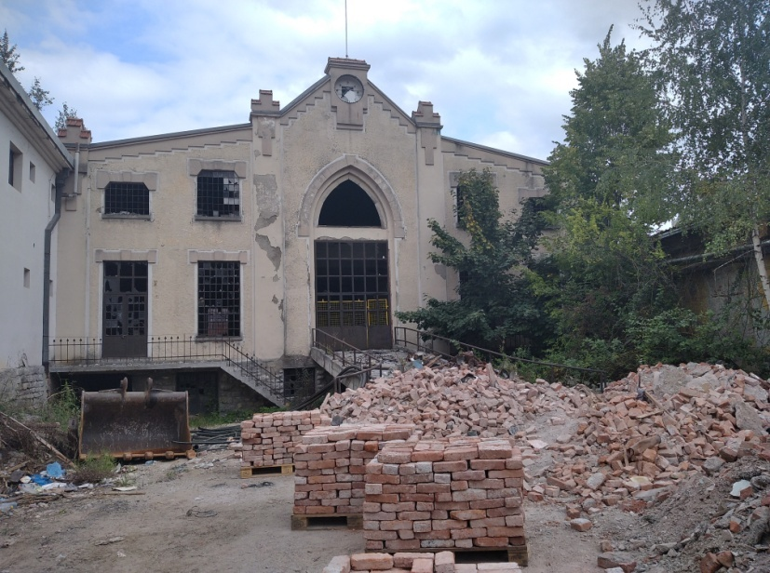

Figure 1: Administrative building of Old weaving mill

In the fundamental and unavoidable article by Angelina Stanimirovic and Zivota Markovic on the Cultural and Historical Monumental Heritage of Titovo Uzice from 1990. [11], a conclusion was given about the relatively modest development of the city in the period 1862-1941. Compared to other environments, the statement could be confirmed, but if we keep in mind the starting point from the undeveloped, hygienically neglected Turkish town and everything that was done before the Second World War, the changes were amazing. Beginning in 1863, work was made on the adoption of urban plans, then at the turn of the two centuries there was a development of crafts, trade, industry (the Hydroelectric Power Plant was built in 1898 and the Weaving Mill 1900-1903), banking, traffic (in 1912 the railway passed through Uzice ). Magnificent buildings were erected: Gymnasiums (1891-1893), Barracks in Krcagovo (1899-1900), Municipalities (1922-27), Hospitals (started before the First World War, completed in 1924), National Bank, today the National Museum (1938). The city's residential architecture, although not marked by the construction of palaces, is moving to a higher standard of hard-built constructions. Park spaces, promenades are being arranged, the city and its surroundings are being greened… In the mentioned article, researchers Stanimirovic and Markovic presented a detailed analysis of the current situation (although with noticeable ideological assumptions) and constructive guidelines on what should be done in the future. Unfortunately, what was set as a priority more than thirty years ago by these two eminent museum experts, has not been started in the city until today, let alone realized.

The elaborated idea of ​​building a kind of Uzice' Skadarlija would include a stretch from St. George's Square (St. Sava), then Zicka Street to Rakijska pijaca with restaurant and Bakery'guild fountain [12],

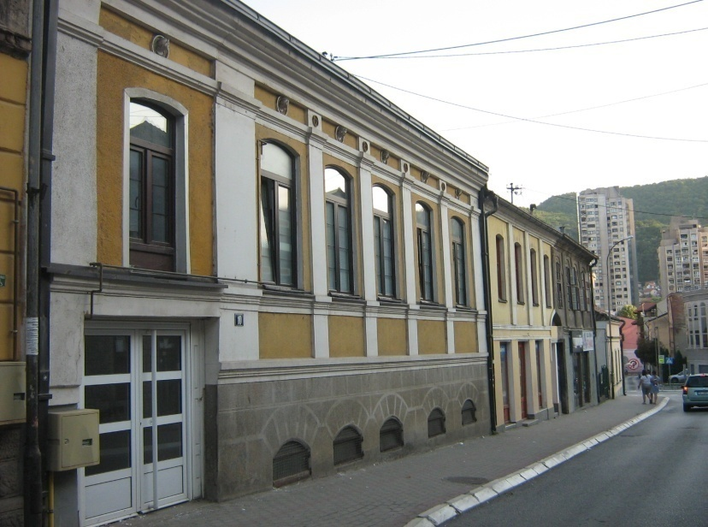

Figure 2: Old houses, Nemanja's Street

then Nemanjina Street to Carina and back, on the other side, by the Nikola Pasic Street, next to the church of St. Mark and again along Zicka Street to the starting point. Many significant facilities would be covered by this move. At the beginning, on St. George's Square, there is the Church of St. George from 1842, the garrison command from 1851, the mentioned Gymnasium, the Art Nouveau house of Milos Trifunovic, (former member of parliament) from 1912 (which as a pearl of architecture deserves a much more convincing role), the house of Malisa Atanackovic (today Music School), by architect Miladin Prljevic from 1934-36. [13] In Nemanjina Street 14 is the house of Andre Stanica (also former member of parliament), in fact the house of his father Milan, built around 1850, an example of Balkan-style architecture, still preserved today.[14] In fact, most of the preserved residential buildings in the row, in Nemanjina Street, contain interesting details of 19th century architecture that need to be preserved and

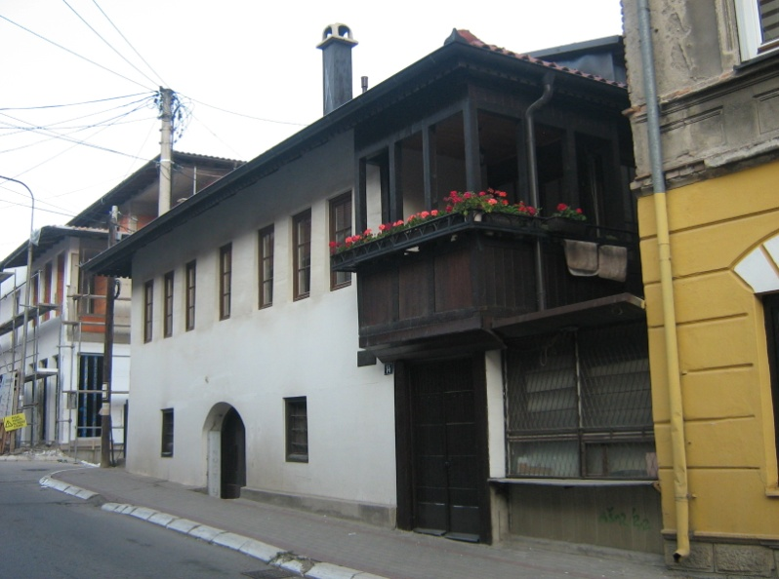

Figure 3: The House of Andra Stanic, Nemanja's Street

adequately presented. These buildings could be given a suitable purpose, either as small museums or galleries, or as workshops of old crafts and handicrafts, or as shops of traditional but also luxury products, or as catering facilities of higher rank (pubs, clubs, restaurants with selected menu and discreet music). In this way, this neglected and forgotten part of the city would be revitalized and included in the living economic flows. A similar project could be applied to the part of Dimitrija Tucovica Street from Trg Partizana to the First Primary School. This part of the city, at the moment when the bypass around Uzice comes to life, could become a part of a unique pedestrian zone all the way to the National Museum, which would give Uzice an urban look of a tourist city.

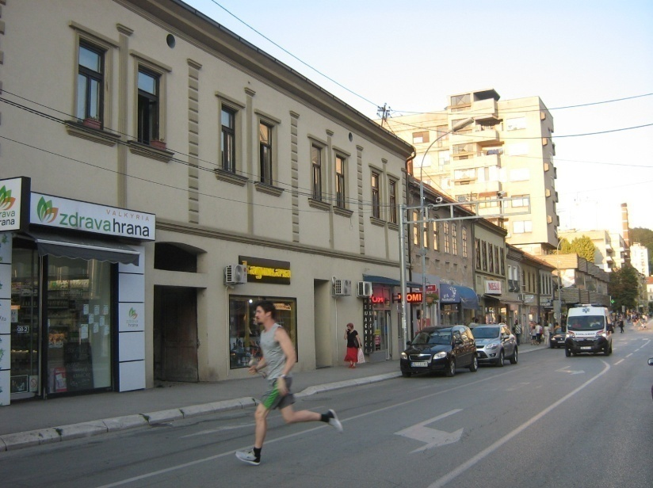

Figure 4: Dimitrija Tucovica Street

Although the period since the Second World War is not the topic of this paper, it should be noted that, devoid of ideological prejudices, the libertarian and anti-fascist history of Uzice should be the pride and not the shame of its inhabitants. Following the example of the well-designed Kadinjaca Memorial Complex, the exhibition on the Uzice' Republic should be modernized in the city'museum itself, and the monument to Josip Broz, the work of sculptor Frane Krsinic from 1961, which was conceived as the focal point of Partisan Square, should be returned to its place. It does not work as a cult of personality, but as a part of the history of the city, which certainly calls for reflection and acceptance of the past, but also for a wiser projection of the future.

3. CONCLUSION

The town of Uzice is characterized by a rich artistic and historical past, from prehistory, through the ancient Roman and medieval periods until modern times. The exhibition windows of the National Museum are filled with exhibits such as finds from the Neolithic and Metal Age, medieval swords from the Old Town and rich documentation of rural and urban life of recent times. There are hidden wooden churches scattered around, but also masterpieces of Raska church architecture, such as Mileseva and Arilje. With the proximity of mountain tourist centers such as Zlatibor and Tara, it would be said that the tourist offer is complete, but in the whole story one important part is missing and that is the city of Uzice. A city that grew on the ruins of the fire of 1862 and which, despite numerous misfortune, developed and grew in pursuit of distant, European models.
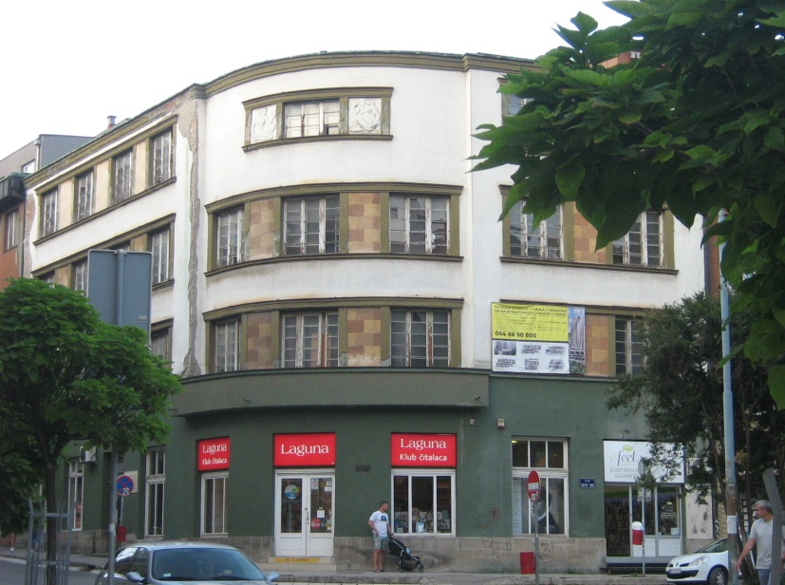

Figure 5: Hotel Palas

The pearls of the city architecture of Uzice from the period 1862-1941 are rare, but there are enough of them to be based on the tourist offer of the city of Uzice. This primarily refers to the ambient units of the preserved town houses at Carina (with the house of Andre Stanica) and in Dimitrija Tucovica Street, then to the Garrison Command, the administrative building of Stara Tkacnica, the house of Milos Trifunovic and the Palace Hotel. Conservation, restoration and revitalization of these buildings and the whole would contribute to the consolidation of the cultural identity of the city of Uzice, which was seriously damaged during the transition period, but would also have a significant effect on the tourist offer of the city.

REFERENCES
[1] Pravilnik o proglasenju turistickih mesta u uzem smislu, Sluzbene novine Kraljevine Jugoslavije, br. 298-85, 25. Decembar 1936., Istorijski arhiv grada Beograda, inv. Br. 1395, str. 1199.
[2] Stojanovic, D. (2009): Kaldrma I asfalt. Urbanizacija I evropeizacija Beograda 1890-1914. Beograd. Udruzenje za drustvenu istoriju (drugo izdanje), 313-328. takodje i: Lazic, S. Razvoj turizma u Beogradu izmedju dva svetska rata, Beograd, Istorijski arhiv Beograda
[3] Popovic, Lj. (1990): Uzicki okrug na Svetskoj izlozbi u Parizu 1889. godine, Uzicki zbornik 19, Uzice, 207-229.
[4] Macura, V. (1989): Srpska varos Uzice 1863-1914. u: Istorija Titovog Uzica,Istorijski institut Beograd,725-742. takodje i: Papic, R.A. (1994): Uzice I uzicki kraj od ranog srednjeg veka do 1941. godine u: Uzice, nastanak I razvoj, Narodni muzej, Uzice, 47-58.
[5] Djajic, M.-Ristovic, D. (1992): Jokanovica kuca, Narodni muzej Uzice
[6] Lazic, G. Sokolana-gnezdo uzickih sokola, Vesti, Uzice 18. Mart 2011, 20-21.
[7] Markovic, R.I.(2015): Arhitekta Miladin Prljevic, Istorijski arhiv Beograda-Istorijski arhiv Uzice, Beograd-Uzice
[8] Solaja, V.B.-Magdic,A.S.(1994): Inzenjeri u Knjazestvu/kraljevini Srbiji, ZTFUB, Muzej nauke I tehnike Beograd, Lola Institut Beograd, 53.
[9] Lazic, G. (2011): Secesija u srpskoj arhitekturi (rukopis doktorske disertacije), Univerzitet u Beogradu, Beograd, 214.
[10] Milivojevic, D. (2018): Procesi planiranja, projektovanja I gradnje urbane celine Trga partizana u Uzicu, (rukopis doktorske disertacije), Arhitektonski fakultet Univerzitet u Beogradu, Beograd, 172-189.
[11] Markovic, Z.-Stanimirovic, A. (1990): Kulturno-istorijsko spomenicko nasledje Titovog Uzica, Uzicki zbornik 19, Uzice, 53-105.
[12] Iskrin, M. (1995): Cesme uzicke, Kulturno-prosvetna zajednica, Uzice
[13] Lazic, G. (1995): Istorija I arhitektura objekata na Trgu Svetog Djordja u Uzicu, Uzicki zbornik 24, Uzice, 165-176.
[14] Markovic, Z.-Stanimirovic, A. (1990): Kulturno-istorijsko spomenicko nasledje Titovog Uzica, Uzicki zbornik 19, Uzice, 74. takodje i: Ivanovic, M.(2009): Kulturno nasledje u turizmu jugozapadne Srbije, Zaduzbina Andrejevic, Beograd, 27-38.

