These are the guidelines for writing a paper for the proceedings of the 12
nd international scientific conference ‘Science
and Higher Education in Function of Sustainable Development - SED 2021’. This document itself is the paper format
template, so we strongly recommend that you follow these step-by-step instructions.
Before submitting your abstract/paper, please name the file as follows:
Given name_Surname_Abstract i.e. Given name_Surname_Paper
When submitting the paper, please indicate the thematic area your paper relates to.

AUTOMATED VEHICLE AND PEDESTRIAN DETECTION

Aleksandar Stjepanovic, Ph.D.; Miroslav Kostadinovic, PhD; Goran Kuzmic, MSc,Mirko Stojcic, M.Sc.;
1 University of East Sarajevo,
Faculty of Transport and Traffic Engineering Doboj, aleksandar.stjepanovic@sf.ues.rs.ba,miroslav.kostadinovic@sf.ues.rs.ba
goran.kuzmic@sf.ues.rs.ba, mirko.stojcic@sf.ues.rs.ba

Abstract: The ability to perceive and understand surrounding road-users behaviors is crucial for self-driving vehicles to correctly plan reliable reactions. Pedestrian fatalities have risen recently, even as vehicles are equipped with sophisticated avoidance technology. Pedestrians have variable physical characteristics and appear in a variety of environments with different background features. Vehicle-based sensors can fail to identify pedestrians even in ideal conditions, and especially when those pedestrians are small, too far or too close to the vehicle, or partially occluded by nearby objects. This paper focuses on the first stage of detection: sensing. The most common classes of sensors presently used in automated driving applications include visible-light cameras (VLC), light detection and ranging (LiDAR). The paper analyzes the possibilities and problems that arise in the detection and recognition of pedestrians.

Keywords: Automated Vehicles, Pedestrian detection, LiDAR, VLC, FIR

INTRODUCTION

Despite the rapid development of technologies for the detection of pedestrians in traffic, there are still significant problems with autonomous vehicle management systems. Often these problems are caused by different external conditions, weather disasters, different light levels, day and night, and more. All these factors can affect the incorrect assessment of the system and the performed detection of the pedestrian object.
Pedestrian detection by an automated vehicle is a very important condition for safe driving and the safety of the installed system as a whole. Visual pedestrian detection has occupied the attention of researchers for a decade, due to its application in various systems from driver assistance systems, autonomous vehicles, and video surveillance systems for monitoring and control. Each of the mentioned systems has certain features that refer to that system. The paper will pay attention to pedestrian detection systems used in autonomous vehicles and parts of early detection systems in the form of visible and FIR cameras and laser systems for object detection, LiDAR.
For the system in the vehicle to react on time and accurately, it is necessary for the object, ie the pedestrian, to be detected in a timely and accurate manner. For this purpose, various detection systems are used, based on visible light, microwave, infrared, and laser waves. Detection of people and objects is especially demanding during the evening and at night. The human eye finds it harder to react to changes in low visibility conditions, which makes driving very difficult. The development of computer vision and the detection of objects, ie objects in motion-pedestrians, can be a very demanding task for computer vision techniques.
Different techniques are applied, from background subtraction techniques, the application of different sample classifiers, and the use of different pedestrian movement patterns. Each of these techniques has its pros and cons and does not provide 100% detection accuracy.
A lot of different techniques were used, such as machine learning based on appearance, shape comparison methods, then symmetry and histogram methods, but none of them was able to 100% detect all pedestrians in motion when the vehicle is in motion in conditions of reduced visibility or at night. for hours. It is, therefore, necessary to develop a new safer method for detecting pedestrians in motion when both the vehicle is in motion, in order to protect both pedestrians and drivers from possible accidents. It should be noted that most vehicles manufactured after 2018 have a built-in system or as an option as part of the system to help the driver on the road, (Advance Driver Assistance System-ADAS), pedestrian protection system in the form of automatic braking, (Pedestrian Automatic Emergency Braking-PAEB).

RELATED WORK

There is a lot of work on the topic of autonomous vehicles and pedestrian protection systems. In [1], the authors analyze data on the number of accidents in which pedestrians were killed and the possibilities for using different types of sensors to reduce the number of accidents. According to the authors, the ability of sensors to detect pedestrians varies from <30% to> 90%. By combining different types of sensors, there is the possibility of drastically reducing the number of accidents in which pedestrians were killed. The paper [1] emphasizes the early detection of pedestrian objects using different technologies. One of the important technologies is visible-light cameras (VLC) which have a lot of good features but also weaknesses, especially in the evening or when the weather conditions are unfavorable. The second type of sensor is LiDARs, which use lasers to scan objects in three dimensions and create a detailed image of the object. LiDARs have the property of working well in conditions of poor visibility, but on the other hand, there is a problem with wet roads and conditions of poor signal reflection. LiDAR-based sensors are used for medium and long distances and are most often realized as a single unit mounted on the roof of a vehicle. The third type of sensor is based on radars that are very little sensitive to weather conditions but give quite poor low-resolution images and there is difficult detection of small pedestrian children. Also, this type of sensor has a hard time detecting pedestrians who are at rest.
In [2], the authors analyze the effects of systems in automated vehicles on the number of accidents in which pedestrians or cyclists were killed, who are also the most endangered population in traffic. According to the authors, the percentage of traffic accidents in which pedestrians were killed in the EU is 21%. The authors in [2] propose a model based on software and hardware solutions for enhanced pedestrian detection and monitoring.
In [3], the authors explain the main elements of the pedestrian detection system, which consist of three main levels of detection: video acquisition, human detection, and tracking. When collecting images, there are aggravating circumstances such as changing the brightness of the subject, shadows, low light, and more. On the other hand, the detection of people and tracking is burdened with various aggravating factors such as traffic jams, a constant movement of objects, various poses, and more.
Very interesting research processed in [4] deals with the analysis of accidents produced by automated self-driving vehicles of Uber Inc. The paper analyzes various object recognition techniques where available data from Uber Inc. were used as a case study. The paper analyzes the case of an accident that occurred in Tempe, Arizona (USA), where a pedestrian was killed by a Volvo XC90 vehicle that was equipped with a fully autonomous driving system. The mentioned system could not register a pedestrian crossing the street in conditions of poor visibility, which caused an accident with a tragic outcome.
In [5], the authors analyze single-camera pedestrian detection systems using thermal cameras. Such systems have many shortcomings, especially in conditions of poor visibility and bad weather conditions. Therefore, the paper proposes a new system that uses two cameras for visible light in combination with a thermal camera, which is a more robust system. The proposed system uses background subtraction techniques based on an image obtained by a thermal camera. After the process of removing the background, the shadow is corrected and the morphological operation is filtered, ie the height and width of the image are filtered. After the procedure, the image obtained from the thermal camera detects the region of interest, ie pedestrians. Based on the obtained results, the authors achieved a safer system for the detection of pedestrians in conditions of poor visibility.
In [6], the authors analyze the possibilities for reducing traffic accidents where the main participants are pedestrians. The author proposes the realization of a hybrid sensor consisting of a camera for visible light in combination with a thermal FIR camera. Both cameras have certain shortcomings that are reduced in the symbiosis of these cameras. Different weather conditions, and low visibility conditions, night mode and the presence of shadows were used to test the system. An algorithm for pedestrian detection using the aforementioned hybrid sensor has also been proposed within the system. The obtained results are in the range of 10% of positively and negatively detected objects.

BASIC HYPOTHESIS

Different types of sensors are used to detect pedestrians in autonomous automated vehicles, most commonly based on visible light cameras, thermal cameras, and laser distance measuring devices with LiDARs and microwave radars. Each of the mentioned sensors has certain good and bad sides which is the integration of all the mentioned ones give acceptably good results. For the successful use of fully automated vehicles, detection errors must be minimized. For an autonomous driving system to work better than a driver, the system must be equipped with capable sensors for detailed detection and recognition of various shapes. The key feature of the system should be diversity, ie the use of different types of sensors with overlapping competencies to confirm accurate information about the detection of the object. As mentioned earlier, there are three key sensors in autonomous vehicles: visible light cameras, radars, and LiDARs.
Cameras are the most accurate device for a visual representation of the outside world. On autonomous vehicles, the cameras are mounted on all four sides, covering a complete circle of 3600. Some of the cameras have a wide range of coverage up to 1200. It is also possible to equip the cameras with a so-called fisheye, which can cover a wide range of panoramic views. These cameras are designed to monitor events and objects over short distances and are often used in automatic parking systems, in case of traffic jams. Only four of these cameras are needed to fully monitor the environment. They are most often equipped with the latest CMOS sensor based on the AR0231 chip.
Each camera is housed in an IP69K waterproof case, with ultra-high resolution optics. They represent a relatively inexpensive solution that provides the ability to detect objects that are static or in motion. These camera features provide the possibility of detecting traffic signs, traffic lights, lanes on the roads, or horizontal traffic signals, and more. Vehicles can be equipped with monocular or binocular cameras. As the name suggests, the monocular system uses one camera to obtain a series of images, while the binocular system uses two cameras placed on the side of the vehicle thus achieving a sense of depth in space.
Another type of sensor that covers certain shortcomings of classic cameras is radars based on millimeter wavelengths (MiliMeter Waves MMW). These radars are characterized by the characteristics of working in difficult conditions, dust, fog, rain, and more. They also have a good ability to adapt to different weather conditions and light intensities.
In conditions of poor visibility, especially at night, radar-based systems can play a decisive role in the detection of objects or pedestrians. Long-Range Radar (LRRs), on the other hand, can detect objects at distances up to 250m. Also, with the help of radar, it is possible to measure the relative speed of an object with an accuracy of 0.1m/s, which is an important feature for decision making and prediction of object movement. Due to their good features and low cost, these radars are indispensable in the serial production of vehicles that have built-in advanced driving-assistance systems (ADAS).
On the other hand, radars also have some bad features such as low angular resolution. To increase the resolution, it is necessary to expand the frequency range of the signal, which greatly complicates the processing of the obtained signal. The other downside of radar is the lack of semantic information in the signal and the inability to reliably perceive an object or event.
It can be concluded that different types of sensors are required for different levels of vehicle automation.
It is known that according to the Society of Automotive Engineers SAE, there are five or six levels of driving automation, where the zero levels is a vehicle without an automatic driving system, ie fully manual control by the driver, and level five is a system with fully automated driving. For vehicles with a low level of driving automation, MMW radars provide the necessary data on objects that can be used in assistance systems for blind-spot detection, lane departure detection, and more.
Thermal cameras are used as the third type of sensor in automated vehicles. This type of camera solves detection problems that are weak points of radar and cameras for visible light.

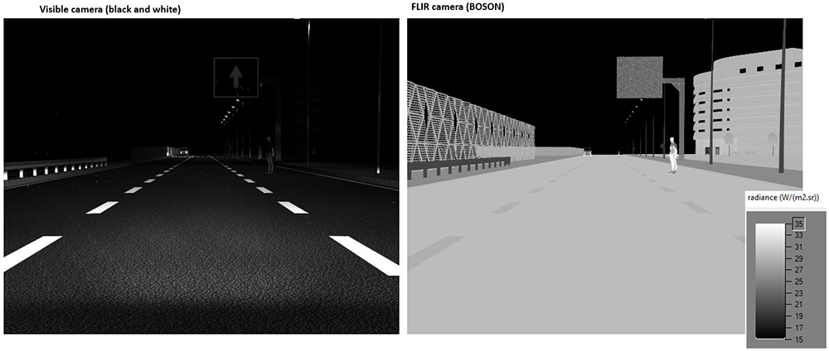

Figure 1: Simulations comparing VLC to FLIR’s thermal imaging camera during nighttime [7]

Figure 1 shows the results of the VLC camera and thermal camera footage. It can be seen that a classic camera finds it very difficult to detect pedestrians in low light conditions, especially at night. The thermal camera gives a much clearer and more complete picture, which makes it easier and more accurate to detect objects on foot.

AUTOMATED-SELF DRIVING VEHICLES AND PEDESTRIAN DETECTION

The use of thermal cameras to detect pedestrians in low or almost no light conditions can be reliable if it is in synergy with certain intelligent algorithms. As an example of solving this problem, the use of a thermal camera that gives an image of the human body based on the received reflected waves can be mentioned.
By classifying images based on the temperatures of individual parts and using correlation techniques with the already proposed probabilistic model. A Kalman filter is used to track and detect pedestrians. The good side of such systems is that the reaction time of the driver or self-driving vehicle is greatly reduced.
The second version of the system is based on the use of millimeter-wave radar (MMW) and ways to present the obtained data. Millimeter-wave radar can provide cluster-layer data and object-layer data. Object-layer data gives less noise while cluster-layer data provides more abundant information with more noise.
Radar-based representations can be divided into two different modelings, dynamic object modeling and static environment modeling. Because the object can be in a static or dynamic state. Dynamic Targets Modeling gives at the output cluster-layer data. A data-based algorithm estimation extended objects by Doppler effect is used for analysis and detection.
Estimate the full 2D motion of extended objects is performed using this algorithm. This algorithm is also used to track a dynamic extended objects.
This algorithm can be used for estimate of the dimension extended objects. Static environment modeling used occupancy of grid maps as an algorithm. As result, it is used to realized road scene understanding and localization of objects. For the motion estimation, the Doppler effect is often used. This method uses Doppler data of two 77 GHz automotive radar sensors to estimate the velocity profile of an extended object. The second method is using DBSCAN (Density-Based Spatial Clustering of Applications with Noise) for original point cloud clustering and estimation of the extended information of targets.
In addition to the sensor system, the development of autonomous vehicles at the L4 and L5 automation levels will require modern control and communication system architectures, which are based on modern information and communication technologies. The transmission of information within the system must meet the need for huge flows of incentives with little delay and a small number of lost packets. Current autonomous vehicles process over 4TB of data in an hour, while the average amount of data that is processed and transmitted in one week is as much as 1PB (1PB = 1000TB).In figure 2. shows flexible vehicle sensor architecture with low-cost but high-performance sensors.

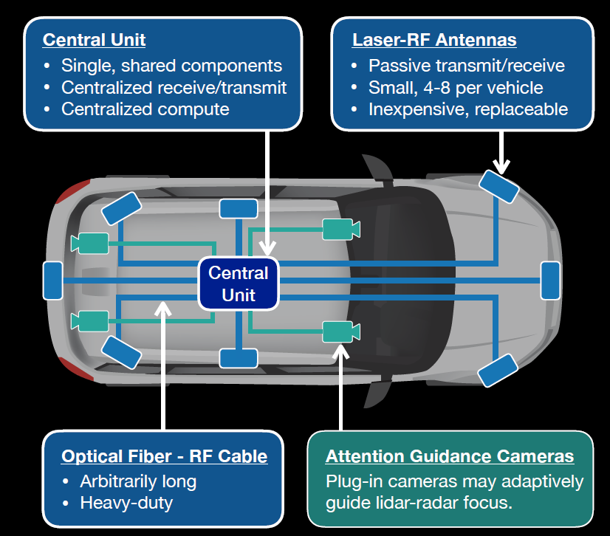

Figure 2: Flexible vehicle sensor architecture with low-cost but high-performance sensors [8]

It can be seen from the picture that the future architecture in autonomous vehicles will include various components that will be connected to physical signal carriers with a very large bandwidth, such as optical fibers and RF cables. Special attention will be paid to laser sensors, which will be 4-8 per car, and which will be a cheap and easily replaceable solution. In addition to laser sensors, as mentioned earlier, the vehicles will be equipped with millimeter-wave radars, cameras for visible light, thermal cameras.
In addition to the group of sensors used to detect pedestrians in traffic, the algorithms used to extract content from the obtained image samples are very important.
For this purpose, various algorithms have been developed that more or less successfully detect pedestrian objects in the image, whether they are static objects or moving objects. Svi algoritmi su većinom usmjereni na korištenje tehnika vještačke inteligencije (Artifical Neural Networks, Suport Vector Machine, Machine Learning).
For quality research in the field of artificial neural networks, an input data set is needed to train the network model so that based on the known data set, the network can detect a new unknown sample.
The INRIA data set is used for this purpose and this data set consists of pictures of pedestrians in streets and other urban scenarios, annotated with bounding boxes of the pedestrians.
The problem with detection can occur for different genders, male, female, and with the detection of children, as these are usually smaller detection objects. A lot of deep learning-based object detectors have been proposed in the past few years in this field. It can be said that the main division of detection algorithms goes into two groups:two-stage detectors and single-stage detectors. Figure 3 shows an example of the layout of a moving pedestrian detection application.

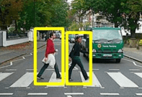

Figure 3: Application for detection of moving pedestrian [9]

Single-stage methods show very good efficiency and performance for general-purpose object detection and adopt a fully convolutional network (FCN). On the other hand two-stage object detection methods are represented by faster region-based convolutional neural networks (R-CNN) and their variants, typically feature a region proposal network (RPN) and a region-based convolutional neural network.
The basic working principle of R-CNN is the generation of ‘region proposals’ or regions in an image that could belong to a particular object. For this purpose used the selective search algorithm.
The selective search algorithm works by generating sub-segmentations of the image that could belong to one object based on color, texture, size and shape. Each of the mentioned techniques does not give 100% accurate detection results but with a combination of different technologies it is possible to reduce the percentage of false detection to an acceptable level.

DISCUSSION

Autonomous vehicles are modern means of transport that will be an unavoidable segment in transport shortly future. For the successful realization of such a complex system, it is necessary to solve a several problems. One of the set tasks is the detection of pedestrians, ie in a broader sense, the detection of objects, static and in motion. Pedestrian detection is a complex task that encompasses a range of activities.
One of the first elements of the system is sensors in the form of visible light cameras, millimeter radars, thermal cameras, and LiDAR laser radars. Each of these sensors represents a solution to a problem in certain circumstances, bad weather conditions, low brightness, night mode, and more.
Therefore, the pedestrian detection system uses a symbiosis of all sensors that together give acceptable detection accuracy results. In addition to the physical-sensory part, the system is equipped with complex algorithms based on artificial neural networks and machine learning.
And in this part, some problems need to be solved. For each ANN it is necessary to provide a set of input data through which the network is trained. There are problems with the detection of different sexes of pedestrians and the detection of children who are usually smaller than adults as objects. For this purpose, R-CNN neural networks based on regions are used, which increases the detection accuracy of the implemented system. This is just one of the techniques most commonly used in pedestrian detection.
Pedestrian-object detection has multiple applications so that in addition to implementation in modern means of transport, these technologies have applications in the robotics industry, video surveillance systems, monitoring and control, and many other modern applications.

CONCLUSION

The paper analyzes the pedestrian detection system and the problems that are closely related to this task. As previously stated, the application of self-driving autonomous vehicles of autonomy levels L4 and L5 requires the implementation of complex information and communication systems. Autonomous-automated vehicles impose huge safety challenges. One of these challenges is an accurate and efficient system for detecting pedestrians in all weather conditions, low visibility conditions, fog, rain, night, day. Based on the conducted research, it can be concluded that accurate detection of pedestrians as static or dynamic objects requires the application of various sensors based on complex imaging technologies.
The so-called computer vision is a synthesis of several complex sensors that will adequately process the collected images from the environment and provide the necessary information about the detected object as an output. The system must have redundant sensors that will represent the control part,all to reduce potential detection errors. Based on the conducted research, it is possible to conclude that the existing pedestrian detection systems are not perfect, but to provide a good starting point for further development, and as such represent an unavoidable part of the overall information and communication system that will be installed in vehicles.

REFERENCES

- Tabitha S.Combs Ph.D., Laura S.Sandt Ph.D., Michael P.Clamann Ph.D., Noreen C.McDonald Ph.D., „Automated Vehicles and Pedestrian Safety: Exploring the Promise and Limits of Pedestrian Detection”, American Journal of Preventive Medicine, Volume 56, Issue 1, January 2019.
- Tomáš Zavodjančík, Gustáv Kasanický, Lýdia Demčáková, “Reduction of Pedestrian Accidents – Automated Road Vehicle”, 14th International scientific conference on sustainable, modern and safe transport TRANSCOM 2021, 2021.
- Ujwalla Gawande, Kamal Hajari and Yogesh Golhar, “Pedestrian Detection and Tracking in Video Surveillance System: Issues, Comprehensive Review, and Challenges”, Recent Trends in Computational Intelligence, DOI: 10.5772/intechopen.90810, 2020.
[4] Puneet Kohli, Anjali Chadha, “Enabling Pedestrian Safety using Computer Vision Techniques: A Case Study of the 2018 Uber Inc. Self-driving Car Crash”, https://arxiv.org/pdf/1805.11815.pdf, 2018.
[5] Ji Hoon Lee, Jong-Suk Choi, Eun Som Jeon, Yeong Gon Kim, Toan Thanh Le, Kwang Yong Shin, Hyeon Chang Lee and Kang Ryoung Park, “Robust Pedestrian Detection by Combining Visible and Thermal Infrared Cameras”, MDPI, Sensors 2015, 15, 10580-10615; doi:10.3390/s150510580, ISNN 1424-8220.
[6] Hiroaki Saito, Kenichi Hatanaka and Toshikatsu Hayasaki, “Development of Hybrid Image Sensor for Pedestrian Detection”, SEI TECHNICAL REVIEW, NUMBER 74, APRIL 2012.
[7] https://www.ansys.com/blog/why-autonomous-vehicles-need-thermal-cameras-flir-ces
[8] https://www.extremetech.com/computing/305691-the-future-of-sensors-for-self-driving-cars-all-roads-all-conditions
[9]https://www.semanticscholar.org/paper/Pedestrian-Detection-on-Mobile-Devices Tchapmi/68f8335b08b81121c7b704c562eee013ad88a97b

