USE OF GEOGEBRA IN THE STUDY OF ROTATIONS

Miroslav Maksimović¹, MSc; Nataša Kontrec², PhD; Stefan Panić³, PhD
¹ University of Priština in Kosovska Mitrovica, Faculty of Sciences and Mathematics, Kosovska Mitrovica, SERBIA, miroslav.maksimovic@pr.ac.rs
¹ University of Priština in Kosovska Mitrovica, Faculty of Sciences and Mathematics, Kosovska Mitrovica, SERBIA, natasa.kontrec@pr.ac.rs
¹ University of Priština in Kosovska Mitrovica, Faculty of Sciences and Mathematics, Kosovska Mitrovica, SERBIA, stefan.panic@pr.ac.rs

Abstract: With the development of information technologies and educational software, there was a need for research and examination of how and in what way to use them in teaching, without losing the quality of existing traditional methods. One of the goals in this process of finding the most suitable model for the use of educational software in teaching is to motivate students to use them independently. For that reason, this paper explores the possibilities and ways of introducing GeoGebra mathematical software at geometry teaching and its impact on understanding of processed material by students. The effects of this software on motivation, interest and confidence of the course participants were observed. For the purposes of this research, we studied the Rotations in geometry. The particular parts of the construction tasks have been considered, so the students could make the most out of Geogebra possibilities. The dynamic component of this software helps them to discover more relations between observed objects which is an important difference from the classic solution of such tasks.
Keywords: Educational Software, Effects on Teaching Process, ICT, GeoGebra, Teaching Geometry.

INTRODUCTION

We live in the era of digitalization, surrounded by various smart devices that have the ability to install numerous software for solving of mathematical problems. However, there are just a few examples that show that such software has actually been used in the teaching process itself [1]. In general, when it comes to teaching mathematics, research has shown [2] that a lecturer must be able to make a balance between mental, classical and digital resources in order to explain the abstract mathematical concepts that are often incomprehensible to students. It has also been noted that technology helps students connect to mathematics by giving them a more realistic insight into the context itself [3].
Today, there are several mathematical tools that have found their application in mathematics teaching. The most famous are Mathematica, MATLAB and GeoGebra.
For the reasons stated above, in this paper, we are examining the possibility of including the GeoGebra software in combination with classical teaching in the Geometry course at the Faculty of Science and Mathematics, University of Pristina in Kosovska Mitrovica.
Why GeoGebra? GeoGebra is a free, dynamic mathematical software that can be used to solve geometric but also algebraic problems. Its basic idea is to unite geometry and algebra into a unique mathematical package that can be used at all levels of education, as presented in the papers [4, 5, 6]. It has been translated into a large number of foreign languages and the number of its users is constantly growing [7].
Some of these symbolic packages allow students to attain a high level of logical-analytical reasoning through visually problematic concepts as in [8, 9, 10]. We must note that the application of this software is not limited to mathematics but it already find its place in physics and technical sciences [11, 12] as well as in computations [13].

RESEARCH METHODOLOGY

The aim of the research presented in this paper is to examine the effects of GeoGebra on the acquisition of geometry lessons and to motivate and encourage students to use this software in the learning process. All students who attend the Geometry 2 course at the Faculty of Science and Mathematics in Kosovska Mitrovica participated in the research. As this is a nonobligatory but elective course, a group of only ten (10) students was formed. The teaching unit was first presented by using the classical teaching methods characteristic for this type of subject, and then the same problems were resolved using GeoGebra. After that, the students filled out a questionnaire with 7 questions.
The questions were as follows:
- Do you use GeoGebra for the first time?
- Do you think that the use of GeoGebra is complicated?
- Do you find more interesting the geometry lesson with the use of GeoGebra?
- Do you understand the lessons better if we use GeoGebra?
- How do you estimate the problem solving in which GeoGebra is used compared to "classical" way of solving geometry problems?
- Do you find solution more precise and obvious to you when presented in GeoGebra compared to the "classic" way?
- Do you find it necessary to use GeoGebra as a standard part of the Geometry course?
In the next chapter of the paper, a teaching unit is discussed in the course.

ROTATIONs IN THE PLANE $E^{2}$

In order to approach problem solving of any type of isometric transformation, knowledge of theory is necessary because geometry is a deductive theory based on axioms and claims derived from these axioms [14]. Students are familiar with the theory of isometric transformations, so we can use GeoGebra to solve geometry problems. In this program, there are already built-in isometric transformation tools, and by clicking on any tool, a message with the instructions for use appears.
In the field of isometric transformations, in this paper we will study Rotational transformations in plane $E^{2}$. We will present a geometry construction problem which often, based on past experience, sets students to a path leading to "mistakes" – they considered only a special case of it. These types of problems are consisting of four parts: analysis, construction, evidence and discussion.
Problem 1. Let $O, P, Q$ detonates three non-collinear points in plane $E^{2}$. Using isometric transformation, construct a square $ABCD$ in the plane $E^{2}$ where $O$ is a square centre and $P$ and $Q$ belong to lines $AB$ and $CD$, consecutively.

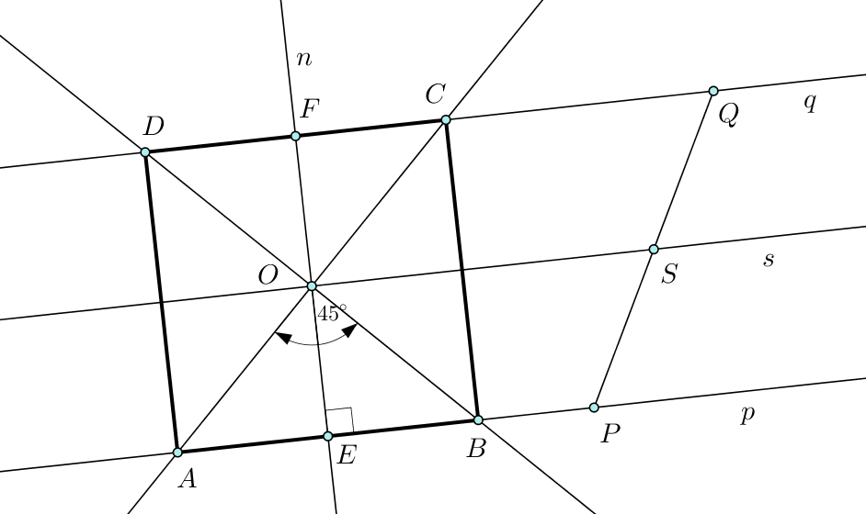
Figure 1: Construction of the problem 1 presented in GeoGebra
Solution: When analyzing the problem, we assumed that the construction under the set conditions was possible and solvable. It is easy to see that $s$, $s\left\|p\right.$, $s\left\|q\right.$, $s∋O$ divides segment $PQ$ in the equal parts.
After inserting the given elements into the GeoGebra command window, we begin the construction by finding the centre $S$ of segment $PQ$ using the Midpoint or Center tool. Now we can construct the line $s$, and then the lines $p\left\|s\right.$ and $q\left\|s\right.$. Further we draw the normal line $n$ from the point $O$ to any of these lines. The element rotation will be performed using the Rotate around Point tool. Using $R_{O, {45}^{°}}$ rotation of the line $n$ (in positive direction) we are getting points $B$ and $D$ in intersection of lines $p$ и $q$, and similarly, by using $R_{O, {45}^{°}}^{-1}$ rotation the points $A$ и $C$ are obtained (Figure 1.)$∎$
Discusion: Interests among students immediately arise. Actually, with the use of the second rotation (for the construction of points $A$ and $C$), they realized that there is another way for problem solving. Knowing that the square diagonals intersect at the right angles, they suggested the construction of points $A$ and$C$ by rotating the line $BD$ around the point $O$ by ${90}^{°}$.
The solution presented in GeoGebra is interactive, dynamic and allows us to move certain objects and then discuss the possible outcomes. Students who started with a special case of the problem, when the point O is at the midpoint of the line segment$PQ$, can easily "correct the error" by moving any of points $O, P$ and $Q$.$∎$
After a detailed explanation of all the GeoGebra tools used in previous task, the students were also assigned with the new one:
Problem 2: Two circles $k, l$ and point$C$ are given in the plane${ E}^{2}$. Construct an isosceles triangle which vertices A and B should be in the given circles, respectively.
Solution: Since we know that the triangle is isosceles, it is clear that the angle of rotation will be $ω={60}^{°}$ and the point $C$ is the center of rotation i.e. we have rotation $R_{C, {60}^{°}}$.
Since two circles are given, we will rotate one of them with $R_{C, {60}^{°}}$, for example $R_{C, {60}^{°}}\left(k\right)=k^{'}.$ Denote intersection of $l$ and $k^{'}$ as $l∩k^{'}=\{B, B_{1}\}$. Now we can rotate point $B$ with $R_{C, {60}^{°}}^{-1}\left(B\right)=A$ which closes triangle construction (Figure 2).
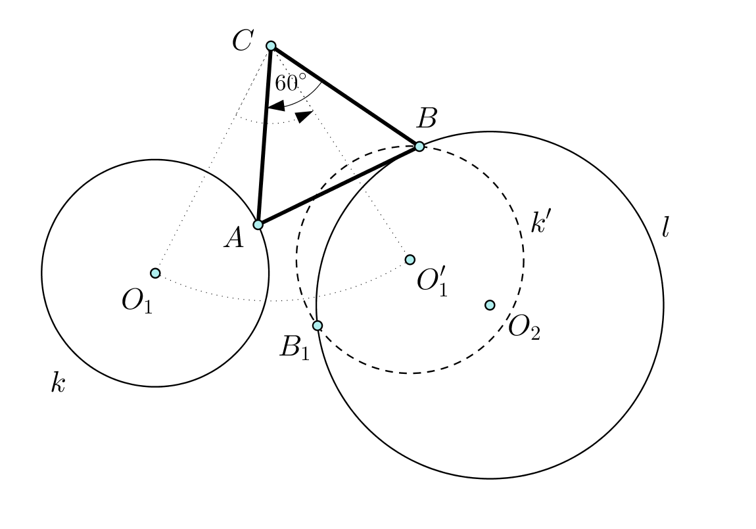
Figure 2: Construction of the problem 2 presented in GeoGebra
Instead of classical proving, in GeoGebra we can easily conclude that all sides of the triangle are of the same length, and that all angles are equal, so that it is an equilateral triangle. Also, using the Relation tool, we conclude that the point $A∈k$, and based on the construction $B∈l$, and in this way, all the conditions of the task are satisfied.
The number of the problem solutions will depend on the number of intersection points of the circles $l$ and $k'$ , and that could be easily noticed in GeoGebra if we move the center or radius of the circle $k$. The students could see in a very transparent way that the problem has no solution if circles $l$ and $k'$ do not have any touching points, and that it has only one solution if circles touch each other and two solutions if they intersect (the case shown in Figure 2).$∎$
They noticed the built-in rotation tool in GeoGebra can rotate every object in just a few seconds (in the first case we had the rotation of the line, and in the second rotation of the circle and the rotation of the point). Both problems were constructive and solving them in a classic way with paper and pen is time consuming. By solving a problem in GeoGebra, we create an interactive material that can serve many users.
The conclusion is that GeoGebra can greatly contribute to the Geometry teaching, especially when solving construction problems. It often happens that students poorly construct an object, so they need to delete the drawing and start over, while GeoGebra constructions were very precise and fast to draw with the help of built-in tools.

results

The students showed great interest in this type of teaching and closely followed the teacher's lecture. By analyzing the results of the survey, the following conclusions can be made:
The students had already met with GeoGebra and were familiar with the work in this mathematical software.
All examined students believe that this mathematical software is not overly complicated and that teaching by using GeoGebra is more interesting and productive, and therefore its use within the course of Geometry should be intensified.
The fifth request of the questionnaire was to evaluate the way of solving assignments using GeoGebra and classical way, grades from 1 to 10 for each of the approaches. For obtained data we did t-Test for means and the results are shown in the Table 1.
Table 1: t-Test: Paired Two Sample for Means
 | Using GeoGebra | Classical way
Mean | 9.1 | 5.2
Variance | 0.544444444 | 1.066666667
Observations | 10 | 10
Pearson Correlation | -0.17496355
Hypothesized Mean Difference | 0
df | 9
t Stat ($t_{s}$) | 9
P(T<=t) one-tail | 0.0000042690
t Critical one-tail | 1.833112933
P(T<=t) two-tail | 0.0000085381
t Critical two-tail ($t_{c}$) | 2.262157163

Since $\left|t_{s}\right|>t_{c}$ (for $α=0.05$), we conclude that there is significant deviation between means. Therefore, it is clear that students solving the problem using GeoGebra achieved better results.
Students continued solving some geometry problems by themselves and compared to classical lessons, they provided better results because they were able to easily see the relationship between objects after “discussing” the solution with GeoGebra.

Appendix

The examples presented in previous section can be found on the following links Example 1., Example 2.

CONCLUSIONS

The geometry teaching and learning should not be purely theoretical. It is necessary to include existing aids such as GeoGebra, Mathematica, MATALAB and etc. in order to make students more interested and motivated for the course. GeoGebra is free software available in many languages and as such it is suitable for use, however, it mostly depends on whether the teacher will use it or not. This paper has shown that solving problems with GeoGebra is more precise and faster, and users are also able to "check" the required result because GeoGebra creates interactive mathematical models, i.e. certain objects can be moved and relations between objects are more obvious. In presented examples, the construction process in GeoGebra is much easier but equally important is the student’s ability to realize what happens if some parameters change. Therefore, there is more time for us to better understand all the issues related to solving problems, because GeoGebra is just a supplementary aid (tool) to teaching of Geometry, and does not completely replace the classic way of working. This research has shown that GeoGebra has a positive impact on motivation, enthusiasm and confidence of students and their opinion is that this software should be included in the regular Geometry teaching. However, both teachers and students must make a certain effort to learn how to use this program, and it is well-known that resistance is an inevitable response to any major change.

acknowledgement

This research was financially supported by internal-junior project IJ-0203, Faculty of Sciences and Mathematics, University of Priština in Kosovska Mitrovica.

REFERENCES

- Arbain N., Shukor N.A., The effects of GeoGebra on students achievement, Procedia - Social and Behavioral Sciences, 172; 2015: 208–214.
- Joglar Prieto N., et al., Designing Geometry 2.0 learning environments: a preliminary study with primary school students, International Journal of Mathematical Education in Science and Technology(ahead-of-print), 2013: 1-21.
- Horton R.M., Storm J., Leonard, W. H., The Graphing Calculator as an Aid to Teaching Algebra, Contemporary Issues in Technology and Teacher Education, 4(2); 2004: 152–162.
- Ljajko E., Ibro V., Development of ideas in a GeoGebra – aided mathematics instruction. Mevlana International Journal of Education (MIJE) Special Issue: Dynamic and Interactive Mathematics Learning Environment, 3(3); 01 July 2013: 1- 7.
- Ljajko E., Uticaj GeoGebra-e na predavanje i učenje analitičke geometrije u srednjoj školi, doktorska disertacija, PMF, Novi Sad, 2014.
- Radovic S., Stevanovic A., Radojcic M., Maric M., Interaktivni prikaz površine geometrijskih figura primenom programskog paketa GeoGebra, Inovacije u nastavi, XXVI, 3; 2013: 135–145.
- Hohenwarter M., Teaching and calculus with free dynamic mathematics software GeoGebra, 11th International Congress n Mathematical Education. 2008.
- Drijvers P., Learning Mathematics in a Computer Algebra Environment: Obstacles are Opportunities, ZDM The International Journal on Mathematics Education, 34(5); 2002: 221–228.
- Fuchs K.J., Computer Algebra Systems in Mathematics Education, ZDM The International Journal on Mathematics Education, 35(1); 2003: 20–23.
- Perjesi I.H., Application of CAS for Teaching of Integral-Transforming Theorems, ZDM The International Journal on Mathematics Education, 35(2); 2003: 43–47.
- Johnson D., Buege J., Rethinking the Way We Teach Undergraduate Physics and Engineering with Mathematica. Mathematics with Vision: Proceedings of the First International Mathematica Symposium, 1995: 233–242.
- Ward J. P., Modern Mathematics for Engineers and Scientists. Teaching Mathematics and its Applications, 22(1); 2003: 37–44.
- Tonkes E. J., Loch B.I., Stace A.W., An Innovation Learning Model for Computation in First Year Mathematics, International Journal of Mathematical Education in Science and Technology, 36(7); 2005: 751–758.
- Lopandić D., Geometrija, Naučna knjiga, Beograd, 1989.

Data analysis tools in Microsoft Excel

