THE VISUALISATION OF ELECTRICITY CONSUMERS AND ELECTRICITY CONSUMPTION IN AN URBAN AREA

Dragana Knežević¹
¹Western Serbia Academy of Applied Studies, Užice, dknezevic28@gmail.com

Abstract: The paper provides grafical presentations of different electricity consumers and their consumption patterns on the territory of a city. The City of Užice is located in Western Serbia and has about 70,000 residents, populating both the urban and suburban zone. The processed data, obtained from a public utility company, represent the actual energy usage during a period of 56 months. The data set includes 1,852,388 readings for a total of 40,548 consumers, thus covering all the actual metering supply points on the territory of the city. The visualisation provides insight into different consumer categories and groups, showing the share of each of them in the total energy consumption, both for the entire observed period and in individual months and seasons. Moreover, the months with the highest energy consumption are graphically presented, as well as the consumers with the highest individual readings, and those with the highest overall consumption. Based on such visual presentations, it is easy to draw conclusions about the demand and sufficient electricity supply during certain months of the year, quarters or longer periods of time. Furthermore, the obtained results can be used for making different plans about the distribution of electricity, and provide the basis for further research as well. And the most important, the results obtained in this paper will serve as a basis for future work.

Keywords: Big Data, Electricity Consumption, Graphical Presentation, Python, Visualisation.

INTRODUCTION

We are increasingly coming across the big data concept, and encountering problems of their interpretation and understanding. A great number of authors are conducting research on the phenomenon using data mining or machine learning techniques, starting from hypotheses that require extensive research and the application of various algorithms in order to be accepted or rejected.
As such data are often quite complex, and data sets themselves comprised of a huge amount of unstructured data, it is difficult to draw conclusions based on their textual presentation. It is in such situations that data visualisation comes to the fore. Using various diagrams and graphical presentations, seemingly unclear and often ambiguous data gain in significance.
This paper focuses on the visualisation of an extensive data set, containing electricity meter readings taken over a specific period of time. In order to generate such a visual presentation of the data, which would facilitate the selection of data processing techniques and methods in further research, the paper presents the data graphically. The aim is to draw conclusions about electricity consumers, i.e. the existing consumer categories and groups, and their share in both the total electricity consumption and the consumption during certain months or seasons of the year. Furthermore, the same procedure will be used to present the consumers with the highest consumption in specific months, as well as those with the highest overall consumption during the observed period. Data processing and visualisation are performed using the Python programming language. According to [1], Python, which suddenly gained popularity between 2000 and 2005, has been the second most frequently used programming language in 2021.
In addition to being substantial and not providing a true image of the actual situation, the data we work with (the raw data) can also appear in different forms and formats [2]. Data visualisation usually refers to the process of presenting data in the form of graphs and images, thus making it possible to communicate analytic results in a visual manner, detect potential outliers, and make proper decisions on data processing and modelling techniques [3]. Python is one of the basic tools for the visualisation of massive amounts of data because it is both easy to use and provides numerous packages used for generating diagrams [3-6]. Although Python is basically a general purpose programming language, which can be used in any field, its special strength lies in its flexibility and the ease of manipulating big data [7]. Since it appeared, (since 1991, when it was published), it has been constantly developing, and now it is one of the world’s leading programming languages [1, 8].
Electricity consumption, especially household energy usage, has been drawing increasing attention over the last decade [9-13]. The number of papers presenting the results of research into various aspects of electricity consumption, including the illegal one, is growing [14]. The research is mostly conducted using data mining techniques and electricity consumption projections obtained by means of these techniques [15-23]. Special emphasis is placed on the projections of electricity consumption in households and residential buildings [24-26]. Based on the available data, collected during a specific period of time in a specific geographical area, the authors in [27] use neural networks to predict energy consumption, whereas in [28] neural networks are used to classify the existing consumers.
The main goal of this paper is to get acquainted with the target set through a graphical representation of dominant characteristics. This will particularly affect the reduction of time of the first - preprocessing phase in future papers.

MATERIALS AND METHODS

The paper provides an overview of processing a specific data set. The set comprises the information on electricity consumption on the territory of the City of Užice, for each metering supply point, over the period of 56 months. The data were obtained from the public utility company engaged in the distribution of electricity (‘EPS’), and comprise a total of 1,852,386 meter readings. Each reading is characterised by eleven attributes, such as the:
- consumer label (instead of personal information),
- consumer category (household or non-household consumers),
- area or zone where the consumer is situated (urban or suburban zone),
- consumer group,
- observed period,
- meter readings taken at the beginning and end of each month from single-rate electricity meters,
- meter readings taken at the beginning and end of each month from dual-rate electricity meters,
- total consumption in kWh for both tariffs.
In order to make more sense and provide a clear idea of the consumption, the collected data must be properly interpreted. Their visualisation makes this possible. However, data visualisation itself is preceded by another important phase, and that is data preprocessing, during which data are prepared for the subsequent phases.
Raw data parsing is one of the initial phases of data processing, which includes several sub-phases, such as data collection, storage in proper formats, cleaning, ect [2]. In this phase, the unnecessary columns are removed and only those relevant to the generation of each individual diagram are kept. For example, the columns providing information on meter readings taken at the beginning and end of each month are removed and replaced with a column showing the months to which the readings refer. Also, the columns showing meter readings taken from each meter type (single-rate and dual-rate ones) are excluded and replaced with a column showing the total consumed energy in kWh for both tariffs. Then, the type of the data relating to some of the attributes must be changed in order to be used for the purpose of visualisation. The entire data processing and generating of diagrams in this case is performed using the Python programming language.
The Python editor (PyCharm) itself is embedded with some basic elements without which work with a data set cannot begin, but any more complex work requires the installation of packages and add-ons that are not included in the basic version of the editor. Several packages are used for data processing and visualisation in this research, such as: numpy, pandas, matplotlib and seaborn. Each of them enables data manipulation, i.e. generating diagrams with specific characteristics.
As the target data set can be viewed from different aspects, several different diagrams can be generated according to different criteria. The y-axis of the diagrams shows electricity consumption in kWh (kilowatt-hours) or the number of readings taken in the given period of time, whereas the x-axis shows the months (the observed period), consumer groups and categories.
Entire data processing and visualization were performed using the Python programming language.

RESULT AND DISCUSSION

Based on the information included in the target data set, the following subchapters provide visual presentations of electricity consumers and their consumption during the observed period in the form of bar charts, pie charts and line graphs. Some of the diagrams show readings and the total electricity consumption during the observed period for all existing consumer categories and groups, whereas some present a specific category, group or period of time.

Consumption overview - criterion: months of the year

Taking the whole data set into consideration, a diagram showing all existing consumers and their monthly consumption during the entire observed period can be generated. In the diagram below (Figure 1), each column represents the total consumption in the given month of the observed period. The months are shown on the x-axis, whereas the y-axis represents the electricity consumption in kWh. The information on the exact consumption in kWh is given above each column.
Figure 1 shows relatively small deviations in the consumption for the most part of the year. The highest consumption was recorded in March (the red bar - 115,625,058 kWh), and the lowest total consumption was recorded in September (the cyan bar - 74,057,810 kWh).

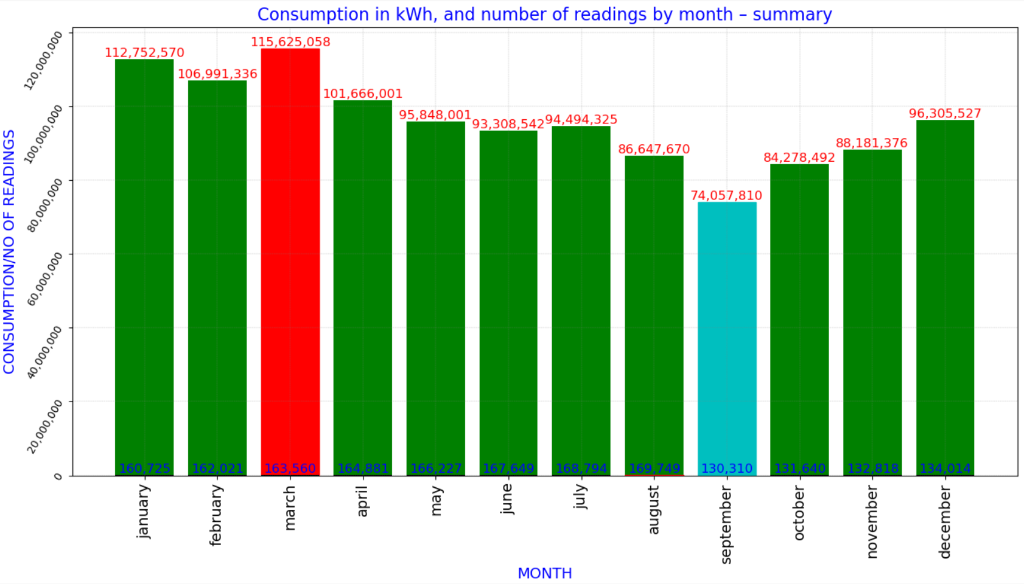
Figure 1: The presentation of the total consumption and number on a monthly basis during the entire observed period

In a similar way, the number of readings in each of the twelve months can be analysed and compared (Figure 1- the numbers in blue at the bottom of each bar). The number varies reaching a peak in August (169,749 readings for a total of 40,854 consumers). The number of readings was the lowest in September. The variation in the number of consumers is the consequence of connecting new meters to the network during the observed period, and disconnecting some of the existing meters, mostly in abandoned rural households. The sudden drop that can be noticed after August results from the fact that the data set does not contain information for the subsequent months.

Consumption overview – criterion: summer and winter months

It is easy to assume that the seasons of the year also play an important role in electricity consumption. Figure 2 provides an overview of the consumption and number of readings in each winter and summer month of the observed period for all the existing consumers and readings taken. The winter months (November through March) are marked in cyan, and the summer ones (April through October) in orange. The graph below (Figure 2) shows, more precisely than the above-given one, that the highest consumption in the winter months was recorded in March 2018 (30,008,798 kWh), and the lowest in February 2014 (13,766,575 kWh), i.e. at the very beginning of the observed period. The total consumption in all winter months is 604,134,359 kWh. As for the summer months, the highest consumption was recorded in May 2018 (24,132,095 kWh) and the lowest in June 2014 (11,454,449 kWh). The total electricity consumption in the summer months was 564,022,349 kWh.
Taking into account the number of consumers during the observed period (Figure 2 – the numbers in black at the bottom of each bar), with regards to the winter months, the lowest number was recorded in January 2014 (the first month in the observed period, with 25,939 consumers), and the highest in March 2018, i.e. the last winter month of the given period, with 38,697 consumers). As for the summer months, the lowest number of consumers was recorded in April 2014 (26,940) and the highest in August 2018 (the last month of the observed period, with 40,584 consumers). Generally speaking, there was a growing trend in the number of consumers during the observed period.

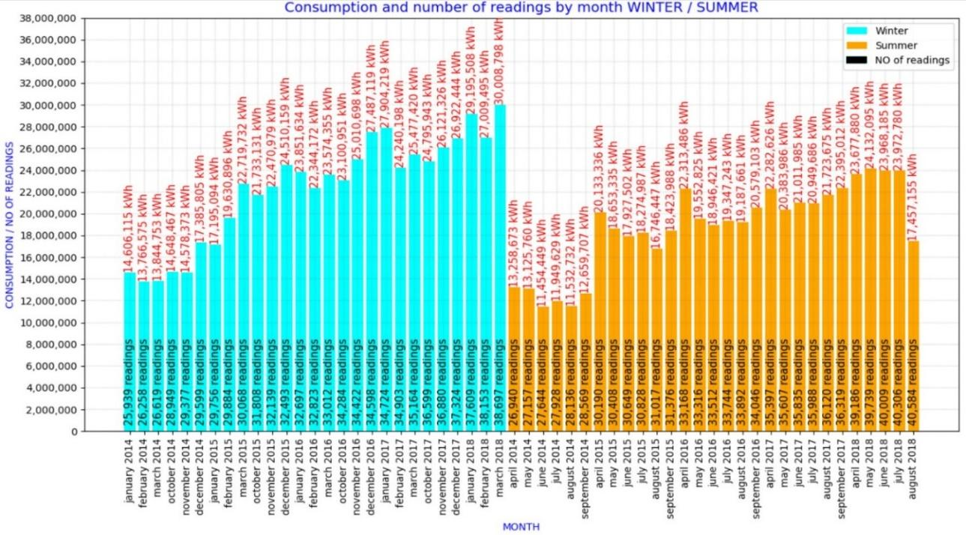
Figure 2: An overview of the consumption add the number of consumers in each month of the observed period (summer and winter months)

Consumption overview – criterion: months with the highest and lowest energy consumption

The above-given Figure 2 shows that the highest consumption was recorded in March 2018, and the lowest in June 2014. By generating the diagrams for these specific months, the representation as shown in the following figure is obtained (Figure 3a and 3b).

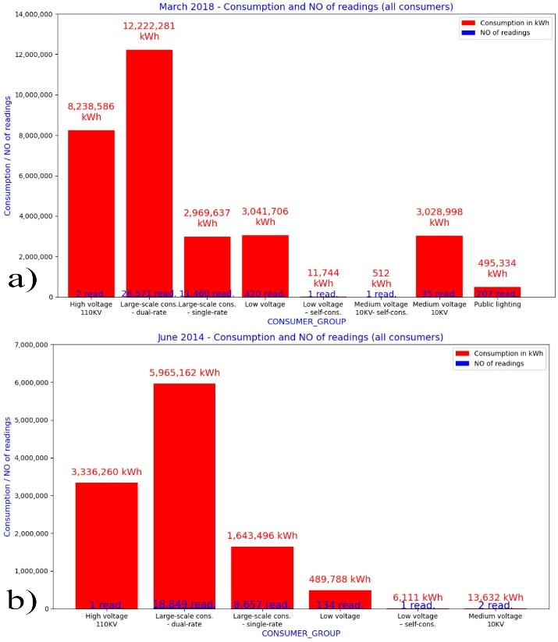
Figure 3: An overview of the consumption and number of readings in a) March 2018 and b) June 2014

The x-axis on Figure 3 shows different groups of existing consumers on the given territory in the given months, and the y-axis represents their consumption, i.e. the number of readings in these months.
Figure 3 shows that the consumer group labeled Large-scale consumption - dual-rate electricity meter had the highest consumption both in March 2018 and June 2014. With regadrs to this consumer group, the same can be said about the number of readings, though that is not the case with other groups. Some of the groups with the lowest number of readings actually had rather high consumption and vice versa. In both observed months, the group labeled High voltage 110KV, which includes only two, i.e. one consumer, had the second highest consumption.

Consumption overview – criterion: consumer category and months

The graphs provided in the previous subchapter (Figure 3a and 3b) shows that there are several different consumer groups. A closer look at the data set shows that there are two basic consumer categories: household and non-household ones. In order to make consumption monitoring easier, the following graph (Figure 4a) provides a comparative overview of the consumption in each month (shown on the x-axis), during the entire observed period, but this time the consumer category itself serves as the visualisation crtierion (the red bars represent household, and the blue ones represent non-household consumers).

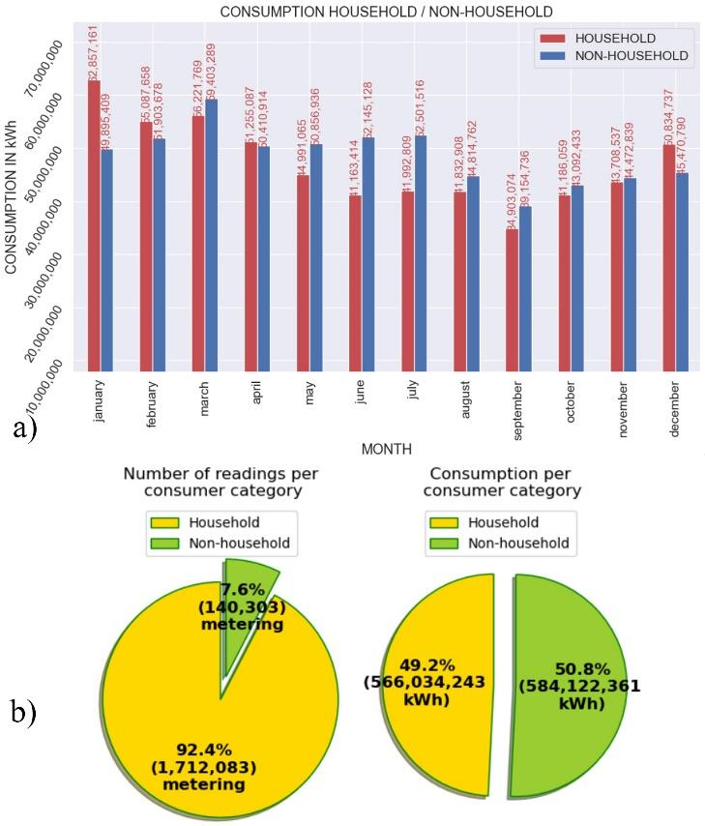
Figure 4: a ) A comparative overview of the consumption in each month b) – An overview of the number of readings and consumption per consumer category

According to Figure 4a, it can be concluded that higher consumption was recorded with non-household consumers. However, household consumers’ energy usage was significantly higher in January, and the situation was similar in February and December. This ‘phenomenon’ could be explained by the fact that the winter months are also the coldest months of the year in this region. Therefore, the amount of consumed energy is highly dependent on the fact that many households use electricity for heating.
As for consumer categories, taking into account two basic ones - household and non-household consumers - the distribution of the total number of consumers and total consumption based on these categories can also be visualised for the entire observed period (Figure 4b). The pie chart (Figure 4b) clearly shows that there were much more readings in the household category (1,712,083) than in the non-household one (only 140,303 readings). In percentages, the ratio between the two categories is 92.4%:7.6%. However, taking the consumption in kWh into consideration, quite unexpected results are obtained. The total consumption of all household consumers was 566,034,243 kWh, whereas the consumption of non-household ones was 584,122,361 kWh, the difference between the two being 18,088,118 kWh, in favor of the non-household category, which had an incomparably lower number of readings. The analysis of both ways of data visualisation (an overview of the consumption in kWh and in percentages) indicates that, in order to draw proper conclusions, it is necessary to communicate the results using their absolute values.
Table 1 shows the consumption and number of readings once again, but this time using consumer categories as the criterion (the household and non-household category respectively), as well as consumer groups identified within these categories. It can be seen that the household category comprises only two groups: Large-scale consumption - dual-rate electricity meter and Large-scale consumption - single-rate electricity meter, whereas a significantly higher number of consumers, i.e. 70.5% (or 1,207,173 precisely) possess dual-rate electricity meters. The remaining 29.5% possess single-rate electricity meters. Such a ratio is clearly reflected in the electricity consumption by these two groups: 82.9% of the total consumption by household consumers was measured using dual-rate electricity meters, and 17.1% using single-rate electricity meters.
Unlike the household category, the non-household consumers comprise eight different consumer groups: Large-scale consumption - single-rate, Large-scale consumption - dual-rate, Low voltage, Low voltage – self-consumption, Public lighting, Medium voltage 10 KV, Medium voltage 10 KV – self-consumption and High voltage 110 KV. According to the column which shows the number of consumers in each consumer group of this category, the lowest total number of readings, i.e. only 12, relate to the group labeled Medium voltage 10 KV - self-consumption, which is immediately followed by the Low voltage - self –consumption group, with only 55 readings, and High voltage 110 KV group with 99 readings, etc. Again, (as in Figure 3), the comparison between the number of readings and the consumption shows that the total consumption of non-household consumers and the number of readings do not increase proportionally, as is the case with the household category. On the contrary, the most numerous groups had a relatively low total consumption in kWh, whereas the highest consumption by far was recorded in the group labeled High voltage 110 KV (the non-household category).

Table 1: The comparison of different groups' consumption and number of readings – by category
Consumer category | Consumer group | Consumption in kWh (sum for all readings) | NO of readings
Household | Large-scale cons. - dual-rate | 469,379,269 | 1,207,173
 | Large-scale cons. - single-rate | 96,655,009 | 504,911
Non-household | Large-scale cons. - dual-rate | 34,238,924 | 55,720
 | Large-scale cons. - single-rate | 32,965,328 | 65,760
 | High voltage 110 KV | 339,395,869 | 99
 | Low voltage | 84,250,447 | 14,192
 | Low voltage – self-cons | 443,738 | 55
 | Medium volt. 10KV - self-cons. | 617 | 12
 | Medium voltage 10KV | 76,361,483 | 615
 | Public lighting | 16,466,024 | 6,851

Consumption overview – criterion: category and consumer groups in months with highest and lowest consumption

Since we know that there are two main categories and several groups of consumers, we can generate graphs for the months with the highest and lowest overall consumption in order to determine the share of individual consumer groups in the total electricity consumption during these specific months. The graphical presentations are given in Figure 5.
Figure 5a and 5b provide an overview of the consumption and the number of readings in the household and non-household category respectively in March 2018, which proved to be the month with the highest total electricity consumption.
The household category comprises two consumer groups: Large-scale consumption - dual-rate electricity meter and Large-scale consumption - single-rate electricity meter (Figure 5a). The first group has a significantly higher share both in the number of readings and the total household consumption. As for non-household consumers (Figure 5b), consumers belonging to the High voltage 110 KV group had the highest consumption even though there were only two of them on the entire territory in this specific month.

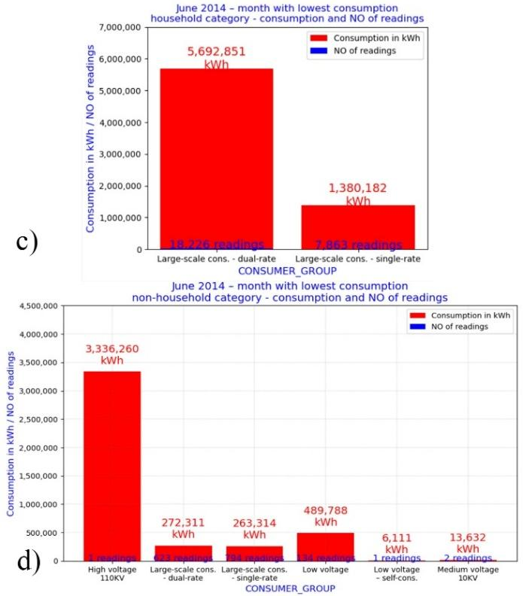
Figure 5: An overview of the consumption and number of readings: a) the household category in March 2018; b) the household category in June 2014; c) the non-household category in March 2018 and d) the non-household category in June 2014

Figure 5c and 5d shows the consumption and number of readings in the household and non-household category respectively, but this time in June 2014, in which the lowest consumption during the entire observed period was recorded. Again, in the household category, consumers with dual-rate electricity meters had both much higher consumption and number of readings, whereas in the non-household category, the highest consumption again was recorded in the High voltage 110 KV group, which included only one consumer in the given month.
If, in each of the two main categories (household and non-household), we were to single out the consumers with the highest consumption on a monthly basis from the entire data set, then in the household category, it would be the consumer labeled ’CONSUMER_14651’, in January 2016, with the consumption of 31,345 kWh. The consumer is located in the urban zone, belongs to the Large-scale consumption group, and owns a dual-rate electricity meter. As for non-household consumers, the highest consumption was achieved by the consumer labeled ’CONSUMER_39385’, in March 2018, and it was 4,762,586 kWh. The consumer belongs to the High voltage 110 KV group.
If we visualise the consumption of these two consumers during the entire observed period, we get the graphs as shown in Figure 6a and 6b.
The consumption by the consumer labeled ’CONSUMER_14651’ (Figure 6a, red line) was monitored from September 2014 until the end of the observed period, whereas monitoring of the consumption by the non-household consumer labeled ’CONSUMER_39385’ (Figure 6b, red line) started in February 2015. Both consumers had no readings taken during the last month. With regards to the consumer labeled ’CONSUMER_14651’, the reason for such high consumption in a single month may be the fact that there was no consumption recorded in the period preceding this reading, i.e. for some reason, meter readings could not be taken for a period of a whole year (from January 2015 to January 2016).
Taking this into account, it can be assumed that these consumers, despite having the highest individual consumption in a single month, are not necessarily the consumers with the highest total consumption during the entire observed period.
Grin line on Figure 6a and 6b provide an overview of the consumption by the consumers who achieved the highest total consumption in all months (in the household and non-household category, respectively). In the household category, it is the consumer labeled ’CONSUMER_28505’, with the total consumption of 270,566 kWh, and in the non-household category, it is the consumer labeled ’CONSUMER_39386’, with much higher total consumption, which equals 176,753,825 kWh. Owing to the possibility of visualisation, the increase and decrease in the consumption during the observed period can be clearly seen, as well as the months in which these consumers had the highest and lowest consumption.

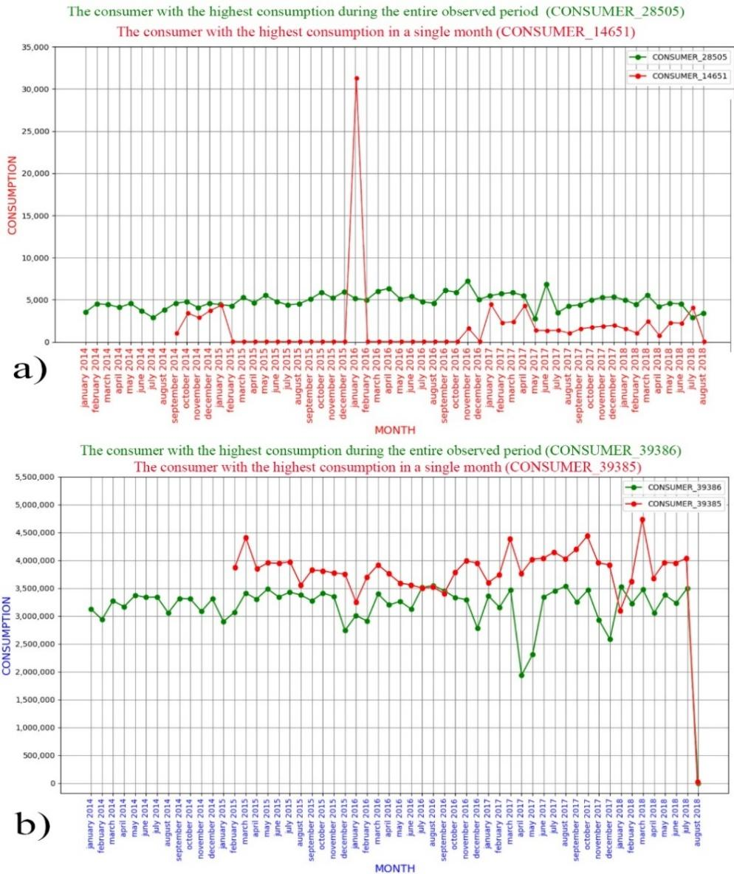
Figure 6: The consumers with the highest consumption in the entire observed period and in a single month –
a) the household category and b) the non-household category

CONCLUSIONS

The analysis of a data set providing information on electricity meter readings in the City of Užice poses a number of questions, which can be answered owing to data visualisation:
As for the months, the highest total consumption on a monthly basis was recorded in March, whereas the lowest consumption was recorded in September. As for the number of consumers (taken readings) on a monthly basis, the number was the highest in August, and the lowest in September.
Several important consumer groups and categories are identified on this territory, but two basic categories include household and non-household consumers. Household consumers actually represent the category with the lowest consumption per metering supply point, whereas the non-household category comprises all metering supply points in companies and enterprises, which are generally big energy users.
The graphs show that, in the household consumer category, there are only two subgroups of meters: Large-scale consumption - single-rate and Large-scale consumption - dual-rate electricity meter, whereas, in addition to these two groups, the non-household consumer category includes six more groups, and they are: Low voltage, Low voltage - self-consumption, Public lighting, Medium voltage 10 KV, Medium voltage 10 KV - self-consumption, High voltage 110 KV.
As for the number of consumers, much more consumers belong to the household category. However, talking about the total amount of consumed energy, the consumption by non-household consumers was higher.
In the household category, the consumer group labeled Large-scale consumption - dual-rate electricity meter achieved higher total consumption. In the non-household category, these figures do not change proportionally. It turned out that the smallest consumer group actually had much higher consumption than any other group (High voltage 110 KV).
With regards to the consumption by each individual consumer, the consumer with the highest consumption in a single month actually was not the consumer with the highest total consumption during the observed period.
Based on the results presented in this paper, the basic consumer groups in terms of electricity consumption, and the categories to which they belong can be identified. Such findings can facilitate the selection of techniques and methodologies for future research. According to the obtained results, it is clear that some consumer groups might be outliers when viewed globally, with other consumers, both because of being small in size and because of their enormous consumption.
This paper is the first in a series of papers that will address the issue of forecasting electricity consumption on a monthly basis using machine learning techniques, so the presentations from this will be useful in future papers.

REFERENCES
[1] TIOBE Index for July 2021. Retrieved from https://www.tiobe.com/tiobe-index/. (July 2021)
[2] Madhavan, S., Mastering Python for Data Science (Packt Publishing) 2015.
[3] Vo. T. H, P., Python: Data Analytics and Visualization (Packt Publishing) 2017.
[4] Milovanović, I., Vettigli, G. & Foures, D., Python Data Visualization Cookbook - Second Edition: Vol. Second edition (Packt Publishing) 2015.
[5] Babcock, J., Mastering Predictive Analytics with Python (Packt Publishing) 2016.
[6] Milovanović, I., Python Data Visualization Cookbook : Over 60 Recipes That Will Enable You to Learn How to Create Attractive Visualizations Using Python’s Most Popular Libraries (Packt Publishing) 2013.
[7] Miller, J. D., Big Data Visualization (Packt Publishing) 2017.
[8] Romano, F. Learning Python (Packt Publishing) 2015.
[9] Ali, U., Buccella, C. & Cecati, C., Households electricity consumption analysis with data mining techniques, IECON Proceedings (Industrial Electronics Conference), 2016, 3966–3971.
https://doi.org/10.1109/IECON.2016.7793118
[10] Guo, Z., Zhou, K., Zhang, X., Yang, S. & Shao, Z., Data mining based framework for exploring household electricity consumption patterns: A case study in China context, Journal of Cleaner Production, 2018, 195, 773–785.
https://doi.org/10.1016/j.jclepro.2018.05.254
[11] Rathod, R. R. & Garg, R. D., Regional electricity consumption analysis for consumers using data mining techniques and consumer meter reading data, International Journal of Electrical Power and Energy Systems, 2016, 78, 368–374. https://doi.org/10.1016/j.ijepes.2015.11.110
[12] Ramos, S., Duarte, J. M., Duarte, F. J. & Vale, Z., A data-mining-based methodology to support MV electricity customers’ characterization. Energy & Buildings, 2015, 91, 16–25. https://doi.org/10.1016/j.enbuild.2015.01.035
[13] Jiang, Z., Lin, R. & Yang, F., A hybrid machine learning model for electricity consumer categorization using smart meter data, Energies, 2018, 11(9).
https://doi.org/10.3390/en11092235
[14] Ghasemi, A. A. & Gitizadeh, M., Detection of illegal consumers using pattern classification approach combined with Levenberg-Marquardt method in smart grid, International Journal of Electrical Power and Energy Systems, 2018, 99, 363–375. https://doi.org/10.1016/j.ijepes.2018.01.036
[15] Tso, G. K. F. & Yau, K. K. W., Predicting electricity energy consumption: A comparison of regression analysis, decision tree and neural networks, Energy, 2018, 32(9), 1761–1768. https://doi.org/10.1016/j.energy.2006.11.010
[16] Sauhats, A., Varfolomejeva, R., Lmkevics, O., Petrecenko, R., Kunickis, M. & Balodis, M., Analysis and prediction of electricity consumption using smart meter data, International Conference on Power Engineering, Energy and Electrical Drives, 2015, 17–22.
https://doi.org/10.1109/PowerEng.2015.7266290
[17] Aman, S., Frincu, M., Chelmis, C., Noor, M. U., Simmhan, Y., Prasanna, V., Empirical Comparison of Prediction Methods for Electricity Consumption Forecasting, ResearchGate, 2014.
[18] Kavaklioglu, K., Modeling and prediction of Turkey’s electricity consumption using Support Vector Regression, Applied Energy, 2011, 88(1), 368–375. https://doi.org/10.1016/j.apenergy.2010.07.021
[19] Kim, M. K., Cha, J., Lee, S., Lee, E., Pham, V. H. & Theera-Umpon, N., Simplified neural network model design with sensitivity analysis and electricity consumption prediction in a commercial building, Energies, 2019, 12(7). https://doi.org/10.3390/en12071201
[20] Nugaliyadde, A., Somaratne, U., Wong, K. W., Predicting Electricity Consumption using Deep Recurrent Neural Networks, Cornell University, Computer Science, Mashine Learning, 2019.
[21] Kargar, M.J. & Charsoghi, K., Predicting annual electricity consumption in iran using artificial neural networks (NARX), Indian J.Sci.Res, 2014, 5 (1): 231-242.
[22] Abiyev, R. H., Fuzzy Wavelet Neural Network for Prediction of Electricity Consumption, Artificial Intelligence For Engineering Design Analysis And Manufacturing, 2009, 2, 109.
[23] Azadeh, A., Ghaderi, S. F., Tarverdian, S., & Saberi, M., Integration of artificial neural networks and genetic algorithm to predict electrical energy consumption, Applied Mathematics and Computation, 2007, 186(2), 1731–1741. https://doi.org/10.1016/j.amc.2006.08.093
[24] Beccali, M., Cellura, M., Lo Brano, V., & Marvuglia, A., Short-term prediction of household electricity consumption: Assessing weather sensitivity in a Mediterranean area, Renewable and Sustainable Energy Reviews, 2008, 12(8), 2040–2065.
https://doi.org/10.1016/j.rser.2007.04.010
[25] Yoo, S. G. & Myriam, H.-Á., Predicting residential electricity consumption using neural networks: A case study, Journal of Physics: Conference Series, 2018, 1072(1).
https://doi.org/10.1088/1742-6596/1072/1/012005
[26] Cai, H., Shen, S., Lin, Q., Li, X. & Xiao, H., Predicting the Energy Consumption of Residential Buildings for Regional Electricity Supply-Side and Demand-Side Management. IEEE Access, 2019, 30386.
[27] Knežević, D., Blagojević, M., Ranković, A., Prediction of electricity consumption using artificial neural networks, KMI: Kopaonik, 2020.
[28] Knežević, D., Blagojević, M., Classification of electricity consumers using artificial neural networks, Facta Universitatis, 2019, Vol. 32, No. 4. https://doi.org/10.2298/FUEE1904529K.

